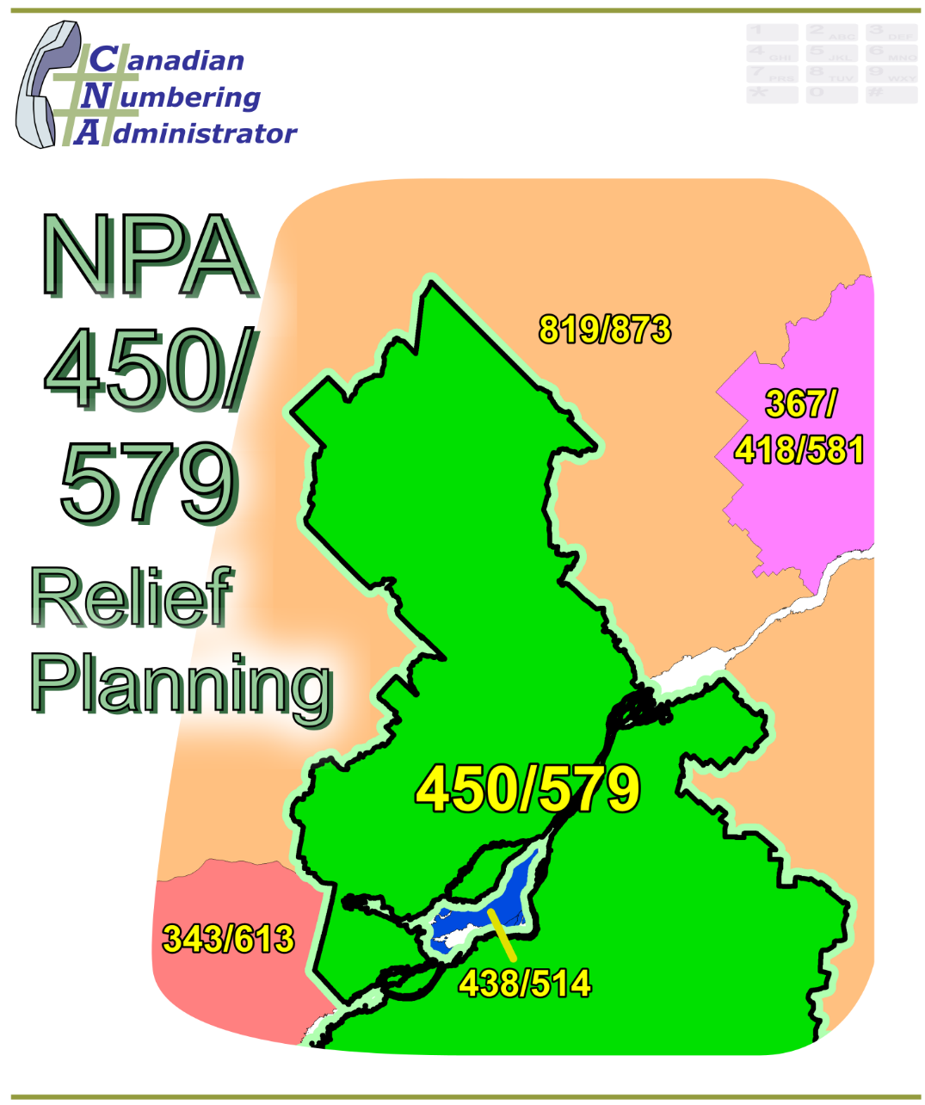

NPA 450/579 Planning Document (PD)

Version 1.0 – 28 September 2018

|  |  |
| --- | --- |
|  |  |

**TABLE OF CONTENTS**

1. INTRODUCTION 1

2. NPA RELIEF PLANNING PROCESS 3

3. NPA RELIEF METHODS 3

4. NPA EXHAUST INFORMATION 4

5. RELIEF OPTIONS 4

5.1. Distributed Overlay 5

5.1.1. Distributed Overlay Option 5

5.2. Concentrated Overlay 5

5.2.1. Concentrated Overlay #1 of NPA 354 on Bell Canada LIRs 5

5.2.2. Concentrated Overlay #2 of NPA 354 LIRs North of the St. Lawrence 5

5.2.3. Concentrated Overlay #3 of NPA 354 LIRs South of the St. Lawrence 5

5.2.4. Concentrated Overlay #4 of NPA 354 Exchange Areas North of the St. Lawrence 6

5.2.5. Concentrated Overlay #5 of NPA 354 Exchange Areas South of the St. Lawrence 6

6. SUMMARY OF RELIEF OPTIONS 7

7. COMPARATIVE ASSESSMENT OF RELIEF OPTIONS 8

7.1. Assessment 8

8. DIALLING CHANGES FOR LOCAL CALLS 9

9. PROPOSED SCHEDULE 10

10. JEOPARDY CONTINGENCY PLAN (JCP) 13

11. SELECTION OF RELIEF NPA CODE 20

12. RECOMMENDATIONS 21

ANNEXES 22

**LIST OF ANNEXES**

**ANNEX A**

Figure 1 – Overview Map of NPA 450/579

Figure 2 – NPA 450/579 Actual and Forecast CO Code Assignments

Figure 3 – NPA 450/579 CO Code Exhaust: January 2017 G‑NRUF

Figure 4 – NPA 450/579 Admin and LEC+WSP Codes: January 2017 G‑NRUF

Figure 5 – NPA 450/579 CO Code Exhaust: July 2017 R-NRUF

Figure 6 – NPA 450/579 Admin and LEC+WSP Codes: July 2017 R‑NRUF

Figure 7 – NPA 450/579 CO Code Exhaust: January 2018 R‑NRUF

Figure 8 – NPA 450/579 Admin and LEC+WSP Codes: January 2018 R‑NRUF

Figure 9 – NPA 450/579 CO Code Exhaust: July 2018 R‑NRUF

Figure 10 – NPA 450/579 Admin and LEC+WSP Codes: July 2018 R‑NRUF

Figure 11 – NPA 450/579 LIRs

Figure 12 – Distributed Overlay

Figure 13 – Concentrated Overlay #1 (Bell Canada LIRs)

Figure 14 – Concentrated Overlay #2 (LIRs North)

Figure 15 – Concentrated Overlay #3 (LIRs South)

Figure 16 – Concentrated Overlay #4 (Exchange Areas North)

Figure 17 – Concentrated Overlay #5 (Exchange Areas South)

**ANNEX B**

Table 1 – NPA 450/579 Exchange Areas for Each Relief Option

Table 2 – Exchange Areas in Each LIR

**ANNEX C**

Distribution List

**ACRONYM LIST**

|  |  |
| --- | --- |
| CATF | Consumer Awareness Task Force |
| CNA | Canadian Numbering Administrator |
| CISC | CRTC Interconnection Steering Committee |
| CLEC | Competitive Local Exchange Carrier |
| CLNPC | Canadian Local Number Portability Consortium |
| CO | Central Office |
| CRTC | Canadian Radio-television and Telecommunications Commission |
| CSCN | Canadian Steering Committee on Numbering |
| G-NRUF | General Numbering Resource Utilization Forecast |
| ILEC | Incumbent Local Exchange Carrier |
| IPD | Initial Planning Document |
| ISP | Internet Service Provider |
| JCP | Jeopardy Contingency Plan |
| J‑NRUF | Jeopardy Numbering Resource Utilization Forecast |
| LEC | Local Exchange Carrier |
| LIR | Local Interconnection Region |
| LNP | Local Number Portability |
| NANP | North American Numbering Plan |
| NANPA | North American Numbering Plan Administrator |
| NITF | Network Implementation Task Force |
| NoC | Notice of Consultation |
| NPA | Numbering Plan Area (Area Code) |
| NRUF | Number Resource Utilization Forecast |
| PD | Planning Document |
| PED | Projected Exhaust Date |
| PL | Planning Letter |
| POI | Point of Interconnection |
| PSAP | Public Safety Answering Point |
| RIP | Relief Implementation Plan |
| R-NRUF | Relief Planning Numbering Resource Utilization Forecast |
| RPC | Relief Planning Committee |
| TSP | Telecommunications Service Provider |
| WNP | Wireless Number Portability |
| WSP | Wireless Service Providers |

**Planning Document (PD) Numbering Plan Area (NPA) 450/579**

# INTRODUCTION

Numbering Plan Area (NPA) 418 and 514, commonly referred to as area codes, were originally assigned to Quebec by AT&T in 1947 as one of the 86 area codes to be used in Canada and the continental United States. In June 1998 NPA 450 was split from NPA 514. NPA 514 was retained for Montreal while NPA 450 become the area code for the area surrounding Montreal. The following table provides a high level summary of the history of area code usage in the area currently served by NPA 450/579 since 1947.

|  |  |
| --- | --- |
| **Year** | **Activity** |
| 1947 | Area code 418 and 514 are assigned to Quebec by AT&T |
| 1998 | Area code 450 is split from 514 to serve the area surrounding Montreal |
| 2010 | New area code 579 overlays 450 in southern Quebec region |

NPA 450/579 consists of 129 Exchange Areas, including some of the rapidly growing Exchange Areas of Granby, Joliette, Laval‑Est, Laval‑Ouest, Longueuil, Pont‑Viau, Sorel, Ste‑Therese, St‑Hyacinthe, St‑Jean, St‑Jerome, St‑Lambert and Valleyfield. The majority of the projected Central Office (CO Code) assignment in NPA 450/579 is forecast to occur in these 13 Exchange Areas. The remaining 116 Exchange Areas are showing forecast assignments at a lower level. A list of the Exchange Areas in NPA 450/579 is provided in Annex B, Table 1.

Approximately 61% of the forecast assignment of CO Codes is a result of the establishment and/or expansion of the Telecommunications Service Providers’ (TSPs) footprints throughout area code 450/579. For the purposes of this document a footprint is the first CO Code assigned to a Code Holder in a unique Exchange Area. The remaining 39% of the forecast assignment of CO Codes is from TSPs’ requirement for additional resources (CO Codes) in a given Exchange Area.

The table below provides a brief overview of recent activities leading to the development of this PD for NPA 450/579.

| **Date** | **Activity** |
| --- | --- |
| 15 December 2016 | The Canadian Numbering Administrator (CNA) initiated its January 2017 General Numbering Resource Utilization Forecast (G‑NRUF); |
| 3 February 2017 | In Telecom Decision CRTC 2017-38, NPA Code **354** was set aside for relief of NPA 450/579.  **For the purposes of this document the new NPA will be 354.** |
| 29 March 2017 | The CNA published the January 2017 G‑NRUF results which indicated that the Projected Exhaust Date (PED) had advanced to June 2022. |
| 6 April 2017 | During the joint CSCN/RPC/NRUF meeting to discuss the January 2017 results the CNA proposed and the membership agreed to use the results of the July 2017 R‑NRUF and the January 2018 NRUF results before beginning work on the Initial Planning Documents (IPDs) for the new NPAs entering the Carrier planning window for which NPA 450/579 was one. This approach was suggested as none of the new NPA complexes entering the NPA Relief Planning window would require transition to 10-digit dialling. |
| 20 September 2017 | The CNA published the July 2017 R-NRUF results which indicated that the PED had moved out to August 2023. |
| 1 March 2018  &  6 March 2018 | The CNA met with Canadian Radio‑television and Telecommunications Commission (CRTC) staff and indicated that NPA 450/579 had entered the Relief Planning window of 72 months, and noted that in accordance with the Guideline, the CRTC is required to issue a Telecom Notice of Consultation (NoC) for the establishment of a CRTC Interconnection Steering Committee (CISC) ad hoc committee for area code Relief Planning in Area Code 450/579 for the province of Quebec. |
| 8 March 2018 | The CNA published the January 2018 R-NRUF results which indicated that the PED had advanced to June 2021. |
| 15 June 2018 | The CNA issued the Initial Planning Document for NPA 450/579 Relief. |
| 11 July 2018 | The CRTC issued Telecom Notice of Consultation CRTC 2018‑233, in which it established a CISC ad hoc Relief Planning Committee (RPC) to examine options and make recommendations for providing numbering relief to area codes 450 and 579 in Quebec. |
| 27 August 2018 | The CNA published the July 2018 R-NRUF results which indicated that the PED had advanced to March 2021. |

This Planning Document (PD) is prepared by the RPC in accordance with the Telecom Notice of Consultation CRTC 2018‑233 and the *Canadian NPA Relief Planning Guideline*, Version 6.0 dated 20 November 2014 (the Guideline). A copy of the Guideline is available from the Canadian Radio-Television and Telecommunications Commission (CRTC), CRTC Interconnection Steering Committee (CISC), Canadian Steering Committee on Numbering (CSCN) guidelines web page at: <http://www.crtc.gc.ca/cisc/eng/cisf3fg.htm>.

The objective of the NPA Relief Planning process is to ensure that CO Codes and telephone numbers are always available for use by TSPs and their customers in the geographic area requiring relief.

It is very important to closely monitor the CO Code requirements of all existing and prospective CO Code Holders so that relief can be timed to ensure that CO Codes and telephone numbers are always available for service providers and customers.

Various options for providing NPA relief in the NPA 450/579 geographic area are identified in this PD.

Given the magnitude of this undertaking, intercompany commitment and co‑operation are essential throughout the planning, provisioning and implementation stages of the introduction of a new NPA.

# NPA RELIEF PLANNING PROCESS

The NPA Relief Planning process and the roles of the participants (e.g., CRTC, CNA, CISC, Relief Planning Committee (RPC) participants, Interested Parties) for NPA Relief Planning are identified in the Guideline.

To increase public awareness and participation in the NPA Relief Planning process, the CRTC has determined that NPA RPCs will be established as ad hoc committees of the CISC. Generally, a separate ad hoc committee is created to deal with relief in each area code. The CNA, in its function as NPA Relief Planning Coordinator, acts as chair of these ad hoc committees. Meetings and conference calls of the ad hoc NPA RPCs are all open to public participation and are conducted in accordance with the *CISC Administrative Guidelines* which are available from the CRTC website at: <http://www.crtc.gc.ca/cisc/eng/cag.htm>.

NPA Relief Planning is conducted under the regulatory oversight of the CRTC. Notwithstanding the process detailed in the Guideline, the CRTC may exercise its authority under the *Telecommunications Act* to alter this process at any time. The CRTC has the authority under the *Telecommunications Act* to review, modify and give final approval to the Planning Document (PD) and the Relief Implementation Plan (RIP) developed and submitted by the RPC to the CRTC via the CISC process.

Section 6.1.6 of the *Canadian NPA Relief Planning Guideline* requires the CNA to create and maintain a distribution list of parties who may be interested in participating in the RPC and to provide them with advance notice of the initial RPC meeting and the release of an IPD.

Any person wishing to participate in the NPA Relief Planning process can contact the CNA and request to be added to the RPC distribution list. More information on how to participate in CRTC public processes is available at: <http://www.crtc.gc.ca/eng/info_sht/g4.htm>.

A summary of Canadian geographic area code relief history is available at: <http://www.cnac.ca/npa_codes/NPA_History.pdf>.

# NPA RELIEF METHODS

The purpose of this section is to identify and briefly describe NPA Relief Methods.

The Guideline states that: “The only Relief Method that should be included in the IPD and PD [Planning Document] is the Overlay Method.”

Under the Overlay Method, a relief NPA Code is superimposed or overlaid on top of part or all of an existing NPA. With overlays, changes to existing customers' telephone numbers are not required. The Overlay Method includes three types of overlays that may be identified and assessed. These types of overlays are detailed in Sections 5.1.1 through 5.1.3 of the Guideline, and are:

* Distributed Overlays - a new relief NPA Code is overlaid on top of all of an exhausting NPA;
* Concentrated Overlays - a new relief NPA Code is overlaid on top of part of an exhausting NPA; and
* Boundary Extension Overlays - the boundary of an existing NPA that has spare capacity is extended to overlay part or all of an exhausting NPA.

# NPA EXHAUST INFORMATION

As indicated in the following table, NRUFs for NPA 450/579 were used to determine PEDs, i.e. the dates when CO Codes in NPA 450/579 would be expected to exhaust.

|  |  |
| --- | --- |
| **NRUF** | **Projected Exhaust Date (PED)** |
| G-NRUF January 2017 | June 2022 |
| R-NRUF July 2017 | August 2023 |
| R‑NRUF January 2018 | June 2021 |
| R-NRUF July 2018 | March 2021 |

Refer to Annex A, Figures 2 to 10 for graphs of forecast CO Code demand from current and prospective CO Code Holders and charts of Administrative Codes set aside in Area Code 450/579.

# RELIEF OPTIONS

Based on the basic Relief Methods, the following Relief Options were identified and examined in detail:

* Distributed Overlay – One option
* Concentrated Overlay – Five options

The Relief Options identified above were evaluated using the following assumptions:

* The Relief Date for the distributed overlay option will be Q1 2020 (approximately 12 months prior to the NPA 450/579 PED of March 2021 identified using the July 2018 R‑NRUF results).
* The Relief Date for the five options that use a concentrated overlay will be Q3 2019 (approximately 18 months prior to the NPA 450/579 PED of March 2021 identified using the July 2018 R‑NRUF results). This length of time is required to ensure that a sufficient number of CO Codes remain available to provide for the future growth of NPA 450/579.

A high level LIR map has been provided for reference purposes in Annex A, Figure 9.

See Annex A, Figures 12 through 17 for diagrams of the Relief Options identified by the CNA.

The boundary extension Relief Method was not examined in detail in this PD since the neighbouring NPA complexes that could be used for this method are not considered to have excessive spare capacity. NPA 418/581 is already in the relief implementation stage so considering a boundary extension could adversely impact its implementation. NPAs 438/514 and 819/873 may soon be entering the NPA Relief Planning window so using these complexes would advance the exhaust of these NPAs, possibly creating a Jeopardy Condition.

## Distributed Overlay

One distributed overlay Relief Option was evaluated to provide CO Code relief in the NPA 450/579 geographic area.

The introduction of a distributed overlay would keep the number of NPA Relief Planning areas in Quebec at four.

### Distributed Overlay Option

This Relief Option would overlay NPA 354 over all 129 Exchange Areas comprising the NPA 450/579 area. See Annex A, Figure 10.

With this overlay, NPA 450/579 and NPA 354 would be expected to exhaust in Q2 2035.

## Concentrated Overlay

Five concentrated overlay Relief Options were evaluated to provide CO Code relief in the NPA 450/579 geographic area. These Relief Options are dependent on Local Interconnection Regions (LIRs) and Exchange Areas in NPA 450/579. See Annex A, Figures 13 to 17.

The introduction of a concentrated overlay in the NPA 450/579 complex creates an additional NPA Relief Planning area in Quebec (i.e., an increase from 4 to 5).

To ensure a quantity of CO Codes is available in NPA 450/579 for forecast growth in the remainder of NPA 450/579 all concentrated overlay options will be implemented in Q3 2019 (approximately 18 months prior to the PED).

### Concentrated Overlay #1 of NPA 354 on Bell Canada LIRs

This Relief Option would overlay NPA 354 on the Bell Canada LIRs (110 Exchange Areas) and the remaining 19 Exchange Areas would continue to grow using CO Codes from NPA 450/579. See Annex A, Figure 11.

After this concentrated overlay, NPA 450/579 and NPA 354 would be expected to exhaust in Q3 2044 and Q4 2030 respectively.

### Concentrated Overlay #2 of NPA 354 LIRs North of the St. Lawrence

This Relief Option would overlay NPA 354 over the LIRs north of the St. Lawrence River and the Valleyfield LIR (59 Exchange Areas) and the remaining 70 Exchange Areas would continue to grow using CO Codes from NPA 450/579. See Annex A, Figure 12.

After this concentrated overlay, NPA 450/579 and NPA 354 would be expected to exhaust in Q4 2022 and Q2 2041 respectively.

### Concentrated Overlay #3 of NPA 354 LIRs South of the St. Lawrence

This Relief Option would overlay NPA 354 over the LIRs south of the St. Lawrence River, excluding the Valleyfield LIR (70 Exchange Areas) and the remaining 59 Exchange Areas would continue to grow using CO Codes from NPA 450/579. See Annex A, Figure 13.

After this concentrated overlay, NPA 450/579 and NPA 354 would be expected to exhaust in Q4 2022 and Q2 2055 respectively.

### Concentrated Overlay #4 of NPA 354 Exchange Areas North of the St. Lawrence

This Relief Option would overlay NPA 354 over the 55 Exchange Areas north of the St. Lawrence River and the remaining 74 Exchange Areas would continue to grow using CO Codes from NPA 450/579. See Annex A, Figure 14.

This option would split the Bell Canada Valleyfield LIR Exchanges Areas between the north and south regions.

After this concentrated overlay, NPA 450/579 and NPA 354 would be expected to exhaust in Q2 2022 and Q3 2046 respectively.

### Concentrated Overlay #5 of NPA 354 Exchange Areas South of the St. Lawrence

This Relief Option would overlay NPA 354 over the 74 Exchange Areas south of the St. Lawrence River and the remaining 55 Exchange Areas would continue to grow using CO Codes from NPA 450/579. See Annex A, Figure 15.

This option would split the Bell Canada Valleyfield LIR Exchanges Areas between the north and south regions.

After this concentrated overlay, NPA 450/579 and NPA 354 would be expected to exhaust in Q3 2023 and Q1 2047 respectively.

# SUMMARY OF RELIEF OPTIONS

|  |  |  |  |
| --- | --- | --- | --- |
| **Relief Option** | **Projected Exhaust Dates** | | **Subsequent Relief Dates** |
| **NPA 450/579** | **NPA 354** |
| Distributed Overlay  Note: NPA 354 in service Q1 2020 | Mar-2021 | Jun-2035 | Jun-2034 |
| Concentrated Overlay #1  (Bell Canada LIRs)  Note**:** NPA 354 in service Q3 2019 | Aug-2044 | Oct-2030 | Aug-2043  Oct-2029 |
| Concentrated Overlay #2  (LIRs North)  Notes**:**   1. NPA 354 in service Q3 2019 2. **With a PED of Oct-2022 for NPA 354/450/579 a subsequent RPC would immediately be required.** | Oct-2022 | Jun-2041 | Oct-2021  Jun-2040 |
| Concentrated Overlay #3  (LIRs South)  Notes**:**   1. NPA 354 in service Q3 2019 2. **With a PED of Oct-2022 for NPA 354/450/579 a subsequent RPC would immediately be required.** | Oct-2022 | Jun-2055 | Oct-2021  Jun-2054 |
| Concentrated Overlay #4  (Exchange Areas North)  Notes**:**   1. NPA 354 in service Q3 2019 2. **With a PED of May-2022 for NPA 354/450/579 a subsequent RPC would immediately be required.** | May-2022 | Jul-2046 | May-2021  Jul-2045 |
| Concentrated Overlay #5  (Exchange Areas South)  Notes**:**   1. NPA 354 in service Q3 2019 2. **With a PED of Jul-2023 for NPA 354/450/579 a subsequent RPC would immediately be required.** | Jul-2023 | Mar-2047 | Jul-2022  Mar-2046 |

# COMPARATIVE ASSESSMENT OF RELIEF OPTIONS

The RPC identified 6 Relief Options in Section 5 of this document. A Pro, Neutral or Con (P, N or C) rating was established for each Relief Option for each of the following attributes. The results are listed in the table below the list of attributes.

1. NPA Code Conservation – quantity of new NPAs required in NPA 450/579 within the next 15 years after relief (2019 – 2034) (P = 0 new NPAs; N = 1 new NPA; C = 2 or more new NPAs)
2. Number of separate Relief Planning areas in Quebec in the long term (P = decrease; N = stays same; C = increase)
3. Level of Carrier Costs – e.g., network implementation, customer awareness (P = Low; N = Medium; C = High)
4. Length of implementation window i.e., length of time available for Carriers to implement relief NPA (P = longest; C = shortest)
5. Longevity – the length of time between this relief and subsequent relief activity in NPA 450/579 (e.g., a new area code) (P = 15 or more years; N = 9 through 14 years; C = within 8 years)
6. Established Geographic Identities – changes in boundaries of existing NPAs (P = none; C = 1 or more existing NPAs affected)
7. New Geographic Identities – boundaries of new NPA align with boundaries of known areas (e.g., existing NPA areas, provinces) or identifiable geographical features (e.g., rivers, islands) (P = aligns with existing NPA boundaries; N = aligns with geographical features but not with existing NPA boundaries; C = aligns with neither existing NPA boundaries, nor identifiable geographical features)
8. Potential maximum quantity of NPAs in an Exchange Area in the next 10 years after relief (2019-2029) (P = 3 NPA; N = 4 NPAs; C = 5 NPAs)

| **Relief Option**  **Description** | **Pro, Neutral or Con for Each Attribute** | | | | | | | | **Rating** |
| --- | --- | --- | --- | --- | --- | --- | --- | --- | --- |
| **A** | **B** | **C** | **D** | **E** | **F** | **G** | **H** |
| Distributed Overlay | N | N | N | P | N | P | P | P | 4 |
| Concentrated Overlay #1  (Bell Canada LIRs) | N | C | C | C | N | P | C | P | -2 |
| Concentrated Overlay #2  (LIRs North) | N | C | C | C | C | P | C | P | -3 |
| Concentrated Overlay #3  (LIRs South) | N | C | C | C | C | P | C | P | -3 |
| Concentrated Overlay #4  (Exchange Areas North) | N | C | C | C | C | P | N | P | -2 |
| Concentrated Overlay #5  (Exchange Areas South) | N | C | C | C | C | P | N | P | -2 |

It should be noted that none of the options require Exchange Area boundary changes.

If P, N and C are assigned a weighting of +1, 0 and -1, respectively, then analysis of the above table gives the highest rating of 4 points to the Distributed Overlay Option, and the next highest rating of -2 points to Concentrated Overlay Options 1, 4 and 5 and finally, -3 for Concentrated Overlay Options 2 and 3.

Distributed Overlay Option has the highest rating when assessed based on the above criteria.

## Assessment

The RPC prefers the Distributed Overlay of new NPA Code 354 on NPA 450/579 for the following reasons:

* The distributed overlay option can be implemented in Q1 2020 which will provide additional time for customers and Carriers to implement the new NPA;
* The existing NPA 450/579 boundary is maintained and no new NPA boundary is created, thus avoiding customer confusion regarding NPA boundaries;
* The quantity of Relief Planning areas in the 450/579 Numbering Plan Area stays the same;
* The distributed overlay option provides long term relief with a PED of 2035;
* For the past 15 years, a vast majority of relief implementations in Canada have been done using the distributed overlay method; and
* The RPC does not see any significant disadvantages to implementing a distributed overlay when compared to a concentrated overlay.

The RPC believes the Concentrated Overlay Options should be rejected for the following reasons:

* All Concentrated Overlay Options are required to be implemented in Q3 2019 in order to ensure a quantity of CO Codes is available for assignment in the non-overlaid region. This does not allow enough time for some Carriers to implement the new NPA;
* The majority of concentrated overlay options will require immediate Relief Planning for NPA 450/579;
* All concentrated overlay options increase the number of separate Relief Planning areas in the Quebec from four to five. This increases the quantity of geographic areas that would require future Relief Planning activity which would require customers and Carriers to incur additional future relief costs than the distributed overlay option;
* Concentrated Overlay Option #1 implements the new NPA on non-contiguous regions resulting in difficulty in providing clear and concise consumer communications;
* Concentrated Overlay Options #2 and #3 create a new NPA boundary between the concentrated overlay NPA and the outlying areas. These boundaries are not easily identifiable which could lead to customer confusion;
* Concentrated Overlay Options #4 and #5 creates a new NPA boundary between the concentrated overlay NPA and the outlying areas. Although the boundary is easily identifiable, there may be some customer confusion with islands and Exchange Areas located in the St. Lawrence River; and
* Concentrated Overlay Options #4 and #5 split the Bell LIR of Valleyfield with 11 Exchange Areas North of the St. Lawrence River and 4 Exchange Areas South of the St. Lawrence River.

# DIALLING CHANGES FOR LOCAL CALLS

Currently 10-digit dialling is mandatory for local calls originating within area code 450/579. Local dialling plans will not change with this relief.

The addition of the new NPA 354 will not affect the dialling plan for long-distance calls originating within NPA 354/450/579.

# PROPOSED SCHEDULE

The RPC submits the following schedule for NPA 450/579 relief based on the recommendations contained in this PD and the current PED of June 2021. The RPC will monitor the PED, and if it changes significantly in the future, the RPC will assess the situation and, if necessary, submit recommendations including a revised schedule to the CRTC for consideration and approval.

**RELIEF IMPLEMENTATION SCHEDULE**

**For an Overlay of new NPA 354 over NPA 450/579**

| **Item** | **Task or Event** | **PRIME** | **START** | **END** |
| --- | --- | --- | --- | --- |
| 1 | CNA identifies NPA exhaust of June 2022 and notifies by e-mail CRTC staff, CSCN, North American Numbering Plan Administrator (NANPA) & CISC that the NPA will exhaust within the future six year time period | CNA |  | 6-Apr-17 |
| 2 | CNA conducts initial R-NRUF and releases results indicating the PED has moved out to August 2023 | CNA | 23-Jun-17 | 20-Sep-17 |
| 3 | CRTC issues Telecom Notice of Consultation regarding establishment of an ad hoc Relief Planning Committee | CRTC |  | 11-Jul-18 |
| 4 | RPC Chair starts preparing and submitting RPC Chair Reports to the CISC, on an as required basis | RPC Chair | 11-Jul-18 | 3-Feb-21 |
| 5 | CNA issues January 2018 R-NRUF results indicating the PED has advanced to June 2021 | CNA |  | 20-Mar-18 |
| 6 | CNA develops and distributes Initial Planning Document (IPD) to RPC | CNA | 6-Apr-17 | 15-Jun-18 |
| 7 | CNA announces the date for the initial NPA Relief Planning face-to-face meeting & requests contributions | CNA |  | 15-Jun-18 |
| 8 | RPC participants review IPD & submit contributions to RPC | RPC | 15-Jun-18 | 12-Sep-18 |
| 9 | CNA chairs initial RPC meeting to start development of PD, RIP & Planning Letter (PL), & schedules future meetings/conference calls including creation & consultation with CATF and NITF | CNA, RPC | 12-Sep-18 | 13-Sep-18 |
| 10 | CNA chairs subsequent RPC meetings/conference calls to finalize PD & RIP | CNA, RPC | 14-Sep-18 | 26-Oct-18 |
| 11 | CNA forwards the PD and RIP to the CISC and CRTC for approval | CNA | 28-Sep-18 | 9-Nov-18 |
| 12 | Special Types of Telecommunications Service Users (911 Public Safety Answering Points (PSAPs), alarm companies, Internet Service Providers (ISPs), paging companies, etc.) to identify any concerns to RPC & CRTC | Special Users | 11-Jul-18 | 9-Nov-18 |
| 13 | CRTC issues Telecom Decision approving the Relief Method, Relief Date, New NPA & RIP | CRTC | 9-Nov-18 | 29-Mar-19 |
| 14 | CNA obtains relief NPA from NANPA | CNA | 29-Mar-19 | 12-Apr-19 |
| 15 | RPC develops the PL | RPC | 12-Apr-19 | 30-Apr-19 |
| 16 | Task Forces, TSPs and users implement relief (starts upon CRTC approval of RIP and ends on Relief Date) | TSPs | 29-Mar-19 | 24-Oct-20 |
| 17 | All TSPs to develop and file individual consumer awareness programs with the CRTC (may be done collectively by Telecommunications Alliance) (starts upon CRTC approval of RIP) | TSPs | 29-Mar-19 | 7-May-19 |
| 18 | CNA issues media release (in coordination with TSPs and/or Telecommunication Alliance) (may start upon CRTC approval of RIP) | CNA | 29-Mar-19 | 12-Apr-19 |
| 19 | CNA submits PL and RIP to NANPA | CNA | 30-Apr-19 | 14-May-19 |
| 20 | NANPA receives and posts PL to NANPA website (within 2 weeks of receipt from the CNA) | NANPA | 14-May-19 | 29-May-19 |
| 21 | All TSPs implement consumer awareness activities (starts upon filing of Consumer Awareness Programs with the CRTC and is completed on the Relief Date) | TSPs | 7-May-19 | 24-Oct-20 |
| 22 | All TSPs to notify all customers (including residence, business & special customers) of the new overlay NPA (may start upon the filing of Consumer Awareness Programs with the CRTC) | TSPs | 7-May-19 | 24-Oct-19 |
| 23 | TSPs to submit Progress Report #1 to Network Implementation Task Force (NITF) and Consumer Awareness Task Force (CATF) (starts after completion date for all TSPs to notify their customers and requires 2 weeks) | TSPs | 24-Oct-19 | 7-Nov-19 |
| 24 | NITF and CATF develop & submit Progress Report #1 to RPC (linked to TSP reports to NITF and CATF) | NITF & CATF | 7-Nov-19 | 22-Nov-19 |
| 25 | RPC submits Progress Report #1 to CRTC staff (linked to NITF and CATF reports) | RPC | 22-Nov-19 | 6-Dec-19 |
| 26 | iconectiv TRA database updates to add Exchange Areas to new overlay NPA (starts on the date that the PL is posted to the NANPA web site and must be completed by 6 months prior to the Relief Date) | iconectiv TRA | 29-May-19 | 19-May-20 |
| 27 | All Telecommunications Service Users (including Special Users 911 PSAPs, alarm companies, ISPs, paging companies, etc.) to implement changes to their telecom equipment & systems to accommodate the new NPA (starts upon CRTC approval of RIP and ends on the Relief Date) | Telecom Service Users | 29-Mar-19 | 24-Oct-20 |
| 28 | Payphone Providers Reprogram Payphones (starts upon CRTC approval of RIP and ends on the Relief Date) | Payphone Providers | 29-Mar-19 | 24-Oct-20 |
| 29 | TSPs and database owners/operators to modify systems and industry databases (starts upon CRTC approval of RIP and ends on the Relief Date) | TSPs & Database Owners | 29-Mar-19 | 24-Oct-20 |
| 30 | Operator Services & Directory Assistance Readiness (starts upon CRTC approval of RIP and ends on the Relief Date) | TSPs | 29-Mar-19 | 24-Oct-20 |
| 31 | Directory Publisher Readiness for overlays (ability to identify the NPA in telephone numbers in the directory published after the Overlay NPA is activated) (starts upon CRTC approval of RIP and ends on the Relief Date) | Directory Publishers | 29-Mar-19 | 24-Oct-20 |
| 32 | 9-1-1 Systems and Databases Readiness (starts upon CRTC approval of RIP and ends on the Relief Date) | PSAPS, 9 1 1 Service Providers & TSPs | 29-Mar-19 | 24-Oct-20 |
| 33 | Network Systems & Equipment Readiness (starts upon CRTC approval of RIP and ends on the Relief Date) | TSPs | 29-Mar-19 | 24-Oct-20 |
| 34 | Service Order & Business System Readiness (starts upon CRTC approval of RIP and ends on the Relief Date) | TSPs | 29-Mar-19 | 24-Oct-20 |
| 35 | International Gateway Switch Translations Readiness for new NPA (starts upon CRTC approval of RIP and ends on the Relief Date) | Int’l TSPs | 29-Mar-19 | 24-Oct-20 |
| 36 | Canadian Local Number Portability Consortium (CLNPC) Database Readiness for new NPA (starts upon CRTC approval of RIP and ends on the Relief Date) | CLNPC & NPAC | 29-Mar-19 | 24-Oct-20 |
| 37 | Toll Free SMS Database Readiness for new NPA (starts upon CRTC approval of RIP and ends on the Relief Date) | Toll TSPs | 29-Mar-19 | 24-Oct-20 |
| 38 | TSPs apply for Test CO Codes in new NPA (applications may be submitted no more than 6 months and no less than 66 days prior to the start date for the Inter-Carrier Testing Period) (Section 7.16.4 Canadian RP GL) | TSPs | 24-Jan-20 | 19-May-20 |
| 39 | Develop Inter-Carrier Network Test Plans and prepare for testing (individual TSPs to make arrangements in accordance with interconnection agreements) (may start upon CRTC approval of RIP and must be completed by start date for the Inter-Carrier Testing Period) | NITF & TSPs | 29-Mar-19 | 24-Jul-20 |
| 40 | All international and domestic TSPs must activate the new NPA in their networks by the start date for the Inter-Carrier Testing Period | TSPs | 29-Mar-19 | 24-Jul-20 |
| 41 | Activation date for Overlay NPA Test CO Codes and Test Numbers in network (should be completed by the start date for the Inter-Carrier Testing Period) | TSPs |  | 24-Jul-20 |
| 42 | Inter-Carrier Testing Period (subject to Inter-Carrier Network Test Plans) (starts about 3 months prior to the Relief Date, and ends about 1 month after the Relief Date) | NITF & TSPs | 24-Jul-20 | 23-Nov-20 |
| 43 | TSPs to submit Progress Report #2 to NITF and CATF (starts on commencement of Inter-Carrier Testing Period) | TSPs | 24-Jul-20 | 10-Aug-20 |
| 44 | NITF and CATF develop & submit Progress Report #2 to RPC (linked to TSP reports to NITF and CATF) | NITF & CATF | 10-Aug-20 | 24-Aug-20 |
| 45 | RPC submits Progress Report #2 to CRTC staff (linked to NITF and CATF reports) | RPC | 24-Aug-20 | 8-Sep-20 |
| 46 | Relief Date (earliest date when CO Codes in new NPA may be activated) |  |  | 24-Oct-20 |
| 47 | TSPs submit Final Report to CATF and NITF (starts on Relief Date and provides 2 weeks for preparation & submission) | TSPs | 26-Oct-20 | 9-Nov-20 |
| 48 | NITF and CATF develop & submit Final Progress Report to RPC (linked to TSP reports to NITF and CATF) | NITF & CATF | 10-Nov-20 | 24-Nov-20 |
| 49 | The RPC submits Final Progress Report to CRTC staff (linked to NITF and CATF reports) | RPC | 24-Nov-20 | 8-Dec-20 |
| 50 | TSPs disconnect Test Codes & Numbers, and submit Part 1 form to return Test Codes (starts 1 month after Relief Date and allows 1 month for completion) | TSPs | 23-Nov-20 | 30-Dec-20 |
| 51 | RPC Chair submits, to the CISC, the final RPC Chair report indicating that theNPA 450/579 ad hoc RPC is no longer required | RPC Chair | 30-Dec-20 | 3-Feb-21 |

# JEOPARDY CONTINGENCY PLAN (JCP)

The RPC has developed the following Jeopardy Contingency Plan (JCP) for inclusion in the PD for NPA 450/579. This JCP is based on the example contained in Appendix F to the *Canadian NPA Relief Planning Guideline*.

This JCP shall remain in effect until superceded by a CRTC-approved JCP, the Jeopardy Condition is suspended, or 66 days prior to the Relief Date.

The following measures shall be implemented in NPA 450/579 while a Jeopardy Condition is in effect.

During a Jeopardy Condition, CO Code Applicants shall submit all CO Code applications and related correspondence for the Jeopardy NPA to CRTC staff in addition to the CNA. The CNA shall only assign CO Codes from the exhausting NPA to a CO Code Applicant when instructed by CRTC staff.

1. Carriers and/or Telecommunications Service Providers (TSPs):
   1. shall age disconnected residential wireline telephone numbers for a maximum of two months;
   2. shall age disconnected wireless telephone numbers for a maximum of three months;
   3. shall age disconnected business wireline telephone numbers for a maximum of six months. Under special circumstances, the six month aging limit for business telephone numbers may be extended to twelve months, if required, to accommodate local directory publishing dates for high volume call-in applications (e.g., heavily advertised local business numbers such as radio talk shows, food ordering services, ticket sales, chat lines), or for numbers associated with public service emergency applications or for numbers advertised in directories for which customers have requested reference of calls;
   4. shall return all CO Codes that are not being used, nor intended to be used to directly serve customers to the assignment pool within two months (e.g., plant test codes);
   5. should work towards, and encourage existing customers, to either activate or return the reserved numbers to bring the reserved quantity down to a maximum of 10% of the quantity of numbers In-Service for that customer;
   6. shall not allow the quantity of reserved numbers to be increased by new reservation requests by existing customers to more than 10% of the quantity of numbers in service for that customer. In the case of new customers, number reservations shall be limited to 10% of the total quantity of telephone numbers being placed into service for that customer;
   7. shall, within 45 days from the date that the CNA declares a Jeopardy Condition submit a Part 1 Form for each remaining reserved CO Code either returning the reserved CO Code to the CNA or requesting assignment of the reserved CO Code. Once the 45-day period has elapsed, the CNA shall make available for general assignment all CO Codes that are still reserved and have not been applied for as assignments on a Part 1 Form received by the CNA. Within 60 days from the date that the CNA declares a Jeopardy Condition, the CNA shall report to CRTC staff and the RPC as to how many of these codes have been assigned or made available for general assignment;
   8. shall not be permitted to obtain a new CO Code reservation;
   9. shall place all CO Codes assigned prior to the Jeopardy Condition being declared In-Service within three months of the effective date for CO Code activation in the network, or within three months of the date that the Jeopardy Condition was declared. If the CO Code is an Initial Code and the CO Code Holder can demonstrate that, due to circumstances beyond its control, the In-Service date has been delayed beyond the applicable timeframe, then the CNA may grant an extension of up to two months to the In-Service date. The CNA shall initiate reclamation procedures for all CO Codes that have not been placed In-Service within these timeframes unless CRTC staff provides a further extension.
2. For new applications for Initial Codes, each CO Code Holder shall certify that the CO Code will be activated in the network and placed In-Service within four months of the date of application for the Code. If the CNA does not receive a Part 4 Form within this timeframe, confirming that the CO Code has been placed In-Service, the CNA will initiate reclamation measures. If the CO Code Holder can demonstrate that, due to circumstances beyond its control, the In-Service date has been delayed not more than six months from the original application date, then the CNA may grant an extension to the In-Service date, so long as the In-Service date is not more than six months beyond the original application date. If the In-Service date has been delayed more than six months from the original application date, then the CNA shall reclaim the Code unless CRTC staff provides a further extension.
3. When applying for an Additional Code for Growth, a CO Code Holder who is submitting a Part 1 Form and Appendix B worksheet shall also submit a completed Supplementary Form for a Growth CO Code Application (attached) which certifies and/or provides the following information for the specific Switching Entity/POI and Exchange Area when the Growth CO Code is being requested in a Jeopardy Condition:
   1. certification that all held telephone numbers have been released;
   2. certification that reserved numbers do not exceed ten percent of the total quantity of numbers as defined in Appendix G of the *Canadian CO Code (NXX) Assignment Guideline*;
   3. certification that each reseller/dealer had been advised of the Jeopardy Condition and the requirement that they would only be allocated additional numbers during the Jeopardy Condition on the provision to the CO Code Holder of written confirmation that their number inventory has been reduced to an amount less than two times the highest quantity of customer numbers assigned in any month during the previous 12 months. Additional numbering resources will only be provided by the CO Code Holder to the reseller/dealer to the extent that the reseller's/dealer's inventory can only increase up to a maximum of three months' inventory;
   4. confirmation that the Part 1 form submitted with the application has the Jeopardy Condition box in section 1.6 checked to certify that the existing CO Codes are projected to exhaust within 4 months of the date of application and that the months-to-exhaust is documented on an Appendix B submitted to the CNA;
   5. a completed Telephone Number Utilization Report for the applicable Switching Entity signed by both a company officer and the company’s authorized representative;
   6. confirmation that the requested Growth CO Code was forecasted in the most recent NRUF or an explanation as to why it was not is attached; and
   7. confirmation that the requested Growth CO Code will be placed In-Service within four months of the date of assignment.
4. Any CO Codes for growth assigned after the implementation of this JCP must be activated in the network and placed In-Service within four months of assignment. In the event that a CO Code Holder is unable to place the CO Code In-Service within four months of the date of assignment, the CO Code Holder must return the assigned CO Codes or submit a written request for extension to the CNA. Such written requests must include documentation explaining the reason(s) for the missed date and proposing the new In-Service date. If the explanation includes reasons beyond the control of the CO Code Holder, the CNA may extend the In-Service date a maximum of one month. If the CO Code Holder does not place the CO Code In-Service within the one-month extension, the CNA shall initiate the reclamation process at the end of the one-month extension unless CRTC staff provides a further extension.
5. A Carrier that has multiple switching entities within an Exchange Area shall examine the possibility of, and implement where feasible, number sharing between those switches as a potential method to delay requirements for additional CO Codes.
6. The CNA will request two versions (two separate worksheets (Form 1 and Form 2)) of the J-NRUF input from all current and prospective CO Code Holders quarterly until three (3) months before relief is provided.
   1. The forecasted quantities in Form 1 should be the same as or lower than the last R-NRUF input submitted, prior to declaration of a Jeopardy Condition. CO Code Holder forecasts may reflect an increase in demand in the period subsequent to the Relief Date.
   2. Form 2 will reflect the actual demand required by the CO Code Holder's current business plan and will be provided for information purposes only.
7. The CNA will compare the initial J-NRUF input to the recent NRUF inputs, to assess forecasting trends. The CNA shall monitor all inputs and shall test them for reasonableness in consultation with the Carrier. If the CNA is dissatisfied with the reasonableness, or the rationale provided for the deviations, then the matter will be referred to the CRTC staff.
8. The CNA will request subsequent J-NRUF input from all current and prospective CO Code Holders quarterly until 3 months before relief is provided. If one or more R-NRUFs have already been conducted, and depending on the severity of the Jeopardy Condition, the CNA may defer a J-NRUF by up to two months if such a deferral brings the timing of that J‑NRUF and subsequent J-NRUFs into alignment with other NRUFs that are conducted at 12, 6 or 3 month intervals. Subsequent J-NRUF input will be compared with the initial J‑NRUF input to evaluate the effectiveness of the JCP. The CNA shall monitor all J-NRUF inputs and shall test them for reasonableness in consultation with the Telecommunications Service Providers. If the CNA is dissatisfied with the reasonableness, or the rationale provided for the changed forecasts, then the matter will be referred to CRTC staff.
9. A CO Code Applicant must have submitted a completed J-NRUF to the CNA before the CNA may assign a CO Code to that CO Code Applicant.
10. If a CO Code Applicant wishes to request more CO Codes than it identified in its most recent J NRUF, the CO Code Applicant should discuss the matter with the CNA. If the CO Code Applicant wishes to proceed with the request, the CO Code Applicant will forward the request and revised forecast to CRTC staff and the CNA for consideration.
11. The CO Codes identified in the NPA CO Code Inventory Chart as “Assignable CO Codes in a Jeopardy Condition” will be assigned in the order determined by the RPC after all CO Codes which are “Available for Assignment as of [day month year] have been assigned.
12. After each J-NRUF, the CNA shall provide CRTC staff, the RPC and CSCN participants with a report providing an updated NPA CO Code Inventory Chart for the NPA in jeopardy as well as the aggregate results of the most recent J-NRUF.
13. Exceptional issues or concerns may be referred by the CNA, or by individual entities (with a courtesy copy to the CNA), to the CRTC staff for resolution.
14. In a situation where the Relief Date is on or after the PED, the quantity of CO Codes that may be assigned to a CO Code Applicant prior to the end of the Jeopardy Condition (i.e., 66 days prior to the Relief Date) shall be limited to the quantity forecasted by the CO Code Applicant in its most recent NRUF forecast submitted prior to the Jeopardy Condition being declared by the CNA (if no previous NRUF was submitted, then the previous forecast will be deemed to be zero codes). When making requests to obtain CO Codes prior to the end of the Jeopardy Condition (i.e., 66 days prior to the Relief Date), the CO Code Applicant may change the Exchange Area or the month when the CO Code assignment is required, provided a new J-NRUF and explanation accompanies the application. The control imposed by this option may be relaxed if subsequent J-NRUFs defer the PED to after the Relief Date. CO Codes that become available for assignment due to future reduced demand from other current and prospective CO Code Holders may be assigned at the discretion of CRTC staff.
15. If the CNA determines that the implementation of the JCP has not extended the Projected Exhaust Date of the NPA beyond the Relief Date, the CNA will consult with CRTC staff and further CO Code conservation and assignment procedures may be ordered by the Commission (e.g., rationing, lottery, etc.).

Supplementary form for a Growth CO Code Application – Page 1 of 2 – Telephone Number Utilization Report

This form is required with each request for an Additional Code for Growth in an NPA where a Jeopardy Condition is in effect. It should be submitted to the CNA together with the Part 1 and Appendix B forms that are required for an application for an Additional Code for Growth. See the Part 1 form for information on how and where to submit the form.

I hereby certify that the following information is true and accurate to the best of my knowledge and has been prepared in accordance with Special Conservation Procedures for a Jeopardy Condition contained in the *Canadian NPA Relief Planning Guideline* or the applicable approved Jeopardy Contingency Plan.



Name & Signature of Authorized Representative of Code Holder Title Date



Name & Signature of Company Officer (see item 3 of this JCP) Title Date

Contact information: Entity Name: __________________ Contact Name: _____________

Address: __________________ City, Province, Postal Code: _____________

Telephone: __________________ Facsimile: _____________

E-mail: __________________

Switch Identification (Switching Entity/POI) CLLI: _______________ Exchange Area: ________________

For the above Switch Identification and Exchange Area for which a Growth CO Code is requested:

I certify that all held telephone numbers have been released

I certify the total quantity of reserved numbers does not exceed ten percent (10%) of the total quantity of telephone numbers as defined in Appendix G of the *Canadian CO Code (NXX) Assignment Guideline*

I certify that each reseller/dealer has been advised of the Jeopardy Condition and the requirement that they would only be allocated additional numbers during the Jeopardy Condition on the provision to the CO Code Holder of written confirmation that their number inventory has been reduced to an amount less than two (2) times the highest quantity of customer numbers assigned in any month during the previous twelve (12) months. Additional numbering resources will only be provided by the CO Code Holder to the reseller/dealer to the extent that the reseller's/dealer's inventory can only increase up to a maximum of three months' inventory.

The Part 1 form submitted with the application has the Jeopardy Condition box in section 6 checked (this certifies that the existing CO Codes are projected to exhaust within four (4) months of the date of the application or within the period specified in an approved Jeopardy Contingency Plan, and that the months-to-exhaust is documented on an Appendix B submitted to the CNA).

The Telephone Number Utilization Report on page 2 of this form has been completed.

The requested Growth CO Code was forecasted in the most recent NRUF, or an explanation as to why it was not is attached.

The requested Growth CO Code will be placed In-Service within four (4) months of the date of assignment.

**Supplementary Form for a Growth CO Code Application – Page 2 of 2 – Telephone Number Utilization Report**

Use Arial 9 to complete this form. (Note: If the spreadsheet below does not show on your display, please change the Work view to "Print Layout" or "Reading Layout")



Remarks: _______________________________________________________________________________

________________________________________________________________________________________

**NPA 450/579 CO Code Inventory Chart**

The following chart and the instructions it contains will apply in NPA 450/579 in a Jeopardy Condition.

The chart below lists quantities of CO Codes unassignable prior to a Jeopardy Condition, CO Codes that become assignable in a Jeopardy Condition, and CO Codes in NPA 450/579 assigned and In‑service as of 28 September 2018. The CO Codes that become assignable in a Jeopardy Condition shall only be made available for assignment when all other available CO Codes have been assigned in the order listed below.

|  |  |  |
| --- | --- | --- |
|  |  | **Quantity** |
| **A** | **Total CO Codes in NPAs 450/579** **(NXX format)** | **1600** |
|  | | |
| **B** | **CO Codes unassignable prior to a Jeopardy Condition** |  |
|  | N11 Service Codes (211, 311, 411, 511, 611, 711, 811, 911) | 16 |
|  | Special Use Codes (555, 950 & 976) | 6 |
|  | Home NPA Code(s) (450, 579) | 4 |
|  | Current Neighbouring NPA Codes (819, 873) | 4 |
|  | Future Geographic NPA Codes (257, 273, 354, 382, 487, 683, 851, 871, 942)  (Note 1) | 18 |
|  | Plant Test Codes (958 & 959) | 4 |
|  | Special 7-digit Dialling Codes (310, 610 & 810) | 5 |
|  | CO Codes set aside for Initial Codes only | 0 |
|  | CO Codes set aside for New Entrants only | 0 |
|  | **Total B** | 57 |
|  | | |
| **C** | **CO Codes assignable prior to a Jeopardy Condition (C=A-B)** | **1543** |
|  | | |
| **D** | CO Codes unassignable prior to a Jeopardy Condition that become assignable in a Jeopardy Condition: |  |
| Future Canadian Geographic NPA Codes (257, 273, 382, 487, 683, 851, 871, 942) (Note 1) | 16 |
| Current Neighbouring NPA Codes (819, 873) (Note 2) | 4 |
| **Total D** | **20** |
|  | | |
| **E** | **Assignable CO Codes in a Jeopardy Condition (E=C+D)** | **1563** |
| **F** | **Assigned CO Codes as of 28 September 2018** | **1146** |
| **G** | **Net CO Codes available for assignment as of 28 September 2018 without a Jeopardy Condition (G=C-F)** | 397 |
| **H** | **Net CO Codes available for assignment as of 28 September 2018 in a Jeopardy Condition (H=E-F)** | 417 |

**Notes:**

1. CO Codes 257, 273, 382, 487, 683, 851, 871, and 942 should become assignable in a Jeopardy Condition. CO Code 354 might not become assignable even in a Jeopardy Condition as it has been set aside in accordance with Telecom Decision CRTC 2017-38 as the Relief NPA for NPA 450/579.the CNA was directed to set aside NPA 354 for the relief of NPA 450/579.
2. In an extreme Jeopardy Condition (i.e., when the Projected Exhaust Date is earlier than the Relief Date), the 2 CO Codes corresponding to current Neighbouring NPA Codes (819 and 873) may be made assignable in certain portions of NPA 450/579 with CRTC staff approval.

.

# SELECTION OF RELIEF NPA CODE

In the event that the recommended Relief Option requires a new NPA Code, the criteria for selection of an appropriate area code for relief is addressed in section 4.10 of the *Canadian NPA Relief Planning Guideline*. The criteria that should be taken into account when Future Canadian Geographic NPAs are being considered as candidates for relief of a specific current Canadian Geographic NPA include the following:

1. The preferred Future Canadian Geographic NPA Code should not be an NPA Code that is assigned as a CO Code in the area that is being relieved (Home NPA(s)).
2. The preferred Future Canadian Geographic NPA Code should not be an NPA Code that is assigned as a CO Code in another NPA within the same province where there is a possibility that a single new NPA Code could be overlaid on more than one NPA within the province, or where boundary realignment could occur that affects another NPA.
3. The preferred Future Canadian Geographic NPA Code should not be an NPA Code that is assigned as a CO Code in an Exchange Area in a neighbouring NPA, if the neighbouring NPA has 7-digit local calling within the NPA, and i) the Exchange Area in the neighbouring NPA where the CO Code is assigned has local calling to the NPA being relieved, or ii) the Exchange Area in the neighbouring NPA where the CO Code is assigned does not have local calling to the NPA being relieved, but other Exchange Areas within that neighbouring NPA have 7-digit local calling to the Exchange Area where the CO Code is assigned as well as local calling to the new NPA.

The NPA Code Selection Tool located on the CNA web site at <http://www.cnac.ca/npa_codes/relief/NPA_Selection_Tool.xlsx> can assist in selecting a relief NPA Code from the pool of NPA Codes reserved for relief of geographic Canadian NPAs. The following table, extracted from the NPA Code Selection Tool, shows all codes corresponding to Future Canadian Geographic NPA Codes that are designated as unassignable CO Codes in the Home NPA, therefore are preferred candidates when selecting a relief NPA Code for NPA 450/579.

| **NXX corresponding to Future NPA** | **257** | **273** | **354** | **382** | **487** | **683** | **851** | **871** | **942** |
| --- | --- | --- | --- | --- | --- | --- | --- | --- | --- |
| Distributed Overlay | ✓ | ✓ | ✓ | ✓ | ✓ | ✓ | ✓ | ✓ | ✓ |
| Concentrated Overlay #1 | ✓ | ✓ | ✓ | ✓ | ✓ | ✓ | ✓ | ✓ | ✓ |
| Concentrated Overlay #2 | ✓ | ✓ | ✓ | ✓ | ✓ | ✓ | ✓ | ✓ | ✓ |
| Concentrated Overlay #3 | ✓ | ✓ | ✓ | ✓ | ✓ | ✓ | ✓ | ✓ | ✓ |
| Concentrated Overlay #4 | ✓ | ✓ | ✓ | ✓ | ✓ | ✓ | ✓ | ✓ | ✓ |
| Concentrated Overlay #5 | ✓ | ✓ | ✓ | ✓ | ✓ | ✓ | ✓ | ✓ | ✓ |

✓ Indicates that corresponding CO Code is designated as unassignable in Home NPA(s)

All of the NPA Codes (257, 273, 354, 382, 487, 683, 851, 871 and 942) are equally suitable as a new NPA Code for the relief of NPA 450/579, unless analysis of potential future code reservations for NPA reliefs in other areas of Canada, or Carrier cost considerations indicate a preference for one code over another for the relief of NPA 450/579.

In Telecom Decision CRTC 2017-38 the CNA was directed to set aside NPA 354 for the relief of NPA 450/579.

In light of the Decision and the fact that the area code 354 still meets the criteria for relief of NPA 450/579, the RPC proposes that NPA Code 354 be implemented for relief of 450/579.

# RECOMMENDATIONS

The RPC recommends:

1. The Relief Method should be a distributed overlay of a new NPA Code on Quebec NPA 450/579;
2. The Relief NPA Code for NPA 450/579 should be NPA 354 as per Telecom Decision CRTC 2017-38 in which the CRTC set aside NPA Code 354 for future relief of NPA 450/579 ; and
3. The Relief Date should be 24 October 2020 in order to provide Carriers and customers with advanced notification and sufficient lead-time to implement relief in NPA 450/579.

ANNEXES

1. Maps and Figures

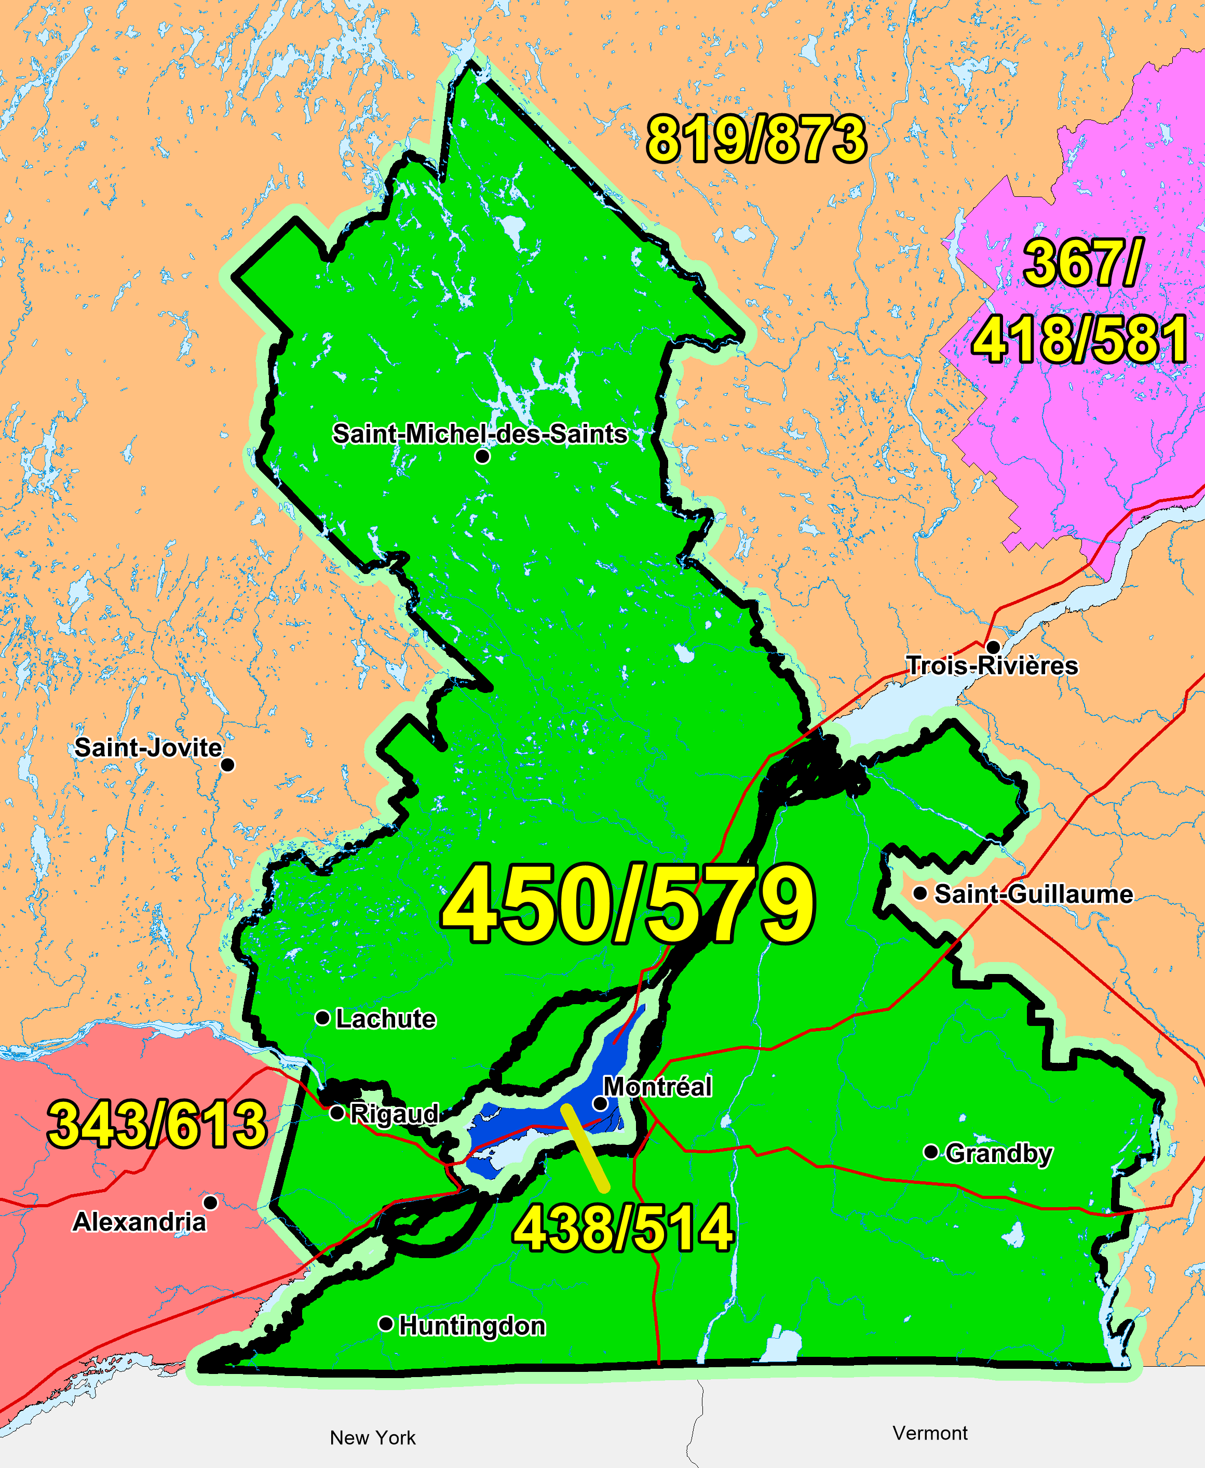

Figure 1 – Overview Map of NPA 450/579

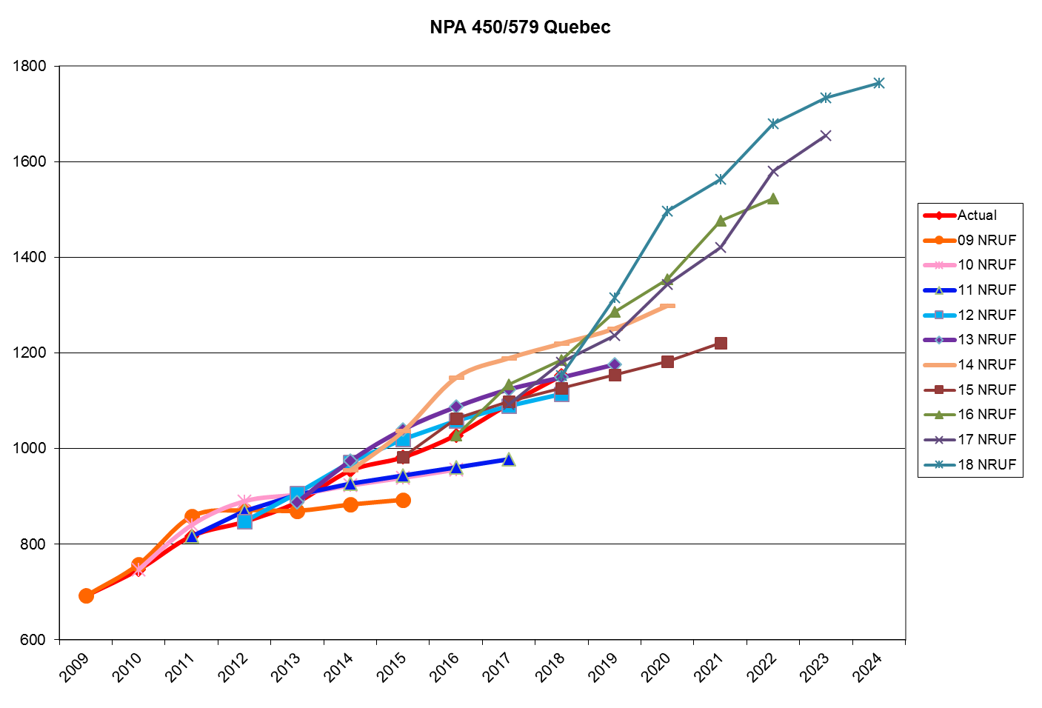

Figure 2 – NPA 450/579 Actual and Forecast CO Code Assignments



Figure 3 – NPA 450/579 CO Code Exhaust: January 2017 G‑NRUF



Figure 4 – NPA 450/579 Admin and LEC+WSP Codes: January 2017 G‑NRUF



Figure 5 – NPA 450/579 CO Code Exhaust: July 2017 R-NRUF



Figure 6 – NPA 450/579 Admin and LEC+WSP Codes: July 2017 R‑NRUF



Figure 7 – NPA 450/579 CO Code Exhaust: January 2018 R‑NRUF



Figure 8 – NPA 450/579 Admin and LEC+WSP Codes: January 2018 R‑NRUF



Figure 9 – NPA 450/579 CO Code Exhaust: July 2018 R‑NRUF



Figure 10 – NPA 450/579 Admin and LEC+WSP Codes: July 2018 R‑NRUF

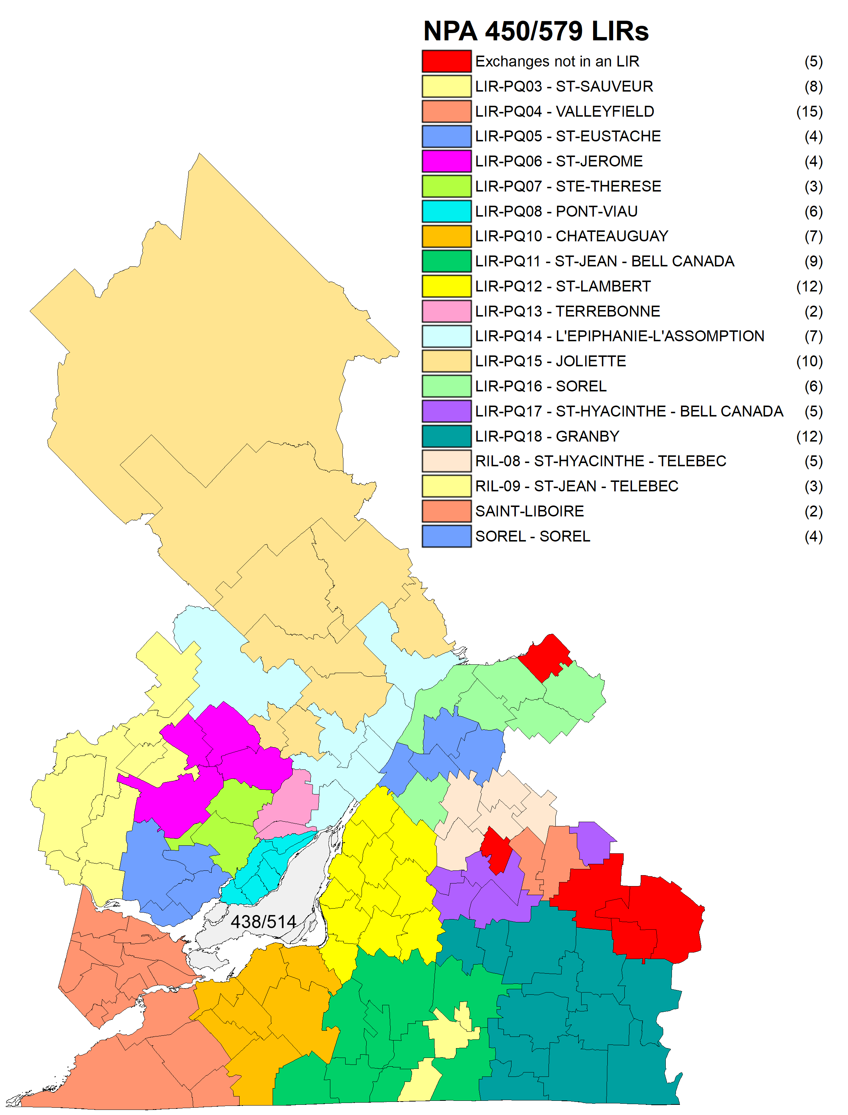

Figure 11 – NPA 450/579 LIRs

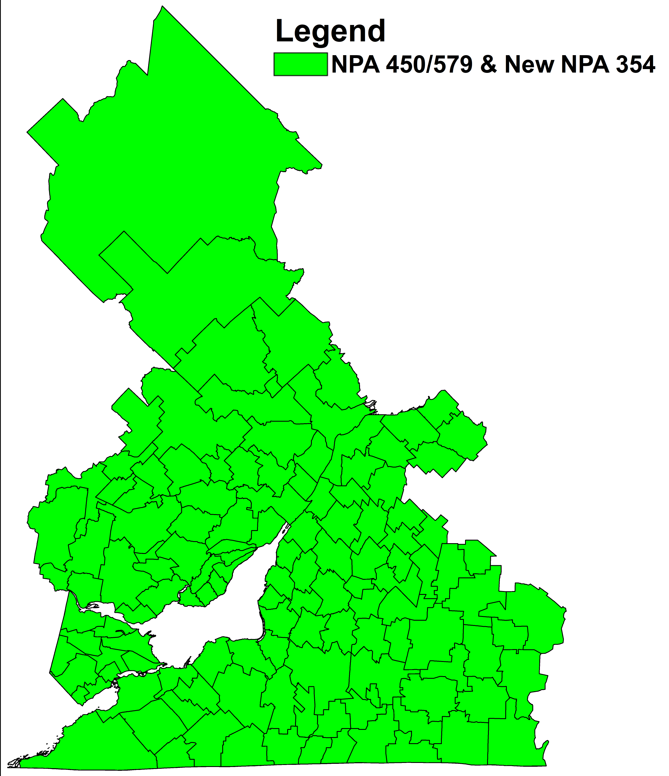

Figure 12 – Distributed Overlay

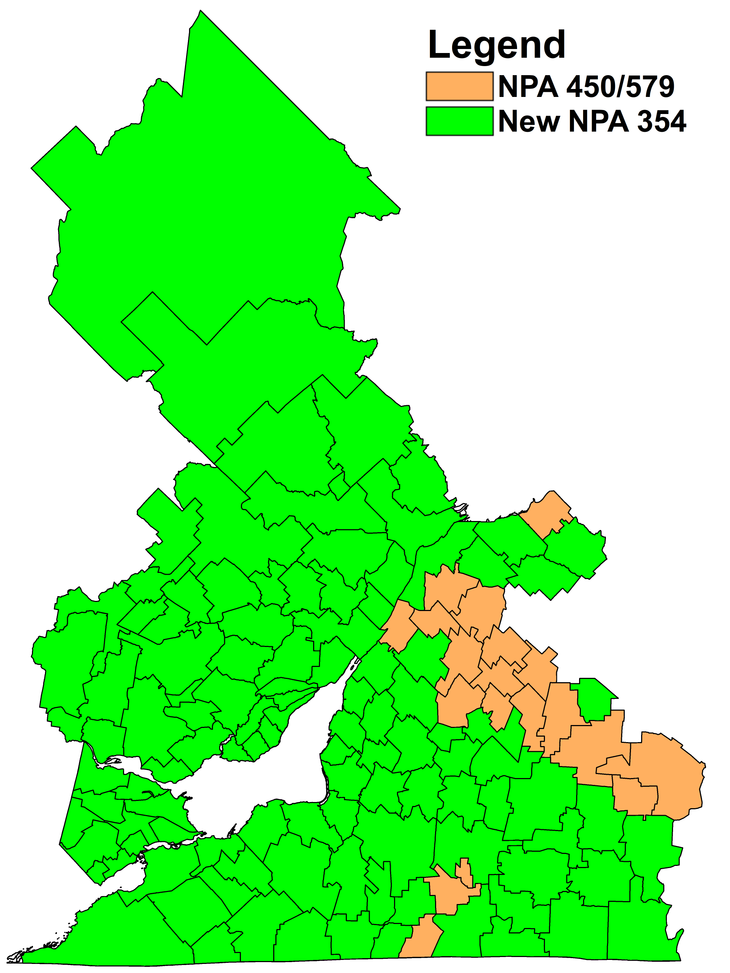

Figure 13 – Concentrated Overlay #1 (Bell Canada LIRs)

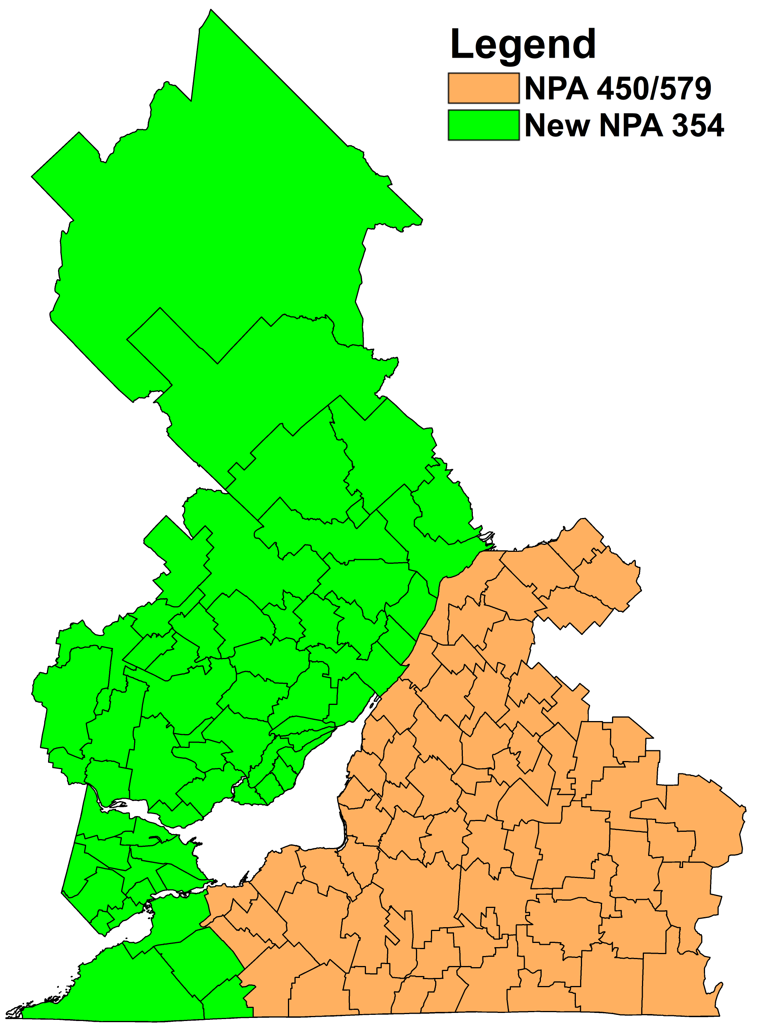

Figure 14 – Concentrated Overlay #2 (LIRs North)

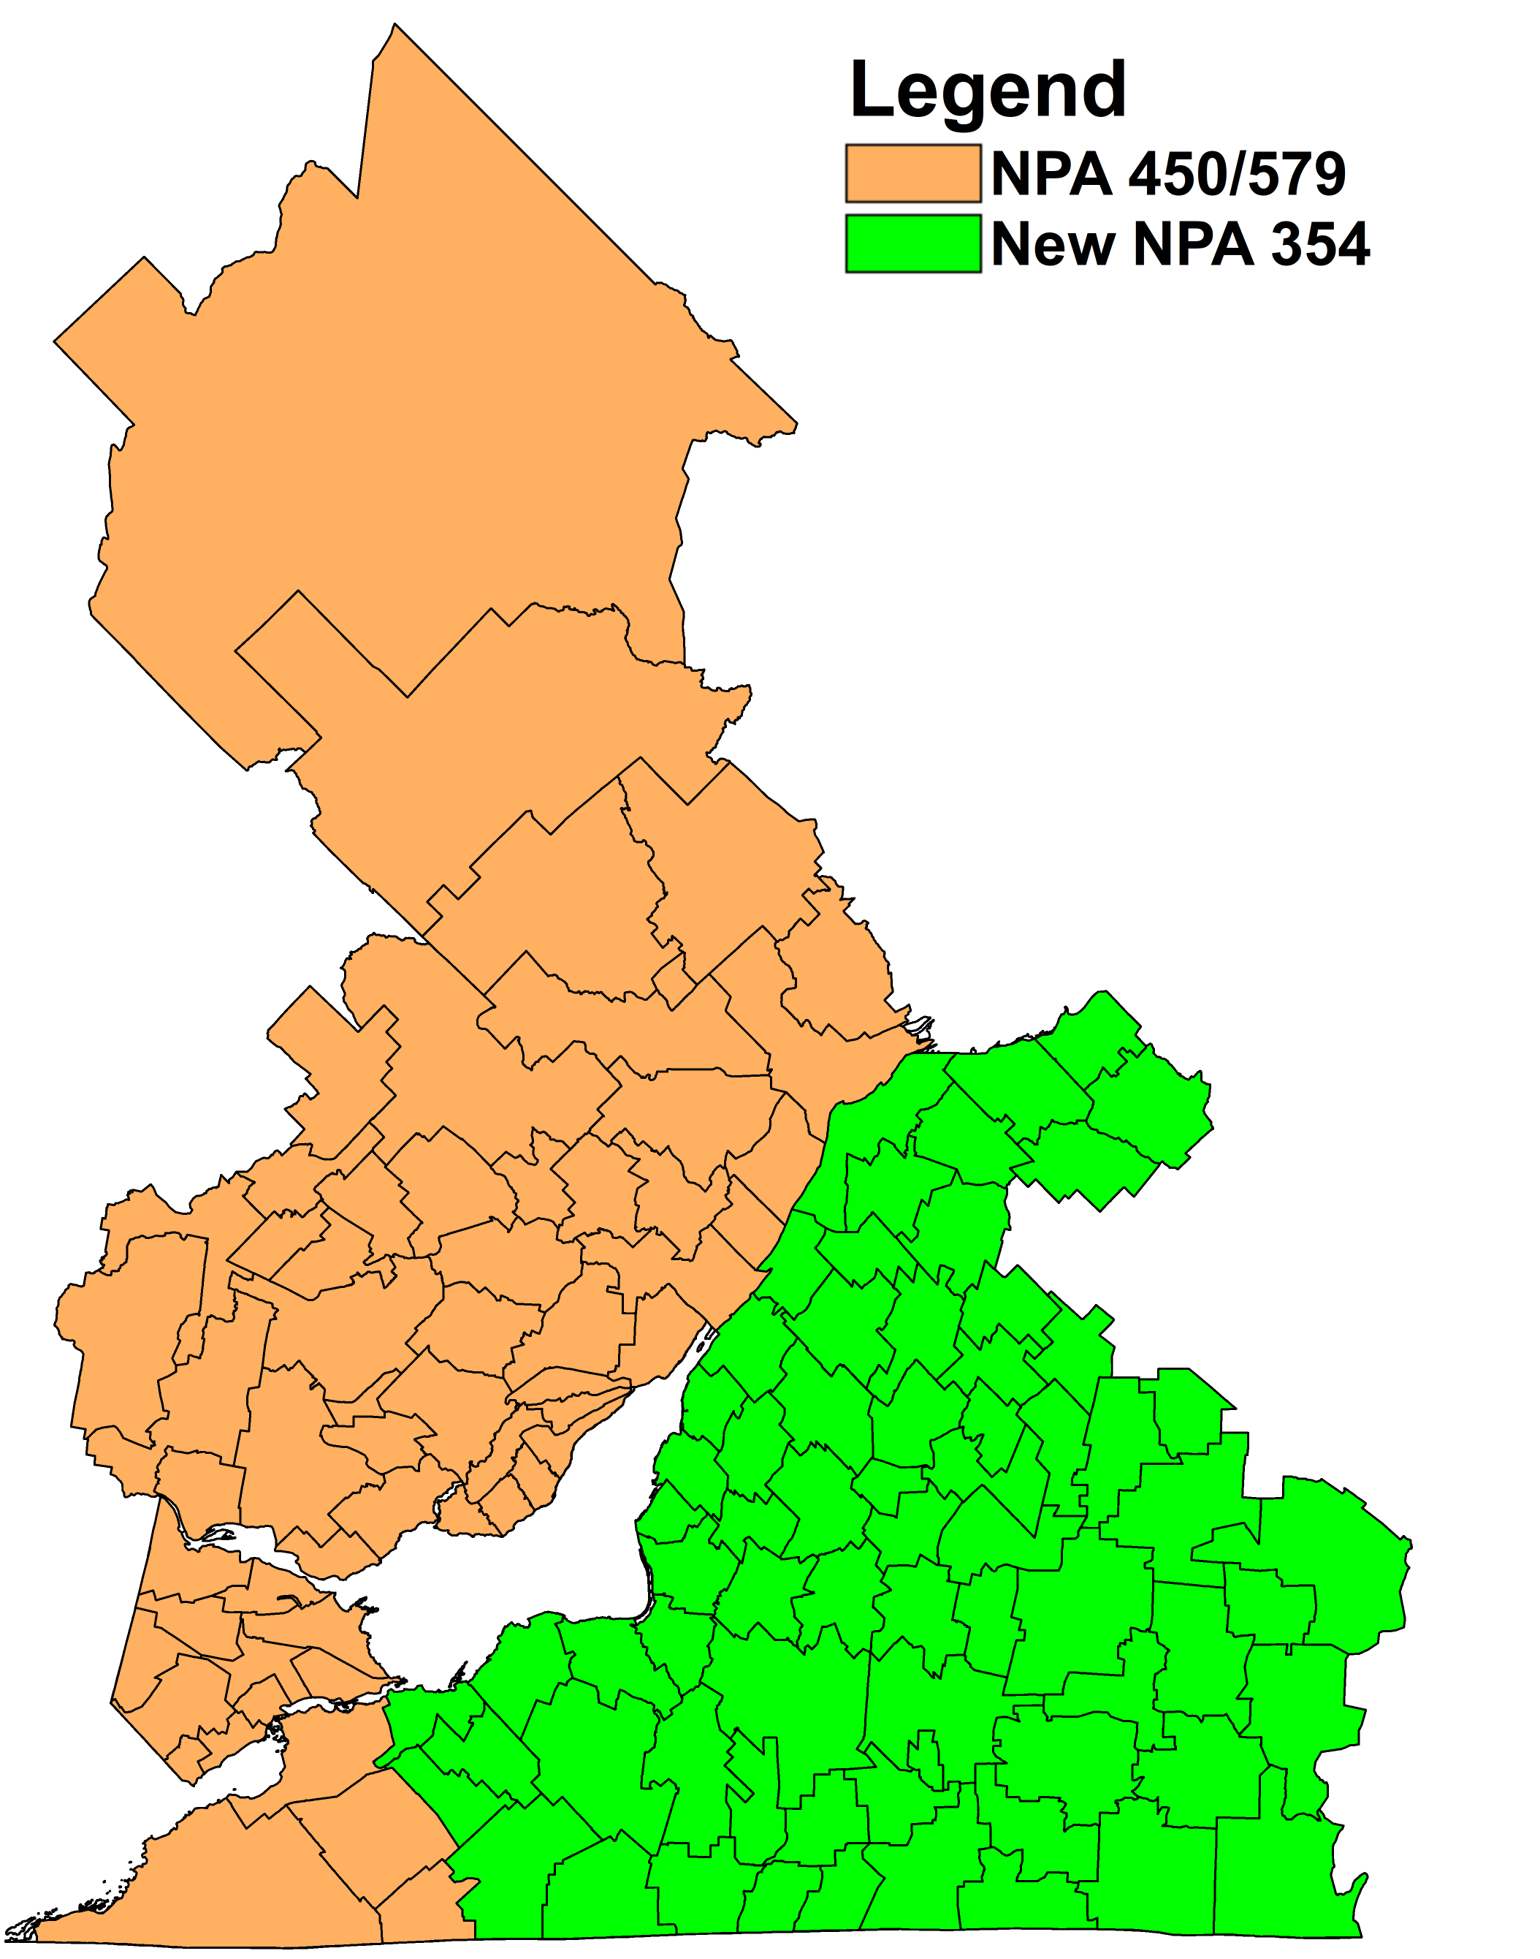

Figure 15 – Concentrated Overlay #3 (LIRs South)

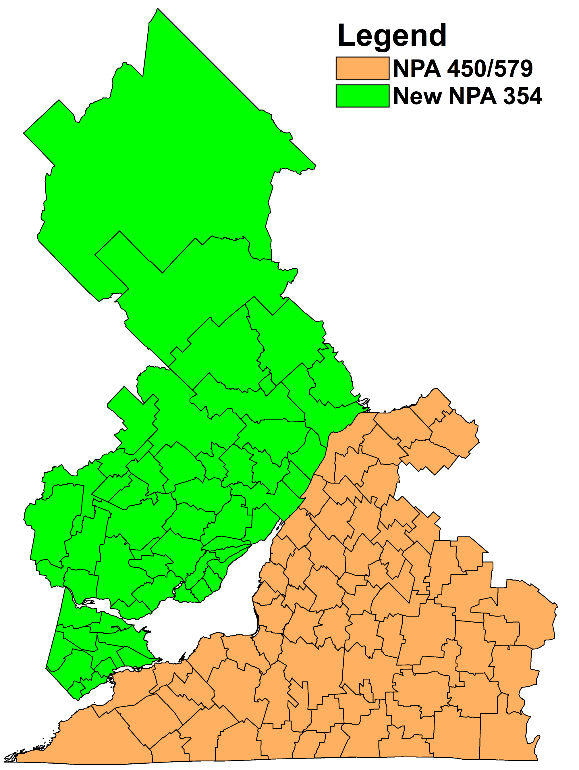

Figure 16 – Concentrated Overlay #4 (Exchange Areas North)

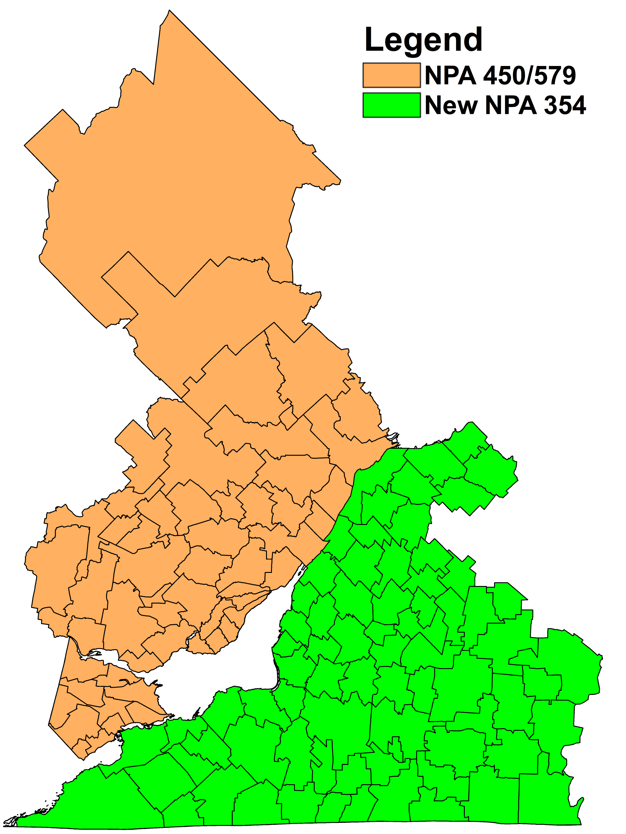

Figure 17 – Concentrated Overlay #5 (Exchange Areas South)

1. NPA 450/579 Quebec Exchange Areas

Table 1 – NPA 450/579 Exchange Areas for Each Relief Option

| **Exchange** | **Distributed Overlay** | **Contracted Overlay** | | | | | | | | | |
| --- | --- | --- | --- | --- | --- | --- | --- | --- | --- | --- | --- |
| **Option 1** | | **Option 2** | | **Option 3** | | **Option 4** | | **Option 5** | |
| **NPA 354/450/579** | **NPA 354/450/579**  **(Bell Canada LIR)** | **NPA 450/579**  **(non-Bell Canada LIR)** | **NPA 354/450/579**  **(LIRs North)** | **NPA 450/579**  **(LIRs South)** | **NPA 354/450/579**  **(LIRs South)** | **NPA 450/579**  **(LIRs North)** | **NPA 354/450/579**  **(Exchange Areas North)** | **NPA 450/579**  **(Exchange Areas South)** | **NPA 354/450/579**  **(Exchange Areas South)** | **NPA 450/579**  **(Exchange Areas North)** |
| Actonvale | ✓ | ✓ |  |  | ✓ | ✓ |  |  | ✓ | ✓ |  |
| Baie-Du-Febvre | ✓ |  | ✓ |  | ✓ | ✓ |  |  | ✓ | ✓ |  |
| Beauharnois | ✓ | ✓ |  |  | ✓ | ✓ |  |  | ✓ | ✓ |  |
| Bedford | ✓ | ✓ |  |  | ✓ | ✓ |  |  | ✓ | ✓ |  |
| Beloeil | ✓ | ✓ |  |  | ✓ | ✓ |  |  | ✓ | ✓ |  |
| Berthierville | ✓ | ✓ |  | ✓ |  |  | ✓ | ✓ |  |  | ✓ |
| Boucherville | ✓ | ✓ |  |  | ✓ | ✓ |  |  | ✓ | ✓ |  |
| Bromont | ✓ | ✓ |  |  | ✓ | ✓ |  |  | ✓ | ✓ |  |
| Brownsburg | ✓ | ✓ |  | ✓ |  |  | ✓ | ✓ |  |  | ✓ |
| Chambly | ✓ | ✓ |  |  | ✓ | ✓ |  |  | ✓ | ✓ |  |
| Chateauguay | ✓ | ✓ |  |  | ✓ | ✓ |  |  | ✓ | ✓ |  |
| Chomedey | ✓ | ✓ |  | ✓ |  |  | ✓ | ✓ |  |  | ✓ |
| Clarenceville | ✓ | ✓ |  |  | ✓ | ✓ |  |  | ✓ | ✓ |  |
| Contrecoeur | ✓ |  | ✓ |  | ✓ | ✓ |  |  | ✓ | ✓ |  |
| Coteau-du-Lac | ✓ | ✓ |  | ✓ |  |  | ✓ | ✓ |  |  | ✓ |
| Coteau-Landing | ✓ | ✓ |  | ✓ |  |  | ✓ | ✓ |  |  | ✓ |
| Cowansville | ✓ | ✓ |  |  | ✓ | ✓ |  |  | ✓ | ✓ |  |
| Crabtree | ✓ | ✓ |  | ✓ |  |  | ✓ | ✓ |  |  | ✓ |
| Dunham | ✓ | ✓ |  |  | ✓ | ✓ |  |  | ✓ | ✓ |  |
| Eastman | ✓ | ✓ |  |  | ✓ | ✓ |  |  | ✓ | ✓ |  |
| Farnham | ✓ | ✓ |  |  | ✓ | ✓ |  |  | ✓ | ✓ |  |
| Franklin Centre | ✓ | ✓ |  | ✓ |  |  | ✓ |  | ✓ | ✓ |  |
| Frelighsburg | ✓ | ✓ |  |  | ✓ | ✓ |  |  | ✓ | ✓ |  |
| Granby | ✓ | ✓ |  |  | ✓ | ✓ |  |  | ✓ | ✓ |  |
| Hemmingford | ✓ | ✓ |  |  | ✓ | ✓ |  |  | ✓ | ✓ |  |
| Henryville | ✓ | ✓ |  |  | ✓ | ✓ |  |  | ✓ | ✓ |  |
| Howick | ✓ | ✓ |  |  | ✓ | ✓ |  |  | ✓ | ✓ |  |
| Hudson | ✓ | ✓ |  | ✓ |  |  | ✓ | ✓ |  |  | ✓ |
| Huntingdon | ✓ | ✓ |  | ✓ |  |  | ✓ |  | ✓ | ✓ |  |
| Joliette | ✓ | ✓ |  | ✓ |  |  | ✓ | ✓ |  |  | ✓ |
| Knowlton | ✓ | ✓ |  |  | ✓ | ✓ |  |  | ✓ | ✓ |  |
| L'Epiphanie-l'Assomption | ✓ | ✓ |  | ✓ |  |  | ✓ | ✓ |  |  | ✓ |
| Lachute | ✓ | ✓ |  | ✓ |  |  | ✓ | ✓ |  |  | ✓ |
| Lacolle | ✓ | ✓ |  |  | ✓ | ✓ |  |  | ✓ | ✓ |  |
| Lanoraie | ✓ | ✓ |  | ✓ |  |  | ✓ | ✓ |  |  | ✓ |
| Laprairie | ✓ | ✓ |  |  | ✓ | ✓ |  |  | ✓ | ✓ |  |
| Laval-Est | ✓ | ✓ |  | ✓ |  |  | ✓ | ✓ |  |  | ✓ |
| Laval-Ouest | ✓ | ✓ |  | ✓ |  |  | ✓ | ✓ |  |  | ✓ |
| Lavaltrie | ✓ | ✓ |  | ✓ |  |  | ✓ | ✓ |  |  | ✓ |
| Lawrenceville | ✓ |  | ✓ |  | ✓ | ✓ |  |  | ✓ | ✓ |  |
| Le Gardeur | ✓ | ✓ |  | ✓ |  |  | ✓ | ✓ |  |  | ✓ |
| Les Cedres | ✓ | ✓ |  | ✓ |  |  | ✓ | ✓ |  |  | ✓ |
| Longueuil | ✓ | ✓ |  |  | ✓ | ✓ |  |  | ✓ | ✓ |  |
| Mansonville | ✓ | ✓ |  |  | ✓ | ✓ |  |  | ✓ | ✓ |  |
| Marieville | ✓ | ✓ |  |  | ✓ | ✓ |  |  | ✓ | ✓ |  |
| Mascouche | ✓ | ✓ |  | ✓ |  |  | ✓ | ✓ |  |  | ✓ |
| Mirabel-Aeroport | ✓ | ✓ |  | ✓ |  |  | ✓ | ✓ |  |  | ✓ |
| Mirabel-St-Augustin | ✓ | ✓ |  | ✓ |  |  | ✓ | ✓ |  |  | ✓ |
| Mirabel-Ste-Scholastique | ✓ | ✓ |  | ✓ |  |  | ✓ | ✓ |  |  | ✓ |
| Morin Heights | ✓ | ✓ |  | ✓ |  |  | ✓ | ✓ |  |  | ✓ |
| Napierville | ✓ | ✓ |  |  | ✓ | ✓ |  |  | ✓ | ✓ |  |
| Notre-Dame-de-Stanbridge | ✓ |  | ✓ |  | ✓ | ✓ |  |  | ✓ | ✓ |  |
| Oka | ✓ | ✓ |  | ✓ |  |  | ✓ | ✓ |  |  | ✓ |
| Ormstown | ✓ | ✓ |  | ✓ |  |  | ✓ |  | ✓ | ✓ |  |
| Pierreville | ✓ | ✓ |  |  | ✓ | ✓ |  |  | ✓ | ✓ |  |
| Pont-Viau | ✓ | ✓ |  | ✓ |  |  | ✓ | ✓ |  |  | ✓ |
| Rawdon | ✓ | ✓ |  | ✓ |  |  | ✓ | ✓ |  |  | ✓ |
| Rigaud | ✓ | ✓ |  | ✓ |  |  | ✓ | ✓ |  |  | ✓ |
| Riviere-Beaudette | ✓ | ✓ |  | ✓ |  |  | ✓ | ✓ |  |  | ✓ |
| Roxton Falls | ✓ |  | ✓ |  | ✓ | ✓ |  |  | ✓ | ✓ |  |
| Saint-Liboire | ✓ |  | ✓ |  | ✓ | ✓ |  |  | ✓ | ✓ |  |
| Shawbridge | ✓ | ✓ |  | ✓ |  |  | ✓ | ✓ |  |  | ✓ |
| Sorel | ✓ | ✓ |  |  | ✓ | ✓ |  |  | ✓ | ✓ |  |
| St-Aime | ✓ |  | ✓ |  | ✓ | ✓ |  |  | ✓ | ✓ |  |
| St-Alphonse-de-Rodriguez | ✓ | ✓ |  | ✓ |  |  | ✓ | ✓ |  |  | ✓ |
| St-Andre Est | ✓ | ✓ |  | ✓ |  |  | ✓ | ✓ |  |  | ✓ |
| St-Barthelemy | ✓ | ✓ |  | ✓ |  |  | ✓ | ✓ |  |  | ✓ |
| St-Blaise | ✓ | ✓ |  |  | ✓ | ✓ |  |  | ✓ | ✓ |  |
| St-Bruno | ✓ | ✓ |  |  | ✓ | ✓ |  |  | ✓ | ✓ |  |
| St-Calixte-de-Kilkenny | ✓ | ✓ |  | ✓ |  |  | ✓ | ✓ |  |  | ✓ |
| St-Cesaire | ✓ | ✓ |  |  | ✓ | ✓ |  |  | ✓ | ✓ |  |
| St-Chrysostome | ✓ | ✓ |  |  | ✓ | ✓ |  |  | ✓ | ✓ |  |
| St-Clet | ✓ | ✓ |  | ✓ |  |  | ✓ | ✓ |  |  | ✓ |
| St-Constant | ✓ | ✓ |  |  | ✓ | ✓ |  |  | ✓ | ✓ |  |
| St-Damase | ✓ | ✓ |  |  | ✓ | ✓ |  |  | ✓ | ✓ |  |
| St-Denis | ✓ | ✓ |  |  | ✓ | ✓ |  |  | ✓ | ✓ |  |
| St-Eustache | ✓ | ✓ |  | ✓ |  |  | ✓ | ✓ |  |  | ✓ |
| St-Felix-de-Valois | ✓ | ✓ |  | ✓ |  |  | ✓ | ✓ |  |  | ✓ |
| St-Gabriel-de-Brandon | ✓ | ✓ |  | ✓ |  |  | ✓ | ✓ |  |  | ✓ |
| St-Hippolyte | ✓ | ✓ |  | ✓ |  |  | ✓ | ✓ |  |  | ✓ |
| St-Hugues | ✓ |  | ✓ |  | ✓ | ✓ |  |  | ✓ | ✓ |  |
| St-Hyacinthe | ✓ | ✓ |  |  | ✓ | ✓ |  |  | ✓ | ✓ |  |
| St-Jacques | ✓ | ✓ |  | ✓ |  |  | ✓ | ✓ |  |  | ✓ |
| St-Jean | ✓ | ✓ |  |  | ✓ | ✓ |  |  | ✓ | ✓ |  |
| St-Jean-de-Matha | ✓ | ✓ |  | ✓ |  |  | ✓ | ✓ |  |  | ✓ |
| St-Jerome | ✓ | ✓ |  | ✓ |  |  | ✓ | ✓ |  |  | ✓ |
| St-Jude | ✓ |  | ✓ |  | ✓ | ✓ |  |  | ✓ | ✓ |  |
| St-Lambert | ✓ | ✓ |  |  | ✓ | ✓ |  |  | ✓ | ✓ |  |
| St-Lin | ✓ | ✓ |  | ✓ |  |  | ✓ | ✓ |  |  | ✓ |
| St-Marc | ✓ | ✓ |  |  | ✓ | ✓ |  |  | ✓ | ✓ |  |
| St-Michel-des-Saints | ✓ | ✓ |  | ✓ |  |  | ✓ | ✓ |  |  | ✓ |
| St-Ours | ✓ |  | ✓ |  | ✓ | ✓ |  |  | ✓ | ✓ |  |
| St-Paul-D'Abbotsford | ✓ | ✓ |  |  | ✓ | ✓ |  |  | ✓ | ✓ |  |
| St-Pie | ✓ | ✓ |  |  | ✓ | ✓ |  |  | ✓ | ✓ |  |
| St-Pie-de-Guire | ✓ | ✓ |  |  | ✓ | ✓ |  |  | ✓ | ✓ |  |
| St-Polycarpe | ✓ | ✓ |  | ✓ |  |  | ✓ | ✓ |  |  | ✓ |
| St-Remi | ✓ | ✓ |  |  | ✓ | ✓ |  |  | ✓ | ✓ |  |
| St-Sauveur | ✓ | ✓ |  | ✓ |  |  | ✓ | ✓ |  |  | ✓ |
| St-Simon | ✓ |  | ✓ |  | ✓ | ✓ |  |  | ✓ | ✓ |  |
| St-Thomas-d'Aquin | ✓ |  | ✓ |  | ✓ | ✓ |  |  | ✓ | ✓ |  |
| St-Vincent-de-Paul | ✓ | ✓ |  | ✓ |  |  | ✓ | ✓ |  |  | ✓ |
| St-Zenon | ✓ | ✓ |  | ✓ |  |  | ✓ | ✓ |  |  | ✓ |
| St-Zephirin | ✓ | ✓ |  |  | ✓ | ✓ |  |  | ✓ | ✓ |  |
| Ste-Adele | ✓ | ✓ |  | ✓ |  |  | ✓ | ✓ |  |  | ✓ |
| Ste-Anne-des-Plaines | ✓ | ✓ |  | ✓ |  |  | ✓ | ✓ |  |  | ✓ |
| Ste-Helene-de-Bagot | ✓ |  | ✓ |  | ✓ | ✓ |  |  | ✓ | ✓ |  |
| Ste-Julie-de-Vercheres | ✓ | ✓ |  |  | ✓ | ✓ |  |  | ✓ | ✓ |  |
| Ste-Julienne | ✓ | ✓ |  | ✓ |  |  | ✓ | ✓ |  |  | ✓ |
| Ste-Justine-de-Newton | ✓ | ✓ |  | ✓ |  |  | ✓ | ✓ |  |  | ✓ |
| Ste-Madeleine | ✓ | ✓ |  |  | ✓ | ✓ |  |  | ✓ | ✓ |  |
| Ste-Marguerite | ✓ | ✓ |  | ✓ |  |  | ✓ | ✓ |  |  | ✓ |
| Ste-Marthe | ✓ | ✓ |  | ✓ |  |  | ✓ | ✓ |  |  | ✓ |
| Ste-Martine | ✓ | ✓ |  |  | ✓ | ✓ |  |  | ✓ | ✓ |  |
| Ste-Rosalie | ✓ |  | ✓ |  | ✓ | ✓ |  |  | ✓ | ✓ |  |
| Ste-Rose | ✓ | ✓ |  | ✓ |  |  | ✓ | ✓ |  |  | ✓ |
| Ste-Sabine | ✓ |  | ✓ |  | ✓ | ✓ |  |  | ✓ | ✓ |  |
| Ste-Therese | ✓ | ✓ |  | ✓ |  |  | ✓ | ✓ |  |  | ✓ |
| Ste-Victoire | ✓ |  | ✓ |  | ✓ | ✓ |  |  | ✓ | ✓ |  |
| Sutton | ✓ | ✓ |  |  | ✓ | ✓ |  |  | ✓ | ✓ |  |
| Terrebonne | ✓ | ✓ |  | ✓ |  |  | ✓ | ✓ |  |  | ✓ |
| Upton | ✓ |  | ✓ |  | ✓ | ✓ |  |  | ✓ | ✓ |  |
| Valcourt | ✓ |  | ✓ |  | ✓ | ✓ |  |  | ✓ | ✓ |  |
| Valleyfield | ✓ | ✓ |  | ✓ |  |  | ✓ |  | ✓ | ✓ |  |
| Varennes | ✓ | ✓ |  |  | ✓ | ✓ |  |  | ✓ | ✓ |  |
| Vaudreuil | ✓ | ✓ |  | ✓ |  |  | ✓ | ✓ |  |  | ✓ |
| Venise-en-Quebec | ✓ |  | ✓ |  | ✓ | ✓ |  |  | ✓ | ✓ |  |
| Vercheres | ✓ | ✓ |  |  | ✓ | ✓ |  |  | ✓ | ✓ |  |
| Waterloo | ✓ | ✓ |  |  | ✓ | ✓ |  |  | ✓ | ✓ |  |
| Yamaska | ✓ | ✓ |  |  | ✓ | ✓ |  |  | ✓ | ✓ |  |

Table 2 – Exchange Areas in Each LIR

| **LIR Name** | **Exchange** |
| --- | --- |
| LIR-PQ03 - ST-SAUVEUR | Brownsburg |
| LIR-PQ03 - ST-SAUVEUR | Lachute |
| LIR-PQ03 - ST-SAUVEUR | Morin Heights |
| LIR-PQ03 - ST-SAUVEUR | Shawbridge |
| LIR-PQ03 - ST-SAUVEUR | St-Andre Est |
| LIR-PQ03 - ST-SAUVEUR | Ste-Adele |
| LIR-PQ03 - ST-SAUVEUR | Ste-Marguerite |
| LIR-PQ03 - ST-SAUVEUR | St-Sauveur |
| LIR-PQ04 - VALLEYFIELD | Coteau-du-Lac |
| LIR-PQ04 - VALLEYFIELD | Coteau-Landing |
| LIR-PQ04 - VALLEYFIELD | Franklin Centre |
| LIR-PQ04 - VALLEYFIELD | Hudson |
| LIR-PQ04 - VALLEYFIELD | Huntingdon |
| LIR-PQ04 - VALLEYFIELD | Les Cedres |
| LIR-PQ04 - VALLEYFIELD | Ormstown |
| LIR-PQ04 - VALLEYFIELD | Rigaud |
| LIR-PQ04 - VALLEYFIELD | Riviere-Beaudette |
| LIR-PQ04 - VALLEYFIELD | St-Clet |
| LIR-PQ04 - VALLEYFIELD | Ste-Justine-de-Newton |
| LIR-PQ04 - VALLEYFIELD | Ste-Marthe |
| LIR-PQ04 - VALLEYFIELD | St-Polycarpe |
| LIR-PQ04 - VALLEYFIELD | Valleyfield |
| LIR-PQ04 - VALLEYFIELD | Vaudreuil |
| LIR-PQ05 - ST-EUSTACHE | Mirabel-St-Augustin |
| LIR-PQ05 - ST-EUSTACHE | Mirabel-Ste-Scholastique |
| LIR-PQ05 - ST-EUSTACHE | Oka |
| LIR-PQ05 - ST-EUSTACHE | St-Eustache |
| LIR-PQ06 - ST-JEROME | St-Calixte-de-Kilkenny |
| LIR-PQ06 - ST-JEROME | St-Hippolyte |
| LIR-PQ06 - ST-JEROME | St-Jerome |
| LIR-PQ06 - ST-JEROME | St-Lin |
| LIR-PQ07 - STE-THERESE | Mirabel-Aeroport |
| LIR-PQ07 - STE-THERESE | Ste-Anne-des-Plaines |
| LIR-PQ07 - STE-THERESE | Ste-Therese |
| LIR-PQ08 - PONT-VIAU | Chomedey |
| LIR-PQ08 - PONT-VIAU | Laval-Est |
| LIR-PQ08 - PONT-VIAU | Laval-Ouest |
| LIR-PQ08 - PONT-VIAU | Pont-Viau |
| LIR-PQ08 - PONT-VIAU | Ste-Rose |
| LIR-PQ08 - PONT-VIAU | St-Vincent-de-Paul |
| LIR-PQ10 - CHATEAUGUAY | Beauharnois |
| LIR-PQ10 - CHATEAUGUAY | Chateauguay |
| LIR-PQ10 - CHATEAUGUAY | Howick |
| LIR-PQ10 - CHATEAUGUAY | St-Chrysostome |
| LIR-PQ10 - CHATEAUGUAY | St-Constant |
| LIR-PQ10 - CHATEAUGUAY | Ste-Martine |
| LIR-PQ10 - CHATEAUGUAY | St-Remi |
| LIR-PQ11 - ST-JEAN - BELL CANADA | Bedford |
| LIR-PQ11 - ST-JEAN - BELL CANADA | Clarenceville |
| LIR-PQ11 - ST-JEAN - BELL CANADA | Farnham |
| LIR-PQ11 - ST-JEAN - BELL CANADA | Hemmingford |
| LIR-PQ11 - ST-JEAN - BELL CANADA | Henryville |
| LIR-PQ11 - ST-JEAN - BELL CANADA | Lacolle |
| LIR-PQ11 - ST-JEAN - BELL CANADA | Napierville |
| LIR-PQ11 - ST-JEAN - BELL CANADA | St-Blaise |
| LIR-PQ11 - ST-JEAN - BELL CANADA | St-Jean |
| LIR-PQ12 - ST-LAMBERT | Beloeil |
| LIR-PQ12 - ST-LAMBERT | Boucherville |
| LIR-PQ12 - ST-LAMBERT | Chambly |
| LIR-PQ12 - ST-LAMBERT | Laprairie |
| LIR-PQ12 - ST-LAMBERT | Longueuil |
| LIR-PQ12 - ST-LAMBERT | Marieville |
| LIR-PQ12 - ST-LAMBERT | St-Bruno |
| LIR-PQ12 - ST-LAMBERT | Ste-Julie-de-Vercheres |
| LIR-PQ12 - ST-LAMBERT | St-Lambert |
| LIR-PQ12 - ST-LAMBERT | St-Marc |
| LIR-PQ12 - ST-LAMBERT | Varennes |
| LIR-PQ12 - ST-LAMBERT | Vercheres |
| LIR-PQ13 - TERREBONNE | Mascouche |
| LIR-PQ13 - TERREBONNE | Terrebonne |
| LIR-PQ14 - L'EPIPHANIE-L'ASSOMPTION | Berthierville |
| LIR-PQ14 - L'EPIPHANIE-L'ASSOMPTION | Crabtree |
| LIR-PQ14 - L'EPIPHANIE-L'ASSOMPTION | Lanoraie |
| LIR-PQ14 - L'EPIPHANIE-L'ASSOMPTION | Lavaltrie |
| LIR-PQ14 - L'EPIPHANIE-L'ASSOMPTION | Le Gardeur |
| LIR-PQ14 - L'EPIPHANIE-L'ASSOMPTION | L'Epiphanie-l'Assomption |
| LIR-PQ14 - L'EPIPHANIE-L'ASSOMPTION | Rawdon |
| LIR-PQ15 - JOLIETTE | Joliette |
| LIR-PQ15 - JOLIETTE | St-Alphonse-de-Rodriguez |
| LIR-PQ15 - JOLIETTE | St-Barthelemy |
| LIR-PQ15 - JOLIETTE | Ste-Julienne |
| LIR-PQ15 - JOLIETTE | St-Felix-de-Valois |
| LIR-PQ15 - JOLIETTE | St-Gabriel-de-Brandon |
| LIR-PQ15 - JOLIETTE | St-Jacques |
| LIR-PQ15 - JOLIETTE | St-Jean-de-Matha |
| LIR-PQ15 - JOLIETTE | St-Michel-des-Saints |
| LIR-PQ15 - JOLIETTE | St-Zenon |
| LIR-PQ16 - SOREL | Pierreville |
| LIR-PQ16 - SOREL | Sorel |
| LIR-PQ16 - SOREL | St-Denis |
| LIR-PQ16 - SOREL | St-Pie-de-Guire |
| LIR-PQ16 - SOREL | St-Zephirin |
| LIR-PQ16 - SOREL | Yamaska |
| LIR-PQ17 - ST-HYACINTHE - BELL CANADA | Actonvale |
| LIR-PQ17 - ST-HYACINTHE - BELL CANADA | St-Damase |
| LIR-PQ17 - ST-HYACINTHE - BELL CANADA | Ste-Madeleine |
| LIR-PQ17 - ST-HYACINTHE - BELL CANADA | St-Hyacinthe |
| LIR-PQ17 - ST-HYACINTHE - BELL CANADA | St-Pie |
| LIR-PQ18 - GRANBY | Bromont |
| LIR-PQ18 - GRANBY | Cowansville |
| LIR-PQ18 - GRANBY | Dunham |
| LIR-PQ18 - GRANBY | Eastman |
| LIR-PQ18 - GRANBY | Frelighsburg |
| LIR-PQ18 - GRANBY | Granby |
| LIR-PQ18 - GRANBY | Knowlton |
| LIR-PQ18 - GRANBY | Mansonville |
| LIR-PQ18 - GRANBY | St-Cesaire |
| LIR-PQ18 - GRANBY | St-Paul-D'Abbotsford |
| LIR-PQ18 - GRANBY | Sutton |
| LIR-PQ18 - GRANBY | Waterloo |
| RIL-08 - ST-HYACINTHE - TELEBEC | Ste-Helene-de-Bagot |
| RIL-08 - ST-HYACINTHE - TELEBEC | St-Hugues |
| RIL-08 - ST-HYACINTHE - TELEBEC | St-Jude |
| RIL-08 - ST-HYACINTHE - TELEBEC | St-Simon |
| RIL-08 - ST-HYACINTHE - TELEBEC | St-Thomas-d'Aquin |
| RIL-09 - ST-JEAN - TELEBEC | Notre-Dame-de-Stanbridge |
| RIL-09 - ST-JEAN - TELEBEC | Ste-Sabine |
| RIL-09 - ST-JEAN - TELEBEC | Venise-en-Quebec |
| SAINT-LIBOIRE | Saint-Liboire |
| SAINT-LIBOIRE | Upton |
| SOREL - SOREL | Contrecoeur |
| SOREL - SOREL | St-Aime |
| SOREL - SOREL | Ste-Victoire |
| SOREL - SOREL | St-Ours |
| No LIR | Baie-Du-Febvre |
| No LIR | Lawrenceville |
| No LIR | Roxton Falls |
| No LIR | Ste-Rosalie |
| No LIR | Valcourt |

1. Distribution List

|  |  |
| --- | --- |
| Iristel  team.regulatory@iristel.com | Rogers  NumberAdmin@rci.rogers.com |
| Telecommunications Xittel Inc  1350 rue Royale, bureau 800  Trois-Rivieres, QC  Canada  G9A 4J4  clec-admin@xittel.net | CLEC Admin  Comwave Networks  61 Wildcat Road  Toronto, ON  Canada  M3J 2P5  clecteam@comwave.net |
| Numbering E-Mail  Distributel Communications Limited  177 Nepean Street  Ottawa, ON  Canada  K2P 0B4  numbering@distributel.ca | NXX Admin  Bell Canada  nxx.admin@bell.ca |
| Regulatory  Fibernetics Corporation  605 Boxwood Dr  Cambridge, ON  Canada  N3E1A5  regulatory@corp.fibernetics.ca | Regulatory Dept.  InnSysVoice Corp.  4500 Sheppard Ave E, Suite 111  Toronto, ON  Canada  M1S 3R6  regulatory@innsys.ca |
| Joey-Lynn Abdulkader  Specialist Regulatory Affairs  Bell Canada  160 Elgin Street, 19th Floor  Ottawa, ON  Canada  K2P 2C4  Telephone: 613-785-6314  Fax: 613-560-0472  joey-lynn.abdulkader@bell.ca | Pierre Allard  Director Business development  CoopTel- coop de telecommunication  5521 Chemin de L'Aeroport C.P. 160  Valcourt, QC  Canada  J0E 2L0  Telephone: 450 532-5656 ext 1032  pallard@cooptel.coop |
| Andreea Badea  Iristel Inc.  11 Bowan Court  Toronto, ON  Canada  M2K 3A8  Telephone: 416-800-4747  abadea@iristel.ro | Bill Barsley  Manager - Planning & Engineering  TELUS  27 Marmac Drive  Etobicoke, ON  Canada  M9W 1E7  Telephone: 416-279-7989  Fax: 416-279-3930  bill.barsley@telus.com |
| Geoff Batstone  V.P., General Counsel  Distributel Communications Limited  177 Nepean Street, Suite 300  Ottawa, ON  Canada  Telephone: 613-319-9964  geoff.batstone@distributel.ca | Chantal Beaudoin  Collaboratrice principale  Coordination WNP & Gestion NPA  Telebec  555, avenue Centrale  Val-d’Or, QC  J9P1P6  Telephone: 819-824-7227  cbeaudoin@telebec.com |
| Dennis Béland  Director, Regulatory Affairs, Telecommunications  Quebecor Media Inc.  612 St-Jacques, 15e étage Tour Sud  Montreal, QC  Canada  H3C 4M8  Telephone: 514-380-4792  Fax: 514-380-4664  dennis.beland@quebecor.com | Marc Berruyer  Network Planner  Videotron General Partnership  2155 Boul. Pie IX, 3e etage, bloc A  Montreal, QC  Canada  H1V 2E4  Telephone: 514-380-4255  Fax: 514-899-8452  marc.berruyer@videotron.com |
| Vivek Bhardwaj  Traffic Specialist  Rogers Communications  8200 Dixie Rd.  Brampton, ON  Canada  L6T 0C1  Telephone: 647-747-3569  vivek.bhardwaj@rci.rogers.com | Olena Bilozerska  Network Planning Manager I,  TS CC Planning & Management  TELUS  200 Consilium Place, Floor 6  Scarborough, ON  Canada  M1H 3G2  Telephone: 647-837-1798  Olena.Bilozerska@telus.com |
| Doug Birdwise  Interested Party  109 Westpark Drive  Ottawa, ON  Canada  K1B 3G4  Telephone: 613-830-0081  douglas.birdwise@sympatico.ca | Richard Biron  Avocat  Telephone Milot Inc.  111 rue du 12-Novembre  Nicolet, QC  Canada  J3T 1S3  Telephone: 819-293-1202  richard.biron@sogetel.com |
| Samer Bishay  CEO  Iristel Inc.  11 Bowan Court  Toronto, ON  Canada  M2K 3A8  Telephone: 416-800-9999  Fax: 416-628-0891  sbishay@iristel.com | Yanick Boily  Sr. Directeur, Affaires réglementaires, Télécommunications  Quebecor Media  Montreal, QC  Canada  Telephone: 514-380-7313  yanick.boily@quebecor.com |
| Laurie Bowie  Network Planning  Bell Canada  100 Dundas Street, Floor 4G  London, ON  Canada  N6A 5B6  Telephone: 519-850-5818  laurie.bowie@bell.ca | Glen Brown  Division Manager  Leidos Canada Inc.  60 Queen Street, Suite 1516  Ottawa, ON  Canada  K1P 5Y7  Telephone: 613-683-3291  Fax: 613-563-3399  browng@leidos.ca |
| Gilles Brunet  Director - Carrier Relations  Videotron General Partnership  465 Mc Gill  Montreal, QC  Canada  H2Y 2H1  Telephone: 514-380-4512  Fax: 514-380-9731  gilles.brunet@videotron.com | Joseph Cabrera  Senior Analyst - Dispute Resolution and Regulatory Implementation  CRTC  1 Promenade du Portage  Gatineau, QC  Canada  J8X 4B1  Telephone: 819-934-6352  Fax: 819-997-4610  joseph.cabrera@crtc.gc.ca |
| Melanye Caisse  Telecom Analyst  ISP Telecom Inc  1155 Boul Rene-Levesque Ouest Suite 2500  Montreal, QC  Canada  H3B 2K4  Telephone: 416-548-4819  Fax: 416-548-4818  melanye@isptelecom.net | Don Cavanagh  VP  Distributel Communications Limited  177 Nepean Street, Suite 300  Ottawa, ON  Canada  K2P 0B4  Telephone: 613-237-7005  Fax: 613-237-7009  donald.cavanagh@distributel.ca |
| Fiona Clegg  CO Code Administration  Leidos Canada Inc.  60 Queen Street, Suite 1516  Ottawa, ON  Canada  K1P 5Y7  Telephone: 613-683-3285  Fax: 613-563-3399  cleggf@leidos.ca | David Comrie  CNA  Leidos Canada Inc.  1516 - 60 Queen Street  Ottawa, ON  Canada  K1P 5Y7  Telephone: 613-683-3287  Fax: 613-563-3399  comried@leidos.ca |
| Yves Cote  Coordonnateur à l'exploitation, région Maskinongé  Téléphone Milot Inc.  2640, rue Laflèche C.P. 30  Saint- Paulin, QC  Canada  J0K 3G0  Telephone: 819-268-2546  Fax: 819-268-2951  yves.cote@sogetel.com | Gaston Dandurand  President  Group Maskatel  Telephone: 514-557-8889  gdandurand@maskatel.qc.ca |
| Tommy Doucet  Telephony Specialist  Telecommunications Xittel  1350 Royale Office #800  Trois-Riviere, QC  G9A 4J4  Telephone: 819-370-3232 X 2022  tdoucet@xittel.net | Irma Dulay  Primus Telecommunications Canada Inc.  500- 5343 Dundas St West  Toronto, ON  Canada  M9B 6K5  Telephone: 416-207-7151  Fax: 877-329-6875  idulay@primustel.ca |
| Yves Duval  Directeur de l-exploitation  Sogetel inc.  111 Rue du 12-Novembre  Nicolet, QC  Canada  J3T 1S3  Telephone: 819-293-1266  Fax: 819-293-6120  yves.duval@sogetel.com | Mona Emond  Director, Marketing & Communications  Canadian Security Association  610 Alden Road, Suite 100  Markham, ON  Canada  L3R 9Z1  Telephone: 905-513-0622 Ext 242  Fax: 905-513-0624  memond@canasa.org |
| Diane Faillant  Associate - Network Management/NSS (National Numbering Solution)  Bell Canada  671 LAGAUCHETIERE Ouest. 11  Montreal, QC  Canada  H3B 2M8  Telephone: 514-870-6044  Fax: 514-786-9062  diane.faillant@bell.ca | Jean-Rene Gaudet  Chef de servie, telephone et television IP  Maskatel  916 Rus Saint-Pierre  Drummondville, QC  J2C3Y2  Telephone: 819-445-0400  jrgaudet@maskatel.qc.ca |
| Michel Gilbert  Directeur Corporatif - Reglementation  Telebec, Societe en commandite  87 rue Ontario ouest 5eme etage St-Urbain  Montreal, QC  Canada  H2X 1Y8  Telephone: 514-493-5396  reglementa@telebec.com | Jacques Gravel  VP Ingenierie Corporative et operations  Group Maskatel LP  780 Boul Casavant Ouest  Saint-Hyacinthe, QC  J2S 7S3  Telephone: 450-252-9345  jgravel@maskatel.qc.ca |
| Praba Gunam  President/CEO  InnSysVoice Corp.  4500 Sheppard Ave E, Suite 111  Toronto, ON  Canada  M1S 3R6  Telephone: 416-800-0797  praba@innsys.ca | Austin He  Network Planning Analyst,Carrier Relations,Network Profitability & Planning  Primus Telecommunications Canada Inc.  5343 Dundas Street W. Suite 500  Toronto, ON  Canada  M9B 6K5  Telephone: 416-207-3361  ahe@primustel.ca |
| Marian Hearn  Project Executive  Canadian LNP Consortium Inc.  350 Palladium Drive, Suite 208  Kanata, ON  Canada  K2V 1A8  Telephone: 613-287-0225  Fax: 800-406-9250  marian.hearn@clnpc.ca | Lynne Hewitson  Membership Manager  Canadian Security Association (CANASA)  610 Alden Road  Markham, ON  Canada  L3R 9Z1  Telephone: 905-513-0622 ext 223  Fax: 905-513-0624  membership@canasa.org |
| Suresh Khare  CO Code Manager  Leidos Canada Inc.  60 Queen Street, Suite 1516  Ottawa, ON  Canada  K1P 5Y7  Telephone: 613-683-3296  Fax: 613-563-3399  khares@leidos.ca | Phillip Koneswaran  VP - Business  IXICA Communications Inc.  174 Shropshire Drive  Toronto, ON  Canada  M1P 1Z7  Telephone: 844-747-2729 ext: 2100  phillip@ixica.com |
| Roland Lamer  Téléphone de St-Éphrem inc.  3455, boulevard Choquette  Saint-Hyacinthe, QC  Canada  J2S 7Z8  Telephone: 450-251-4082  Fax: 450-252-2281  reglementaire@maskatel.qc.ca | Celine Laporte  Vice-presidente- Strategies- marketing et ventes  Telephone de St-ephrem inc.  3455 boulevard Choquette  Saint-Hyacinthe, QC  Canada  J2S 7Z8  Telephone: 450-251-2233  celinelaporte@maskatel.qc.ca |
| Natalie Lessard  CO Code Administration  Leidos Canada Inc.  60 Queen Street, Suite 1516  Ottawa, ON  Canada  K1P 5Y7  Telephone: 613-683-3288  Fax: 613-563-3399  lessardn@leidos.ca | Jennifer Mack  Traffic Specialist  Rogers Communications  8200 Dixie Rd.  Brampton, ON  Canada  L6T 0C1  Telephone: 647-747-2168  jennifer.mack@rci.rogers.ca |
| John MacKenzie  Regulatory Affairs  Telus  Telephone: 780-493-5579  john.mackenzie@telus.com | Wanda Marie Mali  Manager - National Numbering Solutions  Bell Canada  100 Borough Dr, Floor 5 Blue  Scarborough, ON  M1P4W2  Telephone: 416-296-6076  Fax: 416-296-0685  wanda_marie.mali@bell.ca |
| Deirdre Massiah-Gomes  Manager - Technology Strategy  TELUS  200 Consilium Place, Suite 1600  Scarborough, ON  Canada  M1H 3J3  Telephone: 416-279-9000  Fax: 416-279-3949  deirdre.massiah-gomes@telus.com | Jean-Francois Mathieu  La Compagne de Telephone Upton (Telupton 2000 Inc.)  732 Rue St-Ephrem C.P. 90  Upton, QC  Canada  J0H 2E0  Telephone: 450-549-1020  Fax: 450-549-4455  j-fmathieu@telupton.qc.ca |
| Andrew Matoga  President  ISP Telecom  1155 Boul Rene-Levesque O Suite 2500  Montreal, QC  Canada  H3B 2K4  Telephone: 416-548-4848  Fax: 416-548-4847  andrew@isptelecom.net | Nicola McLaughlin  Team Lead  Allstream  200 Wellington St W. F12  Toronto, ON  Canada  M5V 3G2  Telephone: 416-640-5271  Nicola.mclaughlin@allstream.com |
| Jacqueline Michelis  Media Relations  Bell Canada  160 Elgin Strett  Ottawa, ON  Canada  K2P 3C4  Telephone: 613-785-1427  jacqueline.michelis@bell.ca | Daniel Morrison  Specialist - Voice Network Services  Bell Canada  100 Dundas St Flr 3  London, ON  Canada  N6A 5B6  Telephone: 519-850-6386  daniel.morrison@bell.ca |
| Sundar Nagulan  Team Lead - Voice Engineering  Comwave Networks  61 Wildcat Rd  Toronto, ON  M3J 2P5  Telephone: 647-427-8363  snagulan@comwave.net | Louise Naud  WNP Projet Coordinator  Telebec/NorthernTel  555, av Centrale  Val-d'Or, QC  Canada  J9P 1P6  Telephone: 819-824-7238  Fax: 819-824-7282  Lnaud@telebec.com |
| Bernard Nicol  Technicien de Central  Maskatel  916 Rus Saint-Pierre  Drummondville, QC  J2C3Y2  Telephone: 819-445-0414  bnicol@maskatel.qc.ca | Catherine O’Grady  Senior Manager, Provisioning  Allstream  200 Wellington St W. F12  Toronto, ON  Canada  M5V 3G2  Telephone: 416-644-9703  catherine.ogrady@allstream.com |
| Simon-Pierre Olivier  Director, Regulatory Affairs  Rogers Communications Canada Inc.  800 de la Gauchetiere West, 4th Floor  Montreal, QC  Canada  H5A 1K3  Telephone: 514-350-6595  Fax: 514-734-6622  simon-pierre.olivier@fidomobile.ca | Normand Ouellet  Telephone Guevremont Inc  QC  Telephone: 450-250-7111  Fax: 450-252-1329  normand.ouellet@maskatel.qc.ca |
| Valerie Plaskacz  Canadian Radio-television and Telecommunications Commission  1 Promenade du Portage  Gatineau, QC  Canada  J8X 4B1  Telephone: 819-994-1576  Valerie.Plaskacz@crtc.gc.ca | Michelle Preda  Regulatory Affairs Manager  Iristel  675 Cochrane Dr  Markham, ON  L3R0B8  Telephone: 416-800-0032  mpreda@iristel.ro |
| Marc Pressault  Manager, Customer Champion  Distributel Communications Limited  177 Nepean Street, Suite 400  Ottawa, ON  Canada  K2P 0B4  Telephone: 613-317-3357  Marc.Presseault@distributel.ca | Lucie Pugliese  Administrator  Telecommunications Alliance  1575 Saturne  Brossard, QC  Canada  J4X 1N4  Telephone: 450-465-8277  Fax: 450-465-0703  lucie.pugliese@sympatico.ca |
| Sarah Reilly  Porting Group Manager - Telecommunications  Distributel Communications Limited  177 Nepean Street, Suite 300  Ottawa, ON  Canada  K2P 0B4  Telephone: 613-237-7191  sarah.reilly@distributel.ca | Brian Reyes  Traffic Specialist  Rogers Communications  8200 Dixie Rd  Brampton, ON  L6T0C1  Telephone: 647-747-4657  brian.reyes@rci.rogers.com |
| Karen Robinson  Telus Mobility  200 Consilium Place  Scarborough, ON  Canada  M1H 3J3  Telephone: 416-279-3053  Karen.Robinson3@telus.com | Marie-Eve Rocheleau  Cooptel  5521 Chemin de l'Aeroport  mrocheleau@cooptel.coop |
| Leo Santoro  Network Analyst  Bell Mobility  5115 Creekbank Rd, Floor 3  Mississauga, ON  Canada  L4W 5R1  Telephone: 905-282-3021  Fax: 905-282-3106  leo.santoro@bell.ca | Rick Schleihauf  VP – Regulatory Affairs and Carrier Relations  Fibernetics Corporation  605 Boxwood Drive  Cambridge, ON  Canada  N3E 1A5  Telephone: 519-489-6700 ext 629  Fax: 519-653-7686  rschleihauf@corp.fibernetics.ca |
| Emmanuel Shousha  Senior Traffic Specialist  Rogers Communications  800, Gauchetiere O, Bureau 4000  Montreal, QC  Canada  H5A 1K3  Telephone: 514-995-0000  se000895@rci.rogers.com | Eric Smith  Vice President, Regulatory Affairs  Canadian Wireless Telecommunications Association (CWTA)  80 Elgin Street, Suite 30  Ottawa, ON  Canada  K1P 6R2  Telephone: 613-233-5884 Ext. 255  Fax: 613-233-2032  documentcontrol@cwta.ca |
| Eric St-Yves  Analyste Planification  Videotron  2155 Pie IX  Montreal, QC  H1V 2E4  Telephone: 514-380-4751  eric.st-yves@videotron.com | Peter Szabo  Sr. Engineer - Voice Traffic Engineering  TELUS  7th Floor, 3777 Kingsway  Burnaby, BC  Canada  V5H 3Z7  Telephone: 604-695-3188  Fax: 604-663-1300  peter.szabo@telus.com |
| Jacques Taillefer  President  Maskatel  3455 Choquette  St-Hyacinthe, QC  J2S7Z8  Telephone: 450-250-7121  jacques.taillefer@maskatel.qc.ca | Gerry Thompson  Manager, Intercarrier Relations  Rogers Communications Canada Inc.  350 Bloor Street East, 6th Floor  Toronto, ON  Canada  M4W 0A1  Telephone: 416-935-5239  Fax: 416-935-7719  Gerry.Thompson@rci.rogers.com |
| Denis Viens  Technicien Commutation  Cooptel  5521, Chemin de l'Aéroport  Valcourt, QC  J0E2L0  Telephone: 450-532-5656  Fax: 450-532-3148  dviens@cooptel.coop | Kelly T. Walsh  CNA System Administrator  Leidos Canada Inc.  60 Queen St, Suite 1516  Ottawa, ON  Canada  K1P 5Y7  Telephone: 613-683-3290  Fax: 613-563-3399  walshkel@leidos.ca |
| Vince Yelle  Telecommunications Xittel Inc  Telephone: 819-370-3232  Fax: 819-374-0325  vyelle@xittel.net |  |