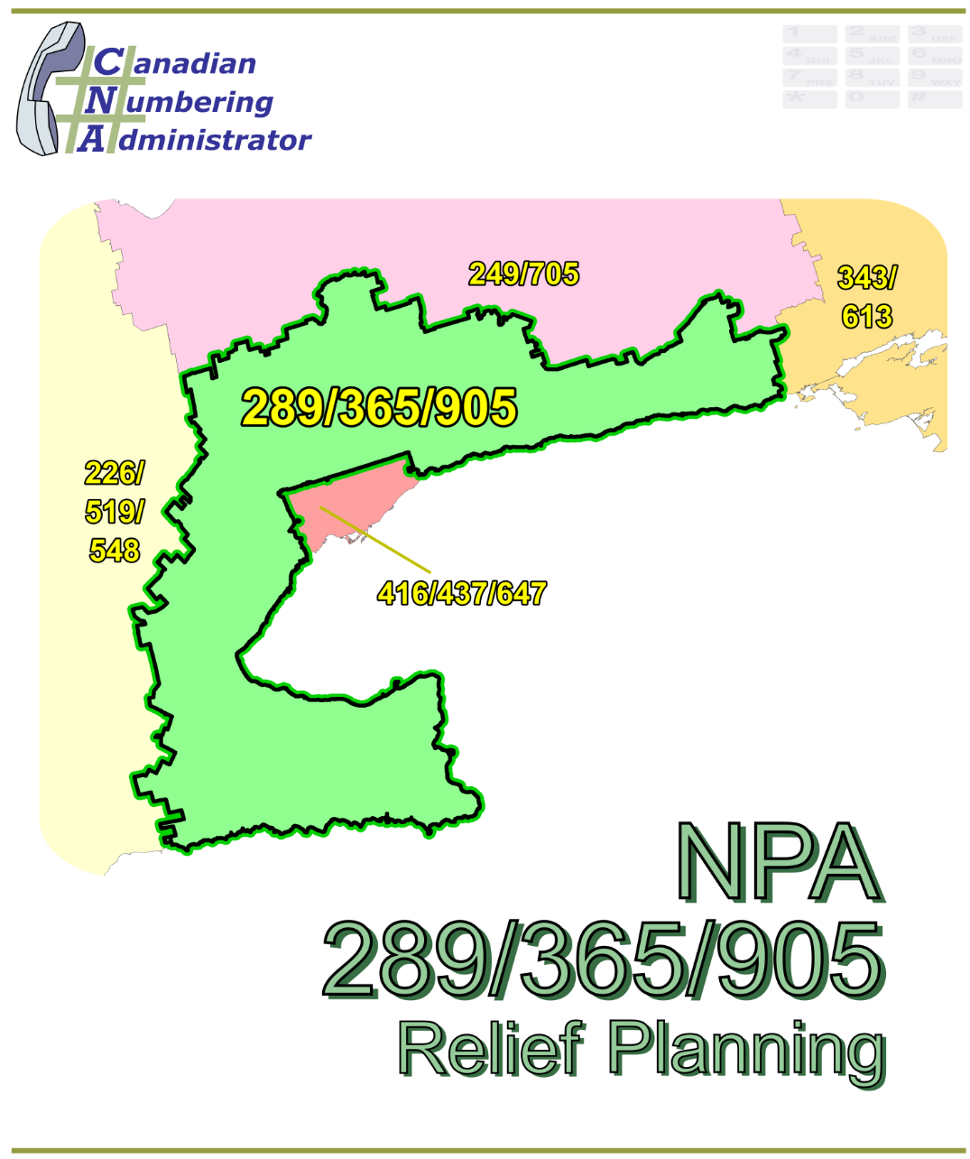

NPA 289/365/905 Planning Document

Version 1.0 – 26 June 2020

|  |  |
| --- | --- |
| Canadian Numbering Administrator (CNA)  Suresh Khare  613-702-0016 ext. 201  150 Isabella Street, Suite 605 Ottawa ON K1S 5H3  suresh.khare@cnac.ca |  |

**TABLE OF CONTENTS**

1. INTRODUCTION 1

2. NPA RELIEF PLANNING PROCESS 3

3. NPA RELIEF METHODS 3

4. NPA EXHAUST INFORMATION 4

5. RELIEF OPTION 4

5.1. Distributed Overlay 5

6. SUMMARY OF RELIEF OPTION 6

7. DIALLING CHANGES FOR LOCAL CALLS 6

8. PROPOSED SCHEDULE 6

9. JEOPARDY CONTINGENCY PLAN (JCP) 10

10. SELECTION OF RELIEF NPA CODE 17

11. RECOMMENDATIONS 18

ANNEXES 1

**LIST OF ANNEXES**

**ANNEX A**

Figure 1 – Overview Map of NPA 289/365/905

Figure 2 – NPA 289/365/905 Actual and Forecast CO Code Assignments

Figure 3 – NPA 289/365/905 CO Code Exhaust: July 2018 R-NRUF

Figure 4 – NPA 289/365/905 CO Code Exhaust: April 2020 R-NRUF (Current)

Figure 5 – NPA 289/365/905 LIRs

Figure 6 – Distributed Overlay

**ANNEX B**

Table 1 – NPA 289/365/905 Exchange Areas – Distributed Overlay Relief Option

Table 2 – NPA 289/365/905 Exchange Areas in Each LIR

**ANNEX C**

Distribution List

**ACRONYM LIST**

|  |  |
| --- | --- |
| CATF | Consumer Awareness Task Force |
| CNA | Canadian Numbering Administrator |
| CISC | CRTC Interconnection Steering Committee |
| CLEC | Competitive Local Exchange Carrier |
| CLNPC | Canadian Local Number Portability Consortium |
| CO | Central Office |
| CRTC | Canadian Radio-television and Telecommunications Commission |
| CSCN | Canadian Steering Committee on Numbering |
| EAS | Extended Area Service |
| G-NRUF | General Numbering Resource Utilization Forecast |
| ILEC | Incumbent Local Exchange Carrier |
| IPD | Initial Planning Document |
| ISP | Internet Service Provider |
| JCP | Jeopardy Contingency Plan |
| J‑NRUF | Jeopardy Numbering Resource Utilization Forecast |
| LEC | Local Exchange Carrier |
| LIR | Local Interconnection Region |
| LNP | Local Number Portability |
| NANP | North American Numbering Plan |
| NANPA | North American Numbering Plan Administrator |
| NITF | Network Implementation Task Force |
| NoC | Notice of Consultation |
| NPA | Numbering Plan Area (Area Code) |
| NRUF | Numbering Resource Utilization Forecast |
| PD | Planning Document |
| PED | Projected Exhaust Date |
| PL | Planning Letter |
| POI | Point of Interconnection |
| PROC | Proposal for Relief of an Overlay NPA Complex |
| PSAP | Public Safety Answering Point |
| RIP | Relief Implementation Plan |
| R-NRUF | Relief Planning Numbering Resource Utilization Forecast |
| RPC | Relief Planning Committee |
| TSP | Telecommunications Service Provider |
| WNP | Wireless Number Portability |
| WSP | Wireless Service Provider |

**Planning Document for Numbering Plan Area (NPA) 289/365/905**

# INTRODUCTION

Numbering Plan Areas (NPAs) 416 and 613, commonly referred to as area codes, were originally assigned to Ontario by AT&T in 1947 as two of the 86 area codes to be used in Canada and the continental United States. In 1993 NPA 905 was split from NPA 416. NPA 416 was retained for Toronto while NPA 905 became the area code for the area surrounding Toronto. The following table provides a high-level summary of the history of area code usage in the area currently served by NPA 289/365/905 since 1947.

|  |  |
| --- | --- |
| **Year** | **Activity** |
| 1947 | Area Codes 416 and 613 are assigned to Ontario by AT&T |
| 1993 | New Area Code 905 is split from 416 to serve the area surrounding Toronto |
| 2001 | New Area Code 289 overlays 905 surrounding the Toronto region |
| 2013 | New Area Code 365 overlays 289/905 surrounding the Toronto region |

NPA 289/365/905 consists of 94 Exchange Areas. A list of the Exchange Areas in NPA 289/365/905 is provided in Annex B, Table 1.

The table below provides a brief overview of recent activities leading to the development of this Planning Document (PD) for NPA 289/365/905.

| **Date** | **Activity** |
| --- | --- |
| 13 April 2010 | In Telecom Decision CRTC 2010-213, the Commission determined that area code 742 should be set aside as a potential future relief area code for area codes 289, 365, and 905.  **For the purposes of this document the new NPA will be 742.** |
| 29 March 2017 | The Canadian Numbering Administrator (CNA) published the January 2017 G‑NRUF results which indicated that the Projected Exhaust Date (PED) had advanced to September 2023. |
| 20 September 2017 | The CNA published the July 2017 R-NRUF results which indicated that the PED had advanced to May 2023. |
| 8 March 2018 | The CNA published the January 2018 G‑NRUF results which indicated that the PED had advanced to November 2022. |
| 11 July 2018 | The CRTC released Telecom Notice of Consultation CRTC 2018-235 - *Establishment of a CISC ad hoc committee for relief planning for area codes 289, 365, and 905 in southern Ontario*. |
| 27 August 2018 | The CNA published the July 2018 R-NRUF results which indicated that the PED had advanced to November 2021. |
| 2 November 2018 | The CNA issued the Initial Planning Document (IPD). |
| 26 March2019 | The CNA published the January 2019 R-NRUF results which indicated that the PED had moved out to June 2022. |
| 31 May 2019 | The CNA issues the PROC and announces the date of the Initial relief Planning Committee (RPC) conference call. |
| 20 June 2019 | The RPC met to review the PROC and contributions on the Relief Implementation Plan and CO Code Inventory Chart. Agreement was reached on the Planning Document and Relief Implementation as modified during the conference call. The RPC agreed to reconvene following the release of the July 2019 NRUF results. |
| 20 September 2019 | The CNA published the July 2019 R-NRUF results which indicated that the PED had moved out to December 2022. |
| 24 March 2020 | The CNA published the January 2020 R-NRUF results which indicated that the PED had moved out to March 2023. |
| 26 May 2020 | CRTC staff advised that the current PED should be discussed with the RPC to make the appropriate decision relative to any changes in a recommended Relief Date. |
| 29 May 2020 | April (Current) 2020 R-NRUF results which indicated that the PED had moved in to December 2022. |
| 29 May 2020 | An RPC conference call was held to finalize the Planning Document, Relief Implementation Plan and Schedule. |

This PD is prepared by the RPC in accordance with Telecom Notice of Consultation CRTC 2018‑235 and the *Canadian NPA Relief Planning Guideline*, Version 7.0 dated 29 January 2019 (the Guideline). A copy of the Guideline is available from the Canadian Radio‑television and Telecommunications Commission (CRTC), CRTC Interconnection Steering Committee (CISC), Canadian Steering Committee on Numbering (CSCN) guidelines web page at: <https://crtc.gc.ca/cisc/eng/cisf3fg.htm>.

The objective of the NPA Relief Planning process is to ensure that CO Codes and telephone numbers are always available for use by TSPs and their customers in the geographic area requiring relief.

It is very important to closely monitor the CO Code requirements of all existing and prospective CO Code Holders so that relief can be timed to ensure that CO Codes and telephone numbers are always available for service providers and customers.

In this PD, a single option is identified for providing NPA relief in the NPA 289/365/905 geographic area. Given the magnitude of this undertaking, intercompany commitment and co‑operation are essential throughout the planning, provisioning and implementation stages of the introduction of the new NPA.

# NPA RELIEF PLANNING PROCESS

The NPA Relief Planning process and the roles of the participants (i.e. CRTC, CNA, CISC, Relief Planning Committee (RPC) participants and Interested Parties) for NPA Relief Planning are identified in the Guideline.

To increase public awareness and participation in the NPA Relief Planning process, the CRTC has determined that NPA RPCs will be established as ad hoc committees of the CISC. Generally, a separate ad hoc committee is created to deal with relief in each area code. The CNA, in its function as NPA Relief Planning Coordinator, acts as chair of these ad hoc committees. Meetings and conference calls of the ad hoc NPA RPCs are all open to public participation and are conducted in accordance with the *CISC Administrative Guidelines* which are available from the CRTC website at: <http://www.crtc.gc.ca/cisc/eng/cag.htm>.

NPA Relief Planning is conducted under the regulatory oversight of the CRTC. Notwithstanding the process detailed in the Guideline, the CRTC may exercise its authority under the *Telecommunications Act* to alter this process at any time. The CRTC has the authority under the *Telecommunications Act* to review, modify and give final approval to the Planning Document (PD) and the Relief Implementation Plan (RIP) developed and submitted by the RPC to the CRTC via the CISC process.

Section 7.1.6 of the *Canadian NPA Relief Planning Guideline* requires the CNA to create and maintain a distribution list of parties who may be interested in participating in the RPC and to provide them with advance notice of the initial RPC meeting and the release of a PROC.

Any person wishing to participate in the NPA Relief Planning process can contact the CNA and request to be added to the RPC distribution list. More information on how to participate in CRTC public processes is available at: <http://www.crtc.gc.ca/eng/info_sht/g4.htm>.

A summary of Canadian geographic area code relief history is available at: <http://www.cnac.ca/npa_codes/NPA_History.pdf>.

# NPA RELIEF METHODS

The purpose of this section is to identify and briefly describe NPA Relief Methods.

The Guideline states that: “The only NPA Relief Method considered in Canada is the Distributed Overlay Method which superimposes or “overlays” a Relief NPA on top of an entire existing NPA or NPAs.” There are three types of Distributed Overlay:

1. a Distributed Overlay over an existing geographic area served by a single existing NPA (A new NPA is overlaid over a single existing NPA (i.e., the geographic area) that is served by a single NPA);
2. a Distributed Overlay over an existing geographic area served by multiple existing overlay NPAs (A new NPA is overlaid over a single existing NPA (i.e., the geographic area) that is served by multiple existing overlay NPAs); and,
3. a Distributed Overlay over multiple existing geographic areas, each served by one or more existing NPAs (A new NPA is overlaid over multiple existing NPAs (i.e., different geographic areas served by multiple NPAs. This type of overlay may be considered for NPA relief for two or more adjacent NPAs (i.e., geographic areas) within a province).

# NPA EXHAUST INFORMATION

As indicated in the following table, NRUFs for NPA 289/365/905 were used to determine PEDs, (i.e. the dates when CO Codes in NPA 289/365/905 would be expected to exhaust).

|  |  |
| --- | --- |
| **NRUF** | **Projected Exhaust Date (PED)** |
| G-NRUF January 2017 | September 2023 |
| R-NRUF July 2017 | May 2023 |
| R‑NRUF January 2018 | November 2022 |
| R-NRUF July 2018 | November 2021 |
| R‑NRUF January 2019 | June 2022 |
| R-NRUF July 2019 | December 2022 |
| R‑NRUF January 2020 | March 2023 |
| R‑NRUF April (Current) 2020 | December 2022 |

Refer to Annex A, Figures 2 through 4 for graphs of forecast CO Code demand from current and prospective CO Code Holders and Administrative Codes set aside in Area Code 289/365/905 for the initial and the most recent NRUFs (July 2018 and April (current) 2020).

# RELIEF OPTION

The Relief Option as identified and examined in this PD is a Distributed Overlay over an existing geographic area served by multiple existing overlay NPAs.

Using this method, a new NPA is overlaid over an existing NPA (i.e., the geographic area) that is served by multiple existing overlay NPAs 289/365/905.

The Relief Option identified above was evaluated using the following assumptions:

1. The average historical growth of 78 CO Codes was used to identify the subsequent PED for this Relief Option by comparing the 2020 April (Current) R-NRUF data in the table below:

|  |  |  |  |
| --- | --- | --- | --- |
| **Statistical Method** | **Data** | **Period** | **Quantity of CO Codes** |
| Average | Forecast growth | Next six years | 113 |
| Average | Forecast growth | Five-year period (January 2021 until January 2026 | 90 |
| Median | Forecast growth | Next six years | 78 |
| Median | Historical growth | Past five years | 82 |
| Average | Historical growth | Past five years | 85 |

1. The Relief Date for the Distributed Overlay will be Q4 2021 (approximately 12 months prior to the NPA 289/365/905 PED of December 2022 identified using the April (current) 2020 R‑NRUF results).

A high-level LIR map has been provided for reference purposes in Annex A, Figure 5.

See Annex A, Figure 6 for diagram of the Distributed Overlay Relief Option identified by the RPC.

## Distributed Overlay

A Distributed Overlay Relief Option was evaluated which would overlay the NPA 742 over all 94 Exchange Areas comprising the NPA 289/365/905 area. See Annex A, Figure 6.

The introduction of a Distributed Overlay would keep the same number of NPA Relief Planning areas in Ontario.

After this Distributed Overlay, CO Codes in NPA 289/365/742/905 would be expected to exhaust in Q4 2032.

# SUMMARY OF RELIEF OPTION

|  |  |  |  |
| --- | --- | --- | --- |
| **Relief Option** | **Projected Exhaust Dates** | | **Subsequent Relief Dates** |
| **NPA 289/365/905** | **NPA 289/365/742/905** |
| Distributed Overlay | December-2022 | December-2032 | Q4-2031 |

**Note: Distributed Overlay NPA 742 would be in service in Q4 2021.**

# DIALLING CHANGES FOR LOCAL CALLS

Currently 10-digit dialling is mandatory for local calls originating within area code NPA 289/365/905 and all neighbouring NPAs (i.e., NPA 226/519/548, NPA 249/705, NPA 343/613 and NPA 416/437/647). Local dialling plans will not change with this relief.

# PROPOSED SCHEDULE

The RPC submits the following schedule for NPA 289/365/905 relief based on the recommendations contained in this PD and the current PED of December 2022. The RPC will monitor the PED, and if it changes significantly in the future, the RPC will assess the situation and, if necessary, submit recommendations including a revised schedule to the CRTC for consideration and approval.

**RELIEF IMPLEMENTATION SCHEDULE**

**For a Distributed Overlay of NPA 742 over NPA 289/365/905**

| **Item** | **Task or Event** | **PRIME** | **START** | **END** |
| --- | --- | --- | --- | --- |
| 1 | CNA identifies NPA exhaust of November 2022 and notifies by e-mail CRTC staff, CSCN, NANPA & CISC that the NPA will exhaust within the future six year time period | CNA |  | 08-Apr-18 |
| 2 | CRTC issues Telecom Notice of Consultation regarding establishment of an ad hoc Relief Planning Committee | CRTC |  | 11-Jul-18 |
| 3 | CNA conducts initial R-NRUF and releases results indicating the PED has moved out to November 2021. | CNA | 22-Jun-18 | 28-Aug-18 |
| 4 | RPC Chair starts preparing and submitting RPC Chair Reports to the CISC, on an as required basis. | RPC Chair | 11-Jul-18 | 24-Jan-22 |
| 5 | CNA develops and distributes Initial Planning Document (IPD) to RPC | CNA | 08-Apr-18 | 02-Nov-18 |
| 6 | CNA issues January 2019 R-NRUF results indicating the PED has deferred to June 2022. | CNA |  | 26-Mar-19 |
| 7 | CRTC approves Canadian NPA Relief Planning Guideline, Version 7.0 |  |  | 29-Jan-19 |
| 8 | CNA releases the PROC and announces the date for the initial RPC conference call |  |  | 31-May-19 |
| 9 | RPC participants review PROC & submit contributions to RPC |  | 31-May-19 | 14-Jun-19 |
| 10 | CNA chairs initial RPC conference call to start development of PD, RIP & PL, & schedules future meetings/conference calls including creation & consultation with CATF and NITF | CNA, RPC | 20-Jun-19 | 20-Jun-19 |
| 11 | CNA conducts July R-NRUF and releases results | CNA | 15-Jun-19 | 20-Sep-19 |
| 12 | CNA chairs subsequent RPC conference calls to finalize PD & RIP | CNA, RPC | 21-Jun-19 | 29-May-20 |
| 13 | CNA forwards the PD and RIP to the CISC and CRTC for approval | CNA | 12-Jun-20 | 25-Jun-20 |
| 14 | Special Types of Telecommunications Service Users (911 PSAPs, alarm companies, ISPs, paging companies, etc.) to identify any concerns to RPC & CRTC | Special Users | 20-Jun-19 | 25-Jun-20 |
| 15 | CRTC issues Telecom Decision approving the Relief Method, Relief Date, New NPA & Relief Implementation Plan (RIP) | CRTC | 25-Jun-20 | 30-Oct-20 |
| 16 | CNA obtains relief NPA from NANPA | CNA | 30-Oct-20 | 16-Nov-20 |
| 17 | RPC develops the Planning Letter (PL) | RPC | 16-Nov-20 | 30-Nov-20 |
| 18 | Task Forces, TSPs and users implement relief (starts upon CRTC approval of RIP and ends on Relief Date) | TSPs | 30-Oct-20 | 16-Oct-21 |
| 19 | All Telecom Service Providers (TSPs) to develop and file individual consumer awareness programs with the CRTC (may be done collectively by Telecommunications Alliance) (starts upon CRTC approval of RIP) | TSPs | 30-Oct-20 | 16-Jan-21 |
| 20 | CNA issues media release (in coordination with TSPs and/or Telecommunication Alliance) (may start upon CRTC approval of RIP) | CNA | 30-Oct-20 | 16-Apr-21 |
| 21 | CNA submits PL and RIP to NANPA | CNA | 30-Nov-20 | 14-Dec-20 |
| 22 | NANPA receives and posts Planning Letter to NANPA website (within 2 weeks of receipt from the CNA) | NANPA | 14-Dec-20 | 30-Dec-20 |
| 23 | All TSPs implement consumer awareness activities (starts upon filing of Consumer Awareness Programs with the CRTC and is completed on the Relief Date) | TSPs | 16-Jan-21 | 16-Oct-21 |
| 24 | All TSPs to notify all customers (including residence, business & special customers) of the new overlay NPA (may start upon the filing of Consumer Awareness Programs with the CRTC) | TSPs | 16-Jan-21 | 16-Apr-21 |
| 25 | TSPs to submit Progress Report #1 to NITF and CATF (starts after completion date for all TSPs to notify their customers and requires 2 weeks) | TSPs | 16-Apr-21 | 30-Apr-21 |
| 26 | NITF and CATF develop & submit Progress Report #1 to RPC (linked to TSP reports to NITF and CATF) | NITF & CATF | 30-Apr-21 | 14-May-21 |
| 27 | RPC submits Progress Report #1 to CISC/CRTC (linked to NITF and CATF reports) | RPC | 14-May-21 | 31-May-21 |
| 28 | iconectiv TRA database updates to add Exchange Areas to new overlay NPA (starts on the date that the PL is posted to the NANPA web site and must be completed by 6 months prior to the Relief Date) | iconectiv TRA | 30-Dec-20 | 11-May-21 |
| 29 | All Telecommunications Service Users (including Special Users 911 PSAPs, alarm companies, ISPs, paging companies, etc.) to implement changes to their telecom equipment & systems to accommodate the new NPA (starts upon CRTC approval of RIP and ends on the Relief Date) | Telecom Service Users | 30-Oct-20 | 16-Oct-21 |
| 30 | Payphone Providers Reprogram Payphones (starts upon CRTC approval of RIP and ends on the Relief Date) | Payphone Providers | 30-Oct-20 | 16-Oct-21 |
| 31 | TSPs and database owners/operators to modify systems and industry databases (starts upon CRTC approval of RIP and ends on the Relief Date) | TSPs & Database Owners | 30-Oct-20 | 16-Oct-21 |
| 32 | Operator Services & Directory Assistance Readiness (starts upon CRTC approval of RIP and ends on the Relief Date) | TSPs | 30-Oct-20 | 16-Oct-21 |
| 33 | Directory Publisher Readiness for overlays (ability to identify the NPA in telephone numbers in the directory published after the Overlay NPA is activated) (starts upon CRTC approval of RIP and ends on the Relief Date) | Directory Publishers | 30-Oct-20 | 16-Oct-21 |
| 34 | 9-1-1 Systems and Databases Readiness (starts upon CRTC approval of RIP and ends on the Relief Date) | PSAPS, 9 1 1 Service Providers & TSPs | 30-Oct-20 | 16-Oct-21 |
| 35 | Network Systems & Equipment Readiness (starts upon CRTC approval of RIP and ends on the Relief Date) | TSPs | 30-Oct-20 | 16-Oct-21 |
| 36 | Service Order & Business System Readiness (starts upon CRTC approval of RIP and ends on the Relief Date) | TSPs | 30-Oct-20 | 16-Oct-21 |
| 37 | International Gateway Switch Translations Readiness for new NPA (starts upon CRTC approval of RIP and ends on the Relief Date) | Int’l TSPs | 30-Oct-20 | 16-Oct-21 |
| 38 | Canadian Local Number Portability Consortium (CLNPC) Database Readiness for new NPA (starts upon CRTC approval of RIP and ends on the Relief Date) | CLNPC & NPAC | 30-Oct-20 | 16-Oct-21 |
| 39 | Toll Free SMS Database Readiness for new NPA (starts upon CRTC approval of RIP and ends on the Relief Date) | Toll TSPs | 30-Oct-20 | 16-Oct-21 |
| 40 | TSPs apply for Test CO Codes in new NPA (applications may be submitted no more than 6 months and no less than 66 days prior to the start date for the Inter-Carrier Testing Period) (Section 7.16.4 Canadian RP GL) | TSPs | 16-Jan-21 | 11-May-21 |
| 41 | Develop Inter-Carrier Network Test Plans and prepare for testing (individual TSPs to make arrangements in accordance with interconnection agreements) (may start upon CRTC approval of RIP and must be completed by start date for the Inter-Carrier Testing Period) | NITF & TSPs | 30-Oct-20 | 16-Jul-21 |
| 42 | All international and domestic Telecommunications Service Providers (TSPs) must activate the new NPA in their networks by the start date for the Inter-Carrier Testing Period | TSPs | 30-Oct-20 | 16-Jul-21 |
| 43 | Activation date for Overlay NPA Test CO Codes and Test Numbers in network (should be completed by the start date for the Inter-Carrier Testing Period) | TSPs |  | 16-Jul-21 |
| 44 | Inter-Carrier Testing Period (subject to Inter-Carrier Network Test Plans) (starts about 3 months prior to the Relief Date, and ends about 1 month after the Relief Date) | NITF & TSPs | 16-Jul-21 | 15-Nov-21 |
| 45 | TSPs to submit Progress Report #2 to NITF and CATF (starts on commencement of Inter-Carrier Testing Period) | TSPs | 16-Jul-21 | 30-Jul-21 |
| 46 | NITF and CATF develop & submit Progress Report #2 to RPC (linked to TSP reports to NITF and CATF) | NITF & CATF | 30-Jul-21 | 16-Aug-21 |
| 47 | RPC submits Progress Report #2 to CRTC staff (linked to NITF and CATF reports) | RPC | 16-Aug-21 | 30-Aug-21 |
| 48 | Relief Date (earliest date when CO Codes in new NPA may be activated) |  |  | 16-Oct-21 |
| 49 | TSPs submit Final Report to CATF and NITF (starts on Relief Date and provides 2 weeks for preparation & submission) | TSPs | 18-Oct-21 | 01-Nov-21 |
| 50 | NITF and CATF develop & submit Final Progress Report to RPC (linked to TSP reports to NITF and CATF) | NITF & CATF | 02-Nov-21 | 16-Nov-21 |
| 51 | The RPC submits Final Progress Report to CRTC staff (linked to NITF and CATF reports) | RPC | 16-Nov-21 | 30-Nov-21 |
| 52 | TSPs disconnect Test Codes & Numbers, and submit Part 1 form to return Test Codes (starts 1 month after Relief Date and allows 1 month for completion) | TSPs | 15-Nov-21 | 20-Dec-21 |
| 53 | RPC Chair submits, to the CISC, the final RPC Chair report indicating that theNPA 289/365/905 ad hoc RPC is no longer required | RPC Chair | 20-Dec-21 | 24-Jan-22 |

# JEOPARDY CONTINGENCY PLAN (JCP)

The RPC has developed the following JCP for inclusion in the PD for NPA 289/365/905. This JCP is based on the example contained in Appendix F to the *Canadian NPA Relief Planning Guideline*.

This JCP shall remain in effect until superseded by a CRTC-approved JCP, the Jeopardy Condition is suspended or 66 days prior to the Relief Date.

The following measures shall be implemented in NPA 289/365/905 while a Jeopardy Condition is in effect.

During a Jeopardy Condition, CO Code Applicants shall submit all CO Code applications and related correspondence for the Jeopardy NPA to CRTC staff in addition to the CNA. The CNA shall only assign CO Codes from the exhausting NPA to a CO Code Applicant when instructed by CRTC staff.

1. Carriers and/or Telecommunications Service Providers (TSPs):
   1. shall age disconnected residential wireline telephone numbers for a maximum of two months;
   2. shall age disconnected wireless telephone numbers for a maximum of three months;
   3. shall age disconnected business wireline telephone numbers for a maximum of six months. Under special circumstances, the six month aging limit for business telephone numbers may be extended to twelve months, if required, to accommodate local directory publishing dates for high volume call-in applications (e.g., heavily advertised local business numbers such as radio talk shows, food ordering services, ticket sales, chat lines), or for numbers associated with public service emergency applications or for numbers advertised in directories for which customers have requested reference of calls;
   4. shall return all CO Codes that are not being used, nor intended to be used to directly serve customers to the assignment pool within two months (e.g., plant test codes);
   5. should work towards, and encourage existing customers, to either activate or return the reserved numbers to bring the reserved quantity down to a maximum of 10% of the quantity of numbers In-Service for that customer;
   6. shall not allow the quantity of reserved numbers to be increased by new reservation requests by existing customers to more than 10% of the quantity of numbers in service for that customer. In the case of new customers, number reservations shall be limited to 10% of the total quantity of telephone numbers being placed into service for that customer;
   7. shall, within 45 days from the date that the CNA declares a Jeopardy Condition submit a Part 1 Form for each remaining reserved CO Code either returning the reserved CO Code to the CNA or requesting assignment of the reserved CO Code. Once the 45-day period has elapsed, the CNA shall make available for general assignment all CO Codes that are still reserved and have not been applied for as assignments on a Part 1 Form received by the CNA. Within 60 days from the date that the CNA declares a Jeopardy Condition, the CNA shall report to CRTC staff and the RPC as to how many of these codes have been assigned or made available for general assignment;
   8. shall not be permitted to obtain a new CO Code reservation;
   9. shall place all CO Codes assigned prior to the Jeopardy Condition being declared In-Service within three months of the effective date for CO Code activation in the network, or within three months of the date that the Jeopardy Condition was declared. If the CO Code is an Initial Code and the CO Code Holder can demonstrate that, due to circumstances beyond its control, the In-Service date has been delayed beyond the applicable timeframe, then the CNA may grant an extension of up to two months to the In-Service date. The CNA shall initiate reclamation procedures for all CO Codes that have not been placed In-Service within these timeframes unless CRTC staff provides a further extension.
2. For new applications for Initial Codes, each CO Code Holder shall certify that the CO Code will be activated in the network and placed In-Service within four months of the date of application for the Code. If the CNA does not receive a Part 4 Form within this timeframe, confirming that the CO Code has been placed In-Service, the CNA will initiate reclamation measures. If the CO Code Holder can demonstrate that, due to circumstances beyond its control, the In-Service date has been delayed not more than six months from the original application date, then the CNA may grant an extension to the In-Service date, so long as the In-Service date is not more than six months beyond the original application date. If the In-Service date has been delayed more than six months from the original application date, then the CNA shall reclaim the Code unless CRTC staff provides a further extension.
3. When applying for an Additional Code for Growth, a CO Code Holder who is submitting a Part 1 Form and Appendix B worksheet shall also submit a completed Supplementary Form for a Growth CO Code Application (attached) which certifies and/or provides the following information for the specific switching entity/POI and Exchange Area when the Growth CO Code is being requested in a Jeopardy Condition:
   1. certification that all held telephone numbers have been released;
   2. certification that reserved numbers do not exceed ten percent of the total quantity of numbers as defined in Appendix G of the Canadian CO Code (NXX) Assignment Guideline;
   3. certification that each reseller/dealer had been advised of the Jeopardy Condition and the requirement that they would only be allocated additional numbers during the Jeopardy Condition on the provision to the CO Code Holder of written confirmation that their number inventory has been reduced to an amount less than two times the highest quantity of customer numbers assigned in any month during the previous 12 months. Additional numbering resources will only be provided by the CO Code Holder to the reseller/dealer to the extent that the reseller's/dealer's inventory can only increase up to a maximum of three months' inventory;
   4. confirmation that the Part 1 form submitted with the application has the Jeopardy Condition box in section 1.6 checked to certify that the existing CO Codes are projected to exhaust within 4 months of the date of application and that the months-to-exhaust is documented on an Appendix B submitted to the CNA;
   5. a completed Telephone Number Utilization Report for the applicable switching entity signed by both a company officer and the company’s authorized representative;
   6. confirmation that the requested Growth CO Code was forecasted in the most recent NRUF or an explanation as to why it was not is attached; and,
   7. confirmation that the requested Growth CO Code will be placed In-Service within four months of the date of assignment.
4. Any CO Codes for growth assigned after the implementation of this JCP must be activated in the network and placed In-Service within four months of assignment. In the event that a CO Code Holder is unable to place the CO Code In-Service within four months of the date of assignment, the CO Code Holder must return the assigned CO Codes or submit a written request for extension to the CNA. Such written requests must include documentation explaining the reason(s) for the missed date and proposing the new In-Service date. If the explanation includes reasons beyond the control of the CO Code Holder, the CNA may extend the In-Service date a maximum of one month. If the CO Code Holder does not place the CO Code In-Service within the one-month extension, the CNA shall initiate the reclamation process at the end of the one-month extension unless CRTC staff provides a further extension.
5. A Carrier that has multiple switching entities within an Exchange Area shall examine the possibility of, and implement where feasible, number sharing between those switches as a potential method to delay requirements for additional CO Codes.
6. The CNA will request two versions (two separate worksheets (Form 1 and Form 2)) of the J-NRUF input from all current and prospective CO Code Holders quarterly until three (3) months before relief is provided.
   1. The forecast quantities in Form 1 should be the same as or lower than the last R‑NRUF input submitted, prior to declaration of a Jeopardy Condition. CO Code Holder forecasts may reflect an increase in demand in the period subsequent to the Relief Date.
   2. Form 2 will reflect the actual demand required by the CO Code Holder's current business plan and will be provided for information purposes only.
7. The CNA will compare the initial J-NRUF input to the recent NRUF inputs, to assess forecasting trends. The CNA shall monitor all inputs and shall test them for reasonableness in consultation with the Carrier. If the CNA is dissatisfied with the reasonableness, or the rationale provided for the deviations, then the matter will be referred to the CRTC staff.
8. The CNA will request subsequent J-NRUF input from all current and prospective CO Code Holders quarterly until 3 months before relief is provided. If one or more R-NRUFs have already been conducted, and depending on the severity of the Jeopardy Condition, the CNA may defer a J-NRUF by up to two months if such a deferral brings the timing of that J‑NRUF and subsequent J-NRUFs into alignment with other NRUFs that are conducted at 12, 6 or 3 month intervals. Subsequent J-NRUF input will be compared with the initial J‑NRUF input to evaluate the effectiveness of the JCP. The CNA shall monitor all J-NRUF inputs and shall test them for reasonableness in consultation with the Telecommunications Service Providers. If the CNA is dissatisfied with the reasonableness, or the rationale provided for the changed forecasts, then the matter will be referred to CRTC staff.
9. A CO Code Applicant must have submitted a completed J-NRUF to the CNA before the CNA may assign a CO Code to that CO Code Applicant.
10. If a CO Code applicant wishes to request more CO Codes than it identified in its most recent J NRUF, the CO Code Applicant should discuss the matter with the CNA. If the CO Code Applicant wishes to proceed with the request, the CO Code Applicant will forward the request and revised forecast to CRTC staff and the CNA for consideration.
11. The CO Codes identified in the NPA CO Code Inventory Chart as “Assignable CO Codes in a Jeopardy Condition” will be assigned in the order determined by the RPC after all CO Codes which are “Available for Assignment as of [day month year] have been assigned.
12. After each J-NRUF, the CNA shall provide CRTC staff, the RPC and CSCN participants with a report providing an updated NPA CO Code Inventory Chart for the NPA in jeopardy as well as the aggregate results of the most recent J-NRUF.
13. Exceptional issues or concerns may be referred by the CNA, or by individual entities (with a courtesy copy to the CNA), to the CRTC staff for resolution.
14. In a situation where the Relief Date is on or after the PED, the quantity of CO Codes that may be assigned to a CO Code Applicant prior to the end of the Jeopardy Condition (i.e. 66 days prior to the Relief Date) shall be limited to the quantity forecasted by the CO Code Applicant in its most recent NRUF forecast submitted prior to the Jeopardy Condition being declared by the CNA (if no previous NRUF was submitted, then the previous forecast will be deemed to be zero codes). When making requests to obtain CO Codes prior to the end of the Jeopardy Condition (i.e. 66 days prior to the Relief Date), the CO Code Applicant may change the Exchange Area or the month when the CO Code assignment is required, provided a new J-NRUF and explanation accompanies the application. The control imposed by this option may be relaxed if subsequent J-NRUFs defer the PED to after the Relief Date. CO Codes that become available for assignment due to future reduced demand from other current and prospective CO Code Holders may be assigned at the discretion of CRTC staff.
15. If the CNA determines that the implementation of the JCP has not extended the Projected Exhaust Date of the NPA beyond the Relief Date, the CNA will consult with CRTC staff and further CO Code conservation and assignment procedures may be ordered by the Commission (e.g., rationing, lottery, etc.).

Supplementary form for a Growth CO Code Application – Page 1 of 2 – Telephone Number Utilization Report

This form is required with each request for an Additional Code for Growth in an NPA where a Jeopardy Condition is in effect. It should be submitted to the CNA together with the Part 1 and Appendix B forms that are required for an application for an Additional Code for Growth. See the Part 1 form for information on how and where to submit the form.

I hereby certify that the following information is true and accurate to the best of my knowledge and has been prepared in accordance with Special Conservation Procedures for a Jeopardy Condition contained in the *Canadian NPA Relief Planning Guideline* or the applicable approved Jeopardy Contingency Plan.



Name & Signature of Authorized Representative of Code Holder Title Date



Name & Signature of Company Officer (see item 3 of this JCP) Title Date

Contact information: Entity Name: __________________ Contact Name: _____________

Address: __________________ City, Province, Postal Code: _____________

Telephone: __________________ Facsimile: _____________

E-mail: __________________

Switch Identification (Switching Entity/POI) CLLI: _______________ Exchange Area: ________________

For the above Switch Identification and Exchange Area for which a Growth CO Code is requested:

I certify that all held telephone numbers have been released

I certify the total quantity of reserved numbers does not exceed ten percent (10%) of the total quantity of telephone numbers as defined in Appendix G of the *Canadian CO Code (NXX) Assignment Guideline*

I certify that each reseller/dealer has been advised of the Jeopardy Condition and the requirement that they would only be allocated additional numbers during the Jeopardy Condition on the provision to the CO Code Holder of written confirmation that their number inventory has been reduced to an amount less than two (2) times the highest quantity of customer numbers assigned in any month during the previous twelve (12) months. Additional numbering resources will only be provided by the CO Code Holder to the reseller/dealer to the extent that the reseller's/dealer's inventory can only increase up to a maximum of three months' inventory.

The Part 1 form submitted with the application has the Jeopardy Condition box in section 6 checked (this certifies that the existing CO Codes are projected to exhaust within four (4) months of the date of the application or within the period specified in an approved Jeopardy Contingency Plan, and that the months-to-exhaust is documented on an Appendix B submitted to the CNA).

The Telephone Number Utilization Report on page 2 of this form has been completed.

The requested Growth CO Code was forecasted in the most recent NRUF, or an explanation as to why it was not is attached.

The requested Growth CO Code will be placed In-Service within four (4) months of the date of assignment.

**Supplementary Form for a Growth CO Code Application – Page 2 of 2 – Telephone Number Utilization Report**

Use Arial 9 to complete this form. (Note: If the spreadsheet below does not show on your display, please change the Work view to "Print Layout" or "Reading Layout")



Remarks: _______________________________________________________________________________

________________________________________________________________________________________

**NPA 289/365/905 CO Code Inventory Chart**

The following chart and the instructions it contains will apply in NPA 289/365/905 in a Jeopardy Condition.

The chart below lists quantities of CO Codes unassignable prior to a Jeopardy Condition, CO Codes that become assignable in a Jeopardy Condition and CO Codes in NPA 289/365/905 assigned and In‑service as of 29 May 2020. The CO Codes that become assignable in a Jeopardy Condition shall only be made available for assignment when all other available CO Codes have been assigned in the order listed below.

|  |  |  |
| --- | --- | --- |
|  |  | **Quantity** |
| **A** | **Total CO Codes in NPAs 289/365/905** **(NXX format)** | **2,400** |
|  | | |
| **B** | **CO Codes unassignable prior to a Jeopardy Condition** |  |
|  | N11 Service Codes (211, 311, 411, 511, 611, 711, 811, 911) | 24 |
|  | Special Use Codes (555, 950 & 976) | 9 |
|  | Home NPA Code(s) | 9 |
|  | Current Neighbouring NPA Codes (249, 343, 416, 437, 613, 647, 705) | 21 |
|  | Future Geographic NPA Codes (742, 942)  (Note 1) | 6 |
|  | Plant Test Codes (958 & 959) | 6 |
|  | Special 7-digit Dialling Codes (310, 610 & 810) | 8 |
|  | **Total B** | 83 |
|  | | |
| **C** | **CO Codes assignable prior to a Jeopardy Condition (C=A-B)** | **2,317** |
|  | | |
| **D** | CO Codes unassignable prior to a Jeopardy Condition that become assignable in a Jeopardy Condition: |  |
| Future Canadian Geographic NPA Codes (Notes 1 & 2) | 0 |
| Current Neighbouring NPA Codes (249, 343, 613, 705) (Note 3) | 12 |
| **Total D** | **12** |
|  | | |
| **E** | **Assignable CO Codes in a Jeopardy Condition (E=C+D)** | **2,329** |
| **F** | **Assigned CO Codes as of 29 May 2020** | **1,854** |
| **G** | **Net CO Codes available for assignment as of 29 May 2020 without a Jeopardy Condition (G=C-F)** | 463 |
| **H** | **Net CO Codes available for assignment as of 29 May 2020 in a Jeopardy Condition (H=E-F)** | 475 |

**Notes:**

1. In Telecom Decision CRTC 2010-213, the Commission determined that area code 742 should be set aside as a potential future relief area code for area codes 289, 365 and 905.
2. In Telecom Decision CRTC Decision 2017-38, the Commission determined that area code 942 should be set aside as a potential future relief area code for area codes 416/437/647.
3. In an extreme Jeopardy Condition (i.e. when the Projected Exhaust Date is earlier than the Relief Date), the current Neighbouring NPA Codes 249, 343, 613, and 705 could be assignable with CRTC staff approval.

# SELECTION OF RELIEF NPA CODE

If the recommended Relief Option requires a new NPA Code, the criteria for selection of an appropriate area code for relief is addressed in section 4.11 of the *Canadian NPA Relief Planning Guideline*. The criteria that should be taken into account when Future Canadian Geographic NPAs are being considered as candidates for relief of a specific current Canadian Geographic NPA include the following:

1. The preferred Future Canadian Geographic NPA Code should not be an NPA Code that is assigned as a CO Code in the area that is being relieved (Home NPA(s)).
2. The preferred Future Canadian Geographic NPA Code should not be an NPA Code that is assigned as a CO Code in another NPA within the same province where there is a possibility that a single new NPA Code could be overlaid on more than one NPA within the province, or where boundary realignment could occur that affects another NPA.
3. The preferred Future Canadian Geographic NPA Code should not be an NPA Code that is assigned as a CO Code in an Exchange Area in a neighbouring NPA, if the neighbouring NPA has 7-digit local calling within the NPA and i) the Exchange Area in the neighbouring NPA where the CO Code is assigned has local calling to the NPA being relieved or ii) the Exchange Area in the neighbouring NPA where the CO Code is assigned does not have local calling to the NPA being relieved, but other Exchange Areas within that neighbouring NPA have 7-digit local calling to the Exchange Area where the CO Code is assigned as well as local calling to the new NPA.

CO Codes corresponding to Future Canadian Geographic NPA Codes which are not assigned in NPA 289/365/905 and therefore meet criterion a) above are 742 and 942.

CO Codes 742 and 942 are all assigned in at least one neighbouring NPA so none of these resources meet criterion b).

Criterion c) is not applicable since NPA 289/365/905 and all neighbouring NPAs have 10-digit local calling.

The NPA Code Selection Tool located on the CNA web site at <http://www.cnac.ca/npa_codes/relief/NPA_Selection_Tool.xlsx> can assist in selecting a relief NPA Code from the pool of NPA Codes reserved for relief of geographic Canadian NPAs. The following table, extracted from the NPA Code Selection Tool, shows all codes corresponding to Future Canadian Geographic NPA Codes that are designated as unassignable CO Codes in the Home NPA, and therefore are preferred candidates when selecting a relief NPA Code for NPA 289/365/905.

| **NXX corresponding to Future NPA** | **742** | **942** |
| --- | --- | --- |
| Distributed Overlay | ✓ | ✓ |

✓ Indicates that corresponding CO Code is designated as unassignable in Home NPA(s)

Both of the NPA Codes (742 and 942) are equally suitable as a new NPA Code for the relief of NPA 289/365/905, unless analysis of potential future code reservations for NPA reliefs in other areas of Canada, or TSP cost considerations indicate a preference for one code over another for the relief of NPA 289/365/905.

In Telecom Decision CRTC 2017‑38, the Commission determined that area code 942 should be set aside as a potential future relief area code for Toronto (NPA 416/437/647).

In Telecom Decision CRTC 2010-213, the Commission determined that area code 742 should be set aside as a potential future relief area code for area codes 289, 365, and 905.

# RECOMMENDATIONS

The RPC recommends:

1. The Relief Method should be a distributed overlay of a new NPA Code on Ontario NPA 289/365/905;
2. The Relief NPA Code for NPA 289/365/905 should be NPA 742 as per Telecom Decision CRTC 2010-213, dated 13 April 2010; and
3. The Relief Date should be 16 October 2021 in order to provide Carriers and customers with advanced notification and sufficient lead-time to implement relief in NPA 289/365/905.

ANNEXES

1. Maps and Figures

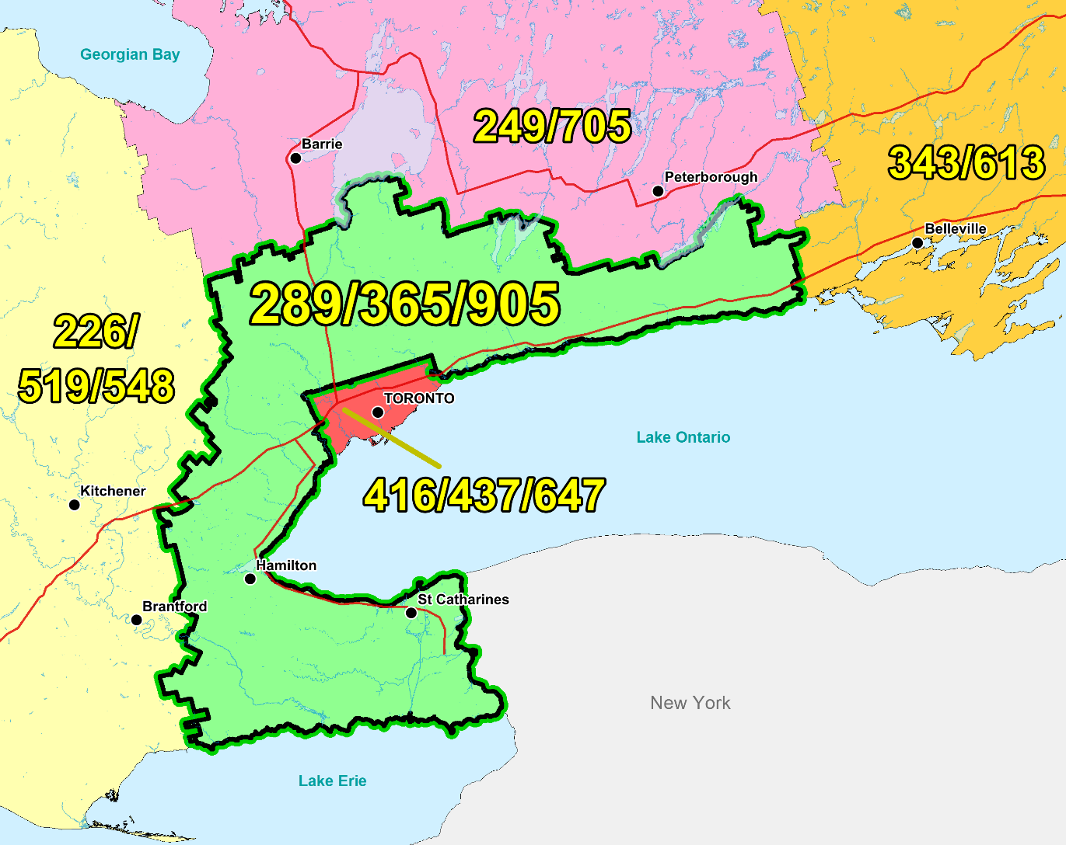

Figure 1 – Overview Map of NPA 289/365/905



Figure 2 – NPA 289/365/905 Actual and Forecast CO Code Assignments



Figure 3 – NPA 289/365/905 CO Code Exhaust: July 2018 R-NRUF



Figure 4 – NPA 289/365/905 CO Code Exhaust: April 2020 R-NRUF (Current)

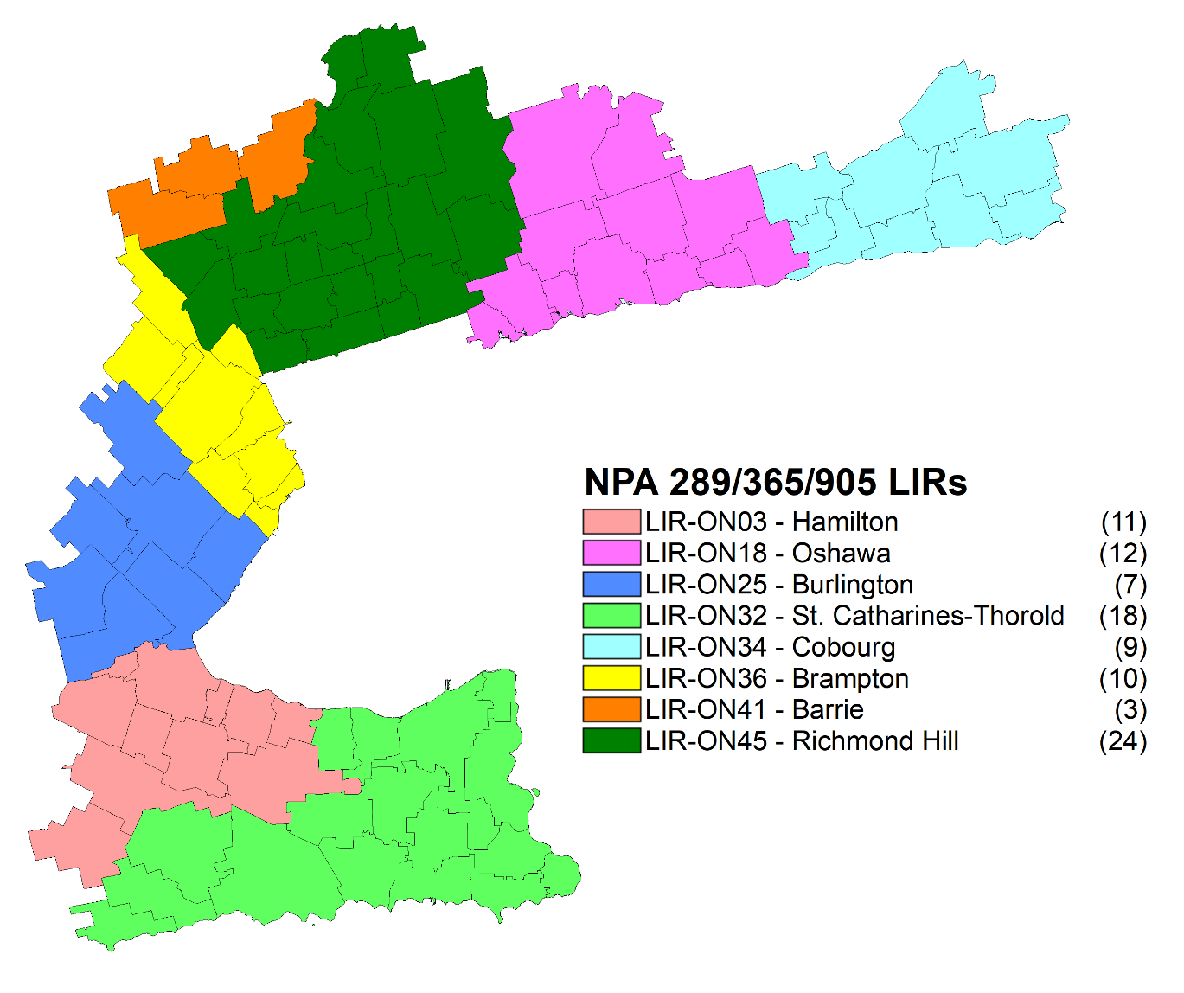

Figure 5 – NPA 289/365/905 LIRs

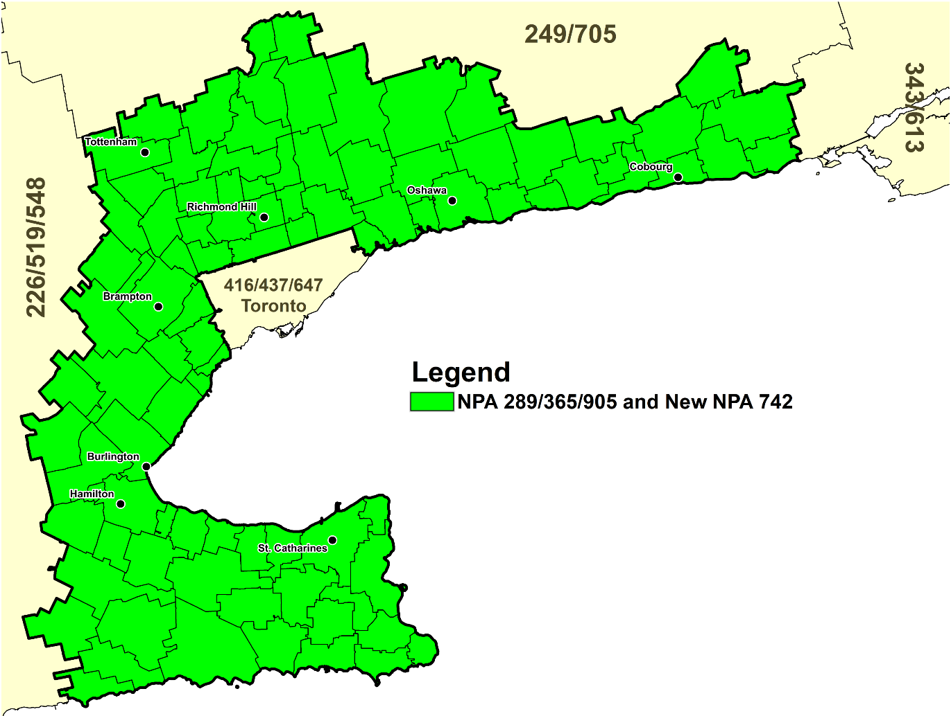

Figure 6 – Distributed Overlay

1. NPA 289/365/905 Exchange Areas

Table 1 – NPA 289/365/905 Exchange Areas – Distributed Overlay Relief Option

| **Exchange** | **Distributed Overlay** |
| --- | --- |
|
| **NPA 289/365/742/905** |
| Ajax-Pickering | ✓ |
| Ancaster | ✓ |
| Aurora | ✓ |
| Beamsville | ✓ |
| Beeton | ✓ |
| Bethesda | ✓ |
| Binbrook | ✓ |
| Blackstock | ✓ |
| Bolton | ✓ |
| Bowmanville | ✓ |
| Bradford | ✓ |
| Brampton | ✓ |
| Brooklin | ✓ |
| Burlington | ✓ |
| Caledon East | ✓ |
| Caledonia | ✓ |
| Campbellville | ✓ |
| Castlemore | ✓ |
| Castleton | ✓ |
| Cayuga | ✓ |
| Claremont | ✓ |
| Clarkson | ✓ |
| Cobourg | ✓ |
| Colborne | ✓ |
| Cold Springs | ✓ |
| Cooksville | ✓ |
| Dundas | ✓ |
| Dunnville | ✓ |
| Fisherville | ✓ |
| Fort Erie | ✓ |
| Freelton | ✓ |
| Garden Hill | ✓ |
| Georgetown | ✓ |
| Gormley | ✓ |
| Grafton | ✓ |
| Grimsby | ✓ |
| Hagersville | ✓ |
| Hamilton | ✓ |
| Hampton | ✓ |
| Keswick | ✓ |
| King City | ✓ |
| Kleinburg | ✓ |
| Malton | ✓ |
| Maple | ✓ |
| Markham | ✓ |
| Milton | ✓ |
| Mount Albert | ✓ |
| Mount Hope | ✓ |
| Newcastle | ✓ |
| Newmarket | ✓ |
| Newtonville | ✓ |
| Niagara Falls | ✓ |
| Niagara-On-The-Lake | ✓ |
| Nobleton | ✓ |
| Oak Ridges | ✓ |
| Oakville | ✓ |
| Orono | ✓ |
| Oshawa | ✓ |
| Palgrave | ✓ |
| Pelham | ✓ |
| Port Colborne | ✓ |
| Port Credit | ✓ |
| Port Hope | ✓ |
| Port Perry | ✓ |
| Port Robinson | ✓ |
| Queensville | ✓ |
| Richmond Hill | ✓ |
| Ridgeway | ✓ |
| Roseneath | ✓ |
| Schomberg | ✓ |
| Selkirk | ✓ |
| Snelgrove | ✓ |
| South Pickering | ✓ |
| St. Catharines-Thorold | ✓ |
| Stevensville | ✓ |
| Stoney Creek | ✓ |
| Stouffville | ✓ |
| Streetsville | ✓ |
| Sutton | ✓ |
| Thornhill | ✓ |
| Tottenham | ✓ |
| Unionville | ✓ |
| Uxbridge | ✓ |
| Victoria | ✓ |
| Vineland | ✓ |
| Wainfleet | ✓ |
| Waterdown | ✓ |
| Welcome | ✓ |
| Welland | ✓ |
| Wellandport | ✓ |
| West Lincoln | ✓ |
| Whitby | ✓ |
| Winona | ✓ |
| Woodbridge | ✓ |

Table 2 – NPA 289/365/905 Exchange Areas in Each LIR

| **LIR Name** | **Exchange** |
| --- | --- |
| Barrie | Beeton |
| Barrie | Bradford |
| Barrie | Tottenham |
| Brampton | Brampton |
| Brampton | Caledon East |
| Brampton | Castlemore |
| Brampton | Clarkson |
| Brampton | Cooksville |
| Brampton | Malton |
| Brampton | Port Credit |
| Brampton | Snelgrove |
| Brampton | Streetsville |
| Brampton | Victoria |
| Burlington | Burlington |
| Burlington | Campbellville |
| Burlington | Freelton |
| Burlington | Georgetown |
| Burlington | Milton |
| Burlington | Oakville |
| Burlington | Waterdown |
| Cobourg | Castleton |
| Cobourg | Cobourg |
| Cobourg | Colborne |
| Cobourg | Cold Springs |
| Cobourg | Garden Hill |
| Cobourg | Grafton |
| Cobourg | Port Hope |
| Cobourg | Roseneath |
| Cobourg | Welcome |
| Hamilton | Ancaster |
| Hamilton | Binbrook |
| Hamilton | Caledonia |
| Hamilton | Dundas |
| Hamilton | Grimsby |
| Hamilton | Hagersville |
| Hamilton | Hamilton |
| Hamilton | Mount Hope |
| Hamilton | Stoney Creek |
| Hamilton | West Lincoln |
| Hamilton | Winona |
| Oshawa | Ajax-Pickering |
| Oshawa | Blackstock |
| Oshawa | Bowmanville |
| Oshawa | Brooklin |
| Oshawa | Hampton |
| Oshawa | Newcastle |
| Oshawa | Newtonville |
| Oshawa | Orono |
| Oshawa | Oshawa |
| Oshawa | Port Perry |
| Oshawa | South Pickering |
| Oshawa | Whitby |
| Richmond Hill | Aurora |
| Richmond Hill | Bethesda |
| Richmond Hill | Bolton |
| Richmond Hill | Claremont |
| Richmond Hill | Gormley |
| Richmond Hill | Keswick |
| Richmond Hill | King City |
| Richmond Hill | Kleinburg |
| Richmond Hill | Maple |
| Richmond Hill | Markham |
| Richmond Hill | Mount Albert |
| Richmond Hill | Newmarket |
| Richmond Hill | Nobleton |
| Richmond Hill | Oak Ridges |
| Richmond Hill | Palgrave |
| Richmond Hill | Queensville |
| Richmond Hill | Richmond Hill |
| Richmond Hill | Schomberg |
| Richmond Hill | Stouffville |
| Richmond Hill | Sutton |
| Richmond Hill | Thornhill |
| Richmond Hill | Unionville |
| Richmond Hill | Uxbridge |
| Richmond Hill | Woodbridge |
| St. Catharines-Thorold | Beamsville |
| St. Catharines-Thorold | Cayuga |
| St. Catharines-Thorold | Dunnville |
| St. Catharines-Thorold | Fisherville |
| St. Catharines-Thorold | Fort Erie |
| St. Catharines-Thorold | Niagara Falls |
| St. Catharines-Thorold | Niagara-On-The-Lake |
| St. Catharines-Thorold | Pelham |
| St. Catharines-Thorold | Port Colborne |
| St. Catharines-Thorold | Port Robinson |
| St. Catharines-Thorold | Ridgeway |
| St. Catharines-Thorold | Selkirk |
| St. Catharines-Thorold | St. Catharines-Thorold |
| St. Catharines-Thorold | Stevensville |
| St. Catharines-Thorold | Vineland |
| St. Catharines-Thorold | Wainfleet |
| St. Catharines-Thorold | Welland |
| St. Catharines-Thorold | Wellandport |

1. Distribution List

|  |  |
| --- | --- |
| Daniel Morrison  Specialist - Voice Network Services  Bell Canada  100 Dundas St Flr 3  London, ON  Canada  N6A 5B6  Telephone: 519-850-6386  daniel.morrison@bell.ca | Vivek Bhardwaj  Traffic Specialist  Rogers Communications  8200 Dixie Rd.  Brampton, ON  Canada  L6T 0C1  Telephone: 647-747-3569  vivek.bhardwaj@rci.rogers.com |
| Brian Reyes  Traffic Specialist  Rogers Communications  8200 Dixie Rd  Brampton, ON  L6T0C1  Telephone: 647-747-4657  brian.reyes@rci.rogers.com | Jennifer Mack  Traffic Specialist  Rogers Communications  8200 Dixie Rd.  Brampton, ON  Canada  L6T 0C1  Telephone: 647-747-2168  jennifer.mack@rci.rogers.ca |
| Emmanuel Shousha  Senior Traffic Specialist  Rogers Communications  800, Gauchetiere O, Bureau 4000  Montreal, QC  Canada  H5A 1K3  Telephone: 514-995-0000  se000895@rci.rogers.com | Joey-Lynn Abdulkader  Specialist Regulatory Affairs  Bell Canada  160 Elgin Street, 19th Floor  Ottawa, ON  Canada  K2P 2C4  Telephone: 613-785-6314  Fax: 613-560-0472  joey-lynn.abdulkader@bell.ca |
| Iristelteam.regulatory@iristel.com | RogersNumberAdmin@rci.rogers.com |
| Geoff Batstone  V.P., General Counsel  Distributel Communications Limited  177 Nepean Street, Suite 300  Ottawa, ON  Canada  Telephone: 613-319-9964  geoff.batstone@distributel.ca | Marc Pressault  Manager, Customer Champion  Distributel Communications Limited  177 Nepean Street, Suite 400  Ottawa, ON  Canada  K2P 0B4  Telephone: 613-317-3357  Marc.Presseault@distributel.ca |
| Sarah Reilly  Porting Group Manager - Telecommunications  Distributel Communications Limited  177 Nepean Street, Suite 300  Ottawa, ON  Canada  K2P 0B4  Telephone: 613-237-7191  sarah.reilly@distributel.ca | Sundar Nagulan  Team Lead - Voice Engineering  Comwave Networks  61 Wildcat Rd  Toronto, ON  M3J 2P5  Telephone: 647-427-8363  snagulan@comwave.net |
| Sabrena McBride  Product Manager  T-Mobile USA  3625 132nd Ave SE  Bellevue, WA  USA  98006  Telephone: 877-413-5903  Sabrena.mcbride32@t-mobile.com | NXX Admin  Bell Canada  nxx.admin@bell.ca |
| Marian Hearn  Project Executive  Canadian LNP Consortium Inc.  350 Palladium Drive, Suite 208  Kanata, ON  Canada  K2V 1A8  Telephone: 613-287-0225  Fax: 800-406-9250  marian.hearn@clnpc.ca | Rodger McNabb  Manager Contracts and Receivables  Canadian LNP Consortium Inc.  350 Palladium Drive. Suite 208  Kanata, ON  Canada  K2V 1A8  Telephone: 613-287-0226  rodger.mcnabb@clnpc.ca |
| Lynne Hewitson  Membership Manager  Canadian Security Association (CANASA)  610 Alden Road  Markham, ON  Canada  L3R 9Z1  Telephone: 905-513-0622 ext 223  Fax: 905-513-0624  membership@canasa.org | Eric Smith  Vice President, Regulatory Affairs  Canadian Wireless Telecommunications Association (CWTA)  80 Elgin Street, Suite 30  Ottawa, ON  Canada  K1P 6R2  Telephone: 613-233-5884 Ext. 255  Fax: 613-233-2032  documentcontrol@cwta.ca |
| Doug Birdwise  Interested Party  109 Westpark Drive  Ottawa, ON  Canada  K1B 3G4  Telephone: 613-830-0081  douglas.birdwise@sympatico.ca | CLEC Admin  Comwave Networks  61 Wildcat Road  Toronto, ON  Canada  M3J 2P5  clecteam@comwave.net |
| umbering E-Mail  Distributel Communications Limited  177 Nepean Street  Ottawa, ON  Canada  K2P 0B4  numbering@distributel.ca | Diane Dolan  Voice Service Manager  TekSavvy Solutions Inc  227 rue Montcalm  Gatineau, QC  Canada  J8Y 3B9  Telephone: 819-484-1234  ddolan@teksavvy.ca |
| Jesse Gasteiger  ExaTEL Inc  128 Larch St., Suite 301  Sudbury, ON  Canada  P3E5J8  Telephone: 705-675-0400  Fax: 705-675-0404  jesse@vianet.ca | Ian Stevens  Operations Manager  Execulink Telecom Inc.  619 Main Street North, Box 33  Burgessville, ON  Canada  N0J 1C0  Telephone: 519-456-7800  Fax: 519-456-7801  istevens@execulink.com |
| Robert Quance  President  ISP TELECOM Inc.  630 René-Lévesque blvd. West, Suite 2360  Montreal, QC  Canada  H3B 1S6  Telephone: 416-548-4636  Fax: 514-484-3662  robert@isptelecom.net | Laurie Bowie  Network Planning  Bell Canada  100 Dundas Street, Floor 3  London, ON  Canada  N6A 5B6  Telephone: 519-850-5818  laurie.bowie@bell.ca |
| Clayton Zekelman  Managed Network Systems Inc.  3363 Tecumseh Rd. E.  Windsor, ON  Canada  N8W 1H4  Telephone: 519-985-8410  Fax: 519-985-8409  clayton@mnsi.net | Leo Santoro  Network Analyst  Bell Mobility  5115 Creekbank Rd, Floor 3  Mississauga, ON  Canada  L4W 5R1  Telephone: 905-282-3021  Fax: 905-282-3106  leo.santoro@bell.ca |
| Kathleen Turnsek  ExaTEL  222 McIntrye Street West, Suite 505  North Bay, ON  Canada  P1B 2Y9  Telephone: 705-474-3364  Fax: 705-472-9202  kturnsek@vianet.ca | Karen Robinson  Network Planning Manager – Translations & Traffic Network Operation  TELUS  200 Consilium Place  Scarborough, ON  Canada  M1H 3J3  Telephone: 647-684-3053  Karen.Robinson3@telus.com |
| Irma Dulay  Primus Telecommunications Canada Inc.  500- 5343 Dundas St West  Toronto, ON  Canada  M9B 6K5  Telephone: 416-207-7151  Fax: 877-329-6875  idulay@primustel.ca | Andrew Matoga  VP President  ISP Telecom  1155 Boul Rene-Levesque O Suite 2500  Montreal, QC  Canada  H3B 2K4  Telephone: 416-548-4626  Fax: 416-548-4847  andrew@isptelecom.net |
| Samer Bishay  CEO  Iristel Inc.  11 Bowan Court  Toronto, ON  Canada  M2K 3A8  Telephone: 416-800-9999  Fax: 416-628-0891  sbishay@iristel.com | Larry Hishon  Senior Network Engineer  Fibernetics Corporation  605 Boxwood Drive  Cambridge, ON  Canada  N3E 1A5  Telephone: 519-571-7433  Fax: 519-772-5014  lhishon@fibernetics.ca |
| Melanye Caisse  Telecom Analyst  ISP Telecom Inc  1155 Boul Rene-Levesque Ouest Suite 2500  Montreal, QC  Canada  H3B 2K4  Telephone: 416-548-4819  Fax: 416-548-4818  melanye@isptelecom.net | Don Cavanagh  VP  Distributel Communications Limited  177 Nepean Street, Suite 300  Ottawa, ON  Canada  K2P 0B4  Telephone: 613-237-7005  Fax: 613-237-7009  donald.cavanagh@distributel.ca |
| Olena Bilozerska  Network Planning Manager I, TS CC Planning & Management  TELUS  200 Consilium Place, Floor 6  Scarborough, ON  Canada  M1H 3G2  Telephone: 647-837-1798  Olena.Bilozerska@telus.com | Rick Schleihauf  VP – Regulatory Affairs and Carrier Relations  Fibernetics Corporation  605 Boxwood Drive  Cambridge, ON  Canada  N3E 1A5  Telephone: 519-489-6700 ext 629  Fax: 519-653-7686  rschleihauf@corp.fibernetics.ca |
| Stephanie Jackson  Manager - Public Services Integration; Traffic Engineering  Rogers Communications Canada Inc.  8200 Dixie Road  Brampton, ON  Canada  L6T 0C1  Telephone: 647-747-4402  Fax: 647-747-4557  stephanie.jackson@rci.rogers.com | Andreea Badea  Iristel Inc.  11 Bowan Court  Toronto, ON  Canada  M2K 3A8  Telephone: 416-800-4747  abadea@iristel.ro |
| Priyesh Modi  Project Manager  Comwave Networks  61 Wildcat Rd  Toronto, ON  M3J 2P5  Telephone: 416-663-9700 X 320  Fax: 416-736-3165  pmodi@comwave.net | Ron Barzakay  CTO  Comwave Networks  61 Wildcat Rd  Toronto, ON  M3J 2P5  Telephone: 416-663-9700 X 302  Fax: 416-736-3150  rbarzakay@comwave.net |
| Michelle Preda  Regulatory Affairs Manager  Iristel  675 Cochrane Dr  Markham, ON  L3R0B8  Telephone: 416-800-0032  mpreda@iristel.ro | Nancy McIntyre  Mgr - Planning & Engineering  TELUS  3777 Kingsway Floor 07S  Burnaby, BC  V5H 3Z7  Telephone: 604-908-2029  nancy.mcintyre2@telus.com |
| Peter Stavropoulos  N/A  FlexITy Holdings Inc  Suite 800, 45 Vogell rd  Richmond, ON  L4B3P6  Telephone: 905-787-3577  Fax: 905-787-3590  peter.stavropoulos@flexity.ca | Wanda Marie Mali  Manager - National Numbering Solutions  Bell Canada  100 Borough Dr, Floor 5 Blue  Scarborough, ON  M1P4W2  Telephone: 416-296-6076  Fax: 416-296-0685  wanda_marie.mali@bell.ca |
| Catherine O’Grady  Senior Manager, Provisioning  Allstream  200 Wellington St W. F12  Toronto, ON  Canada  M5V 3G2  Telephone: 416-644-9703  catherine.ogrady@allstream.com | Nicola McLaughlin  Team Lead  Allstream  200 Wellington St W. F12  Toronto, ON  Canada  M5V 3G2  Telephone: 416-640-5271  Nicola.mclaughlin@allstream.com |
| Praba Gunam  President/CEO  InnSysVoice Corp.  4500 Sheppard Ave E, Suite 111  Toronto, ON  Canada  M1S 3R6  Telephone: 416-800-0797  praba@innsys.ca | Jill Schatz  Corporate Affairs  Execulink Telecom  1127 Ridgeway Rd  Woodstock, ON  Canada  Telephone: 519-456-7230  Fax: 519-860-7242  jill.schatz@execulinktelecom.ca |
| Jenoshan Balasingam  IXICA Communications Inc.  174 Shropshire Drive  Toronto, ON  Canada  M1P 1Z7  Telephone: 844-747-2729 ext: 1100  jenoshan@ixica.com | Phillip Koneswaran  VP - Business  IXICA Communications Inc.  174 Shropshire Drive  Toronto, ON  Canada  M1P 1Z7  Telephone: 844-747-2729 ext: 2100  phillip@ixica.com |
| Johny Fernandez  Technology Strategy  TELUS Mobility  200 Consilium Place, 6th Flr  Scarborough, ON  Canada  M1H 3J3  Telephone: 647-453-4442  Johny.fernandez@telus.com | Bruce Uy  TN Administrator  Shaw Telecom Inc  2728 Hopewell Pl NE  Calgary, AB  T1Y 7J7  Telephone: 403-234-6271  Fax: 403-750-4501  bruce.uy@sjrb.ca |
| Gerry Thompson  Manager, Intercarrier Relations  Rogers Communications Canada Inc.  350 Bloor Street East, 6th Floor  Toronto, ON  Canada  M4W 0A1  Telephone: 416-935-5239  Fax: 416-935-7719  Gerry.Thompson@rci.rogers.com | Nicholas Bayly  Carrier Services Specialist  Shaw Business  3636 23 ST NE  Calgary, AB  Canada  T2E 6Y7  Telephone: 403-538-5223  nicholas.bayly@sjrb.ca |
| Ofir Smadja  President  COMsolve  3601 Highway 7 East, Suite 400  Markham, ON  Canada  L3R 0M3  Telephone: 416-915-5008  info@comsolveinc.com | Austin He  Network Planning Analyst, Network Planning  Primus Management ULC.  2680 Skymark Avenue, Suite 100  Mississauga, ON  Canada  L4W 5L6  Telephone: 416-207-3361  AHe@primustel.ca |
| Zahra Deliri  Contractor  Shaw Telecom Inc.  Telephone: 587-390-2964  Zahra.Deliri@sjrb.ca | Regulatory  Execulink Telecom  1127 Ridgeway Rd  Woodstock, ON  Canada  regulatory@execulinktelecom.ca |
| Kelly T. Walsh  CNA Program Manager  Canadian Numbering Administrator  150 Isabella Street - Suite 605  Ottawa, ON  Canada  K1S 5H3  Telephone: 613-702-0016 ext 205  kelly.walsh@cnac.ca | Edward Antecol  VP Professional Services  COMsolve Inc.  70 East Beaver Creek Road, #202  Richmond Hill, ON  Canada  L4B 3B2  Telephone: 613-702-0016 ext. 106  Edward.Antecol@cnac.ca |
| Bill Mason  Manager, Numbering Administration  Canadian Radio-television and Telecommunications Commission  Central Building Les Terrasses de la Chaudière 1 Promenade du Portage  Gatineau, QC  Canada  K1A 0N2  Telephone: 819-953-8882  Fax: 819-953-0795  bill.mason@crtc.gc.ca | Rob Conklin  Consultant for FGLTEL  FGLTEL Inc.  100 King St W  Toronto, ON  Canada  M5X 1C9  Telephone: 502-815-7000  robconklin@win.net |
| Claude Tambu  President  FGLTEL Inc.  5600-100 King Street  Toronto, ON  Canada  M5X1C9  Telephone: 416-848-8431 x8062  Fax: 416-848-8432  ctambu@fgltelecom.ca | Regulatory  FGLTEL Inc.  5600-100 King Street  Toronto, ON  Canada  M5X1C9  regularoy@fgltelecom.ca |
| David Comrie  Numbering Resource Administration  Canadian Numbering Administrator  150 Isabella Street, Suite 605  Ottawa, ON  Canada  K1S 5H3  Telephone: 613-702-0016 ext. 204  david.comrie@cnac.ca | Fiona Clegg  Numbering Resource Administration  Canadian Numbering Administrator  150 Isabella Street, Suite 605  Ottawa, ON  Canada  K1S 5H3  Telephone: 613-702-0016 ext. 202  fiona.clegg@cnac.ca |
| Natalie Lessard  Numbering Resource Administration  Canadian Numbering Administrator  150 Isabella Street, Suite 605  Ottawa, ON  Canada  K1S 5H3  Telephone: 613-702-0016 ext. 203  natalie.lessard@cnac.ca | Suresh Khare  CO Code Manager  Canadian Numbering Administrator  150 Isabella Street, Suite 605  Ottawa, ON  Canada  K1S 5H3  Telephone: 613-702-0016 ext. 201  suresh.khare@cnac.ca |
| Lien Kaura  Carrier Service Specialist  Shaw Communications Inc.  2441 37th Ave NE  Calgary, AB  Canada  T2E 6Y7  Telephone: 587-390-2982  Lien.Kaura@sjrb.ca | Diane Faillant  Associate - Network Management/NSS (National Numbering Solution)  Bell Canada  671 LAGAUCHETIERE Ouest. 11  Montreal, QC  Canada  H3B 2M8  Telephone: 514-870-6044  Fax: 514-786-9062  diane.faillant@bell.ca |
| Iristel Inc.  11 Bowan Court  Toronto, ON  Canada  M2K 3A8  didorders@iristel.com | Deirdre Massiah-Gomes  Interested PartyCanada  Telephone: 416-684-3070  Massiahgomesdeirdre@gmail.com |
| Pavel Bigarov  CNA System Administrator  Canadian Numbering Administrator  150 Isabella Street - Suite 605  Ottawa, ON  Canada  K1S 5H3  Telephone: 613-702-0016  pavel.bigarov@cnac.ca |  |