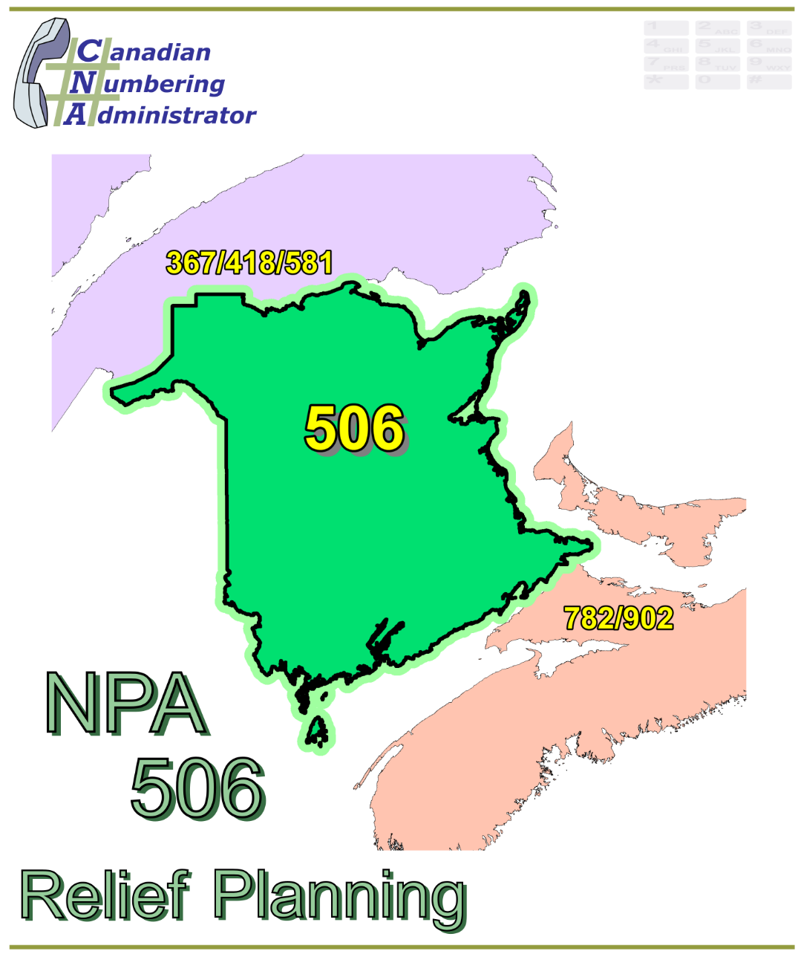

NPA 506 Planning Document

Version 2.0 – 30 August 2018

|  |  |
| --- | --- |
|  |  |

**TABLE OF CONTENTS**

1. INTRODUCTION 1

2. NPA RELIEF PLANNING PROCESS 3

3. NPA RELIEF METHODS 4

4. NPA EXHAUST INFORMATION 4

5. RELIEF OPTIONS 5

5.1. Distributed Overlay 5

5.1.1. Option 1: Distributed Overlay 5

5.2. Concentrated Overlay 5

5.2.1. Option 2: Concentrated Overlay on MADAWASKA, NORTHUBRLD, SAINT JOHN, WESTMORLD and YORK LIRs 6

5.2.2. Option 3: Concentrated Overlay on GLOUCESTER, MADAWASKA, NORTHUBRLD, WESTMORLD and YORK LIRs 6

5.2.3. Option 4: Concentrated Overlay on SAINT JOHN and WESTMORLD LIRs 6

5.2.4. Option 5: Concentrated Overlay on SAINT JOHN, YORK and WESTMORLD LIRs 7

5.2.5. Option 6: Concentrated Overlay on NORTHUBRLD, SAINT JOHN, WESTMORLD and YORK LIRs 7

6. SUMMARY OF RELIEF OPTIONS 8

7. COMPARATIVE ASSESSMENT OF RELIEF OPTIONS 8

8. DIALLING CHANGES FOR LOCAL CALLS 11

9. IMPLEMENTATION OF MANDATORY 10-DIGIT LOCAL DIALLING 11

10. SET ASIDE CO CODES PER NOTICE OF CONSULTATION 12

11. PROPOSED SCHEDULE 12

12. JEOPARDY CONTINGENCY PLAN (JCP) 15

13. SELECTION OF RELIEF NPA CODE 22

14. RECOMMENDATIONS 23

ANNEXES 24

**LIST OF ANNEXES**

**ANNEX A**

Figure 1 – Overview Map of NPA 506

Figure 2 – NPA 506 Actual and Forecast CO Code Assignments

Figure 3 – NPA 506 CO Code Exhaust: January 2016 R-NRUF

Figure 4 – NPA 506 Admin and LEC+WSP Codes: January 2016 R‑NRUF

Figure 5 – NPA 506 CO Code Exhaust: January 2017 R‑NRUF

Figure 6 – NPA 506 Admin and LEC+WSP Codes: January 2017 R‑NRUF

Figure 7 – NPA 506 CO Code Exhaust: July 2017 R–NRUF

Figure 8 – NPA 506 Admin and LEC+WSP Codes: July 2017 R‑NRUF

Figure 9 – NPA 506 LIRs

Figure 10 – Option 1: Distributed Overlay

Figure 11 – Option 2: Concentrated Overlay on MADAWASKA, NORTHUBRLD, SAINT JOHN, WESTMORLD and YORK LIRs

Figure 12 – Option 3: Concentrated Overlay on GLOUCESTER, MADAWASKA, NORTHUBRLD, WESTMORLD and YORK LIRs

Figure 13 – Option 4: Concentrated Overlay on SAINT JOHN and WESTMORLD LIRs

Figure 14 – Option 5: Concentrated Overlay on SAINT JOHN, YORK and WESTMORLD LIRs

Figure 15 – Option 6: Concentrated Overlay on NORTHUBRLD, SAINT JOHN, YORK and WESTMORLD LIRs

**ANNEX B**

Table 1 – Exchange Areas in NPA 506 before and after each Relief Option

Table 2 – Exchange Areas in each LIR

**ANNEX C**

Distribution List

**ACRONYM LIST**

|  |  |
| --- | --- |
| CATF | Consumer Awareness Task Force |
| CNA | Canadian Numbering Administrator |
| CISC | CRTC Interconnection Steering Committee |
| CLEC | Competitive Local Exchange Carrier |
| CLNPC | Canadian Local Number Portability Consortium |
| CO | Central Office |
| CRTC | Canadian Radio-television and Telecommunications Commission |
| CSCN | Canadian Steering Committee on Numbering |
| G-NRUF | General Numbering Resource Utilization Forecast |
| ILEC | Incumbent Local Exchange Carrier |
| IPD | Initial Planning Document |
| ISP | Internet Service Provider |
| JCP | Jeopardy Contingency Plan |
| J‑NRUF | Jeopardy Numbering Resource Utilization Forecast |
| LEC | Local Exchange Carrier |
| LIR | Local Interconnection Region |
| LNP | Local Number Portability |
| NANP | North American Numbering Plan |
| NANPA | North American Numbering Plan Administrator |
| NITF | Network Implementation Task Force |
| NoC | Notice of Consultation |
| NPA | Numbering Plan Area (Area Code) |
| NRUF | Number Resource Utilization Forecast |
| PD | Planning Document |
| PED | Projected Exhaust Date |
| PL | Planning Letter |
| POI | Point of Interconnection |
| PSAP | Public Safety Answering Point |
| RIP | Relief Implementation Plan |
| R-NRUF | Relief Planning Numbering Resource Utilization Forecast |
| RPC | Relief Planning Committee |
| TSP | Telecommunications Service Provider |
| WNP | Wireless Number Portability |
| WSP | Wireless Service Providers |

**Planning Document (PD) Number Plan Area (NPA) 506**

# INTRODUCTION

The new Area Code 506 for New Brunswick and Newfoundland and Labrador was created in 1955 by splitting from Area Code 902. In 1962 Newfoundland split to create their own Area Code 709, with 506 being retained by New Brunswick. Area Code 506 consists of 88 Exchange Areas serving the province of New Brunswick which includes the major communities of Bathurst, Campbellton, Edmundston, Fredericton, Miramichi, Moncton, and Saint John. A list of the Exchange Areas in NPA 506 is provided in Annex B.

Most of the growth for existing service providers in Area Code 506 is concentrated in less than ten (10) Exchange Areas, with the majority of this growth being in the Exchange Areas of Bathurst, Edmundston, Fredericton, Miramichi, Moncton and Saint John. However, the growth resulting from service providers introducing initial service in new areas is spread over a larger number of Exchange Areas throughout Area Code 506, with proportionally greater growth occurring outside the major communities. The total combined growth is therefore not concentrated in or limited to the Exchange Areas serving the major communities.

Assignment of Central Office (CO) Codes for Local Exchange Carriers (LECs) and Wireless Service Providers (WSPs) has accelerated demand for CO Codes primarily due to the establishment and/or expansion of the Telecommunications Service Providers’ (TSPs) footprints throughout Area Code 506. For the purposes of this document a footprint is the first CO Code assigned to a Code Holder in a unique Exchange Area.

The table below provides a brief overview of recent activities leading to the development of this Planning Document (PD) for NPA 506:

| **Date** | **Activity** |
| --- | --- |
| 15 December 2015 | The Canadian Numbering Administrator (CNA) initiated its January 2016 General Numbering Resource Utilization Forecast (G‑NRUF). |
| 9 March 2016 | The CNA notified Canadian Radio‑television and Telecommunications Commission (CRTC) staff that NPA 506 had entered the relief planning window of 72 months, and asked the CRTC to issue a Telecom Notice of Consultation (NoC) for the establishment of a CRTC Interconnection Steering Committee (CISC) ad hoc committee for area code relief planning in Area Code 506 for the province of New Brunswick; |
| 11 March 2016 | The CNA released the aggregate results of the January 2016 G‑NRUF which indicated that the Projected Exhaust Date (PED) for NPA 506 had moved in from April 2025 to February 2021; |
| 31 May 2016 | The CRTC issued Telecom Notice of Consultation CRTC 2016‑206, in which it established a CISC ad hoc Relief Planning Committee (RPC) to examine options for providing relief to Area Code 506 in New Brunswick.  The Notice of Consultation (NoC) directed the RPC to set aside 4 CO Codes for initial assignment and 3 CO Codes for initial code assignments exclusively for New Entrants. |
| 24 June 2016 | The CNA requested a Relief NRUF (R‑NRUF) from the current and prospective Code Holders in NPA 506; |
| 16 May 2016 | The CNA published the July 2016 R‑NRUF results which indicated that the PED had advanced to July 2020; |
| 15 December 2016 | The CNA requested a Relief NRUF (R‑NRUF) from the current and prospective Code Holders in NPA 506; |
| 29 March 2017 | The CNA published the January 2017 R‑NRUF results which indicated that the PED had moved out to December 2021; |
| 8 September 2017 | The CNA published the July 2017 R-NRUF results which indicated that the PED had moved out to November 2024; and |
| 8 March 2018 | The CNA published the January 2018 R-NRUF results which indicated that the PED had advanced to December 2021. |

The Initial Planning Document (IPD) dated 30 June 2017 was prepared by the CNA in accordance with Telecom Notice of Consultation CRTC 2016‑206 and the CRTC‑approved *Canadian NPA Relief Planning Guideline*, Version 6.0 dated 20 November 2014 (the Guideline). A copy of the Guideline is available from the Canadian Radio-Television and Telecommunications Commission (CRTC), CRTC Interconnection Steering Committee (CISC), Canadian Steering Committee on Numbering (CSCN) guidelines web page at: <http://www.crtc.gc.ca/cisc/eng/cisf3fg.htm>.

The objective of the NPA Relief Planning process is to ensure that CO Codes and telephone numbers are always available for use by TSPs and their customers in the geographic area requiring relief.

It is very important to closely monitor the CO Code requirements of all existing and prospective CO Code Holders so that relief can be timed to ensure that CO Codes and telephone numbers are always available for service providers and customers.

This PD was developed by the RPC based on the IPD and the Guideline. Various options for providing NPA relief in the NPA 506 geographic area are identified in this PD.

Given the magnitude of this undertaking, intercompany commitment and co‑operation are essential throughout the planning, provisioning and implementation stages of the introduction of a new NPA.

# NPA RELIEF PLANNING PROCESS

The NPA Relief Planning process and the roles of the participants (e.g., CRTC, CNA, CISC, RPC participants, Interested Parties) for NPA Relief Planning are identified in the Guideline.

To increase public awareness and participation in the NPA Relief Planning process, the CRTC has determined that NPA RPCs will be established as ad hoc committees of the CISC. Generally, a separate ad hoc committee is created to deal with relief in each area code. The CNA, in its function as NPA Relief Planning Coordinator, acts as chair of these ad hoc committees. Meetings and conference calls of the ad hoc NPA RPCs are all open to public participation and are conducted in accordance with the CISC Administrative Guidelines which are available from the CRTC website at: <http://www.crtc.gc.ca/cisc/eng/cag.htm>.

NPA Relief Planning is conducted under the regulatory oversight of the CRTC. Notwithstanding the process detailed in the Guideline, the CRTC may exercise its authority under the *Telecommunications Act* to alter this process at any time. The CRTC has the authority under the *Telecommunications Act* to review, modify and give final approval to the PD and the Relief Implementation Plan (RIP) developed and submitted by the RPC to the CRTC via the CISC process.

Section 6.1.6 of the *Canadian NPA Relief Planning Guideline* requires the CNA to create and maintain a distribution list of parties who may be interested in participating in the RPC and to provide them with advance notice of the initial RPC meeting and the release of the IPD.

Any person wishing to participate in the NPA Relief Planning process can contact the CNA and request to be added to the RPC distribution lists. More information on how to participate in CRTC public processes is available at: <http://www.crtc.gc.ca/eng/info_sht/g4.htm>.

A summary of Canadian geographic area code relief history is available at: <http://www.cnac.ca/npa_codes/NPA_History.pdf>.

The following table provides a brief history of the evolution of NPA 506:

|  |  |
| --- | --- |
| **Year** | **Activity** |
| 1947 | AT&T created the 9 new Area Codes for Canada, NPA 902 was assigned for the provinces of New Brunswick, Nova Scotia, Prince Edward Island and Newfoundland and Labrador (Note 1); |
| 1955 | The new Area Code 506 was created by splitting NPA 902. NPA 506 was assigned for New Brunswick and Newfoundland and Labrador, and Nova Scotia and Prince Edward Island retained NPA 902; and |
| 1962 | NPA 506 split, New Brunswick retained 506 and new area code 709 was created for Newfoundland and Labrador. |

Note 1: Newfoundland and Labrador became the tenth province to enter the [Canadian Confederation](https://en.wikipedia.org/wiki/Canadian_Confederation) on March 31, 1949, as "Newfoundland". On December 6, 2001, an [amendment](https://en.wikipedia.org/wiki/Amendments_to_the_Constitution_of_Canada) was made to the [Constitution of Canada](https://en.wikipedia.org/wiki/Constitution_of_Canada) to [change the province's official name](https://en.wikipedia.org/wiki/Geographical_renaming) to Newfoundland and Labrador.

The CNA has analysed the January 2018 R‑NRUF results and has concluded that the average actual annual forecast growth is approximately 33 CO Codes per year. The rest of the forecast demand is due to CO Code requests for establishing a footprint in NPA 506 Exchange Areas.

For calculations of future Projected Exhaust Dates (PEDs) of the current and Relief NPAs in all plans the CNA has used average historical annual growth beyond the six-year forecast period; thereby discounting the footprint expansion.

# NPA RELIEF METHODS

The purpose of this section is to identify and briefly describe NPA Relief Methods.

The Guideline states that “The only Relief Method that should be included in the IPD and PD [Planning Document] is the Overlay Method.”

Under the Overlay Method, a relief NPA Code is superimposed or overlaid on top of part or all of an existing NPA. With overlays, changes to existing customers' telephone numbers are not required. The Overlay Method includes three types of overlays that may be identified and assessed. These types of overlays are detailed in Sections 5.1.1 through 5.1.3 of the Guideline, and are:

* Distributed Overlays - a new relief NPA Code is overlaid on top of all of an exhausting NPA;
* Concentrated Overlays - a new relief NPA Code is overlaid on top of part of an exhausting NPA; and
* Boundary Extension Overlays - the boundary of an existing NPA that has spare capacity is extended to overlay part or all of an exhausting NPA.

# NPA EXHAUST INFORMATION

As indicated in the following table, NRUFs for NPA 506 were used to determine PEDs, i.e. the dates when CO Codes in NPA 506 would be expected to exhaust.

|  |  |
| --- | --- |
| **NRUF** | **Projected Exhaust Date (PED)** |
| G-NRUF January 2015 | April 2025 |
| G-NRUF January 2016 | February 2021 |
| R-NRUF June 2016 | July 2020 |
| R‑NRUF January 2017 | December 2021 |
| R-NRUF July 2017 | November 2024 |
| R‑NRUF January 2018 | December 2021 |

Refer to Annex A, Figures 2, 3, 4, 5, 6, 7, 8, 9 and 10 for graphs of forecast CO Code demand from current and prospective CO Code Holders and charts of Administrative Codes set aside in Area Code 506.

# RELIEF OPTIONS

Based on the basic Relief Methods, the following Relief Options were identified and examined in detail:

* Distributed Overlay – One option
* Concentrated Overlay – Five options

In accordance with the Guideline the CNA did not examine a boundary extension overlay because this would create an NPA boundary that crosses provincial borders. See Annex A, Figures 12 through 15 for diagrams of the Relief Options identified by the CNA.

The Relief Options identified above were evaluated using the following assumptions:

* The Relief Date for the distributed overlay option will be 1Q 2021, ten (10) months prior to the NPA 506 PED of December 2021 identified using the January 2018 R‑NRUF results.
* The Relief Date for the concentrated overlay options will be 1Q 2020, more than two (2) years prior to the NPA 506 PED of December 2021 identified using the January 2018 R‑NRUF results. If the implementation of the concentrated overlay was delayed beyond 1Q 2020, there may not be sufficient CO Codes available for assignment in NPA 506, thereby advancing the exhaust of NPA 506 in all concentrated overlay plans.
* In accordance with Section 5.1 of the Guideline, 10-digit local dialling will be implemented in all overlay relief options.

## Distributed Overlay

One distributed overlay Relief Option was evaluated to provide CO Code relief in the NPA 506 geographic area.

### Option 1: Distributed Overlay

This Relief Option would introduce a new NPA Code as an overlay on all 88 Exchange Areas in the NPA 506 area. See Annex A, Figure 10.

With this Relief Option, the number of separate Relief Planning areas in New Brunswick would not change.

After this distributed overlay, NPA 506 and the new NPA would be expected to exhaust in 2Q 2053.

## Concentrated Overlay

Five concentrated overlay Relief Options were evaluated to provide CO Code relief in the NPA 506 geographic area. These Relief Options are dependent on the Local Interconnection Regions (LIRs) in NPA 506 (See Annex A, Figure 9) as shown in the following table.

|  |  |
| --- | --- |
| **LIR Abbreviation** | **LIR Full Name** |
| GLOUCESTER | Gloucester - Bathurst |
| MADAWASKA | Madawaska - Edmundston |
| NORTHUBRLD | Northumberland - Newcastle/Miramichi |
| SAINT JOHN | Saint John - Saint John |
| WESTMORLD | Westmorland - Moncton |
| YORK | York - Fredericton |

### 

### Option 2: Concentrated Overlay on MADAWASKA, NORTHUBRLD, SAINT JOHN, WESTMORLD and YORK LIRs

This Relief Option would overlay a new NPA Code over the MADAWASKA, NORTHUBRLD, SAINT JOHN, WESTMORLD and YORK LIR (74 Exchange Areas) and the remaining GLOUCESTER LIR (14 Exchange Areas) in the province of New Brunswick would continue to grow using CO Codes from NPA 506. This concentrated overlay would have to be implemented in 1Q 2020 to ensure a quantity of NXXs is available in NPA 506 for forecast growth in the remainder of the province. See Annex A, Figure 11.

With this Relief Option, the number of separate Relief Planning areas in New Brunswick would increase from one to two.

After this concentrated overlay, NPA 506 and the new NPA would be expected to exhaust in

1Q 2038 and 2Q 2059 respectively.

### Option 3: Concentrated Overlay on GLOUCESTER, MADAWASKA, NORTHUBRLD, WESTMORLD and YORK LIRs

This Relief Option would overlay a new NPA Code over the GLOUCESTER, MADAWASKA, NORTHUBRLD, WESTMORLD and YORK LIRS (66 Exchange Areas) and the remaining SAINT JOHN (22 Exchange Areas) in the province of New Brunswick would continue to grow using CO Codes from NPA 506. This concentrated overlay would have to be implemented in 1Q 2020 to ensure a quantity of NXXs is available in NPA 506 for forecast growth in the remainder of the province. See Annex A, Figure 12.

With this Relief Option, the number of separate Relief Planning areas in New Brunswick would increase from one to two.

After this concentrated overlay, NPA 506 and the new NPA would be expected to exhaust in 4Q 2032 and 4Q 2061 respectively.

### Option 4: Concentrated Overlay on SAINT JOHN and WESTMORLD LIRs

This Relief Option would overlay a new NPA Code over the SAINT JOHN and WESTMORLD LIR (27 Exchange Areas) and the remaining GLOUCESTER, MADAWASKA, NORTHUBRLD and YORK LIRS (61 Exchange Areas) in the province of New Brunswick would continue to grow using CO Codes from NPA 506. This concentrated overlay would have to be implemented in 1Q 2020 to ensure a quantity of NXXs is available in NPA 506 for forecast growth in the remainder of the province. See Annex A, Figure 13.

With this Relief Option, the number of separate Relief Planning areas in New Brunswick would increase from one to two.

After this concentrated overlay, NPA 506 and the new NPA would be expected to exhaust in

2Q 2027 and 2Q 2117 respectively.

### Option 5: Concentrated Overlay on SAINT JOHN, YORK and WESTMORLD LIRs

This Relief Option would overlay a new NPA Code over the SAINT JOHN, YORK and WESTMORLD LIRS (48 Exchange Areas) and the remaining GLOUCESTER, MADAWASKA and NORTHUBRLD LIRS (40 Exchange Areas) in the province of New Brunswick would continue to grow using CO Codes from NPA 506. This concentrated overlay would have to be implemented in 1Q 2020 to ensure a quantity of NXXs is available in NPA 506 for forecast growth in the remainder of the province. See Annex A, Figure 14.

With this Relief Option, the number of separate Relief Planning areas in New Brunswick would increase from one to two.

After this concentrated overlay, NPA 506 and the new NPA would be expected to exhaust in 3Q 2028 and 4Q 2094 respectively.

### Option 6: Concentrated Overlay on NORTHUBRLD, SAINT JOHN, WESTMORLD and YORK LIRs

This Relief Option would overlay a new NPA Code over the NORTHUBRLD, SAINT JOHN and WESTMORLD and YORK LIR (59 Exchange Areas) and the remaining GLOUCESTER and MADAWASKA LIR (29 Exchange Areas) in the province of New Brunswick would continue to grow using CO Codes from NPA 506. This concentrated overlay would have to be implemented in 1Q 2020 to ensure a quantity of NXXs is available in NPA 506 for forecast growth in the remainder of the province. See Annex A, Figure 15.

With this Relief Option, the number of separate Relief Planning areas in New Brunswick would increase from one to two.

After this concentrated overlay, NPA 506 and the new NPA would be expected to exhaust in 4Q 2030 and 4Q 2069 respectively.

# SUMMARY OF RELIEF OPTIONS

| **Relief Option** | | **New NPA Implementation Date** | **Projected Exhaust Dates** | |
| --- | --- | --- | --- | --- |
| # | **Description** | **NPA 506** | **New NPA** |
| 1 | Distributed Overlay of new NPA Code on NPA 506 | 1Q 2021 | 1Q 2021 | 4Q 2053 |
| 2 | Concentrated Overlay on MADAWASKA, NORTHUBRLD, SAINT JOHN, WESTMORLD and YORK LIRs | 1Q 2020 | 1Q 2038 | 2Q 2059 |
| 3 | Concentrated Overlay on GLOUCESTER, MADAWASKA, NORTHUBRLD, WESTMORLD and YORK LIRs | 1Q 2020 | 4Q 2032 | 4Q 2061 |
| 4 | Concentrated Overlay on SAINT JOHN and WESTMORLD LIRs | 1Q 2020 | 2Q 2027 | 2Q 2117 |
| 5 | Concentrated Overlay on SAINT JOHN, YORK and WESTMORLD LIRs | 1Q 2020 | 3Q 2028 | 4Q 2094 |
| 6 | Concentrated Overlay on NORTHUBRLD, SAINT JOHN, YORK and WESTMORLD LIRs | 1Q 2020 | 4Q 2033 | 4Q 2069 |

# COMPARATIVE ASSESSMENT OF RELIEF OPTIONS

The RPC identified 6 Relief Options in Section 5 of this document. A Pro, Neutral or Con (P, N or C) rating was established for each Relief Option for each of the following attributes. The results are listed in the table below the list of attributes.

1. NPA Code Conservation – quantity of new NPAs required in New Brunswick within the next 30 years after relief (P = 0 new NPAs; N = 1 new NPA; C = 2 or more new NPAs)
2. Number of separate Relief Planning areas in New Brunswick in the long term (P = decrease; N = stays same; C = increase)
3. Level of Carrier Costs – e.g., including implementation, customer awareness (P = Low; N = Medium; C = High)
4. Time required to implement relief, i.e., time between the CRTC's Decision date and the date when CO Codes in the new/relief NPA can be activated (P = shortest; N = medium; C = longest)
5. Length of implementation window i.e., length of time for Carriers to implement relief NPA (P = longest; N = medium; C = shortest)
6. Longevity – the length of time between this relief and subsequent relief activity in NPA 506 (e.g., a new area code) (P = 30 or more years; N = 9 through 29 years; C = within 8 years)
7. Established Geographic Identities – changes in boundaries of existing NPAs (P = none; C = 1 or more existing NPAs affected)
8. New Geographic Identities – boundaries of new NPA align with boundaries of known areas (e.g., existing NPA areas, provinces) or identifiable geographical features (e.g., rivers, islands) (P = aligns with existing NPA boundaries; N = aligns with geographical features but not with existing NPA boundaries; C = aligns with neither existing NPA boundaries, nor identifiable geographical features)
9. Consistent with the transition towards universal 10‑digit local dialling, the Uniform Dialling Plan and future NANP Expansion (P = Yes; C = No)
10. Potential maximum quantity of NPAs in an Exchange Area in the next 30 years after relief (P = 1 NPA; N = 2 NPAs)

|  | **Relief Option** | **Pro, Neutral or Con for Each Attribute** | | | | | | | | | | **Rating** |
| --- | --- | --- | --- | --- | --- | --- | --- | --- | --- | --- | --- | --- |
| # | **Description** | **A** | **B** | **C** | **D** | **E** | **F** | **G** | **H** | **I** | **J** |  |
| **1** | Distributed Overlay of new NPA Code on NPA 506 | P | N | N | C | P | P | P | P | P | N | 5 |
| **2** | Concentrated Overlay on MADAWASKA, NORTHUBRLD, SAINT JOHN, WESTMORLD and YORK LIRs | N | C | C | P | C | N | C | C | P | N | -3 |
| **3** | Concentrated Overlay on GLOUCESTER, MADAWASKA, NORTHUBRLD, WESTMORLD and YORK LIRs | N | C | C | P | C | N | C | C | P | N | -3 |
| **4** | Concentrated Overlay on SAINT JOHN and WESTMORLD LIRs | N | C | C | P | C | C | C | C | P | N | -4 |
| **5** | Concentrated Overlay on SAINT JOHN, YORK and WESTMORLD LIRs | N | C | C | P | C | C | C | C | P | N | -4 |
| **6** | Concentrated Overlay on NORTHUBRLD, SAINT JOHN, YORK and WESTMORLD LIRs | N | C | C | P | C | N | C | C | P | N | -3 |

It should be noted that none of the options require Exchange Area boundary changes.

If P, N and C are assigned a weighting of +1, 0 and -1, respectively, then analysis of the above table gives the highest rating of 5 points to Relief Option 1, and the next highest rating of -3 points to Relief Options 2, 3 and 6 and the subsequent rating of -4 for Relief Options 4 and 5.

Relief Option 1 has the highest rating when assessed based on the above criteria.

## Assessment

The RPC recommends **Relief** **Option 1 (Distributed Overlay) of new NPA Code on NPA 506** for the following reasons:

* The existing NPA 506 boundary is maintained and no new NPA boundary is created, thus avoiding customer confusion regarding NPA boundaries;
* The quantity of Relief Planning areas in New Brunswick remains unchanged;
* The distributed overlay option can be implemented in 1Q 2021 which will provide additional time for customers and carriers to implement 10-digit dialling and the new NPA;
* The distributed overlay option provides long term relief with a PED of 2053;
* Defers the industry cost of implementation for 2 years; and
* There are no significant disadvantages to implementing a distributed overlay when compared to a concentrated overlay.

The RPC does not recommend the Concentrated Overlay Options for the following reasons:

* All concentrated overlay options create a new NPA boundary between the concentrated overlay NPA and the outlying areas. These boundaries are not easily identifiable which could lead to customer confusion;
* All concentrated overlay options implement the new NPA on non-contiguous regions resulting in difficulty in providing clear and concise consumer communications;
* All concentrated overlay options will be required to be implemented in 1Q 2020 in order to ensure a quantity of CO Codes is available for assignment in the non-overlaid region. This does not allow enough time for some Carriers to implement 10-digit dialling and the new NPA;
* The earlier implementation of Relief would require that customers change over to 10-digit dialling earlier than they would have to in a Distributed Overlay that could be problematic for some customers (e.g., alarm companies, telemetric services; 9-1-1 PSAPS); and
* All concentrated overlay options increase the number of separate Relief Planning areas in New Brunswick from one to two. This increases the quantity of geographic areas that would require future relief planning activity which would require customers and Carriers to incur higher future relief costs than the distributed overlay option.

In addition to the above, some additional reasons for the specific relief options are as follows:

* **Options 2 (Concentrated Overlay of new NPA Code on MADAWASKA, NORTHUBRLD, SAINT JOHN, WESTMORLD and YORK LIRs)** does not provide a significant advantage in terms of PED for the new NPA. In this case the new NPA would be expected to exhaust in the same relative time frame as **Option 1 (Distributed Overlay).**
* **Option 3 (Concentrated Overlay of new NPA Code on GLOUCESTER, MADAWASKA, NORTHUBRLD, WESTMORLD and YORK LIRs)** does not provide a significant advantage in terms of PED for the new NPA. In addition, a third NPA may be required in order to address exhaust in NPA 506 in less than 11 years (2032).
* **Option 4 (Concentrated Overlay of new NPA Code on SAINT JOHN and WESTMORLD LIRs)** and **Option 5 (Concentrated Overlay of new NPA Code on SAINT JOHN, YORK and WESTMORLD LIRs)** do not significantly extend the PED of NPA 506 beyond the relief planning window. Subsequent relief planning would have to begin immediately after implementation of these plans.
* **Option 6 (Concentrated Overlay of new NPA Code on NORTHUBRLD, SAINT JOHN, YORK and WESTMORLD LIRs)** does not provide a significant advantage in terms of PED for the new NPA. In addition, a third NPA may be required in order to address exhaust in NPA 506 in less than 12 years (2033).

# DIALLING CHANGES FOR LOCAL CALLS

Currently the dialling for local calls within NPA 506 and across its boundaries is as follows:

* 7-digit dialling for local calls within NPA 506;
* in addition to providing 7-digit dialling for local calls within NPA 506, most TSPs permit 10‑digit dialling;
* 10-digit local calling between NPA 782/902 and adjacent Canadian NPA 506 between Amherst, Nova Scotia and Sackville, New Brunswick;
* 7-digit local calling from NPA 506 (Campbellton) into Canadian NPA 418/581; and
* 7-digit local calling from NPA 506 into NPA 207 (Maine).

The table below identifies recommended modifications to the dialling plan for local calls originating within the NPA 506 area.

**Local Dialling Plan for Customers in NPA 506 and new NPA**

| **Local Calling Scenarios** | **Dial Plan \*** |
| --- | --- |
| **Before Relief** | 7/10-digits |
| **After 506 Concentrated Overlay** | 10-digits |
| **After 506 Distributed Overlay** | 10-digits |

* Dependent on local Carrier

The Toll call dialling arrangement for NPA 506 will be 0 or 1+10 digits after NPA relief. NPA relief does not affect any Toll ratings.

# IMPLEMENTATION OF MANDATORY 10-DIGIT LOCAL DIALLING

In Telecom Regulatory Policy CRTC 2009‑156, Section 13, regarding dialling plan changes, the Commission retained the general obligation for all relevant TSPs to inform all customers about dialling plan changes but that TSPs may determine the appropriate methods to inform their customers. Accordingly, TSPs may determine the appropriate methods for informing their customers of dialling plan changes that will occur as part of NPA relief projects (e.g., network announcements on 7‑digit dialled calls, bill messages and inserts, customer letters, e-mail messages, media advertising, web sites, etc.).

Equipment used by LECs to provide service in some Exchange Areas may not be able to connect a call following an announcement (i.e., cut-through), as is usually expected during transition to an overlay. Investments that would be required to upgrade or replace network elements to provide transition announcements in some communities could be significant relative to their size, and such investments would provide a capability that would only be used for a short time, i.e. during the dialling transition period.

In Telecom Decision CRTC 2006‑26, the CRTC addressed the above situation and established a process and requirements for Carriers to follow. It is expected that the same approach will be adopted for NPA 506.

In the Decision, the Commission directed TSPs to:

* send monthly bill inserts in each of the four (4) months immediately prior to the month when mandatory 10‑digit local dialling is scheduled to be implemented;
* place two (2) notices in local newspapers (if available), one during the month prior to the month when mandatory 10‑digit local dialling is scheduled to be implemented, and one during the month when mandatory 10-digit local dialling is scheduled to be implemented;
* send a personal letter to each affected customer, to be received ten (10) days prior to the implementation date of mandatory 10-digit local dialling; and
* place information on the TSPs' websites in a prominent, highly visible location for the minimum period of about five (5) months ending at the end of the month when mandatory 10-digit local dialling is scheduled to be implemented.

# SET ASIDE CO CODES PER NOTICE OF CONSULTATION

Telecom Notice of Consultation CRTC 2016‑206, *Establishment of a CISC ad hoc committee for area code relief planning for area code 506 in New Brunswick*, was issued by the Commission on 31 May 2016.

In Paragraph 8 of the Notice of Consultation, the Commission directed the NPA 506 RPC to set aside four (4) CO Codes for initial code assignments for carriers already providing service in the area served by area code 506. The Commission also directed the 506 RPC to set aside three (3) CO Codes from area code 506 to be made available for new entrants, and to ensure that those CO Codes remain unassigned, other than to new entrants, for a period of two years after the introduction of the new area code in New Brunswick, or until the pool is depleted, whichever comes first. Each new entrant may only request one CO Code from the available pool.

Further information regarding set-aside CO Codes in a Jeopardy Condition is provided by subparagraphs a), b) and c) of the fifth paragraph of section 9.1 of the *Canadian NPA Relief Planning Guideline*.

# PROPOSED SCHEDULE

The RPC submits the following schedule for NPA 506 relief based on the recommendations contained in this PD and the current PED of December 2021. The RPC will monitor the PED, and if it changes significantly in the future (e.g., is advanced or delayed by greater than six (6) months), the RPC will assess the situation and, if necessary, submit recommendations including a revised schedule to the CRTC for consideration and approval.

**RELIEF IMPLEMENTATION SCHEDULE**

**For a Distributed Overlay of new NPA over NPA 506**

| **Item** | **Task or Event** | **PRIME** | **START** | **END** |
| --- | --- | --- | --- | --- |
| 1 | CNA identifies NPA exhaust and notifies by e-mail CRTC staff, CSCN, NANPA & CISC that the NPA will exhaust within 72 months | CNA |  | 11-Mar-16 |
| 2 | CNA conducts R-NRUF & releases results | CNA | 20-Jun-16 | 12-Oct-16 |
| 3 | CRTC issues Telecom Notice of Consultation regarding establishment of an ad hoc Relief Planning Committee (RPC) | CRTC |  | 31-May-16 |
| 4 | RPC Chair starts preparing and submitting NPA 506 RPC Chair Reports to the CISC, on an as required basis. | RPC Chair | 1-Jun-16 |  |
| 5 | CNA announces the date for the initial NPA Relief Planning face-to-face meeting | CNA | 9-Mar-17 |  |
| 6 | CNA develops and distributes Initial Planning Document (IPD) to RPC & requests contributions | CNA | 30-Jun-17 |  |
| 7 | RPC participants review IPD & submit contributions to RPC | RPC | 30-Jun-17 | 31-Aug -17 |
| 8 | CNA chairs initial RPC meeting to start development of Planning Document (PD) & Relief Implementation Plan (RIP) & schedules future meetings/conference calls | CNA, RPC | 12-Sep-17 | 14-Sep-17 |
| 9 | CNA chairs subsequent RPC meetings/conference calls to finalize PD and RIP | CNA, RPC | 14-Sep-17 | 14-Sep-18 |
| 10 | The RPC creates Consumer Awareness (CATF) and Network Implementation (NITF) Task Forces | RPC | 14-Sep-18 | 12-Oct-18 |
| 11 | CNA forwards PD and RIP to the CISC and CRTC for approval | CNA | 12-Oct-18 | 26-Oct-18 |
| 12 | Special Types of Telecommunications Service Users (9-1-1 PSAPs, alarm companies, ISPs, paging companies, etc.) to identify any concerns to RPC & CRTC | Special Users | 12-May-18 | 12-Oct-18 |
| 13 | CRTC issues Telecom Decision approving a Relief Option, Relief Date, & New NPA, and RIP | CRTC | 26-Oct-18 | 24-Jan-19 |
| 14 | CNA obtains relief NPA from NANPA | CNA | 24-Jan-19 | 7-Feb-19 |
| 15 | RPC develops the Planning Letter (PL) | RPC | 7-Feb-19 | 21-Feb-19 |
| 16 | Task Forces, Telecommunications Service Providers (TSPs) and users implement relief (starts at CRTC approval of Relief Option & Date and ends on Relief Date) | TSPs | 24-Jan-19 | 21-Nov-20 |
| 17 | All TSPs to develop and file individual consumer awareness programs with the CRTC (may be done collectively by Telecommunications Alliance) (starts at CRTC approval of RIP and should be completed about 24 months prior to the Relief Date) | TSPs | 30-Jan-19 | 19-Feb-19 |
| 18 | CNA issues media release (in coordination with Telecommunications Alliance) (may start upon CRTC approval of RIP and should be issued at least 18 months prior to the Relief Date) | CNA | 30-Jan-19 | 21-May-19 |
| 19 | CNA submits PL and RIP to NANPA (should be submitted at least 18 months prior to the Relief Date) | CNA | 30-Jan-19 | 21-May-19 |
| 20 | NANPA receives and posts Planning Letter to NANPA website (within 2 weeks of receipt from the CNA) | NANPA | 21-May-19 | 4-Jun-19 |
| 21 | All TSPs implement consumer awareness activities (starts upon filing of Consumer Awareness Programs with the CRTC and is completed on the Relief Date) | TSPs | 19-Feb-19 | 21-Nov-20 |
| 22 | All TSPs to notify all customers (residence, business & special customers) of the new NPA and, if applicable, of the need to transition from 7- to 10-digit local dialling (may start with the filing of Consumer Awareness Programs with the CRTC and all customers should be notified at least 18 months prior to the Relief Date) | TSPs | 19-Feb-19 | 21-May-19 |
| 23 | TSPs to submit Progress Report #1 to NITF and CATF (starts after completion date for all TSPs to notify their customers and requires 2 weeks) | TSPs | 21-May-19 | 4-Jun-19 |
| 24 | NITF and CATF develop & submit Progress Report #1 to RPC (linked to TSP reports to NITF and CATF) | NITF & CATF | 4-Jun-19 | 18-Jun-19 |
| 25 | RPC submits Progress Report #1 to CRTC staff (linked to NITF and CATF reports) | RPC | 18-Jun-19 | 2-Jul-19 |
| 26 | iconectiv TRA database updates to add Exchanges to new overlay NPA (starts on the date that the PL is posted to the NANPA web site and must be completed by 6 months prior to the Relief Date) | iconectiv TRA | 4-Jun-19 | 22-May-20 |
| 27 | All Telecommunications Service Providers and Telecommunications Service Users (including Special Users 9-1-1 PSAPs, alarm companies, ISPs, paging companies, payphone providers, etc.) to implement changes to their telecom equipment & systems to accommodate the new NPA and the transition from 7- to 10-digit local dialling (starts upon CRTC approval of RIP and ends on the Relief Date) | TSPs & Telecom Service Users | 30-Jan-19 | 21-Nov-20 |
| 28 | Payphone Providers reprogram payphones (starts upon CRTC approval of RIP and ends on the Relief Date) | Payphone Providers | 30-Jan-19 | 21-Nov-20 |
| 29 | TSPs and database owners/operators to modify systems and industry databases (starts on CRTC approval of RIP and ends on the Relief Date) | TSPs & Database Owners | 30-Jan-19 | 21-Nov-20 |
| 30 | Operator Services & Directory Assistance Readiness (starts on CRTC approval of RIP and ends on the Relief Date) | TSPs | 30-Jan-19 | 21-Nov-20 |
| 31 | Directory Publisher Readiness for relief (ability to identify the NPA in telephone numbers in the directory published after the new NPA is activated) (starts upon CRTC approval of RIP and ends on the Relief Date) | Directory Publishers | 30-Jan-19 | 21-Nov-20 |
| 32 | 9-1-1 Systems and Databases Readiness (starts on CRTC approval of RIP and ends on the Relief Date) | PSAPS, | 30-Jan-19 | 21-Nov-20 |
| 9‑1‑1 Service Providers & TSPs | 30-Jan-19 | 21-Nov-20 |
| 33 | Network Systems & Equipment Readiness (starts on CRTC approval of RIP and ends on the Relief Date) | TSPs | 30-Jan-19 | 21-Nov-20 |
| 34 | Service Order & Business System Readiness (starts on CRTC approval of RIP and ends on the Relief Date) | TSPs | 30-Jan-19 | 21-Nov-20 |
| 35 | International Gateway Switch Translations Readiness for new NPA (starts on CRTC approval of RIP and ends on the Relief Date) | Int’l TSPs | 30-Jan-19 | 21-Nov-20 |
| 36 | Canadian Local Number Portability Consortium (CLNPC) Database Readiness for new NPA (starts on CRTC approval of RIP and ends on the Relief Date) | CLNPC & NPAC | 30-Jan-19 | 21-Nov-20 |
| 37 | Toll Free SMS Database Readiness for new NPA (starts on CRTC approval of RIP and ends on the Relief Date) | Toll TSPs | 30-Jan-19 | 21-Nov-20 |
| 38 | TSPs apply for Test CO Codes in new NPA (applications may be submitted no more than 6 months and no less than 66 days prior to the start date for the Inter-Carrier Testing Period) (Section 7.16.4 Canadian RP GL) | TSPs | 21-Nov-19 | 12-Mar-20 |
| 39 | Develop Inter-Carrier Network Test Plans and prepare for testing (individual TSPs to make arrangements in accordance with interconnection agreements) (may start upon CRTC approval of RIP and must be completed by start date for the Inter-Carrier Testing Period) | NITF & TSPs | 30-Jan-19 | 22-May-20 |
| 40 | All international and domestic TSPs must activate the new NPA in their networks by the start date for the Inter-Carrier Testing Period | TSPs | 30-Jan-19 | 22-May-20 |
| 41 | Date by which TSPs must route all calls using 10-digit signalling (i.e., cease use of 7-digit signalling) for local traffic sent to and received from other TSPs (must be completed by the start date for the Inter-Carrier Testing Period) (TSPs may, but are not obligated to, negotiate special routing arrangements on a bilateral basis if required) | TSPs |  | 22-May-20 |
| 42 | Activation date for new NPA Test CO Codes and Test Numbers in network must be completed by the start date for the Inter-Carrier Testing Period) | TSPs |  | 22-May-20 |
| 43 | Inter-Carrier Testing Period (subject to Inter-Carrier Network Test Plans) (starts about 3 months prior to the start date for the 7- to 10-Digit dialling transition period) | NITF & TSPs | 22-May-20 | 21-Nov-20 |
| 44 | TSPs to submit Progress Report #2 to NITF and CATF (starts on commencement of Inter-Carrier Testing Period) | TSPs | 22-May-20 | 4-Jun-20 |
| 45 | NITF and CATF develop & submit Progress Report #2 to RPC (linked to TSP reports to NITF and CATF) | NITF & CATF | 4-Jun-20 | 18-Jun-20 |
| 46 | RPC submits Progress Report #2 to CRTC staff (linked to NITF and CATF reports) | RPC | 18-Jun-20 | 2-Jul-20 |
| 47 | Phase-in of 7- to 10-Digit Dialling Transition Period announcements (starts about 3 months prior to Relief Date and occurs over 1 week) | TSPs | 13-Aug-20 | 20-Aug-20 |
| 48 | Phase-in of mandatory 10 digit dialling announcements (occurs over 1 week and should be completed at least 1 week prior to Relief Date to address any problems that may arise) | TSPs | 7-Nov-20 | 14-Nov-20 |
| 49 | Relief Date (earliest date when CO Codes in new NPA may be activated) |  |  | 21-Nov-20 |
| 50 | TSPs submit Final Report to CATF and NITF (starts on Relief Date and provides 2 weeks for preparation & submission) | TSPs | 21-Nov-20 | 5-Dec-20 |
| 51 | NITF and CATF develop & submit Final Progress Report to RPC (linked to TSP reports to NITF and CATF) | NITF & CATF | 5-Dec-20 | 12-Dec-20 |
| 52 | RPC submits Final Progress Report to CRTC staff (linked to NITF and CATF reports) [note: moved this out to after Christmas period] | RPC | 11-Jan-21 | 25-Jan-21 |
| 53 | TSPs disconnect Test Codes & Numbers, and submit Part 1 form to return Test Codes (starts 1 month after Relief Date and allows 1 month for completion) [note: moved this out to after Christmas period] | TSPs | 25-Jan-21 | 24-Feb-21 |
| 54 | TSPs change Mandatory 10-Digit Dialling Announcement to standard announcement (mandatory announcement is required for a minimum of 3 months) (removal starts about 3 months after Relief Date and must be completed within 1 month) | TSPs | 24-Feb-21 | 26-Mar-21 |
| 55 | RPC Chair submits, to the CISC, the final RPC Chair Report indicating that the NPA 506 ad hoc RPC is no longer required. | RPC Chair | 25-Jan-21 | 1-Mar-21 |

# JEOPARDY CONTINGENCY PLAN (JCP)

The RPC has developed the following Jeopardy Contingency Plan (JCP) for inclusion in the PD for NPA 506. This JCP is based on the example contained in Appendix F to the *Canadian NPA Relief Planning Guideline* (the Guideline).

This JCP shall remain in effect until superseded by a CRTC-approved JCP, the Jeopardy Condition is suspended, or 66 days prior to the Relief Date.

The following measures shall be implemented in NPA 506 while a Jeopardy Condition is in effect.

During a Jeopardy Condition, CO Code Applicants shall submit all CO Code applications and related correspondence for the Jeopardy NPA to CRTC staff in addition to the CNA. The CNA shall only assign CO Codes from the exhausting NPA to a CO Code Applicant when instructed by CRTC staff.

1. Carriers and/or Telecommunications Service Providers (TSPs):
   1. shall age disconnected residential wireline telephone numbers for a maximum of two months;
   2. shall age disconnected wireless telephone numbers for a maximum of three months;
   3. shall age disconnected business wireline telephone numbers for a maximum of six months. Under special circumstances, the six month aging limit for business telephone numbers may be extended to twelve months, if required, to accommodate local directory publishing dates for high volume call-in applications (e.g., heavily advertised local business numbers such as radio talk shows, food ordering services, ticket sales, chat lines), or for numbers associated with public service emergency applications or for numbers advertised in directories for which customers have requested reference of calls;
   4. shall return all CO Codes that are not being used, nor intended to be used to directly serve customers to the assignment pool within two months (e.g., plant test codes);
   5. should work towards, and encourage existing customers, to either activate or return the reserved numbers to bring the reserved quantity down to a maximum of 10% of the quantity of numbers In-Service for that customer;
   6. shall not allow the quantity of reserved numbers to be increased by new reservation requests by existing customers to more than 10% of the quantity of numbers in service for that customer. In the case of new customers, number reservations shall be limited to 10% of the total quantity of telephone numbers being placed into service for that customer;
   7. shall, within 45 days from the date that the CNA declares a Jeopardy Condition submit a Part 1 Form for each remaining reserved CO Code either returning the reserved CO Code to the CNA or requesting assignment of the reserved CO Code. Once the 45-day period has elapsed, the CNA shall make available for general assignment all CO Codes that are still reserved and have not been applied for as assignments on a Part 1 Form received by the CNA. Within 60 days from the date that the CNA declares a Jeopardy Condition, the CNA shall report to CRTC staff and the RPC as to how many of these codes have been assigned or made available for general assignment;
   8. shall not be permitted to obtain a new CO Code reservation;
   9. shall place all CO Codes assigned prior to the Jeopardy Condition being declared In-Service within three months of the effective date for CO Code activation in the network, or within three months of the date that the Jeopardy Condition was declared. If the CO Code is an Initial Code and the CO Code Holder can demonstrate that, due to circumstances beyond its control, the In-Service date has been delayed beyond the applicable timeframe, then the CNA may grant an extension of up to two months to the In-Service date. The CNA shall initiate reclamation procedures for all CO Codes that have not been placed In-Service within these timeframes unless CRTC staff provides a further extension; and
   10. all CO Code Holders in NPA 506 need to certify to CRTC staff (with a courtesy copy to the CNA) within 90 days of the declaration of a Jeopardy Condition that they are in compliance with this JCP.
2. For new applications for Initial Codes, each CO Code Holder shall certify that the CO Code will be activated in the network and placed In-Service within four months of the date of application for the Code. If the CNA does not receive a Part 4 Form within this timeframe, confirming that the CO Code has been placed In-Service, the CNA will initiate reclamation measures. If the CO Code Holder can demonstrate that, due to circumstances beyond its control, the In-Service date has been delayed not more than six months from the original application date, then the CNA may grant an extension to the In-Service date, so long as the In-Service date is not more than six months beyond the original application date. If the In-Service date has been delayed more than six months from the original application date, then the CNA shall reclaim the Code unless CRTC staff provides a further extension.
3. When applying for an Additional Code for Growth, a CO Code Holder who is submitting a Part 1 Form and Appendix B worksheet shall also submit a completed Supplementary Form for a Growth CO Code Application (attached) which certifies and/or provides the following information for the specific switching entity/POI and Exchange Area when the Growth CO Code is being requested in a Jeopardy Condition:
   1. certification that all held telephone numbers have been released;
   2. certification that reserved numbers do not exceed ten percent of the total quantity of numbers as defined in Appendix G of the Canadian CO Code (NXX) Assignment Guideline;
   3. certification that each reseller/dealer had been advised of the Jeopardy Condition and the requirement that they would only be allocated additional numbers during the Jeopardy Condition on the provision to the CO Code Holder of written confirmation that their number inventory has been reduced to an amount less than two times the highest quantity of customer numbers assigned in any month during the previous 12 months. Additional numbering resources will only be provided by the CO Code Holder to the reseller/dealer to the extent that the reseller's/dealer's inventory can only increase up to a maximum of three months' inventory;
   4. confirmation that the Part 1 form submitted with the application has the Jeopardy Condition box in section 1.6 checked to certify that the existing CO Codes are projected to exhaust within 4 months of the date of application and that the months-to-exhaust is documented on an Appendix B submitted to the CNA;
   5. a completed Telephone Number Utilization Report for the applicable switching entity signed by both a company officer and the company’s authorized representative;
   6. confirmation that the requested Growth CO Code was forecasted in the most recent NRUF or an explanation as to why it was not is attached; and
   7. confirmation that the requested Growth CO Code will be placed In-Service within four months of the date of assignment.
4. Any CO Codes for growth assigned after the implementation of this JCP must be activated in the network and placed In-Service within four months of assignment. In the event that a CO Code Holder is unable to place the CO Code In-Service within four months of the date of assignment, the CO Code Holder must return the assigned CO Codes or submit a written request for extension to the CNA. Such written requests must include documentation explaining the reason(s) for the missed date and proposing the new In-Service date. If the explanation includes reasons beyond the control of the CO Code Holder, the CNA may extend the In-Service date a maximum of one month. If the CO Code Holder does not place the CO Code In-Service within the one-month extension, the CNA shall initiate the reclamation process at the end of the one-month extension unless CRTC staff provides a further extension.
5. A Carrier that has multiple switching entities within an Exchange Area shall examine the possibility of, and implement where feasible, number sharing between those switches as a potential method to delay requirements for additional CO Codes.
6. The CNA will request two versions (two separate worksheets (Form 1 and Form 2)) of the J-NRUF input from all current and prospective CO Code Holders quarterly until three (3) months before relief is provided.
   1. The forecasted quantities in Form 1 should be the same as, or lower than the last R-NRUF input submitted, prior to declaration of a Jeopardy Condition. CO Code Holder forecasts may reflect an increase in demand in the period subsequent to the Relief Date.
   2. Form 2 will reflect the actual demand required by the CO Code Holder's current business plan and will be provided for information purposes only.
7. The CNA will compare the initial J-NRUF input to the recent NRUF inputs, to assess forecasting trends. The CNA shall monitor all inputs and shall test them for reasonableness in consultation with the Carrier. If the CNA is dissatisfied with the reasonableness, or the rationale provided for the deviations, then the matter will be referred to the CRTC staff.
8. The CNA will request subsequent J-NRUF input from all current and prospective CO Code Holders quarterly until 3 months before relief is provided. If one or more R-NRUFs have already been conducted, and depending on the severity of the Jeopardy Condition, the CNA may defer a J-NRUF by up to two months if such a deferral brings the timing of that J‑NRUF and subsequent J-NRUFs into alignment with other NRUFs that are conducted at 12, 6 or 3 month intervals. Subsequent J-NRUF input will be compared with the initial J‑NRUF input to evaluate the effectiveness of the JCP. The CNA shall monitor all J-NRUF inputs and shall test them for reasonableness in consultation with the Telecommunications Service Providers. If the CNA is dissatisfied with the reasonableness, or the rationale provided for the changed forecasts, then the matter will be referred to CRTC staff.
9. A CO Code Applicant must have submitted a completed J-NRUF to the CNA before the CNA may assign a CO Code to that CO Code Applicant.
10. If a CO Code applicant wishes to request more CO Codes than it identified in its most recent J NRUF, the CO Code Applicant should discuss the matter with the CNA. If the CO Code Applicant wishes to proceed with the request, the CO Code Applicant will forward the request and revised forecast to CRTC staff and the CNA for consideration.
11. The CO Codes identified in the NPA CO Code Inventory Chart as “Assignable CO Codes in a Jeopardy Condition” will be assigned in the order determined by the RPC after all CO Codes which are “Available for Assignment as of [day month year] have been assigned.
12. After each J-NRUF, the CNA shall provide CRTC staff, the RPC and CSCN participants with a report providing an updated NPA CO Code Inventory Chart for the NPA in jeopardy as well as the aggregate results of the most recent J-NRUF.
13. Exceptional issues or concerns may be referred by the CNA, or by individual entities (with a courtesy copy to the CNA), to the CRTC staff for resolution.
14. In a situation where the Relief Date is on or after the PED, the quantity of CO Codes that may be assigned to a CO Code Applicant prior to the end of the Jeopardy Condition (i.e., 66 days prior to the Relief Date) shall be limited to the quantity forecasted by the CO Code Applicant in its most recent NRUF forecast submitted prior to the Jeopardy Condition being declared by the CNA (if no previous NRUF was submitted, then the previous forecast will be deemed to be zero codes). When making requests to obtain CO Codes prior to the end of the Jeopardy Condition (i.e., 66 days prior to the Relief Date), the CO Code Applicant may change the Exchange Area or the month when the CO Code assignment is required, provided a new J-NRUF and explanation accompanies the application. The control imposed by this option may be relaxed if subsequent J-NRUFs defer the PED to after the Relief Date. CO Codes that become available for assignment due to future reduced demand from other current and prospective CO Code Holders may be assigned at the discretion of CRTC staff.
15. If the CNA determines that the implementation of the JCP has not extended the Projected Exhaust Date of the NPA beyond the Relief Date, the CNA will consult with CRTC staff and further CO Code conservation and assignment procedures may be ordered by the Commission (e.g., rationing, lottery, etc.).
16. In circumstances where the CRTC has directed the CNA to set aside a quantity of CO Codes for Initial Code assignments for Carriers already providing service in the exhausting NPA, and a quantity of CO Codes for Initial Code assignments exclusively for New Entrants, the following actions will be taken:

The CO Codes set aside for Initial Code assignments exclusively for New Entrants shall be made available, subject to any CRTC staff instruction, for Initial Code assignment to New Entrants prior to the relief if all other available CO Codes in the exhausting NPA have been assigned. Any CO Codes from this previously set aside pool that remain when the Jeopardy Condition ends shall be returned to the pool for Initial Code assignments for New Entrants for assignment following relief.

The CO Codes set aside for Initial Code assignments for Carriers already providing service in the exhausting NPA shall be made available, subject to any CRTC staff instruction, for Initial Code assignment prior to relief. Any CO Codes from this previously set-aside pool that remain when the Jeopardy Condition ends shall be returned to the pool for Initial Code assignments for applicants in general for assignment following relief.

If all other available CO Codes in the exhausting NPA have been assigned, CRTC staff may make some or all of the CO Codes in the two set aside pools available for assignment to any entity for any purpose.

Supplementary form for a Growth CO Code Application – Page 1 of 2 – Telephone Number Utilization Report

This form is required with each request for an Additional Code for Growth in an NPA where a Jeopardy Condition is in effect. It should be submitted to the CNA together with the Part 1 and Appendix B forms that are required for an application for an Additional Code for Growth. See the Part 1 form for information on how and where to submit the form.

I hereby certify that the following information is true and accurate to the best of my knowledge and has been prepared in accordance with Special Conservation Procedures for a Jeopardy Condition contained in the Canadian NPA Relief Planning Guideline or the applicable approved Jeopardy Contingency Plan.



Name & Signature of Authorized Representative of Code Holder Title Date



Name & Signature of Company Officer (see item 3 of this JCP) Title Date

Contact information: Entity Name: __________________ Contact Name: _____________

Address: __________________ City, Province, Postal Code: _____________

Telephone: __________________ Facsimile: _____________

E-mail: __________________

Switch Identification (Switching Entity/POI) CLLI: _______________ Exchange Area: ________________

For the above Switch Identification and Exchange Area for which a Growth CO Code is requested:

I certify that all held telephone numbers have been released

I certify the total quantity of reserved numbers does not exceed ten percent (10%) of the total quantity of telephone numbers as defined in Appendix G of the Canadian CO Code (NXX) Assignment Guideline

I certify that each reseller/dealer has been advised of the Jeopardy Condition and the requirement that they would only be allocated additional numbers during the Jeopardy Condition on the provision to the CO Code Holder of written confirmation that their number inventory has been reduced to an amount less than two (2) times the highest quantity of customer numbers assigned in any month during the previous twelve (12) months. Additional numbering resources will only be provided by the CO Code Holder to the reseller/dealer to the extent that the reseller's/dealer's inventory can only increase up to a maximum of three months' inventory.

The Part 1 form submitted with the application has the Jeopardy Condition box in section 6 checked (this certifies that the existing CO Codes are projected to exhaust within four (4) months of the date of the application or within the period specified in an approved Jeopardy Contingency Plan, and that the months-to-exhaust is documented on an Appendix B submitted to the CNA).

The Telephone Number Utilization Report on page 2 of this form has been completed.

The requested Growth CO Code was forecasted in the most recent NRUF, or an explanation as to why it was not is attached.

The requested Growth CO Code will be placed In-Service within four (4) months of the date of assignment.

**Supplementary Form for a Growth CO Code Application – Page 2 of 2 – Telephone Number Utilization Report**

Use Arial 9 to complete this form. (Note: If the spreadsheet below does not show on your display, please change the Work view to "Print Layout" or "Reading Layout")



Remarks: _______________________________________________________________________________

________________________________________________________________________________________

**NPA 506 CO Code Inventory Chart**

The following chart and the instructions it contains will apply in NPA 506 in a Jeopardy Condition.

The chart below lists quantities of CO Codes unassignable prior to a Jeopardy Condition, CO Codes that become assignable in a Jeopardy Condition, and CO Codes in NPA 506 assigned and in‑service as of 30 August 2018. The CO Codes that become assignable in a Jeopardy Condition shall only be made available for assignment when all other available CO Codes have been assigned in the order listed below.

|  |  |  |
| --- | --- | --- |
|  |  | **Quantity** |
| **A** | **Total CO Codes in NPAs 506** **(NXX format)** | **800** |
|  | | |
| **B** | **CO Codes unassignable prior to a Jeopardy Condition** |  |
| N11 Service Codes (211, 311, 411, 511, 611, 711, 811, 911) | 8 |
| Special Use Codes (555, 950 & 976) | 3 |
| Home NPA Code(s) (506) | 1 |
| Current Neighbouring NPA Codes (782, 902) | 2 |
| Current Neighbouring US NPA Codes – as outlined in section 3.7 f) of CO Code Guidelines (207) | 1 |
| Future Geographic NPA Codes (257, 354, 428, 487, 537, 568, 584, 683, 942) (Note 1) | 9 |
| Plant Test Codes (958 & 959) | 2 |
| Special 7-digit Dialling Codes (610 & 810) | 2 |
| CO Codes set aside for Initial Codes only | 4 |
| CO Codes set aside for New Entrants only | 3 |
| 9-1-1 Misdial Codes (912, 914 & 915) | 3 |
| **Total B** | **38** |
|  | | |
| **C** | **CO Codes assignable prior to a Jeopardy Condition (C=A-B)** | **762** |
|  | | |
| **D** | CO Codes unassignable prior to a Jeopardy Condition that become assignable in a Jeopardy Condition: |  |
| Future Canadian Geographic NPA Codes (257, 354, 487, 537, 568, 584, 683, 942) (Note 2) | 8 |
| Current Neighbouring NPA Codes (assign CO Code 782 and 902 in certain portion of NPA 506) (Note 3) | 2 |
| 911 Misdial Codes (912, 914 & 915) | 3 |
| **Total D** | **13** |
|  | | |
| **E** | **Assignable CO Codes in a Jeopardy Condition (E=C+D)** | **775** |
| **F** | **Assigned CO Codes as of 30 August 2018** | **580** |
| **G** | **Net CO Codes available for assignment as of 30 August 2018 without a Jeopardy Condition (G=C-F)** | 182 |
| **H** | **Net CO Codes available for assignment as of 30 August 2018 in a Jeopardy Condition (H=E-F)** | 195 |

**Notes:**

1. 13 out of a total 22 Future Canadian Geographic NPAs are already assigned or assignable as CO Codes in NPA 506.
2. CO Codes 257, 354, 487, 537, 568, 584, 683, and 942 should become assignable in a Jeopardy Condition. CO Code 428 should not become assignable even in a Jeopardy Condition as it has been set aside in accordance with Telecom Decision CRTC 2010-784 as the Relief NPA for NPA 506.
3. In an extreme Jeopardy Condition (i.e., when the Projected Exhaust Date is earlier than the Relief Date), the 2 CO Codes corresponding to current Neighbouring NPA Codes (782 and 902) may be made assignable in certain portions of NPA 506 with CRTC staff approval.

# SELECTION OF RELIEF NPA CODE

In the event that the recommended relief option requires a new NPA Code, the criteria for selection of an appropriate area code for relief is addressed in section 4.10 of the Canadian NPA Relief Planning Guideline. The criteria that should be taken into account when Future Canadian Geographic NPAs are being considered as candidates for relief of a specific current Canadian Geographic NPA include the following:

1. The preferred Future Canadian Geographic NPA Code should not be an NPA Code that is assigned as a CO Code in the area that is being relieved (Home NPA(s)).
2. The preferred Future Canadian Geographic NPA Code should not be an NPA Code that is assigned as a CO Code in another NPA within the same province where there is a possibility that a single new NPA Code could be overlaid on more than one NPA within the province, or where boundary realignment could occur that affects another NPA.
3. The preferred Future Canadian Geographic NPA Code should not be an NPA Code that is assigned as a CO Code in an Exchange Area in a neighbouring NPA, if the neighbouring NPA has 7-digit local calling within the NPA, and i) the Exchange Area in the neighbouring NPA where the CO Code is assigned has local calling to the NPA being relieved, or ii) the Exchange Area in the neighbouring NPA where the CO Code is assigned does not have local calling to the NPA being relieved, but other Exchange Areas within that neighbouring NPA have 7-digit local calling to the Exchange Area where the CO Code is assigned as well as local calling to the new NPA.

On the CNA web site at <http://www.cnac.ca/npa_codes/relief/NPA_Selection_Tool.xlsx> there is an NPA Selection Tool that may assist in determining which of the NPA Codes that are currently available for assignment in Canada are most suitable for relief of an exhausting NPA.

CO Codes corresponding to Future Canadian Geographic NPA Codes which are not assigned in NPA 506 and therefore meet criterion a) above are 257, 354, 428, 487, 537, 568, 584, 683, and 942.

Criterion b) is not applicable since New Brunswick has a single Numbering Plan Area.

Criterion c) is not applicable since the only neighbouring NPAs have 10-digit local calling.

All of the NPA Codes (257, 354, 428, 487, 537, 568, 584, 683, and 942) are therefore equally suitable as a new NPA Code for the relief of NPA 506, unless analysis of potential future code reservations for NPA reliefs in other areas of Canada, or Carrier cost considerations indicate a preference for one code over another for the relief of NPA 506.

The NPA Code Selection Tool located on the CNA web site at <http://www.cnac.ca/npa_codes/relief/NPA_Selection_Tool.xlsx> can assist in selecting a relief NPA Code from the pool of NPA Codes reserved for relief of geographic Canadian NPAs. The following table, extracted from the NPA Code Selection Tool, shows all codes corresponding to Future Canadian Geographic NPA Codes that are designated as unassignable CO Codes in the Home NPA, therefore are preferred candidates when selecting a relief NPA Code for NPA 506.

| **NXX corresponding to Future NPA** | **257** | **354** | **428** | **487** | **537** | **568** | **584** | **683** | **942** |
| --- | --- | --- | --- | --- | --- | --- | --- | --- | --- |
| Distributed Overlay (Option 1) | ✓ | ✓ | ✓ | ✓ | ✓ | ✓ | ✓ | ✓ | ✓✓ |
| Concentrated Overlay (Option 2) | ✓ | ✓ | ✓ | ✓ | ✓ | ✓ | ✓ | ✓ | ✓✓ |
| Concentrated Overlay (Option 3) | ✓ | ✓ | ✓ | ✓ | ✓ | ✓ | ✓ | ✓ | ✓✓ |
| Concentrated Overlay (Option 4) | ✓ | ✓ | ✓ | ✓ | ✓ | ✓ | ✓ | ✓ | ✓✓ |
| Concentrated Overlay (Option 5) | ✓ | ✓ | ✓ | ✓ | ✓ | ✓ | ✓ | ✓ | ✓✓ |
| Concentrated Overlay (Option 6) | ✓ | ✓ | ✓ | ✓ | ✓ | ✓ | ✓ | ✓ | ✓✓ |

✓ Indicates that corresponding CO Code is designated as unassignable in Home NPA(s)

✓✓ Indicates that corresponding CO Code is designated as unassignable in Home NPA(s) and all neighbouring NPA(s)

Based on the above table, all of the Future Canadian Geographic NPA Codes which are not assigned in NPA 506 meet all the criteria for relief of NPA 506.

In the CRTC Telecom Decision 2010-784 the CNA was directed to set aside NPA 428 for the relief of NPA 506.

Although 942 has two checkmarks, in CRTC Telecom Decision 2017-38 it was set aside for future relief of Ontario NPAs 416/437/647 (Toronto).

In light of the Decision and the fact that the area code 428 still meets the criteria for relief of NPA 506, the RPC proposes that NPA Code 428 be implemented for relief of 506.

# RECOMMENDATIONS

1. The Relief Method should be a Distributed Overlay of a new NPA Code on New Brunswick NPA 506;
2. NPA Code 428 should be the Relief NPA Code (In Telecom Decision CRTC 2010-784 *CRTC Interconnection Steering Committee consensus item – Reservation of area codes for future area code relief*, the CRTC directed the CNA to set aside NPA 428 for the relief of NPA 506);
3. The Relief Date should be 21 November 2020 in order to provide Carriers and customers with advanced notification and sufficient lead-time to implement relief;
4. The local dialling plan should be changed to 10 digits for all local calls within NPA 506;
5. A 7- to 10-digit local dialling transition period should be implemented commencing on 13 August 2020[1], with network announcements on calls dialled using 7 digits phased in over one week between 13 August 2020 and 20 August 2020;
6. Mandatory 10-digit local dialling should be implemented commencing on 7 November 20201, with network announcements on calls dialled using 7 digits phased in over one week between 7 November 2020 and 14 November 2020; and
7. The standard network announcements should be implemented commencing on 24 February 2021 and completed within one month by 26 March 2021.

ANNEXES

1. Maps and Figures

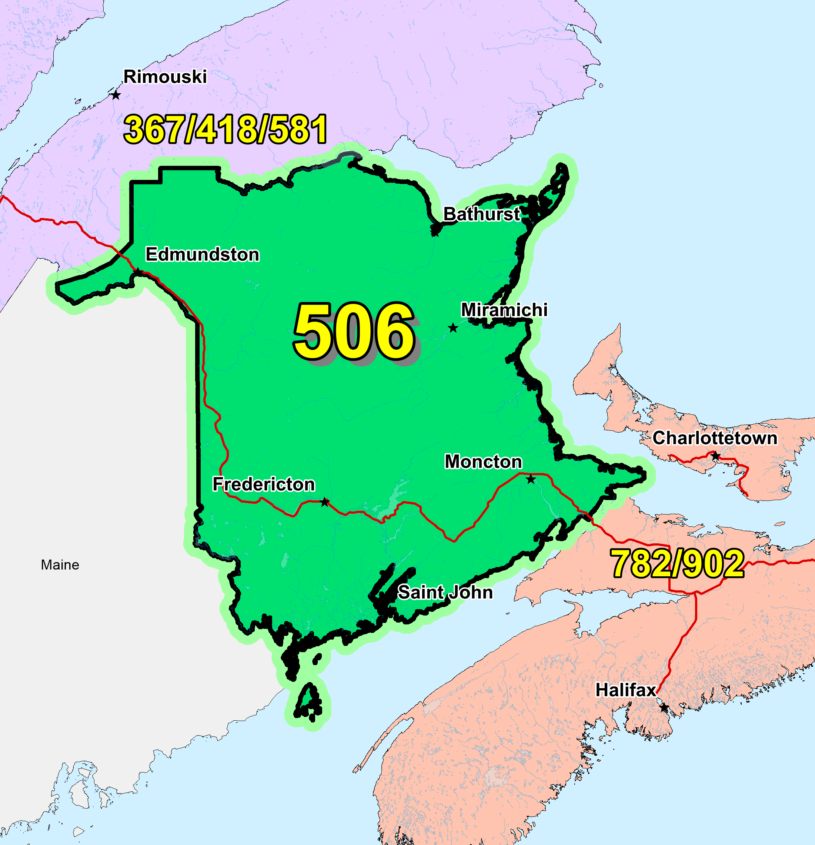

Figure 1 – Overview Map of NPA 506



Figure 2 – NPA 506 Actual and Forecast CO Code Assignments



Figure 3 – NPA 506 CO Code Exhaust: January 2016 G-NRUF



Figure 4 – NPA 506 Admin and LEC+WSP Codes: January 2016 G‑NRUF



Figure 5 – NPA 506 CO Code Exhaust: January 2017 R‑NRUF



Figure 6 – NPA 506 Admin and LEC+WSP Codes: January 2017 R‑NRUF



Figure 7 – NPA 506 CO Code Exhaust: July 2017 R–NRUF



Figure 8 – NPA 506 Admin and LEC+WSP Codes: July 2017 R–NRUF



Figure 9 – NPA 506 CO Code Exhaust: January 2018 R–NRUF



Figure 10 – NPA 506 Admin and LEC+WSP Codes: January 2018 R–NRUF

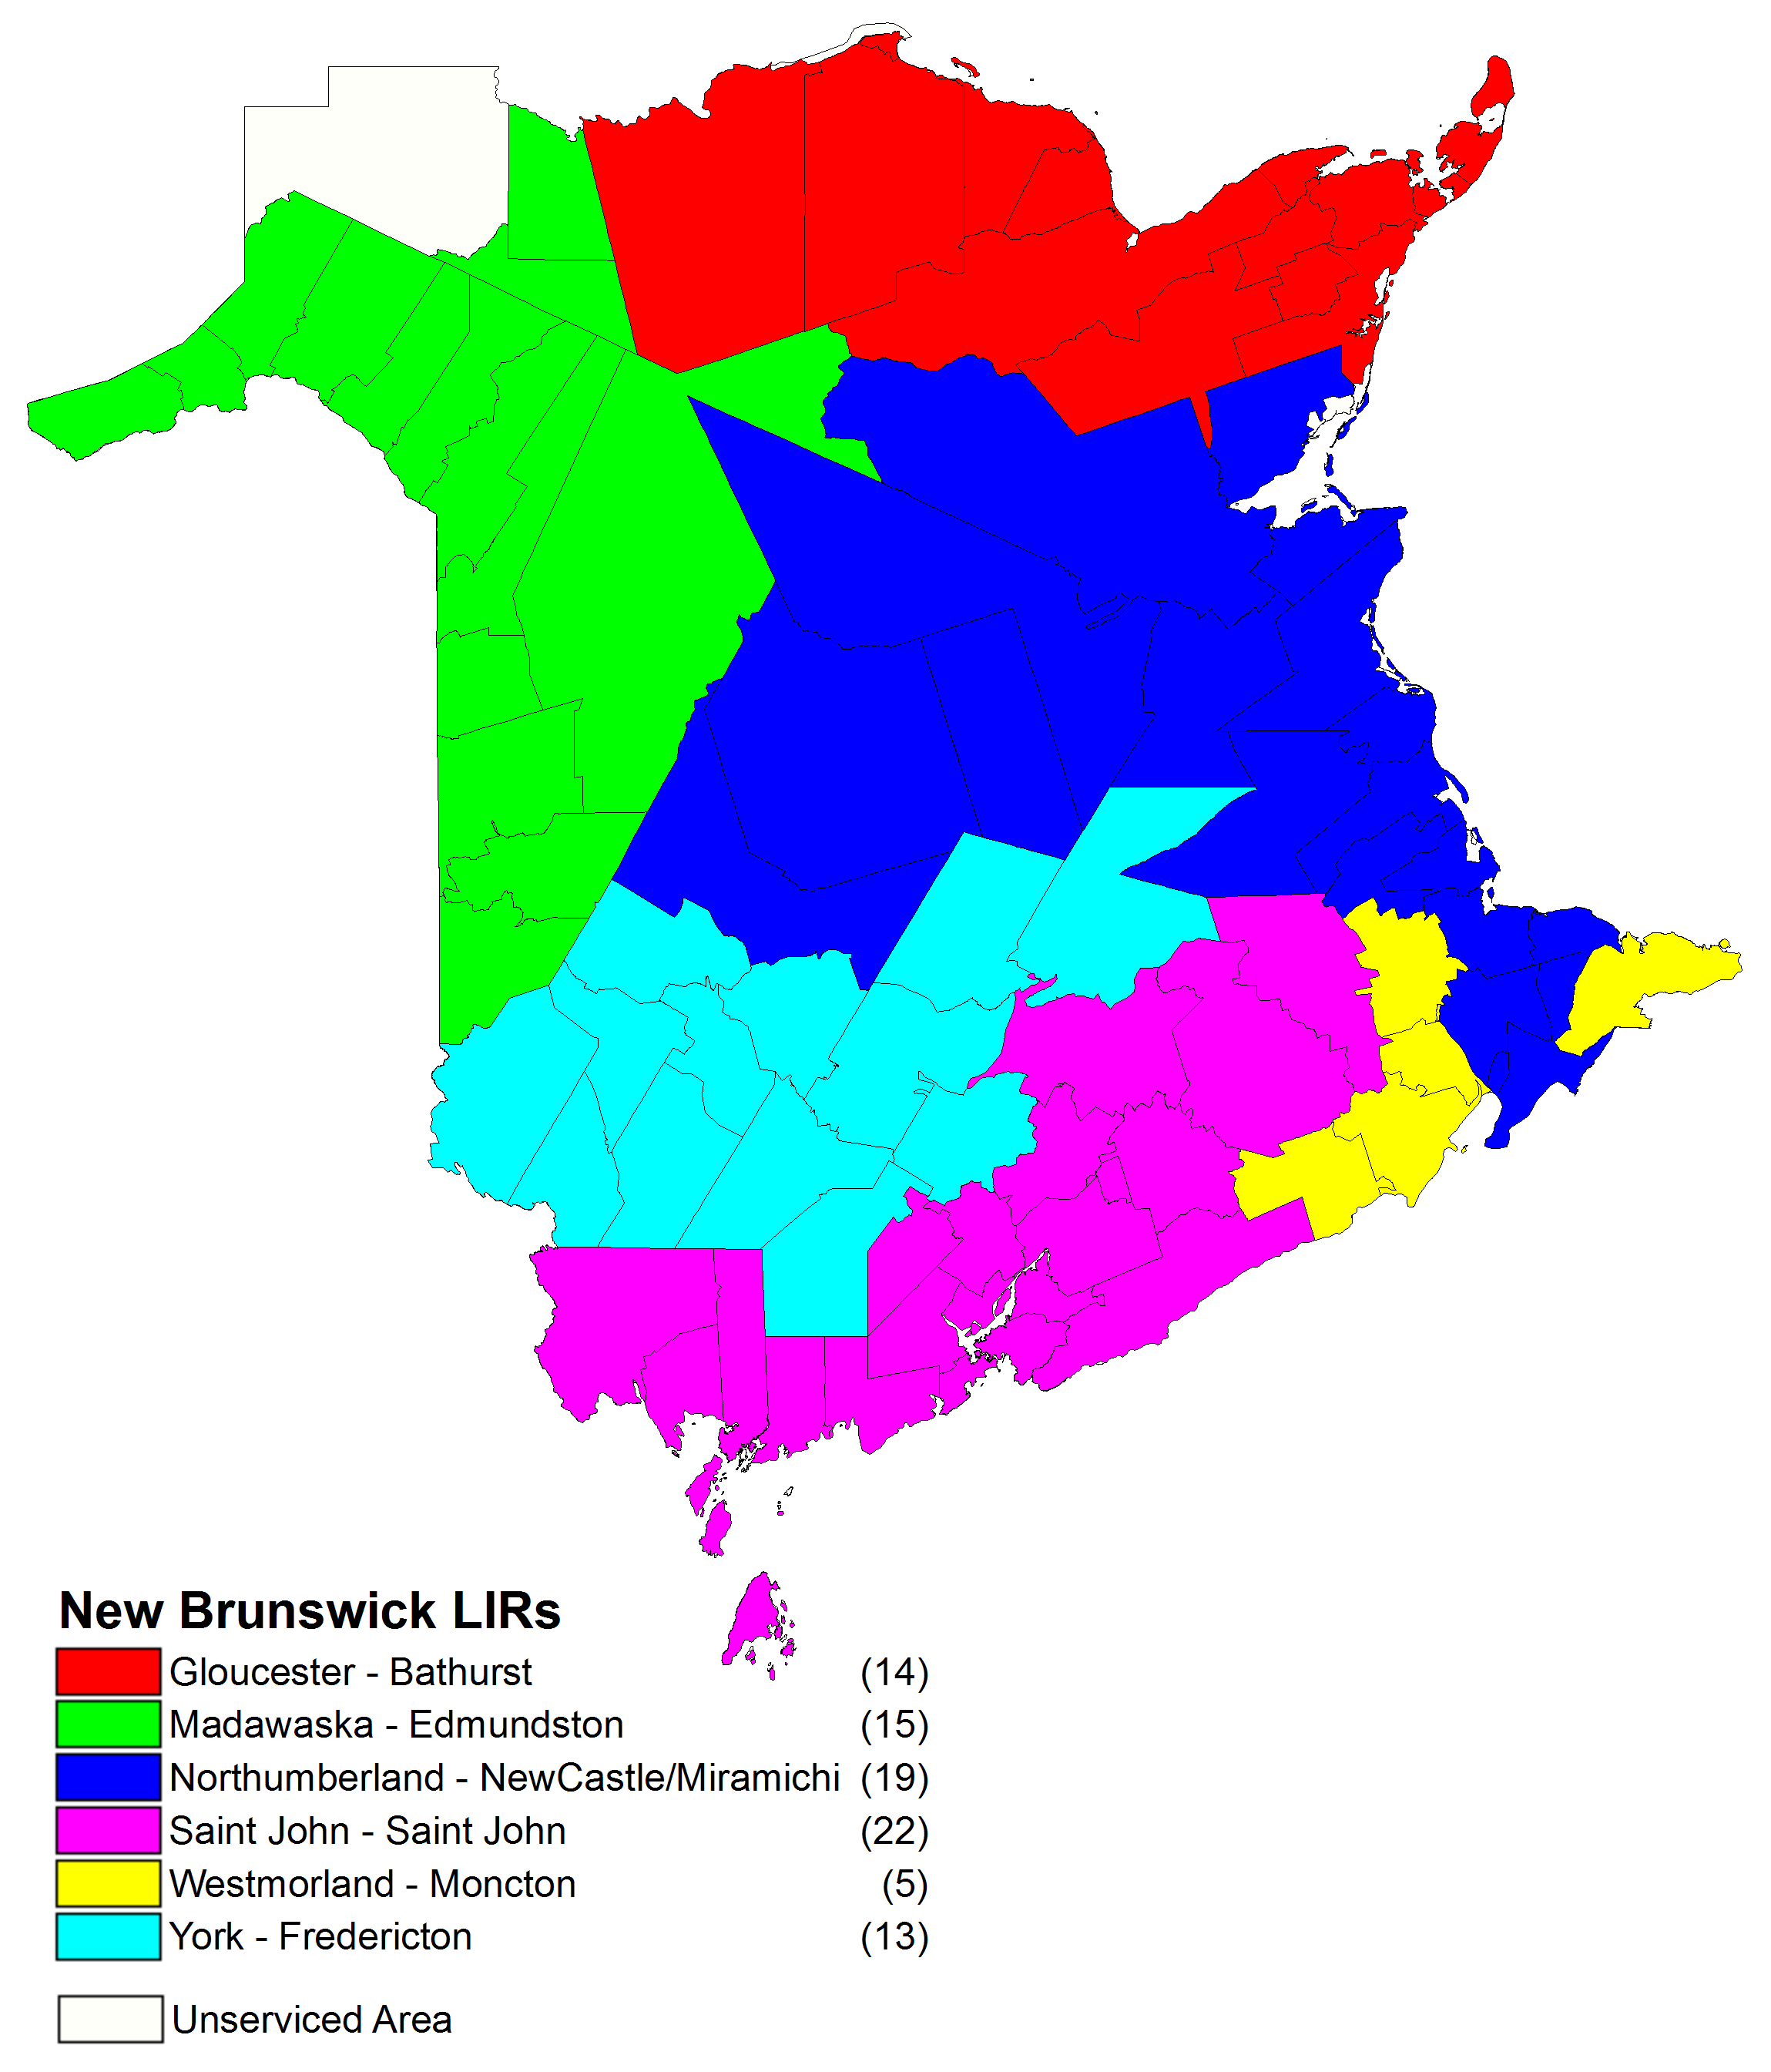

Figure 9 – NPA 506 LIRs

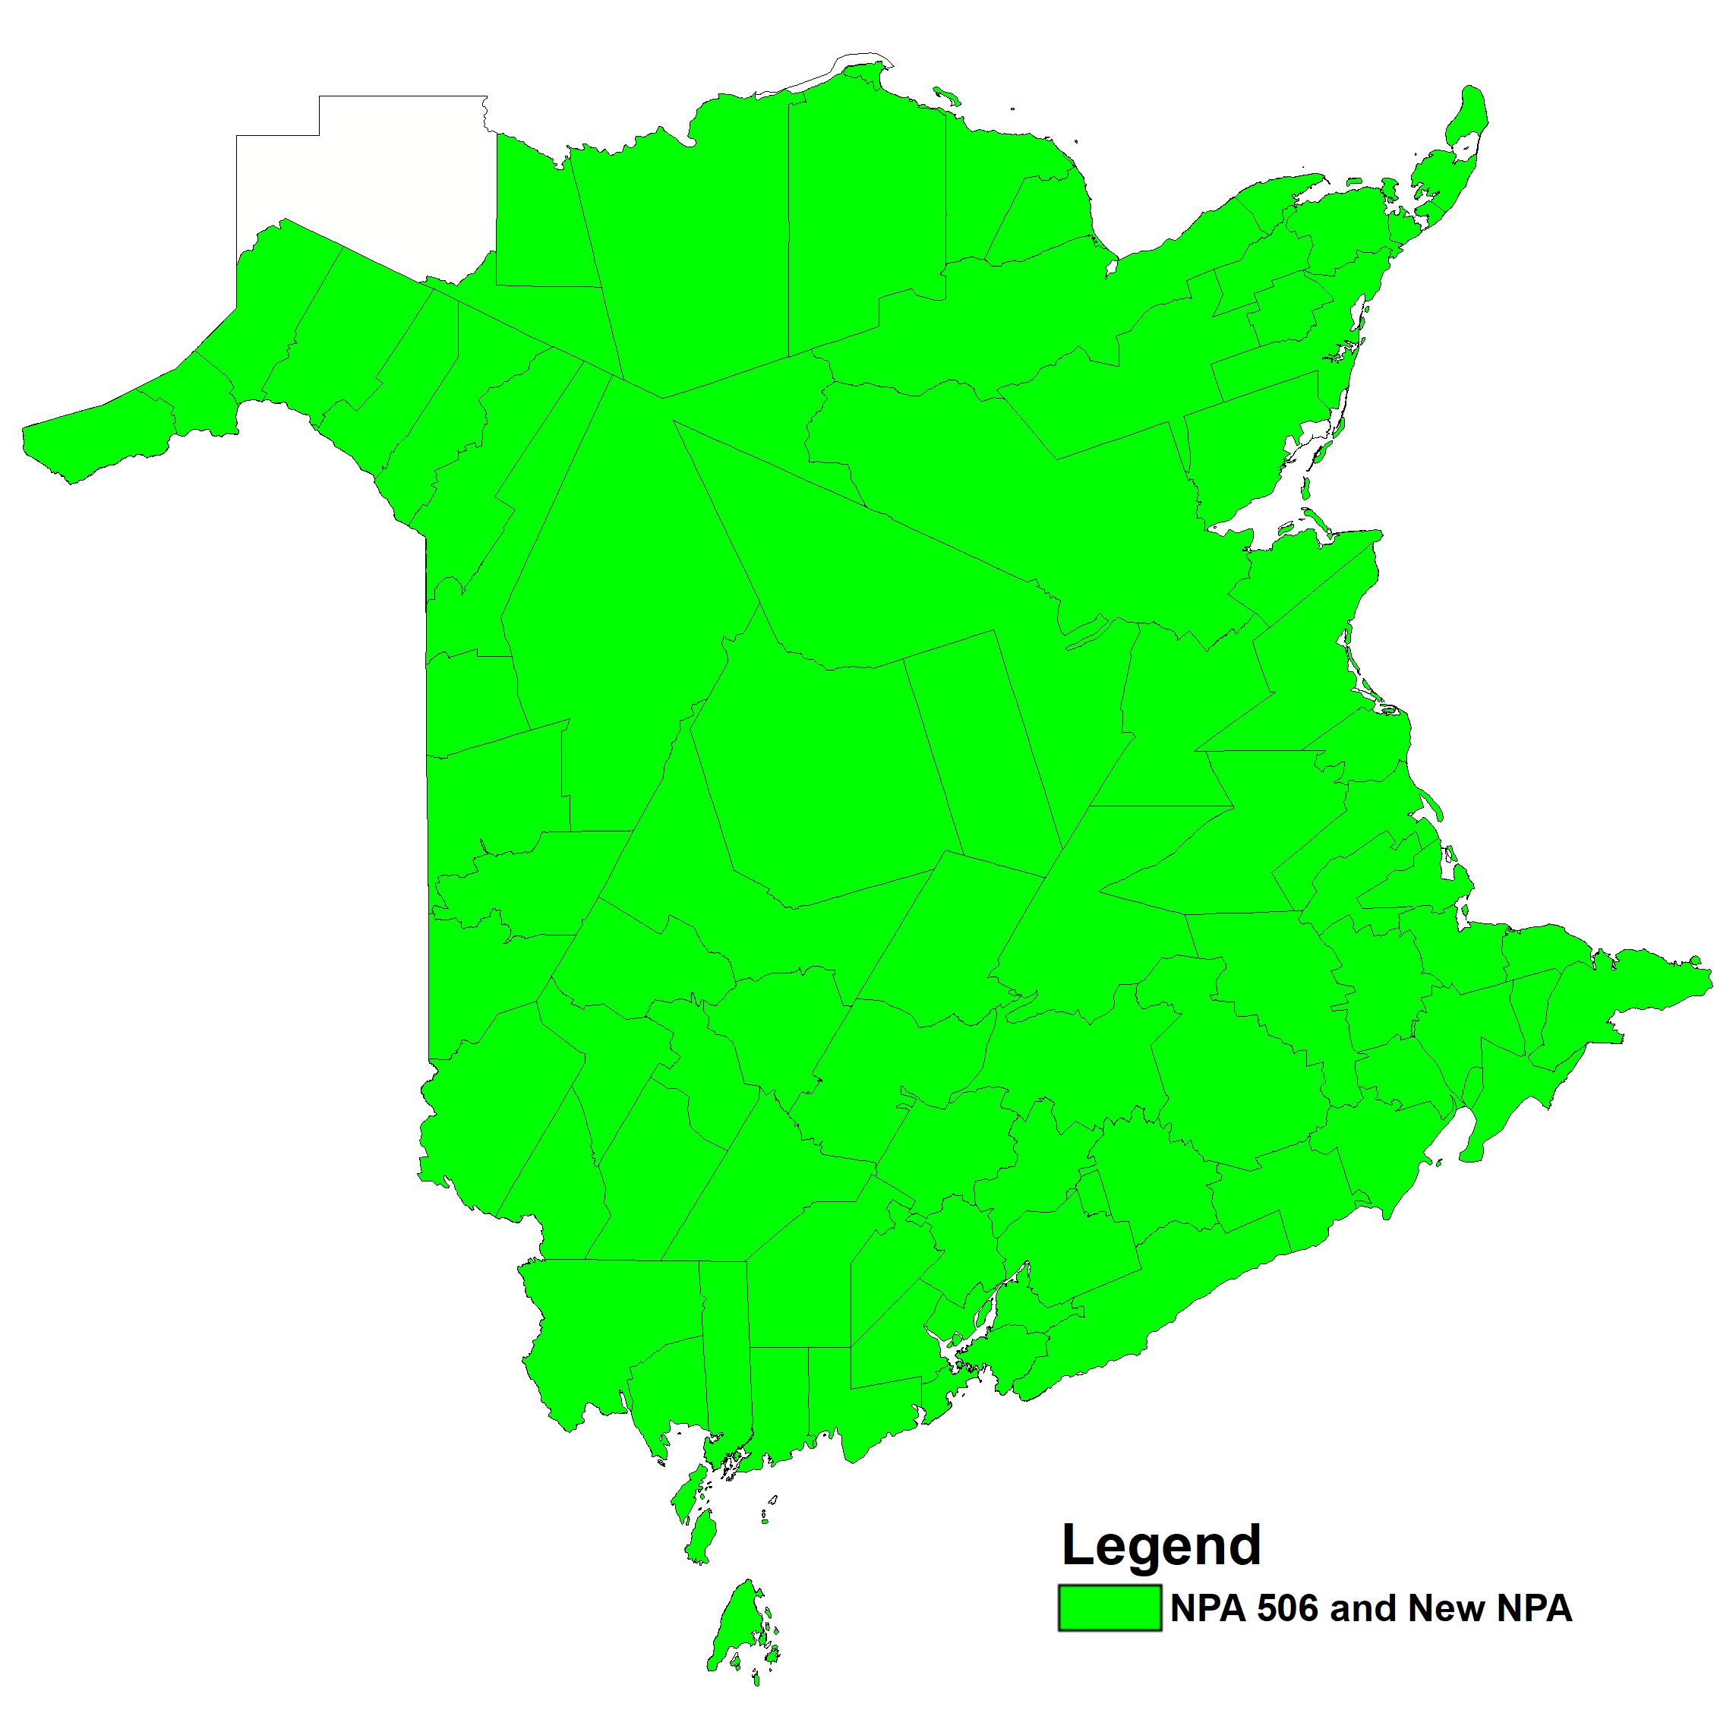

Figure 10 – Option 1: Distributed Overlay

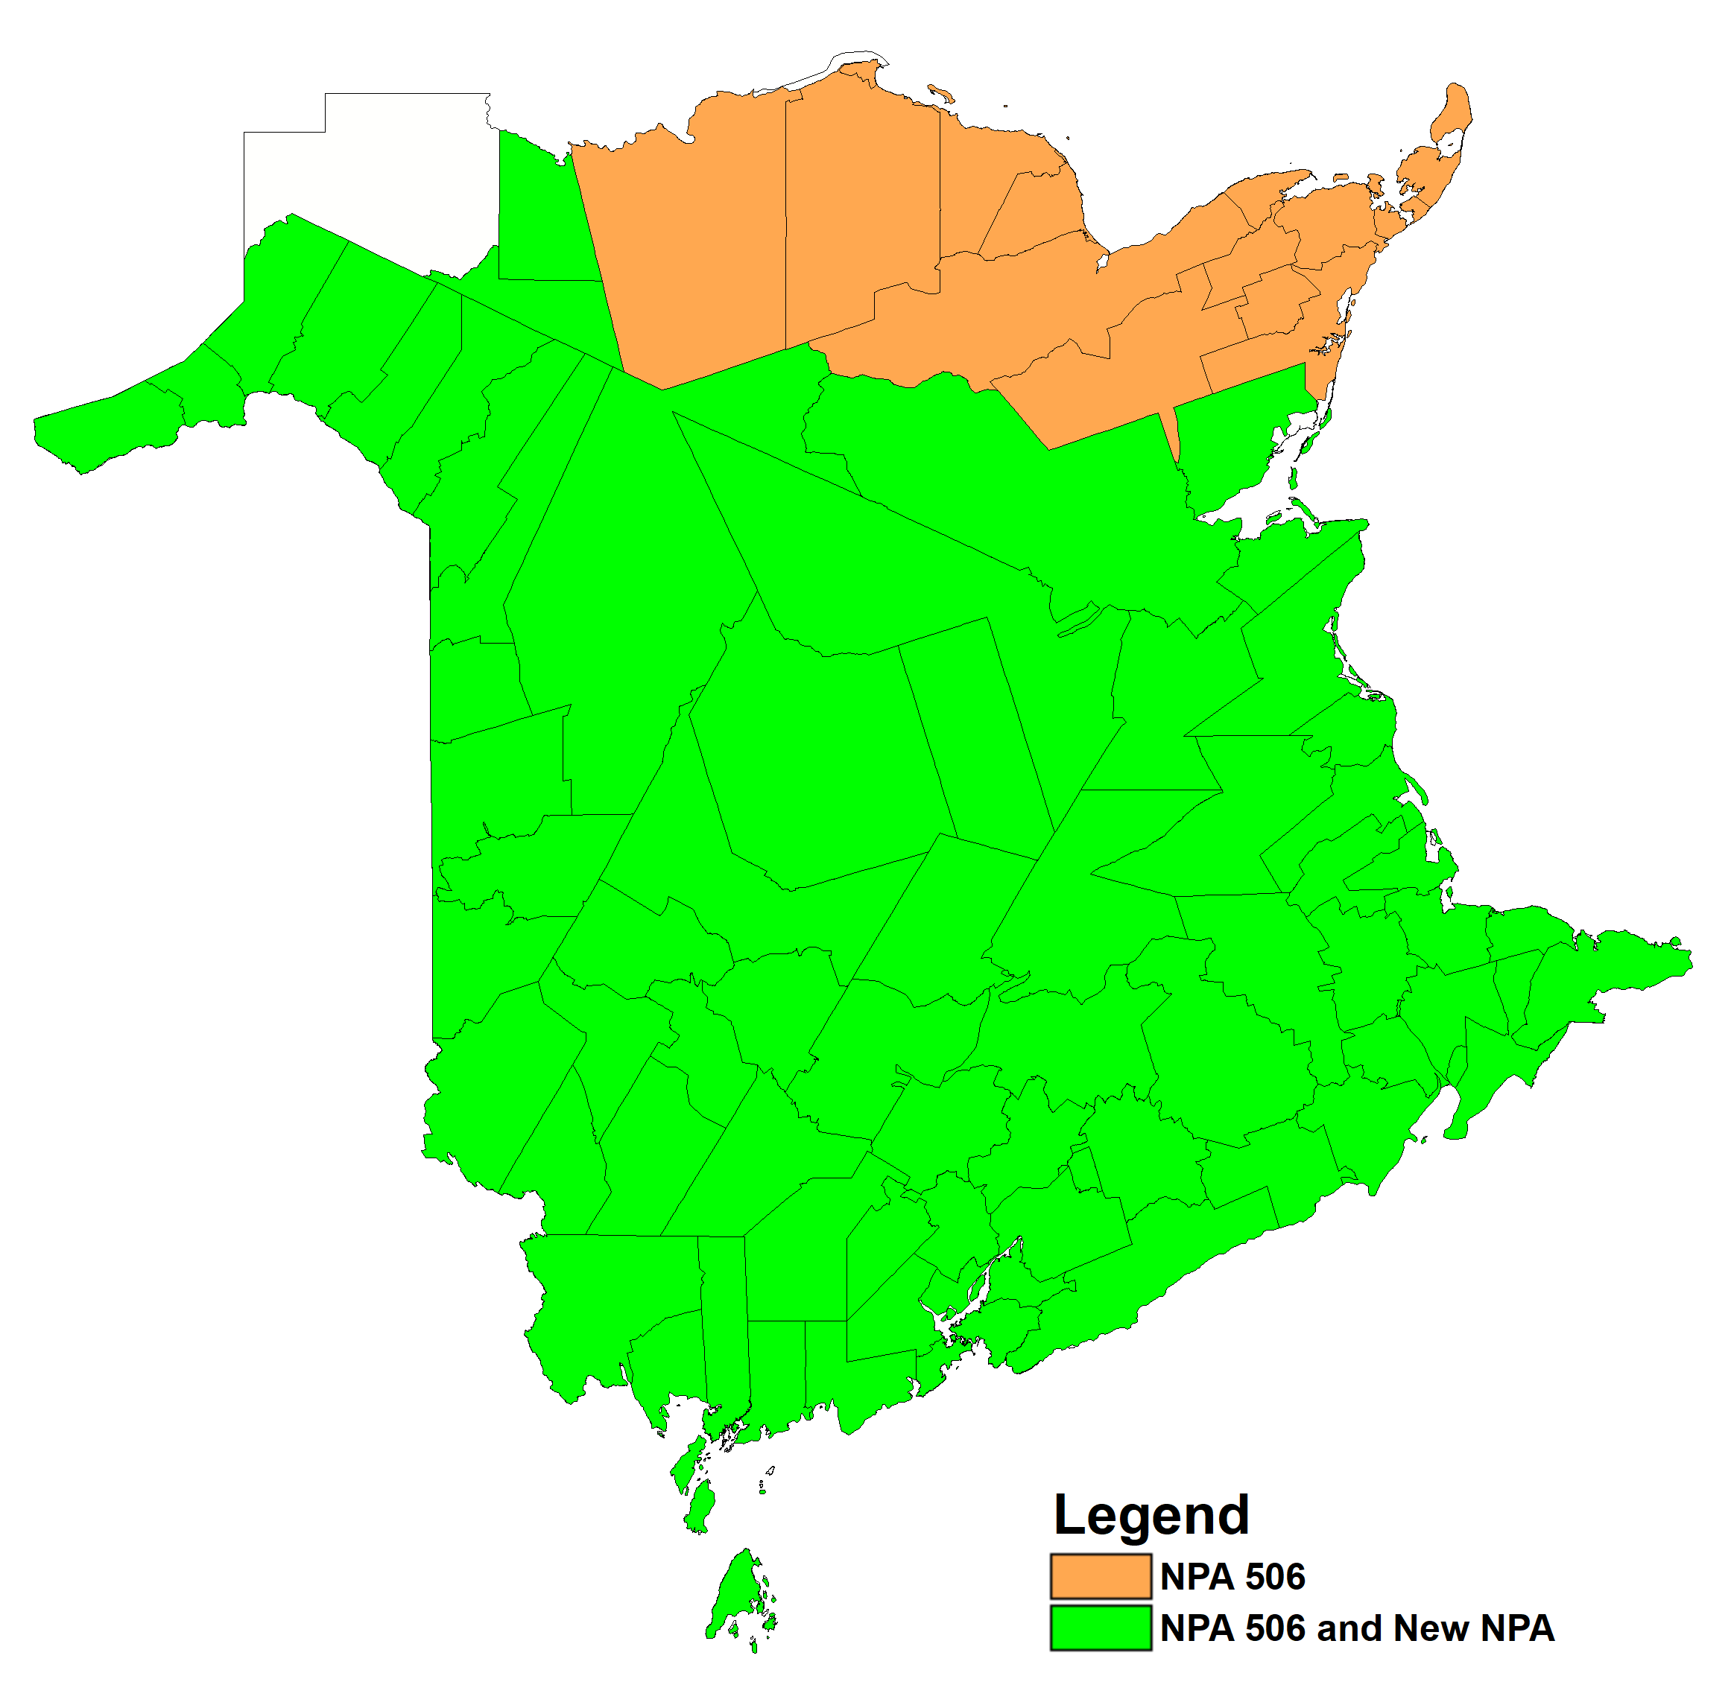

Figure 11 – Option 2: Concentrated Overlay on MADAWASKA, NORTHUBRLD, SAINT JOHN, WESTMORLD and YORK LIRs

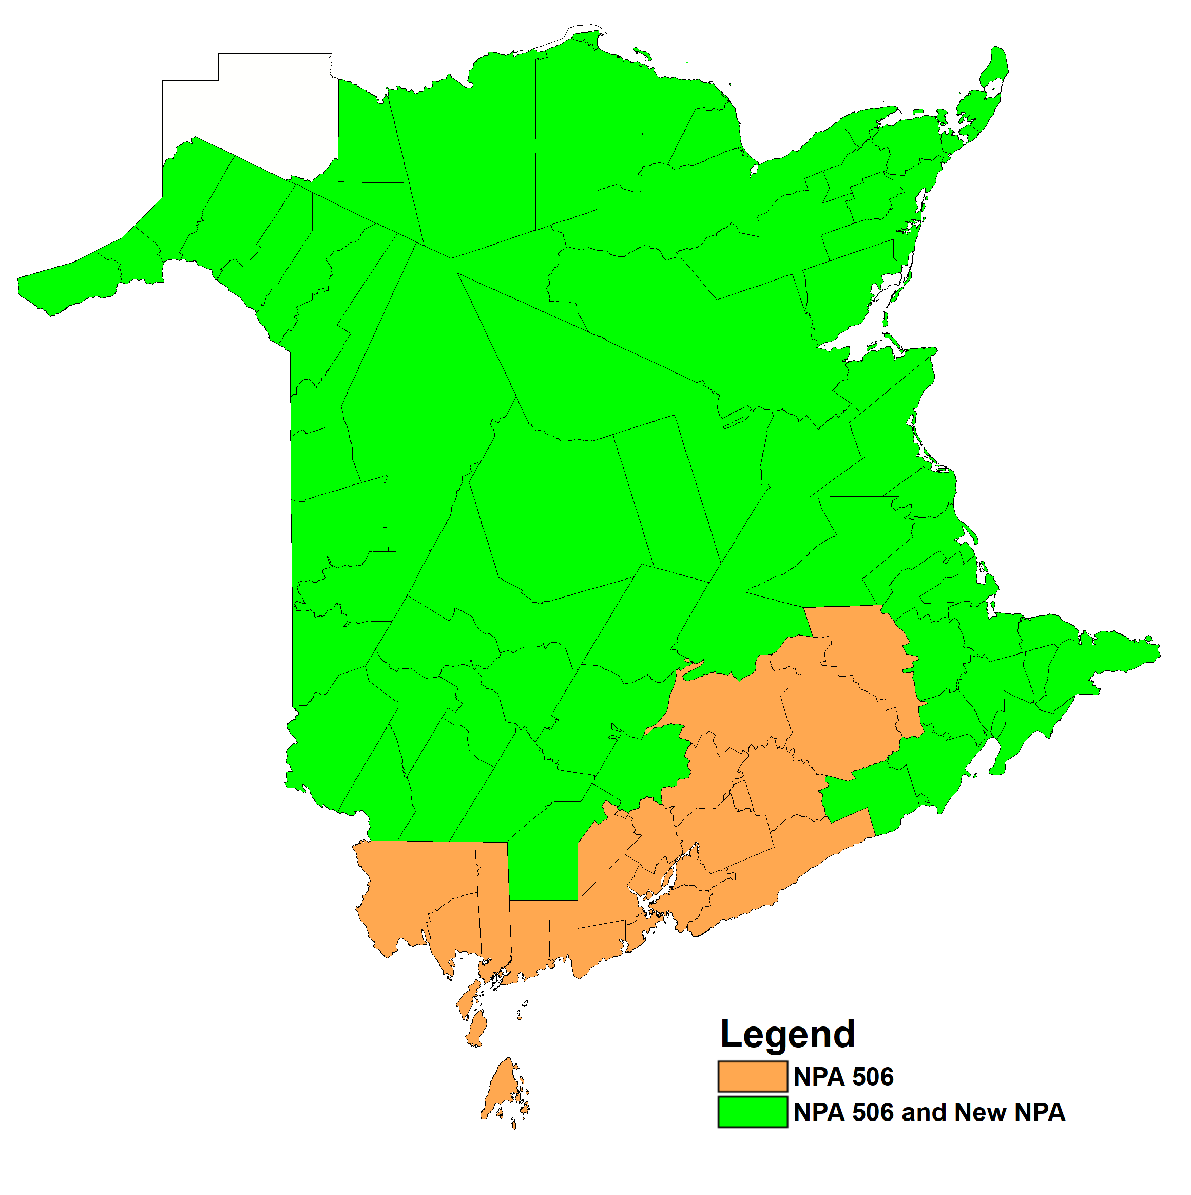

Figure 12 – Option 3: Concentrated Overlay on GLOUCESTER, MADAWASKA, NORTHUBRLD, WESTMORLD and YORK LIRs

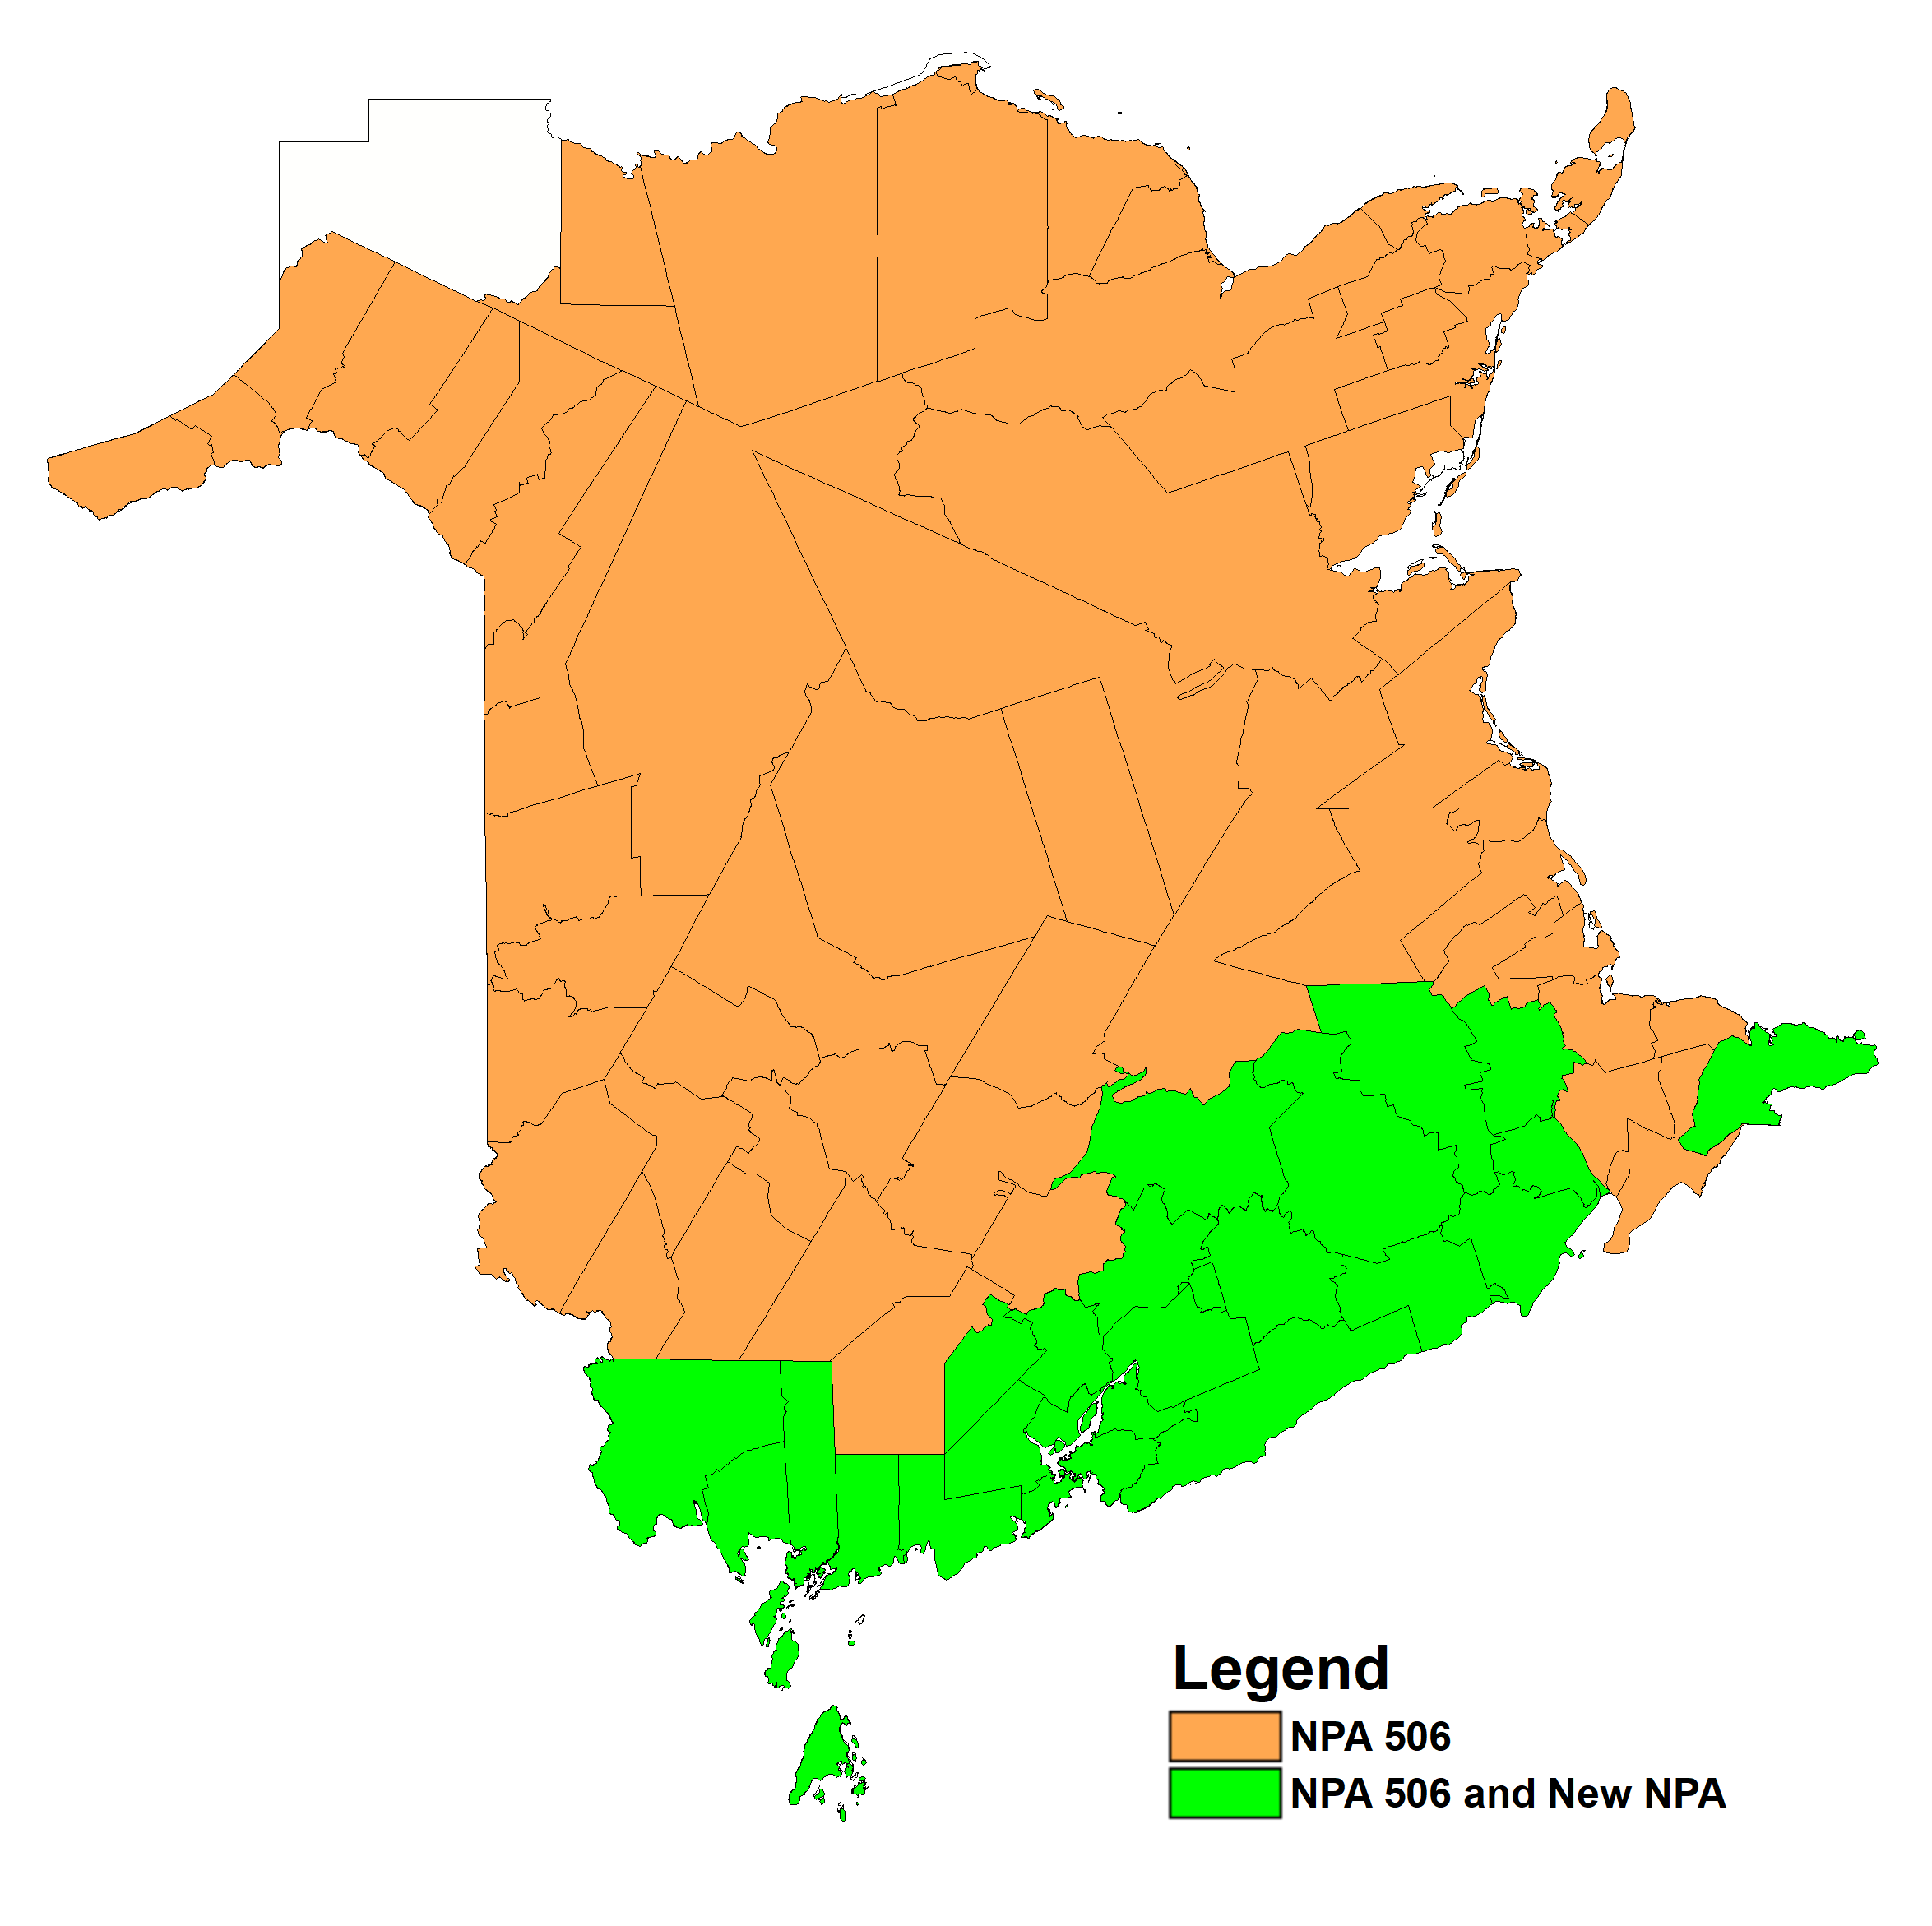

Figure 13 – Option 4: Concentrated Overlay on SAINT JOHN and WESTMORLD LIRs

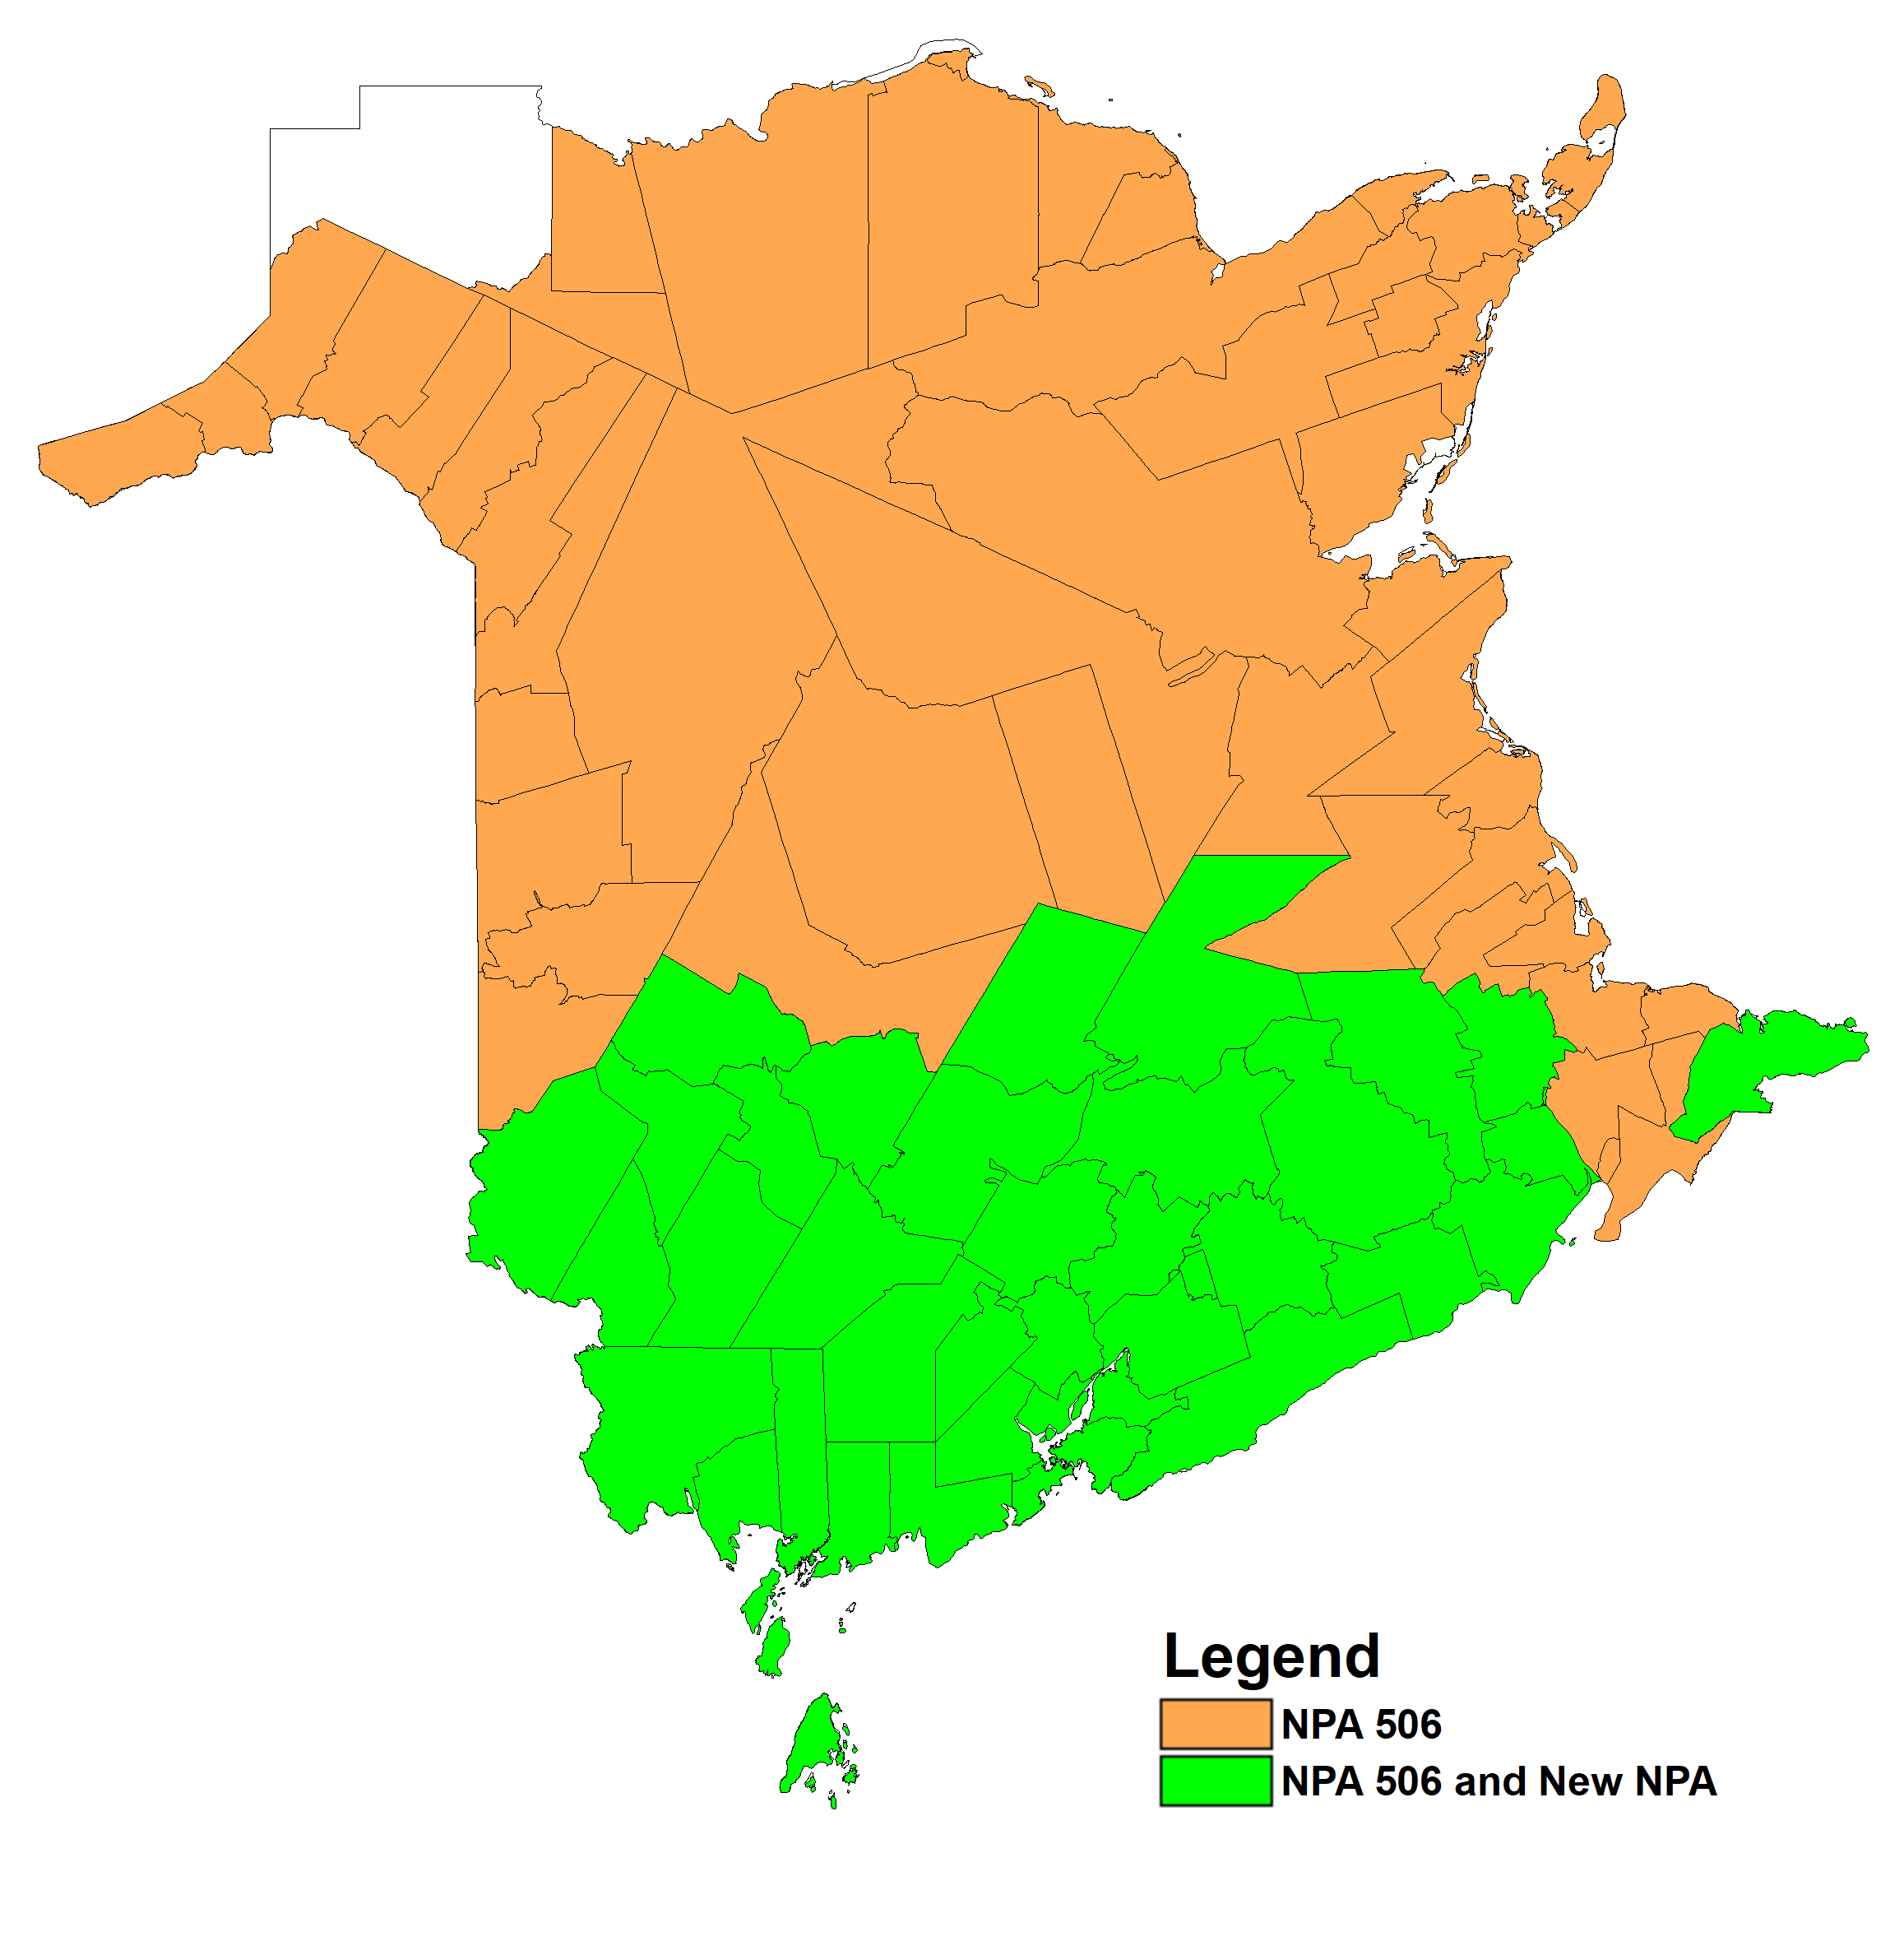

Figure 14 – Option 5: Concentrated Overlay on SAINT JOHN, YORK and WESTMORLD LIRs

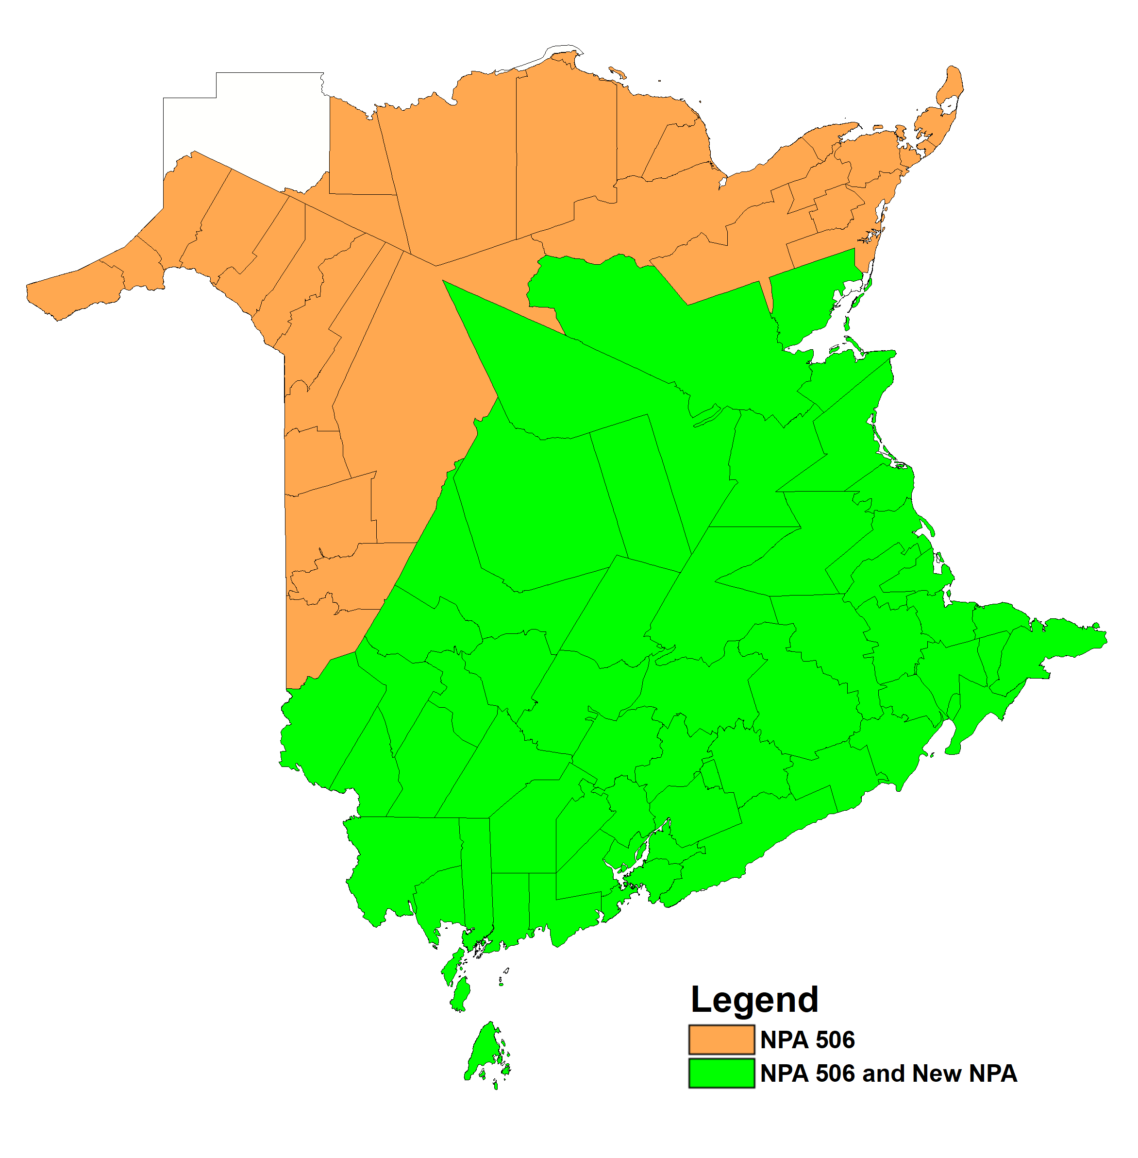

Figure 15 – Option 6: Concentrated Overlay on NORTHUBRLD, SAINT JOHN, YORK and WESTMORLD LIRs

1. NPA 506 Exchange Areas

Table 1 – Exchange Areas in NPA 506 before and after each Relief Option

|  | **Distributed Overlay** | **Contracted Overlay** | | | | | | | | | |
| --- | --- | --- | --- | --- | --- | --- | --- | --- | --- | --- | --- |
|  | **Option 1** | **Option 2** | | **Option 3** | | **Option 4** | | **Option 5** | | **Option 6** | |
| **Exchange Area** | **New NPA and 506 NPA in All NB Exchanges** | **New NPA and 506 NPA on MADAWASK, NORTHUBRLD, SAINT JOHN, WESTMORLD, YORK LIRs** | **506 NPA GLOUCESTER LIR Only** | **New NPA and 506 NPA GLOUCESTER, MADAWASK, NORTHUBRLD, WESTMORLD, YORK LIRs** | **506 NPA SAINT JOHN LIR Only** | **New NPA and 506 NA on SAINT JOHN, WESTMORLD LIRs** | **506 NPA GLOUCESTER, MADAWASK, NORTHUBRLD, YORK LIRs Only** | **New NPA and 506 NPA on SAINT JOHN, WESTMORLD, YORK LIRs** | **506 NPA GLOUCESTER, MADAWASK, NORTHUBRLD LIRs Only** | **New NPA and 506 NPA on NORTHHUBRLD, SAINT JOHN, WESTMORLD, YORK LIRs** | **506 NPA GLOUCESTER, MADAWASK, LIRs Only** |
| Albert | ✓ | ✓ |  | ✓ |  | ✓ |  | ✓ |  | ✓ |  |
| Allardville | ✓ |  | ✓ | ✓ |  |  | ✓ |  | ✓ |  | ✓ |
| Alma | ✓ | ✓ |  | ✓ |  | ✓ |  | ✓ |  | ✓ |  |
| Baie-Sainte Anne | ✓ | ✓ |  | ✓ |  |  | ✓ |  | ✓ | ✓ |  |
| Baker Brook | ✓ | ✓ |  | ✓ |  |  | ✓ |  | ✓ |  | ✓ |
| Balmoral | ✓ |  | ✓ | ✓ |  |  | ✓ |  | ✓ |  | ✓ |
| Bathurst | ✓ |  | ✓ | ✓ |  |  | ✓ |  | ✓ |  | ✓ |
| Belledune | ✓ |  | ✓ | ✓ |  |  | ✓ |  | ✓ |  | ✓ |
| Blacks Harbour | ✓ | ✓ |  |  | ✓ | ✓ |  | ✓ |  | ✓ |  |
| Blackville | ✓ | ✓ |  | ✓ |  |  | ✓ |  | ✓ | ✓ |  |
| Boiestown | ✓ | ✓ |  | ✓ |  |  | ✓ |  | ✓ | ✓ |  |
| Bouctouche | ✓ | ✓ |  | ✓ |  |  | ✓ |  | ✓ | ✓ |  |
| Browns Flat | ✓ | ✓ |  |  | ✓ | ✓ |  | ✓ |  | ✓ |  |
| Campbellton | ✓ |  | ✓ | ✓ |  |  | ✓ |  | ✓ |  | ✓ |
| Campobello | ✓ | ✓ |  |  | ✓ | ✓ |  | ✓ |  | ✓ |  |
| Cap-Pele | ✓ | ✓ |  | ✓ |  |  | ✓ |  | ✓ | ✓ |  |
| Caraquet | ✓ |  | ✓ | ✓ |  |  | ✓ |  | ✓ |  | ✓ |
| Chipman | ✓ | ✓ |  | ✓ |  |  | ✓ | ✓ | ✓ | ✓ |  |
| Clair | ✓ | ✓ |  | ✓ |  |  | ✓ |  | ✓ |  | ✓ |
| Cocagne | ✓ | ✓ |  | ✓ |  |  | ✓ |  | ✓ | ✓ |  |
| Dalhousie | ✓ |  | ✓ | ✓ |  |  | ✓ |  | ✓ |  | ✓ |
| Deer Island | ✓ | ✓ |  |  | ✓ | ✓ |  | ✓ |  | ✓ |  |
| Doaktown | ✓ | ✓ |  | ✓ |  |  | ✓ |  | ✓ | ✓ |  |
| Dorchester | ✓ | ✓ |  | ✓ |  |  | ✓ |  | ✓ | ✓ |  |
| Edmundston | ✓ | ✓ |  | ✓ |  |  | ✓ |  | ✓ |  | ✓ |
| Florenceville | ✓ | ✓ |  | ✓ |  |  | ✓ |  | ✓ |  | ✓ |
| Fords Mills | ✓ | ✓ |  | ✓ |  |  | ✓ |  | ✓ | ✓ |  |
| Fredericton | ✓ | ✓ |  | ✓ |  |  | ✓ | ✓ | ✓ | ✓ |  |
| Fredericton Junction | ✓ | ✓ |  | ✓ |  |  | ✓ | ✓ | ✓ | ✓ |  |
| Gagetown | ✓ | ✓ |  | ✓ |  |  | ✓ | ✓ | ✓ | ✓ |  |
| Grand Bay-Westfield | ✓ | ✓ |  |  | ✓ | ✓ |  | ✓ |  | ✓ |  |
| Grand Falls | ✓ | ✓ |  | ✓ |  |  | ✓ |  | ✓ |  | ✓ |
| Grand Manan | ✓ | ✓ |  |  | ✓ | ✓ |  | ✓ |  | ✓ |  |
| Grande-Anse | ✓ |  | ✓ | ✓ |  |  | ✓ |  | ✓ |  | ✓ |
| Hampton | ✓ | ✓ |  |  | ✓ | ✓ |  | ✓ |  | ✓ |  |
| Hartland | ✓ | ✓ |  | ✓ |  |  | ✓ |  | ✓ |  | ✓ |
| Harvey Station | ✓ | ✓ |  | ✓ |  |  | ✓ | ✓ | ✓ | ✓ |  |
| Hillsborough | ✓ | ✓ |  | ✓ |  | ✓ |  | ✓ |  | ✓ |  |
| Hoyt | ✓ | ✓ |  | ✓ |  |  | ✓ | ✓ | ✓ | ✓ |  |
| Kedgwick | ✓ | ✓ |  | ✓ |  |  | ✓ |  | ✓ |  | ✓ |
| Keswick | ✓ | ✓ |  | ✓ |  |  | ✓ | ✓ | ✓ | ✓ |  |
| Lameque | ✓ |  | ✓ | ✓ |  |  | ✓ |  | ✓ |  | ✓ |
| Maces Bay | ✓ | ✓ |  |  | ✓ | ✓ |  | ✓ |  | ✓ |  |
| McAdam | ✓ | ✓ |  | ✓ |  |  | ✓ | ✓ | ✓ | ✓ |  |
| Meductic | ✓ | ✓ |  | ✓ |  |  | ✓ | ✓ | ✓ | ✓ |  |
| Memramcook | ✓ | ✓ |  | ✓ |  |  | ✓ |  | ✓ | ✓ |  |
| Millville | ✓ | ✓ |  | ✓ |  |  | ✓ | ✓ | ✓ | ✓ |  |
| Minto | ✓ | ✓ |  | ✓ |  |  | ✓ | ✓ | ✓ | ✓ |  |
| Miramichi | ✓ | ✓ |  | ✓ |  |  | ✓ |  | ✓ | ✓ |  |
| Moncton | ✓ | ✓ |  | ✓ |  | ✓ |  | ✓ |  | ✓ |  |
| Nackawic | ✓ | ✓ |  | ✓ |  |  | ✓ | ✓ | ✓ | ✓ |  |
| Neguac | ✓ | ✓ |  | ✓ |  |  | ✓ |  | ✓ | ✓ |  |
| New Denmark | ✓ | ✓ |  | ✓ |  |  | ✓ |  | ✓ |  | ✓ |
| Norton | ✓ | ✓ |  |  | ✓ | ✓ |  | ✓ |  | ✓ |  |
| Oromocto | ✓ | ✓ |  | ✓ |  |  | ✓ | ✓ | ✓ | ✓ |  |
| Paquetville | ✓ |  | ✓ | ✓ |  |  | ✓ |  | ✓ |  | ✓ |
| Perth-Andover | ✓ | ✓ |  | ✓ |  |  | ✓ |  | ✓ |  | ✓ |
| Petit-Rocher | ✓ |  | ✓ | ✓ |  |  | ✓ |  | ✓ |  | ✓ |
| Petitcodiac | ✓ | ✓ |  |  | ✓ | ✓ |  | ✓ |  | ✓ |  |
| Plaster Rock | ✓ | ✓ |  | ✓ |  |  | ✓ |  | ✓ |  | ✓ |
| Port Elgin | ✓ | ✓ |  | ✓ |  | ✓ |  | ✓ |  | ✓ |  |
| Richibucto | ✓ | ✓ |  | ✓ |  |  | ✓ |  | ✓ | ✓ |  |
| Rogersville | ✓ | ✓ |  | ✓ |  |  | ✓ |  | ✓ | ✓ |  |
| Rothesay | ✓ | ✓ |  |  | ✓ | ✓ |  | ✓ |  | ✓ |  |
| Sackville | ✓ | ✓ |  | ✓ |  |  | ✓ |  | ✓ | ✓ |  |
| Saint Basile | ✓ | ✓ |  | ✓ |  |  | ✓ |  | ✓ |  | ✓ |
| Saint John | ✓ | ✓ |  |  | ✓ | ✓ |  | ✓ |  | ✓ |  |
| Saint-Antoine | ✓ | ✓ |  | ✓ |  |  | ✓ |  | ✓ | ✓ |  |
| Saint-Isidore | ✓ |  | ✓ | ✓ |  |  | ✓ |  | ✓ |  | ✓ |
| Saint-Quentin | ✓ | ✓ |  | ✓ |  |  | ✓ |  | ✓ |  | ✓ |
| Sainte-Anne-de-Madawaska | ✓ | ✓ |  | ✓ |  |  | ✓ |  | ✓ |  | ✓ |
| Salisbury | ✓ | ✓ |  |  | ✓ | ✓ |  | ✓ |  | ✓ |  |
| Shediac | ✓ | ✓ |  | ✓ |  |  | ✓ |  | ✓ | ✓ |  |
| Shippagan | ✓ |  | ✓ | ✓ |  |  | ✓ |  | ✓ |  | ✓ |
| Springfield | ✓ | ✓ |  |  | ✓ | ✓ |  | ✓ |  | ✓ |  |
| St. Andrews | ✓ | ✓ |  |  | ✓ | ✓ |  | ✓ |  | ✓ |  |
| St. George | ✓ | ✓ |  |  | ✓ | ✓ |  | ✓ |  | ✓ |  |
| St. Leonard | ✓ | ✓ |  | ✓ |  |  | ✓ |  | ✓ |  | ✓ |
| St. Louis-de-Kent | ✓ | ✓ |  | ✓ |  |  | ✓ |  | ✓ | ✓ |  |
| St. Martins | ✓ | ✓ |  |  | ✓ | ✓ |  | ✓ |  | ✓ |  |
| St. Stephen | ✓ | ✓ |  |  | ✓ | ✓ |  | ✓ |  | ✓ |  |
| Stanley | ✓ | ✓ |  | ✓ |  |  | ✓ |  | ✓ | ✓ |  |
| Summerville | ✓ | ✓ |  |  | ✓ | ✓ |  | ✓ |  | ✓ |  |
| Sussex | ✓ | ✓ |  |  | ✓ | ✓ |  | ✓ |  | ✓ |  |
| Tracadie | ✓ |  | ✓ | ✓ |  |  | ✓ |  | ✓ |  | ✓ |
| Welsford | ✓ | ✓ |  |  | ✓ | ✓ |  | ✓ |  | ✓ |  |
| Woodstock | ✓ | ✓ |  | ✓ |  |  | ✓ |  | ✓ |  | ✓ |
| Youngs Cove Road | ✓ | ✓ |  |  | ✓ | ✓ |  | ✓ |  | ✓ |  |

Table 2 – Exchange Areas in each LIR

| **LIR Name** | **Exchange Name** |
| --- | --- |
| Gloucester - Bathurst | Allardville |
| Gloucester - Bathurst | Balmoral |
| Gloucester - Bathurst | Bathurst |
| Gloucester - Bathurst | Belledune |
| Gloucester - Bathurst | Campbellton |
| Gloucester - Bathurst | Caraquet |
| Gloucester - Bathurst | Dalhousie |
| Gloucester - Bathurst | Grande-Anse |
| Gloucester - Bathurst | Lameque |
| Gloucester - Bathurst | Paquetville |
| Gloucester - Bathurst | Petit-Rocher |
| Gloucester - Bathurst | Saint-Isidore |
| Gloucester - Bathurst | Shippagan |
| Gloucester - Bathurst | Tracadie |
| Madawaska - Edmundston | Baker Brook |
| Madawaska - Edmundston | Clair |
| Madawaska - Edmundston | Edmundston |
| Madawaska - Edmundston | Florenceville |
| Madawaska - Edmundston | Grand Falls |
| Madawaska - Edmundston | Hartland |
| Madawaska - Edmundston | Kedgwick |
| Madawaska - Edmundston | New Denmark |
| Madawaska - Edmundston | Perth-Andover |
| Madawaska - Edmundston | Plaster Rock |
| Madawaska - Edmundston | Saint Basile |
| Madawaska - Edmundston | Sainte-Anne-de-Madawaska |
| Madawaska - Edmundston | Saint-Quentin |
| Madawaska - Edmundston | St. Leonard |
| Madawaska - Edmundston | Woodstock |
| Northumberland - Newcastle/Miramichi | Baie-Sainte Anne |
| Northumberland - Newcastle/Miramichi | Blackville |
| Northumberland - Newcastle/Miramichi | Boiestown |
| Northumberland - Newcastle/Miramichi | Bouctouche |
| Northumberland - Newcastle/Miramichi | Cap-Pele |
| Northumberland - Newcastle/Miramichi | Cocagne |
| Northumberland - Newcastle/Miramichi | Doaktown |
| Northumberland - Newcastle/Miramichi | Dorchester |
| Northumberland - Newcastle/Miramichi | Fords Mills |
| Northumberland - Newcastle/Miramichi | Memramcook |
| Northumberland - Newcastle/Miramichi | Miramichi |
| Northumberland - Newcastle/Miramichi | Neguac |
| Northumberland - Newcastle/Miramichi | Richibucto |
| Northumberland - Newcastle/Miramichi | Rogersville |
| Northumberland - Newcastle/Miramichi | Sackville |
| Northumberland - Newcastle/Miramichi | Saint-Antoine |
| Northumberland - Newcastle/Miramichi | Shediac |
| Northumberland - Newcastle/Miramichi | St. Louis-de-Kent |
| Northumberland - Newcastle/Miramichi | Stanley |
| Saint John - Saint John | Blacks Harbour |
| Saint John - Saint John | Browns Flat |
| Saint John - Saint John | Campobello |
| Saint John - Saint John | Deer Island |
| Saint John - Saint John | Grand Bay-Westfield |
| Saint John - Saint John | Grand Manan |
| Saint John - Saint John | Hampton |
| Saint John - Saint John | Maces Bay |
| Saint John - Saint John | Norton |
| Saint John - Saint John | Petitcodiac |
| Saint John - Saint John | Rothesay |
| Saint John - Saint John | Saint John |
| Saint John - Saint John | Salisbury |
| Saint John - Saint John | Springfield |
| Saint John - Saint John | St. Andrews |
| Saint John - Saint John | St. George |
| Saint John - Saint John | St. Martins |
| Saint John - Saint John | St. Stephen |
| Saint John - Saint John | Summerville |
| Saint John - Saint John | Sussex |
| Saint John - Saint John | Welsford |
| Saint John - Saint John | Youngs Cove Road |
| Westmorland - Moncton | Albert |
| Westmorland - Moncton | Alma |
| Westmorland - Moncton | Hillsborough |
| Westmorland - Moncton | Moncton |
| Westmorland - Moncton | Port Elgin |
| York - Fredericton | Chipman |
| York - Fredericton | Fredericton |
| York - Fredericton | Fredericton Junction |
| York - Fredericton | Gagetown |
| York - Fredericton | Harvey Station |
| York - Fredericton | Hoyt |
| York - Fredericton | Keswick |
| York - Fredericton | McAdam |
| York - Fredericton | Meductic |
| York - Fredericton | Millville |
| York - Fredericton | Minto |
| York - Fredericton | Nackawic |
| York - Fredericton | Oromocto |

1. Distribution List

|  |  |
| --- | --- |
| NXX Admin  Bell Canada  nxx.admin@bell.ca | CLEC Admin  Comwave Networks  61 Wildcat Road  Toronto, ON  Canada  M3J 2P5  clecteam@comwave.net |
| Numbering E-Mail  Distributel Communications Limited  177 Nepean Street  Ottawa, ON  Canada  K2P 0B4  numbering@distributel.ca | FairPoint Communications  USA  code-administration@fairpoint.com |
| Iristel  team.regulatory@iristel.com | Rogers  NumberAdmin@rci.rogers.com |
| Joey-Lynn Abdulkader  Specialist Regulatory Affairs  Bell Canada  160 Elgin Street, 19th Floor  Ottawa, ON  Canada  K2P 2C4  Telephone: 613-785-6314  Fax: 613-560-0472  joey-lynn.abdulkader@bell.ca | Edward Antecol  VP, Regulatory and Carrier Relations  Freedom Mobile Inc.  207 Queen Quay West Suite 710  Toronto, ON  Canada  M5J 1A7  Telephone: 416-849-1277  Fax: 866-247-1890  EAntecol@FreedomMobile.ca |
| Andreea Badea  Iristel Inc.  11 Bowan Court  Toronto, ON  Canada  M2K 3A8  Telephone: 416-800-4747  abadea@iristel.ro | Bill Barsley  Manager - Planning & Engineering  TELUS  27 Marmac Drive  Etobicoke, ON  Canada  M9W 1E7  Telephone: 416-279-7989  Fax: 416-279-3930  bill.barsley@telus.com |
| Ron Barzakay  CTO  Comwave Networks  61 Wildcat Rd  Toronto, ON  M3J 2P5  Telephone: 416-663-9700 X 302  Fax: 416-736-3150  rbarzakay@comwave.net | Geoff Batstone  V.P., General Counsel  Distributel Communications Limited  177 Nepean Street, Suite 300  Ottawa, ON  Canada  Telephone: 613-319-9964  geoff.batstone@distributel.ca |
| Vivek Bhardwaj  Traffic Specialist  Rogers Communications  8200 Dixie Rd.  Brampton, ON  Canada  L6T 0C1  Telephone: 647-747-3569  vivek.bhardwaj@rci.rogers.com | Olena Bilozerska  Network Planning Manager I, TS CC Planning & Management  TELUS  200 Consilium Place, Floor 6  Scarborough, ON  Canada  M1H 3G2  Telephone: 647-837-1798  Olena.Bilozerska@telus.com |
| Doug Birdwise  Interested Party  109 Westpark Drive  Ottawa, ON  Canada  K1B 3G4  Telephone: 613-830-0081  douglas.birdwise@sympatico.ca | Samer Bishay  CEO  Iristel Inc.  11 Bowan Court  Toronto, ON  Canada  M2K 3A8  Telephone: 416-800-9999  Fax: 416-628-0891  sbishay@iristel.com |
| Laurie Bowie  Network Planning  Bell Canada  100 Dundas Street, Floor 4G  London, ON  Canada  N6A 5B6  Telephone: 519-850-5818  laurie.bowie@bell.ca | Kim Brown  Telephone Infrastructure Specialist  Eastlink  PO Box 8660, Station “A”:  6080 Young St, 7th Floor  Halifax, NS  Canada  B3K 5M3  Telephone: 902-446-3794  Fax: 902-405-3426  kim.brown@corp.eastlink.ca |
| Glen Brown  Division Manager  Leidos Canada Inc.  60 Queen Street, Suite 1516  Ottawa, ON  Canada  K1P 5Y7  Telephone: 613-683-3291  Fax: 613-563-3399  browng@leidos.ca | Joseph Cabrera  Senior Analyst  CRTC  1 Promenade du Portage  Gatineau, QC  Canada  J8X 4B1  Telephone: 819-934-6352  Fax: 819-997-4610  joseph.cabrera@crtc.gc.ca |
| Melanye Caisse  Telecom Analyst  ISP Telecom Inc  1155 Boul Rene-Levesque Ouest Suite 2500  Montreal, QC  Canada  H3B 2K4  Telephone: 416-548-4819  Fax: 416-548-4818  melanye@isptelecom.net | Don Cavanagh  VP  Distributel Communications Limited  177 Nepean Street, Suite 300  Ottawa, ON  Canada  K2P 0B4  Telephone: 613-237-7005  Fax: 613-237-7009  donald.cavanagh@distributel.ca |
| Fiona Clegg  CO Code Administration  Leidos Canada Inc.  60 Queen Street, Suite 1516  Ottawa, ON  Canada  K1P 5Y7  Telephone: 613-683-3285  Fax: 613-563-3399  cleggf@leidos.ca | Eric Coburn  IP Management Specialist  Shaw Telecom Inc.  Suite 800, 630 – 3rd Ave SW  Calgary, AB  Canada  T2P 4L4  Telephone: 403-750-7481  Fax: 403-750-6999  dp-tnadmin@sjrb.ca |
| David Comrie  CNA  Leidos Canada Inc.  1516 - 60 Queen Street  Ottawa, ON  Canada  K1P 5Y7  Telephone: 613-683-3287  Fax: 613-563-3399  comried@leidos.ca | Gregory Connolly  AT&T  USA  gc8733@att.com |
| Arnie Dehoop  Manager, Network Optimization  Freedom Mobile Inc.  207 Queens Quay West, Suite 710  Toronto, ON  Canada  M5J 1A7  Telephone: 289-700-2200  Fax: 866-247-1890  Adehoop@FreedomMobile.ca | Irma Dulay  Primus Telecommunications Canada Inc.  500- 5343 Dundas St West  Toronto, ON  Canada  M9B 6K5  Telephone: 416-207-7151  Fax: 877-329-6875  idulay@primustel.ca |
| Jean-Michel Dupuis  Senior Public Services Specialist  Rogers Communications Canada Inc.  800 rue de la Gauchetiere Ouest, Suite 4000  Montreal, QC  Canada  H5A 1K3  Telephone: 1-866-501-7727  Fax: 1-800-506-3962  jeanmichel.dupuis@rci.rogers.com | Mona Emond  Director, Marketing & Communications  Canadian Security Association  610 Alden Road, Suite 100  Markham, ON  Canada  L3R 9Z1  Telephone: 905-513-0622 Ext 242  Fax: 905-513-0624  memond@canasa.org |
| Diane Faillant  Associate - Network Management/NSS (National Numbering Solution)  Bell Canada  671 Lagauchetiere Ouest. 11  Montreal, QC  Canada  H3B 2M8  Telephone: 514-870-6044  Fax: 514-786-9062  diane.faillant@bell.ca | Ling Fang  Traffic Specialist  Rogers Communications  8200 Dixie Rd  Brampton, ON  Canada  L6T0C1  Telephone: 647-747-4657  ling.fang@rci.rogers.com |
| Johny Fernandez  Technology Strategy  TELUS Mobility  300 C  Scarborough, ON  Canada  M1H 3J3  Telephone: 647-453-4442  Johny.fernandez@telus.com | David Fiala  US Cellular  USA  David.Fiala@uscellular.com |
| George Guerra  AT&T  USA  gg2395@att.com | Pierre Guynot de Boismenu  Manager of Core Network Engineering and Operations, Wireless  Bragg Communications Inc  60800 Young St 6th Floor  Halifax, NS  Canada  B3K5M3  Telephone: 902-414-8020  Fax: 902-444-1019  pierre.guynotdeboismenu@corp.eastlink.ca |
| Austin He  Network Planning Analyst,Carrier Relations,Network Profitability & Planning  Primus Telecommunications Canada Inc.  5343 Dundas Street W. Suite 500  Toronto, ON  Canada  M9B 6K5  Telephone: 416-207-3361  ahe@primustel.ca | Marian Hearn  Project Executive  Canadian LNP Consortium Inc.  350 Palladium Drive, Suite 208  Kanata, ON  Canada  K2V 1A8  Telephone: 613-287-0225  Fax: 800-406-9250  marian.hearn@clnpc.ca |
| Lynne Hewitson  Membership Manager  Canadian Security Association (CANASA)  610 Alden Road  Markham, ON  Canada  L3R 9Z1  Telephone: 905-513-0622 ext 223  Fax: 905-513-0624  membership@canasa.org | Larry Hishon  Vice-President Business Development  Fibernetics Corporation  583 Eastgate Walk  Waterloo, ON  Canada  N2K 2V9  Telephone: 519-571-7433  Fax: 519-772-5014  lhishon@fibernetics.ca |
| Steven Hrabok  Product Specialist - Digital Phone  Shaw  Suite 800, 630 - 3rd Ave SW  Calgary, AB  Canada  T2P 4L4  Telephone: 403-234-6284  Fax: 403-750-6969  dp-tnadmin@sjrb.ca | Laine Hutchinson  MGR, CARRIER SERVICES (VOICE)  Shaw Business  2431 37 AVENUE NE  Calgary, AB  Canada  T2E 6Y7  Telephone: (587) 390-2238  Laine.Hutchinson@sjrb.ca |
| Kim Isaacs  Director Carrier Relations  Allstream  6160 Golden Hills Dr  Golden Valley, MN  USA  55416  Telephone: 763-745-8463  Kim.Isaacs@allstream.com | Stephanie Jackson  Manager - Public Services Integration; Traffic Engineering  Rogers Communications Canada Inc.  8200 Dixie Road  Brampton, ON  Canada  L6T 0C1  Telephone: 647-747-4402  Fax: 647-747-4557  stephanie.jackson@rci.rogers.com |
| Alan Jordache  Senior Engineer  TELUS Mobility  200 Consilium Pl, Floor 13  Scarborough, ON  M1H 3J3  Telephone: 416-279-3248  Fax: 416-279-3930  ALAN.JORDACHE@TELUS.COM | Suresh Khare  CO Code Manager  Leidos Canada Inc.  60 Queen Street, Suite 1516  Ottawa, ON  Canada  K1P 5Y7  Telephone: 613-683-3296  Fax: 613-563-3399  khares@leidos.ca |
| Denning Lai  City Telecom Inc. (CITI)  3781 Victoria Park Ave., Unit 13  Scarborough, ON  Canada  M1W 3K5  Telephone: 416-502-6038  denning@ctinets.ca | Mark Lancaster  AT&T  USA  ml1217@att.com |
| Graham LeGeyt  Principal Systems Architect  Shaw Communications Inc.  2728 Hopewell Place, N.E.  Calgary, AB  Canada  T1Y 7J7  Telephone: 403-781-4940  graham.legeyt@sjrb.ca | Natalie Lessard  CO Code Administration  Leidos Canada Inc.  60 Queen Street, Suite 1516  Ottawa, ON  Canada  K1P 5Y7  Telephone: 613-683-3288  Fax: 613-563-3399  lessardn@leidos.ca |
| Natalie MacDonald  Director of Regulatory Matters  Bragg Communications Incorporated  6080 Young Street, Suite 801  Halifax, NS  Canada  B3K 5M3  Telephone: 902-431-9979  Fax: 902-446-9979  regulatory.matters@corp.eastlink.ca | Jennifer Mack  Traffic Specialist  Rogers Communications  8200 Dixie Rd.  Brampton, ON  Canada  L6T 0C1  Telephone: 647-747-2168  jennifer.mack@rci.rogers.ca |
| John MacKenzie  Regulatory Affairs  Telus  Telephone: 780-493-5579  john.mackenzie@telus.com | Lindsay Magri  Marketing Manager  Eastlink  18 Sydenham Street East, PO Box 1800  Aylmer, ON  Canada  N5H 3E7  Telephone: 519-773-1214  Fax: 519-764-3217  lindsay.magri@corp.eastlink.ca |
| Wanda Marie Mali  Manager - National Numbering Solutions  Bell Canada  100 Borough Dr, Floor 5 Blue  Scarborough, ON  M1P4W2  Telephone: 416-296-6076  Fax: 416-296-0685  wanda_marie.mali@bell.ca | John C. Manning  Director  NANPA  46000 Center Oak Plaza  Sterling, VA  USA  20166  Telephone: 571-434-5770  Fax: 571-434-5502  john.manning@team.neustar |
| Deirdre Massiah-Gomes  Manager - Technology Strategy  TELUS  200 Consilium Place, Suite 1600  Scarborough, ON  Canada  M1H 3J3  Telephone: 416-279-9000  Fax: 416-279-3949  deirdre.massiah-gomes@telus.com | Andrew Matoga  President  ISP Telecom  1155 Boul Rene-Levesque O Suite 2500  Montreal, QC  Canada  H3B 2K4  Telephone: 416-548-4848  Fax: 416-548-4847  andrew@isptelecom.net |
| Kevin McGouran  Tech Ops Engineering Specialist  Allstream Inc.  85 Riviera Drive  Markham, ON  Canada  L3R 5J6  Telephone: 416-640-9419  Fax: 416-644-9672  kevin.mcgouran@zayo.com | Nicola McLaughlin  Team Lead  Allstream  200 Wellington St W. F12  Toronto, ON  Canada  M5V 3G2  Telephone: 416-640-5271  Nicola.mclaughlin@allstream.com |
| Priyesh Modi  Project Manager  Comwave Networks  61 Wildcat Rd  Toronto, ON  M3J 2P5  Telephone: 416-663-9700 X 320  Fax: 416-736-3165  pmodi@comwave.net | Amor Mohammed  Director, RF Planning & Optimization  Globalive Wireless Management Corp  207 Queen Quay W, Suite 700  Toronto, ON  Canada  M5J1A7  Telephone: 647-260-1486  amohammed@freedommobile.ca |
| Isabelle Morneau  Telecom Policy & Regulatory Affairs  TELUS  21st Floor, 10020-100 Street  Edmonton, AB  Canada  T5J 0N5  isabelle.morneau@telus.com | Daniel Morrison  Specialist - Voice Network Services  Bell Canada  100 Dundas St Flr 3  London, ON  Canada  N6A 5B6  Telephone: 519-850-6386  daniel.morrison@bell.ca |
| Sundar Nagulan  SS7 Voice Engineer  Comwave Networks  61 Wildcat Rd  Toronto, ON  M3J 2P5  Telephone: 416-663-9700 X 3210  snagulan@comwave.net | Catherine O’Grady  Senior Manager, Provisioning  Allstream  200 Wellington St W. F12  Toronto, ON  Canada  M5V 3G2  Telephone: 416-644-9703  catherine.ogrady@allstream.com |
| Peter Oldfield  Manager, Strategic Industry Planning  Rogers Communications Canada Inc.  1 Mount Pleasant Road  Toronto, ON  Canada  M4Y 2Y5  Telephone: 416-935-6030  Fax: 416-935-7502  peter.oldfield@rci.rogers.com | Simon-Pierre Olivier  Director, Regulatory Affairs  Rogers Communications Canada Inc.  800 de la Gauchetiere West, 4th Floor  Montreal, QC  Canada  H5A 1K3  Telephone: 514-350-6595  Fax: 514-734-6622  simon-pierre.olivier@fidomobile.ca |
| Sandra Paglia  Project Manager  Bell Canada (Bell West & GT Group Telecom Services)  76 Adelaide West  Toronto, ON  Canada  M5H 1P6  Telephone: 905-833-7020  sandra.paglia@bell.ca | Helen Petronski  Project Manager II, BBB & Strategic AB  TELUS  25 York Street, Floor 22  Toronto, ON  Canada  M5J 2V5  Telephone: 647-837-4875  helen.petronski@telus.com |
| Valerie Plaskacz  Canadian Radio-television and Telecommunications Commission  1 Promenade du Portage  Gatineau, QC  Canada  J8X 4B1  Telephone: 819-994-1576  Valerie.Plaskacz@crtc.gc.ca | Sharon Poer  AT&T  Telephone: 205-969-6975  sp1441@att.com |
| Michelle Preda  Regulatory Affairs Manager  Iristel  675 Cochrane Dr  Markham, ON  L3R0B8  Telephone: 416-800-0032  mpreda@iristel.ro | Marc Pressault  Manager, Customer Champion  Distributel Communications Limited  177 Nepean Street, Suite 400  Ottawa, ON  Canada  K2P 0B4  Telephone: 613-317-3357  Marc.Presseault@distributel.ca |
| Lucie Pugliese  Administrator  Telecommunications Alliance  1575 Saturne  Brossard, QC  Canada  J4X 1N4  Telephone: 450-465-8277  Fax: 450-465-0703  lucie.pugliese@sympatico.ca | Robert Quance  President  ISP TELECOM Inc.  630 René-Lévesque blvd. West, Suite 2360  Montreal, QC  Canada  H3B 1S6  Telephone: 514-726-1199  Fax: 514-484-3662  robert@isptelecom.net |
| Sarah Reilly  Porting Group Manager - Telecommunications  Distributel Communications Limited  177 Nepean Street, Suite 300  Ottawa, ON  Canada  K2P 0B4  Telephone: 613-237-7191  sarah.reilly@distributel.ca | Brian Reyes  Traffic Specialist  Rogers Communications  8200 Dixie Rd  Brampton, ON  L6T0C1  Telephone: 647-747-4657  brian.reyes@rci.rogers.com |
| Linda Richardson  AT&T  USA  lr3262@att.com | Karen Robinson  Telus Mobility  200 Consilium Place  Scarborough, ON  Canada  M1H 3J3  Telephone: 416-279-3053  Karen.Robinson3@telus.com |
| Leo Santoro  Network Analyst  Bell Mobility  5115 Creekbank Rd, Floor 3  Mississauga, ON  Canada  L4W 5R1  Telephone: 905-282-3021  Fax: 905-282-3106  leo.santoro@bell.ca | Rick Schleihauf  VP – Regulatory Affairs and Carrier Relations  Fibernetics Corporation  605 Boxwood Drive  Cambridge, ON  Canada  N3E 1A5  Telephone: 519-489-6700 ext 629  Fax: 519-653-7686  rschleihauf@corp.fibernetics.ca |
| Emmanuel Shousha  Senior Traffic Specialist  Rogers Communications  800, Gauchetiere O, Bureau 4000  Montreal, QC  Canada  H5A 1K3  Telephone: 514-995-0000  se000895@rci.rogers.com | Eric Smith  Vice President, Regulatory Affairs  Canadian Wireless Telecommunications Association (CWTA)  80 Elgin Street, Suite 30  Ottawa, ON  Canada  K1P 6R2  Telephone: 613-233-5884 Ext. 255  Fax: 613-233-2032  documentcontrol@cwta.ca |
| Esther Snow  Manager, Regulatory Affairs  Shaw Telecom Inc.  630 - 3 Ave SW  Calgary, AB  Canada  T2P 4L4  Telephone: 250-417-3885  Fax: 250-417-3899  regulatory@sjrb.ca | Gord Sutherland  Regulatory Manager  Bell  111, 5th Avenue SW  Calgary, AB  Canada  T2P 3Y6  Telephone: 403-410-8663  Fax: 403-410-4026  Gord.Sutherland@bell.ca |
| Peter Szabo  Sr. Engineer - Voice Traffic Engineering  TELUS  7th Floor, 3777 Kingsway  Burnaby, BC  Canada  V5H 3Z7  Telephone: 604-695-3188  Fax: 604-663-1300  peter.szabo@telus.com | Alan Tang  Network Planning Manager I  TELUS  300 Consilium Place, Floor 9  Scarborough, ON  Canada  M1H 3G2  Telephone: 416-279-3803  Fax: 416-279-3949  alan.tang@telus.com |
| Gerry Thompson  Manager, Intercarrier Relations  Rogers Communications Canada Inc.  350 Bloor Street East, 6th Floor  Toronto, ON  Canada  M4W 0A1  Telephone: 416-935-5239  Fax: 416-935-7719  Gerry.Thompson@rci.rogers.com | Kelly Walsh  CNA System Administrator  Leidos Canada Inc.  60 Queen St, Suite 1516  Ottawa, ON  Canada  K1P 5Y7  Telephone: 613-683-3290  Fax: 613-563-3399  walshkel@leidos.ca |
| Albert Yin  Comwave Networks Inc.  Telephone: 416-663-9700 Ext 330  Fax: 416-736-3165  ayin@comwave.net |  |

1. The commencement date was updated iaw Telecom Decision CRTC 2018-332