23 April 2026
CSCN Meeting
TIF 125 (TBP Controlled Production Rollout)
Conference Call

Participants: David Comrie - COMsolve Inc. (CNA)
Fiona Clegg - COMsolve Inc. (CNA)
Kelly T. Walsh - COMsolve Inc. (CNA)
Natalie Ann Lessard - COMsolve Inc. (CNA)
Stephen Walsh - COMsolve Inc. (CNA)
Jill Byers - Bell Canada
Joey-Lynn Abdulkader - Bell Canada
Julie Distasio - Bell Canada
Marie-Christine Hudon - Bell Canada
Francois Dalton - City West
Paul Fleming - City West
Chantale Neapole - CLNPC
Bill Barsley - CNAC
Glenn Pilley - CNAC
Anamika Bharti - Cogeco
Ed Antecol - COMsolve Inc.
Étienne Robelin - CRTC staff
Sage Wiese - CTA
Sarah Reilly - Distributel
Richard Schleihauf - Fibernetics
Michael Adesina - Freedom Mobile
Vince Yelle - Groupe Maskatel
Karen Robinson - KROB Numbering Solutions
Tara Farquhar - NANPA
Marcel Champagne - Neustar/Transunion
Temitope Adeyemi - NorthWestel
Gabriel Picard Mandeville - Quebecor
Andrew Hew - Rogers
Jennifer Mack - Rogers
Bruce Uy - Rogers West
Damandeep Singh - Sasktel
Allyson Blevins - Sinch / INC Co-Chair
Bob Bruce - Syniverse
Brian Duce - Tbaytel
David Perrier - Tbaytel
Laura Foulds - Tbaytel
Ajit Arya - TELUS
Akshay Chaturvedi - TELUS
Beth Connell - TELUS
Olena Bilozerska - TELUS
Rick Cousineau - TELUS
Jean-Sebastien Tremblay - Videotron
Martin Perreault - Videotron
James Sewell - Westman Communications
Shauna Colby - Tbaytel

Welcome:

Kelly Walsh, as CSCN Chair, welcomed the attendees.

David Comrie, as CSCN Secretary, reviewed the list of participants.

Action Item Review:

- The CSCN Secretary will post the modified version of CNRE160B as CNRE160C and post it for a shortened comment period of 5 business days. If there are no substantive changes, it will be considered final, the affirmation form will be attached, and the report will be sent to the CISC for consideration. (Completed)

- The CSCN Secretary will post CNRE161A and CNCO312H on the CNA website for comment for 5 business days. If there are no substantive changes, they will be combined and submitted to the CISC for consideration. (Completed)

Discussion:

The group reviewed the Phase 1 Launch plan (CNCO323B).

CNCO323B - TIF 125 - TBP Phase 1-LaunchTrial Implementation Plan

David Comrie showed the following table of responses the CNA has received for the Carrier RBP Readiness Affirmation form for Phase 1 Launch Trial of Thousands-Block Pooling.

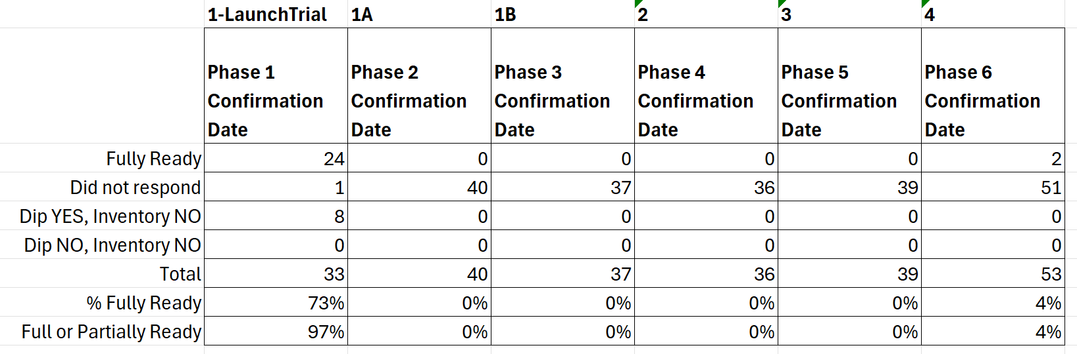

Kelly Walsh noted that the CNA has actually been chasing companies to get them to submit their attestation forms despite stating previously that they would not be doing that.

Jill Byers asked how many CO Codes are held by the company that did not respond? Kelly Walsh noted that he can’t be specific for privacy reasons but that they hold very few CO Codes.

Kelly Walsh asked if anyone is aware of any reason the Canadian Telecom Industry should not proceed with the Phase 1 Launch Trial. There were no stated concerns.

Ed Antecol noted that we are aware of the 33 CO Code Holders in this rollout but there is no information about groups like re-sellers. Hopefully the Commission gets a letter out to other non-code holders that they need to be using a TBP-compliant database for their LNP dips.

Agreement was reached that the Phase 1 Launch Trial will proceed as scheduled.

Jennifer Mack noted that there is an inconsistency between the summary of phase dates in CNCO312H. The group reviewed it and the dates were corrected to be consistent.

CNCO312H - TIF 125 - TBP Canada Rollout Schedule (incl. in-meeting changes)

Sage Wiese asked if there will be any gating for the subsequent phases regarding whether or not companies have requested any pooled resources in the previous rollout prior to implementing the next phase.

Jennifer Mack noted that the final phase in the plan has a due date of 27 July 2027 and only covers 110 Exchange Areas and noted that Telecom Regulatory Policy CRTC 2024-26 says that TBP is to be implemented in all Portable Exchange Areas by that date. Kelly Walsh noted that his understanding is that there is expected to be something going on outside of the CSCN like a Part 1 that would impact the range of Exchange Areas to be included.

Sage Wiese asked why the action would be going on outside of the CSCN? Kelly Walsh noted that it was discussed that the current plan does not include all Exchange Areas and that it seems to be against the policy. The group agreed that a modification to the approach should be something happening outside of the CSCN.

Agreement was reached to accept the TBP Rollout Schedule as revised today.

Action Item: The CNA will post an updated version of CNCO312H as CNCO312I and update the CNA TBP Implementation page. (Completed)

Ed Antecol noted that tomorrow, 24 April 2026, is the date for companies to tell us if they plan to donate Blocks. The CNA would like an indication of how many Blocks are expected to be donated.

Kelly Walsh noted that he has spoken to some companies and they have let him know that they are planning at least one donation and they are looking at whether not they plan to donate more. It seems to be a low number. If the volume is significant, then the CNA will have to make arrangements with TRA and NPAC.

Ed Antecol asked if Commission staff are going to follow-up with the one company that has not responded at all to the Carrier TBP Readiness Affirmation form. Étienne Robelin asked that the CNA provide him with the name of the company but that Commission staff did follow-up last week.

Action Item: The CNA will notify the CRTC staff about the company did not respond to the Carrier TBP Readiness Affirmation form. (Completed)

The Chair thanked everyone for participating.

Summary of Agreements Reached:

- Agreement was reached that the Phase 1 Launch Trial will proceed as scheduled.

- Agreement was reached to accept the TBP Rollout Schedule as revised today.

Summary of Action Items:

- The CNA will post an updated version of CNCO312H as CNCO312I and update the CNA TBP Implementation page. (Completed)

- The CNA will notify the CRTC staff about the company did not respond to the Carrier TBP Readiness Affirmation form. (Completed)

Attachments:

See text above for the attachments.

