CRTC INTERCONNECTION STEERING COMMITTEE
CONTRIBUTION FORM:
Working Group: CSCN Date of Submission: 2025-11-03
Contribution #: 308A
TIF #: 118 File ID: CNCO308A
Task Title: Update CSCN-Administered Guidelines for Thousands-Block Pooling
Related to Task(s) ID:
Contributor:
Name: Ed Antecol
Company: COMsolve Inc.
Address:
Tel:
Fax:
E-mail:
Distribution to: CSCN
Subject: Discussion of Section 4.2.3 of the draft TBCOCAG

4.2.3. For an Additional CO Code for a Pool Replenishment (which includes at least one Thousands-Block), the Code Applicant must certify in section 1.6 of the Part 1A Form (Pooled CO Code/Thousands-Block Assignment, Information Change, or Disconnect) that:

· existing Telephone Numbers (TNs) reported as available for assignment include either all TNs assigned to a single Switching Entity/POI of the Exchange Area or all TNs assigned in the Exchange Area across multiple Switching Entities/POIs; and

· these TNs are projected to exhaust within 12 months.

This shall be documented with supporting data in the Appendix B Months to Exhaust Certification Worksheet.

Proposed Additional Language

“An application for a CO Code for Pool Replenishment shall only be permitted where the requested number of Blocks is greater than the number of available Blocks in the Exchange Area Pool. For the purpose of this rule, Blocks with Contamination and Blocks with a future availability date (i.e., Blocks available after the CO Code Effective Date) shall be considered available blocks. Blocks that are awaiting PSTN Activation shall not be considered available Blocks.”

Commentary: The above assignment rule is less efficient than the approach in the US (described below). A carrier who requires 10 blocks that cannot qualify for a CO Code for Pool Replenishment will be required to provision and test the translations for each of the 10 Blocks. Suggestion: We can plan to develop systems to accommodate the US approach at a later date followed by an update to the guideline. Or should we put the US equivalent rule into the current guideline with a “when available” qualifier.

US Approach

To implement the US Rule equivalent, there needs to be a requirement for carriers to file additional semi-annual twelve-month forecasts for each Exchange Area Pool they operate in. CNA would be required to aggregate these forecasts and make available to applicants the industry Block Demand for each Exchange Area for the current month for use prior to submitting a Pool Replenishment application (likely current as of the previous business day as carriers can update these forecasts).

US Rule Equivalent: An application for a CO Code for Pool Replenishment shall only be permitted where the requested number of Blocks is greater than the number of available Blocks in the Exchange Area Pool or the aggregate forecasted demand for Blocks in the Exchange Area Pool is greater than the available Blocks in the Exchange Area Pool.

For the purpose of this rule, Blocks with Contamination and Blocks with a future availability date (i.e., Blocks available after the CO Code Effective Date) shall be considered available blocks. Blocks that are awaiting PSTN Activation shall not be considered available Blocks.

Forecast Sample From US Pool Admin System

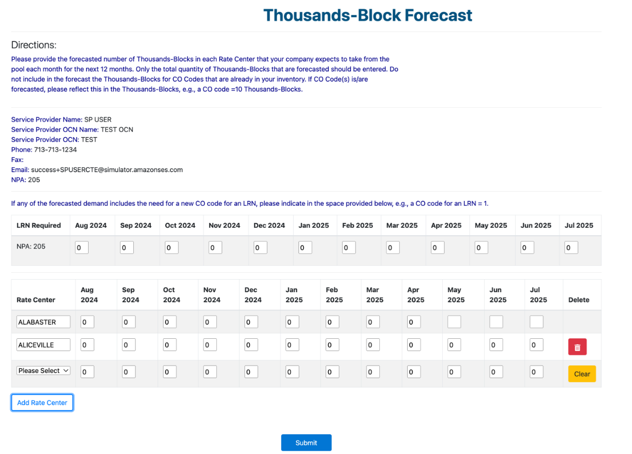

Sample Feedback to Carriers at time of Block Request from US Pool Admin System

