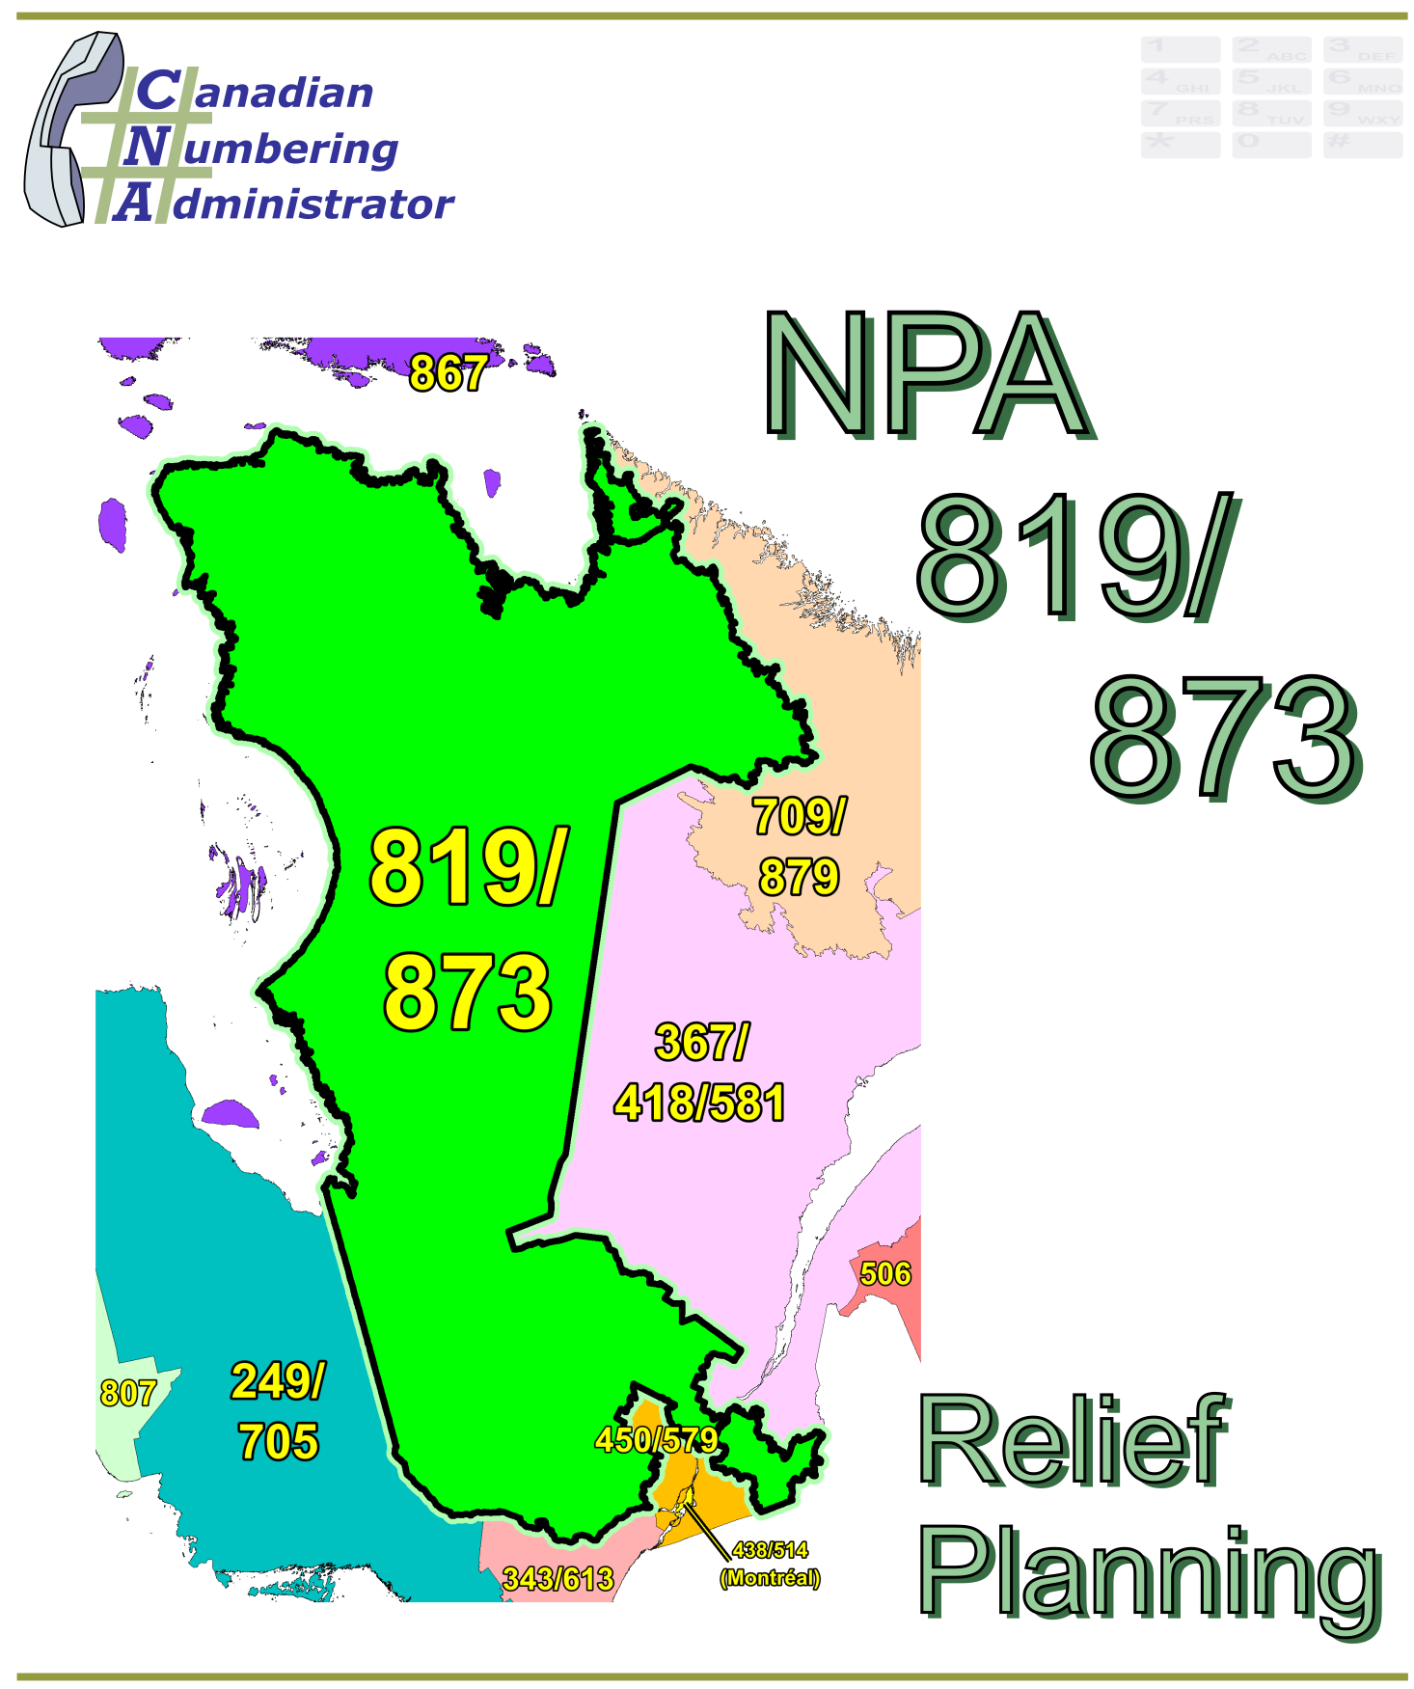

NPA 819/873 Planning Document (PD)

Version 1.0 – 10 March 2021

|  |  |
| --- | --- |
|  |  |

**TABLE OF CONTENTS**

1. INTRODUCTION 1

2. NPA RELIEF PLANNING PROCESS 2

3. NPA RELIEF METHODS 3

4. NPA EXHAUST INFORMATION 3

5. RELIEF OPTION 3

5.1. Distributed Overlay 4

6. SUMMARY OF RELIEF OPTION 4

7. DIALLING CHANGES FOR LOCAL CALLS 4

8. PROPOSED SCHEDULE 5

9. JEOPARDY CONTINGENCY PLAN (JCP) 0

10. SELECTION OF RELIEF NPA CODE 7

11. RECOMMENDATIONS 8

ANNEXES 9

**LIST OF ANNEXES**

**ANNEX A**

Figure 1 – Overview Map of NPA 819/873 1

Figure 2 – NPA 819/873 Actual and Forecast CO Code Assignments 2

Figure 3 – NPA 819/873 CO Code Exhaust – January 2021 R-NRUF 3

Figure 4 – NPA 819/873 CO Code Exhaust – July 2020 R-NRUF 3

Figure 5 – Distributed Overlay 5

**ANNEX B**

Table 1 – NPA 468/819/873 Exchange Areas After Distributed Overlay B-1

**ANNEX C**

Distribution List

**ACRONYM LIST**

|  |  |
| --- | --- |
| CATF | Consumer Awareness Task Force |
| CNA | Canadian Numbering Administrator |
| CISC | CRTC Interconnection Steering Committee |
| CLEC | Competitive Local Exchange Carrier |
| CLNPC | Canadian Local Number Portability Consortium |
| CO | Central Office |
| CRTC | Canadian Radio-television and Telecommunications Commission |
| CSCN | Canadian Steering Committee on Numbering |
| EAS | Extended Area Service |
| G-NRUF | General Numbering Resource Utilization Forecast |
| ILEC | Incumbent Local Exchange Carrier |
| IPD | Initial Planning Document |
| ISP | Internet Service Provider |
| JCP | Jeopardy Contingency Plan |
| J‑NRUF | Jeopardy Numbering Resource Utilization Forecast |
| LEC | Local Exchange Carrier |
| LIR | Local Interconnection Region |
| LNP | Local Number Portability |
| NANP | North American Numbering Plan |
| NANPA | North American Numbering Plan Administrator |
| NITF | Network Implementation Task Force |
| NoC | Notice of Consultation |
| NPA | Numbering Plan Area (Area Code) |
| NRUF | Numbering Resource Utilization Forecast |
| PD | Planning Document |
| PED | Projected Exhaust Date |
| PL | Planning Letter |
| POI | Point of Interconnection |
| PROC | Proposal for Relief of an Overlay NPA Complex |
| PSAP | Public Safety Answering Point |
| RIP | Relief Implementation Plan |
| R-NRUF | Relief Planning Numbering Resource Utilization Forecast |
| RPC | Relief Planning Committee |
| TSP | Telecommunications Service Provider |
| WNP | Wireless Number Portability |
| WSP | Wireless Service Provider |

**Planning Document (PD) Numbering Plan Area (NPA) 819/873**

# INTRODUCTION

Numbering Plan Areas (NPAs) 418 and 514, commonly referred to as area codes, were originally assigned to Québec by AT&T in 1947 as two of the 86 area codes to be used in Canada and the continental United States. In 1957 new area code 819 for Québec was split from parts of 514 and 418. The following table provides a high-level summary of the history of area code usage in the area currently served by NPA 819/873 since 1947.

|  |  |
| --- | --- |
| **Year** | **Activity** |
| 1947 | Area Codes 418 and 514 are assigned to Québec by AT&T |
| 1957 | New Area Code 819 is split from 418 and 514 to serve western Québec |
| 2012 | New Area Code 873 overlays 819 in western Québec |

The 819/873 area code or NPA consists of 211 Exchange Areas serving western Québec, and includes the major communities of Hull, Drummondville, Gatineau, Shawinigan, Sherbrooke, Trois-Rivières, Val d’Or and Victoriaville. A list of the Exchange Areas in NPA 819/873 is provided in Annex B, Table 1.

The table below provides a brief overview of recent activities leading to the development of this PD for NPA 819/873.

| **Date** | **Activity** |
| --- | --- |
| 3 February 2017 | NPA 468 is set aside for future relief of NPA complex 819/873 per Telecom Decision CRTC 2017-38 but could be used elsewhere if required.  **For the purpose of this document the new NPA will be 468.** |
| 26 March 2019 | The Canadian Numbering Administrator (CNA) published the January 2019 G‑NRUF results which indicated that the Projected Exhaust Date (PED) had advanced to October 2025. |
| 20 September 2019 | The CNA published the July 2019 R-NRUF results which indicated that the PED had advanced to March 2025. |
| 30 January 2020 | The CRTC released Telecom Notice of Consultation CRTC 2020‑34 - The Commission announces the establishment of a CRTC Interconnection Steering Committee ad hoc relief planning committee (RPC) to examine options and make recommendations for providing numbering relief to area codes 819 and 873 in western Quebec |
| 24 March 2020 | The CNA published the January 2020 R‑NRUF results which indicated that the PED had moved out to July 2025. |
| 18 August 2020 | The CNA published the July 2020 R-NRUF results which indicated that the PED had advanced to December 2023. |
| 21 September 2020 | The CNA issued the PROC and announced the date of the initial Relief Planning Committee (RPC) conference call. |
| 23 February 2021 | The CNA published the January 2021 R-NRUF results which indicated that the PED had advanced to July 2023 |

This Planning Document is prepared by the RPC in accordance with Telecom Notice of Consultation CRTC 2018‑409 and the *Canadian NPA Relief Planning Guideline*, Version 7.0 dated 29 January 2019 (the Guideline). A copy of the Guideline is available from the Canadian Radio-Television and Telecommunications Commission (CRTC), CRTC Interconnection Steering Committee (CISC), Canadian Steering Committee on Numbering (CSCN) guidelines web page at: <https://crtc.gc.ca/cisc/eng/cisf3fg.htm>.

The objective of the NPA Relief Planning process is to ensure that CO Codes and telephone numbers are always available for use by TSPs and their customers in the geographic area requiring relief.

It is very important to closely monitor the CO Code requirements of all existing and prospective CO Code Holders so that relief can be timed to ensure that CO Codes and telephone numbers are always available for service providers and customers.

In this PD, a single option is identified for providing NPA relief in the NPA 819/873 geographic area. Given the magnitude of this undertaking, intercompany commitment and co‑operation are essential throughout the planning, provisioning and implementation stages of the introduction of the new NPA.

# NPA RELIEF PLANNING PROCESS

The NPA Relief Planning process and the roles of the participants (i.e. CRTC, CNA, CISC, Relief Planning Committee (RPC) participants and Interested Parties) for NPA Relief Planning are identified in the Guideline.

To increase public awareness and participation in the NPA Relief Planning process, the CRTC has determined that NPA RPCs will be established as ad hoc committees of the CISC. Generally, a separate ad hoc committee is created to deal with relief in each area code. The CNA, in its function as NPA Relief Planning Coordinator, acts as chair of these ad hoc committees. Meetings and conference calls of the ad hoc NPA RPCs are all open to public participation and are conducted in accordance with the *CISC Administrative Guidelines* which are available from the CRTC website at: <https://www.crtc.gc.ca/cisc/eng/cag.htm>.

NPA Relief Planning is conducted under the regulatory oversight of the CRTC. Notwithstanding the process detailed in the Guideline, the CRTC may exercise its authority under the *Telecommunications Act* to alter this process at any time. The CRTC has the authority under the *Telecommunications Act* to review, modify and give final approval to the Planning Document (PD) and the Relief Implementation Plan (RIP) developed and submitted by the RPC to the CRTC via the CISC process.

Section 7.1.6 of the *Canadian NPA Relief Planning Guideline* requires the CNA to create and maintain a distribution list of parties who may be interested in participating in the RPC and to provide them with advance notice of the initial RPC meeting and the release of a PROC.

Any person wishing to participate in the NPA Relief Planning process can contact the CNA and request to be added to the RPC distribution list. More information on how to participate in CRTC public processes is available at: <http://www.crtc.gc.ca/eng/info_sht/g4.htm>.

A summary of Canadian geographic area code relief history is available at: <https://www.cnac.ca/npa_codes/NPA_History.pdf>.

# NPA RELIEF METHODS

The purpose of this section is to identify and briefly describe NPA Relief Methods.

The Guideline states that: “The only NPA Relief Method considered in Canada is the Distributed Overlay Method which superimposes or “overlays” a Relief NPA on top of an entire existing NPA or NPAs.” There are three types of Distributed Overlay:

1. a Distributed Overlay over an existing geographic area served by a single existing NPA (a new NPA is overlaid over a single existing NPA (i.e., the geographic area) that is served by a single NPA);
2. a Distributed Overlay over an existing geographic area served by multiple existing overlay NPAs (a new NPA is overlaid over a single existing NPA (i.e., the geographic area) that is served by multiple existing overlay NPAs) and,
3. a Distributed Overlay over multiple existing geographic areas, each served by one or more existing NPAs (a new NPA is overlaid over multiple existing NPAs (i.e., different geographic areas served by multiple NPAs. This type of overlay may be considered for NPA relief for two or more adjacent NPAs (i.e., geographic areas) within a province).

# NPA EXHAUST INFORMATION

As indicated in the following table, NRUFs for NPA 819/873 were used to determine PEDs, (i.e. the dates when CO Codes in NPA 819/873 would be expected to exhaust).

|  |  |
| --- | --- |
| **NRUF** | **Projected Exhaust Date (PED)** |
| G‑NRUF January 2019 | October 2025 |
| R-NRUF July 2019 | March 2025 |
| R‑NRUF January 2020 | July 2025 |
| R‑NRUF July 2020 | December 2023 |
| R‑NRUF January 2021 | July 2023 |

Refer to Annex A, Figures 2 through to 4 for graphs of forecast CO Code demand from current and prospective CO Code Holders and Administrative Codes set aside in area code 819/873 for the two most recent NRUFs (January 2021 and July 2020).

# RELIEF OPTION

The Relief Option as identified and examined in this PD is a Distributed Overlay over an existing geographic area served by multiple existing overlay NPAs.

Using this method, a new NPA is overlaid over an existing NPA (i.e., the geographic area) that is served by the overlay complex of NPAs 819/873.

The Relief Option identified above was evaluated using the following assumption:

1. The Relief Date for the Distributed Overlay will be 22 October 2022 (approximately 9 months prior to the NPA 819/873 PED of July 2023 identified using the January 2021 R‑NRUF results).

See Annex A, Figure 5 for diagram of the Distributed Overlay Relief Option identified by the RPC.

## Distributed Overlay

A Distributed Overlay Relief Option was evaluated which would overlay the NPA 468 over all 211 Exchange Areas comprising the NPA 819/873 area. See Annex A, Figure 5.

The introduction of a Distributed Overlay would keep the same number of NPA Relief Planning areas in Québec.

After this Distributed Overlay, CO Codes in NPA 468/819/873 would be expected to exhaust in Q3 2034.

Subsequent exhaust of NPA 819/873 was forecast using the Five-Year Historical growth value of 61 CO Codes per year by comparing the January 2021 R-NRUF data in the table below:

|  |  |  |  |
| --- | --- | --- | --- |
| **Statistical Method** | **Data** | **Period** | **Quantity of CO Codes** |
| median | forecast growth | next six years | 96 |
| average | forecast growth | five-year period (January 2022 until January 2027) | 93 |
| average | forecast growth | next six years | 103 |
| average | historical growth | past five years | 64 |
| median | historical growth | past five years | 61 |

# SUMMARY OF RELIEF OPTION

|  |  |  |  |
| --- | --- | --- | --- |
| **Relief Option** | **Projected Exhaust Dates** | | **Subsequent Relief Dates** |
| **NPA 819/873** | **NPA 468/819/873** |
| Distributed Overlay | July 2023 | July 2034 | July 2033 |

**Note: Distributed Overlay NPA 468 would be in service on 22 October 2022.**

# DIALLING CHANGES FOR LOCAL CALLS

Currently 10-digit dialling is mandatory for local calls originating within area code NPA 819/873 and all neighbouring NPAs (i.e., NPA 249/705, NPA 343/613/753, NPA 354/450/579 and NPA 367/418/581). Local dialling plans will not change with this relief.

# PROPOSED SCHEDULE

The RPC submits the following schedule for NPA 819/873 relief based on the recommendations contained in this PD and the current PED of July 2023. The RPC will monitor the PED, and if it changes significantly in the future, the RPC will assess the situation and, if necessary, submit recommendations including a revised schedule to the CRTC for consideration and approval.

**RELIEF IMPLEMENTATION SCHEDULE**

**For a Distributed Overlay of NPA 468 over NPA 819/873**

| **Item** | **Task or Event** | **PRIME** | **START** | **END** |
| --- | --- | --- | --- | --- |
| 1 | NPA 468 is set aside for future relief of QC NPAs 819/873 per CRTC decision 2017-38 but could be used elsewhere if required. **For the purpose of this document the new NPA will ne 468** | CRTC |  | 2017-02-03 |
| 2 | CNA identifies NPA exhaust of October 2025 and notifies by e-mail CRTC staff, CSCN, NANPA & CISC that the NPA will exhaust within the future six-year time period | CNA |  | 2019-03-26 |
| 3 | CNA published the Initial R-NRUF (July 2019) results which indicated that PED has advanced to March 2025 | CNA | 2019-06-15 | 2019-09-20 |
| 4 | CRTC issues Telecom Notice of Consultation regarding establishment of an ad hoc Relief Planning Committee | CRTC |  | 2020-01-30 |
| 5 | CNA conducts January 2020 R-NRUF results indicating the PED has moved out to July 2025. | CNA |  | 2020-03-24 |
| 6 | CNA identifies NPA exhaust of December 2023 and notifies by e-mail CRTC staff, CSCN, NANPA & CISC that the NPA will exhaust within the future three-year time period | CNA |  | 2020-08-18 |
| 7 | RPC Chair starts preparing and submitting RPC Chair Reports to the CISC, on an as required basis. | RPC Chair | 2020-01-30 | 2023-02-17 |
| 8 | CNA releases the PROC and announces the date for the initial RPC conference call | CNA | 2020-08-18 | 2020-09-21 |
| 9 | RPC participants review PROC & submit contributions to RPC |  | 2020-09-21 | 2020-10-23 |
| 10 | CNA issues July 2020 R-NRUF results indicating the PED has advanced to December 2023. |  |  | 2020-08-18 |
| 11 | At the request of the ILEC, the date of the initial RPC conference call was postponed until after the January 2021 R-NRUF results were published |  |  | 2020-10-20 |
| 12 | CNA issues January 2021 R-NRUF results showing the PED has advanced to July 2023 |  |  | 2021-02-23 |
| 13 | RPC participants review PROC & submit contributions base on January 2021 R-NRUF results to RPC |  | 2021-02-23 | 2021-03-24 |
| 14 | CNA chairs initial RPC conference call to start development of PD, RIP & PL, & schedules future meetings/conference calls including creation & consultation with CATF and NITF | CNA, RPC | 2021-03-24 | 2021-04-01 |
| 15 | CNA chairs subsequent RPC conference calls to finalize PD & RIP | CNA, RPC | 2021-04-06 | 2021-04-20 |
| 16 | CNA forwards the PD and RIP to the CISC and CRTC for approval | CNA | 2021-04-20 | 2021-04-27 |
| 17 | Special Types of Telecommunications Service Users (911 PSAPs, alarm companies, ISPs, paging companies, etc.) to identify any concerns to RPC & CRTC | Special Users | 2021-04-01 | 2021-04-27 |
| 18 | CRTC issues Telecom Decision approving the Relief Method, Relief Date, New NPA & Relief Implementation Plan (RIP) | CRTC | 2021-04-27 | 2021-08-27 |
| 19 | CNA obtains relief NPA from NANPA | CNA | 2021-08-27 | 2021-09-13 |
| 20 | RPC develops the Planning Letter (PL) | RPC | 2021-09-13 | 2021-09-27 |
| 21 | Task Forces, TSPs and users implement relief (starts upon CRTC approval of RIP and ends on Relief Date) | TSPs | 2021-08-27 | 2022-10-22 |
| 22 | All Telecom Service Providers (TSPs) to develop and file individual consumer awareness programs with the CRTC (may be done collectively by Telecommunications Alliance) (starts upon CRTC approval of RIP) | TSPs | 2021-08-27 | 2022-01-22 |
| 23 | CNA submits PL and RIP to NANPA | CNA | 2021-09-27 | 2021-10-12 |
| 24 | NANPA receives and posts Planning Letter to NANPA website (within 2 weeks of receipt from the CNA) | NANPA | 2021-10-12 | 2021-10-26 |
| 25 | All TSPs implement consumer awareness activities (starts upon filing of Consumer Awareness Programs with the CRTC and is completed on the Relief Date) | TSPs | 2022-01-22 | 2022-10-22 |
| 26 | CNA issues media release (in coordination with TSPs and/or Telecommunication Alliance) (may start upon CRTC approval of RIP) | CNA | 2021-08-27 | 2022-03-22 |
| 27 | All TSPs to notify all customers (including residence, business & special customers) of the new overlay NPA (may start upon the filing of Consumer Awareness Programs with the CRTC) | TSPs | 2022-01-22 | 2022-03-22 |
| 28 | TSPs to submit Progress Report #1 to NITF and CATF (starts after completion date for all TSPs to notify their customers and requires 2 weeks) | TSPs | 2022-03-22 | 2022-04-05 |
| 29 | NITF and CATF develop & submit Progress Report #1 to RPC (linked to TSP reports to NITF and CATF) | NITF & CATF | 2022-04-05 | 2022-04-21 |
| 30 | RPC submits Progress Report #1 to CISC/CRTC (linked to NITF and CATF reports) | RPC | 2022-04-21 | 2022-05-05 |
| 31 | iconectiv TRA database updates to add Exchange Areas to new overlay NPA (starts on the date that the PL is posted to the NANPA web site) | iconectiv TRA | 2021-10-26 | 2021-12-21 |
| 32 | All Telecommunications Service Users (including Special Users 911 PSAPs, alarm companies, ISPs, paging companies, etc.) to implement changes to their telecom equipment & systems to accommodate the new NPA (starts upon CRTC approval of RIP and ends on the Relief Date) | Telecom Service Users | 2021-08-27 | 2022-10-22 |
| 33 | Payphone Providers Reprogram Payphones (starts upon CRTC approval of RIP and ends on the Relief Date) | Payphone Providers | 2021-08-27 | 2022-10-22 |
| 34 | TSPs and database owners/operators to modify systems and industry databases (starts upon CRTC approval of RIP and ends on the Relief Date) | TSPs & Database Owners | 2021-08-27 | 2022-10-22 |
| 35 | Operator Services & Directory Assistance Readiness (starts upon CRTC approval of RIP and ends on the Relief Date) | TSPs | 2021-08-27 | 2022-10-22 |
| 36 | Directory Publisher Readiness for overlays (ability to identify the NPA in telephone numbers in the directory published after the Overlay NPA is activated) (starts upon CRTC approval of RIP and ends on the Relief Date) | Directory Publishers | 2021-08-27 | 2022-10-22 |
| 37 | 9-1-1 Systems and Databases Readiness (starts upon CRTC approval of RIP and ends on the Relief Date) | PSAPS, 9 1 1 Service Providers & TSPs | 2021-08-27 | 2022-10-22 |
| 38 | Network Systems & Equipment Readiness (starts upon CRTC approval of RIP and ends on the Relief Date) | TSPs | 2021-08-27 | 2022-10-22 |
| 39 | Service Order & Business System Readiness (starts upon CRTC approval of RIP and ends on the Relief Date) | TSPs | 2021-08-27 | 2022-10-22 |
| 40 | International Gateway Switch Translations Readiness for new NPA (starts upon CRTC approval of RIP and ends on the Relief Date) | Int’l TSPs | 2021-08-27 | 2022-10-22 |
| 41 | Canadian Local Number Portability Consortium (CLNPC) Database Readiness for new NPA (starts upon CRTC approval of RIP and ends on the Relief Date) | CLNPC & NPAC | 2021-08-27 | 2022-10-22 |
| 42 | Toll Free SMS Database Readiness for new NPA (starts upon CRTC approval of RIP and ends on the Relief Date) | Toll TSPs | 2021-08-27 | 2022-10-22 |
| 43 | TSPs apply for Test CO Codes in new NPA (applications may be submitted no more than 6 months and no less than 66 days prior to the start date for the Inter-Carrier Testing Period) (Section 7.16.4 Canadian RP GL) | TSPs | 2021-12-22 | 2022-04-17 |
| 44 | Develop Inter-Carrier Network Test Plans and prepare for testing (individual TSPs to make arrangements in accordance with interconnection agreements) (may start upon CRTC approval of RIP and must be completed by start date for the Inter-Carrier Testing Period) | NITF & TSPs | 2021-08-27 | 2022-06-22 |
| 45 | All international and domestic Telecommunications Service Providers (TSPs) must activate the new NPA in their networks by the start date for the Inter-Carrier Testing Period | TSPs | 2021-08-27 | 2022-06-22 |
| 46 | Activation date for Overlay NPA Test CO Codes and Test Numbers in network (should be completed by the start date for the Inter-Carrier Testing Period) | TSPs |  | 2022-06-22 |
| 47 | Inter-Carrier Testing Period (subject to Inter-Carrier Network Test Plans) (starts about 3 months prior to the Relief Date, and ends about 1 month after the Relief Date) | NITF & TSPs | 2022-06-22 | 2022-11-21 |
| 48 | TSPs to submit Progress Report #2 to NITF ~~and CATF~~ (starts on commencement of Inter-Carrier Testing Period) | TSPs | 2022-06-22 | 2022-07-08 |
| 49 | NITF ~~and CATF~~ develops & submits Progress Report #2 to RPC (linked to TSP reports to NITF ~~and CATF~~) | NITF ~~& CATF~~ | 2022-07-08 | 2022-07-22 |
| 50 | RPC submits Progress Report #2 to CRTC staff (linked to NITF ~~and CATF~~ report) | RPC | 2022-07-22 | 2022-08-08 |
| 51 | Relief Date (earliest date when CO Codes in new NPA may be activated) |  |  | 2022-10-22 |
| 52 | TSPs submit Final Report to CATF and NITF (starts on Relief Date and provides 2 weeks for preparation & submission) | TSPs | 2022-10-24 | 2022-11-07 |
| 53 | NITF and CATF develop & submit Final Progress Report to RPC (linked to TSP reports to NITF and CATF) | NITF & CATF | 2022-11-08 | 2022-11-22 |
| 54 | The RPC submits Final Progress Report to CRTC staff (linked to NITF and CATF reports) | RPC | 2022-11-22 | 2022-12-06 |
| 55 | TSPs disconnect Test Codes & Numbers, and submit Part 1 form to return Test Codes (starts 1 month after Relief Date and allows 1 month for completion) | TSPs | 2022-11-21 | 2023-01-13 |
| 56 | RPC Chair submits, to the CISC, the final RPC Chair report indicating that the **NPA 819/873** ad hoc RPC is no longer required | RPC Chair | 2023-01-13 | 2023-02-17 |

# JEOPARDY CONTINGENCY PLAN (JCP)

The RPC has developed the following JCP for inclusion in the PD for NPA 819/873. This JCP is based on the example contained in Appendix F to the *Canadian NPA Relief Planning Guideline*.

This JCP shall remain in effect until superseded by a CRTC-approved JCP, the Jeopardy Condition is suspended or 66 days prior to the Relief Date.

The following measures shall be implemented in NPA 819/873 while a Jeopardy Condition is in effect.

During a Jeopardy Condition, CO Code Applicants shall submit all CO Code applications and related correspondence for the Jeopardy NPA to CRTC staff in addition to the CNA. The CNA shall only assign CO Codes from the exhausting NPA to a CO Code Applicant when instructed by CRTC staff.

1. Carriers and/or Telecommunications Service Providers (TSPs):
   1. shall age disconnected residential wireline telephone numbers for a maximum of two months;
   2. shall age disconnected wireless telephone numbers for a maximum of three months;
   3. shall age disconnected business wireline telephone numbers for a maximum of six months. Under special circumstances, the six month aging limit for business telephone numbers may be extended to twelve months, if required, to accommodate local directory publishing dates for high volume call-in applications (e.g., heavily advertised local business numbers such as radio talk shows, food ordering services, ticket sales, chat lines), or for numbers associated with public service emergency applications or for numbers advertised in directories for which customers have requested reference of calls;
   4. shall return all CO Codes that are not being used, nor intended to be used to directly serve customers to the assignment pool within two months (e.g., plant test codes);
   5. should work towards, and encourage existing customers, to either activate or return the reserved numbers to bring the reserved quantity down to a maximum of 10% of the quantity of numbers In-Service for that customer;
   6. shall not allow the quantity of reserved numbers to be increased by new reservation requests by existing customers to more than 10% of the quantity of numbers in service for that customer. In the case of new customers, number reservations shall be limited to 10% of the total quantity of telephone numbers being placed into service for that customer;
   7. shall, within 45 days from the date that the CNA declares a Jeopardy Condition submit a Part 1 Form for each remaining reserved CO Code either returning the reserved CO Code to the CNA or requesting assignment of the reserved CO Code. Once the 45-day period has elapsed, the CNA shall make available for general assignment all CO Codes that are still reserved and have not been applied for as assignments on a Part 1 Form received by the CNA. Within 60 days from the date that the CNA declares a Jeopardy Condition, the CNA shall report to CRTC staff and the RPC as to how many of these codes have been assigned or made available for general assignment;
   8. shall not be permitted to obtain a new CO Code reservation;
   9. shall place all CO Codes assigned prior to the Jeopardy Condition being declared In-Service within three months of the effective date for CO Code activation in the network, or within three months of the date that the Jeopardy Condition was declared. If the CO Code is an Initial Code and the CO Code Holder can demonstrate that, due to circumstances beyond its control, the In-Service date has been delayed beyond the applicable timeframe, then the CNA may grant an extension of up to two months to the In-Service date. The CNA shall initiate reclamation procedures for all CO Codes that have not been placed In-Service within these timeframes unless CRTC staff provides a further extension.
2. For new applications for Initial Codes, each CO Code Holder shall certify that the CO Code will be activated in the network and placed In-Service within four months of the date of application for the Code. If the CNA does not receive a Part 4 Form within this timeframe, confirming that the CO Code has been placed In-Service, the CNA will initiate reclamation measures. If the CO Code Holder can demonstrate that, due to circumstances beyond its control, the In-Service date has been delayed not more than six months from the original application date, then the CNA may grant an extension to the In-Service date, so long as the In-Service date is not more than six months beyond the original application date. If the In-Service date has been delayed more than six months from the original application date, then the CNA shall reclaim the Code unless CRTC staff provides a further extension.
3. When applying for an Additional Code for Growth, a CO Code Holder who is submitting a Part 1 Form and Appendix B worksheet shall also submit a completed Supplementary Form for a Growth CO Code Application (attached) which certifies and/or provides the following information for the specific switching entity/POI and Exchange Area when the Growth CO Code is being requested in a Jeopardy Condition:
   1. certification that all held telephone numbers have been released;
   2. certification that reserved numbers do not exceed ten percent of the total quantity of numbers as defined in Appendix G of the Canadian CO Code (NXX) Assignment Guideline;
   3. certification that each reseller/dealer had been advised of the Jeopardy Condition and the requirement that they would only be allocated additional numbers during the Jeopardy Condition on the provision to the CO Code Holder of written confirmation that their number inventory has been reduced to an amount less than two times the highest quantity of customer numbers assigned in any month during the previous 12 months. Additional numbering resources will only be provided by the CO Code Holder to the reseller/dealer to the extent that the reseller's/dealer's inventory can only increase up to a maximum of three months' inventory;
   4. confirmation that the Part 1 form submitted with the application has the Jeopardy Condition box in section 1.6 checked to certify that the existing CO Codes are projected to exhaust within 4 months of the date of application and that the months-to-exhaust is documented on an Appendix B submitted to the CNA;
   5. a completed Telephone Number Utilization Report for the applicable switching entity signed by both a company officer and the company’s authorized representative;
   6. confirmation that the requested Growth CO Code was forecasted in the most recent NRUF or an explanation as to why it was not is attached; and,
   7. confirmation that the requested Growth CO Code will be placed In-Service within four months of the date of assignment.
4. Any CO Codes for growth assigned after the implementation of this JCP must be activated in the network and placed In-Service within four months of assignment. In the event that a CO Code Holder is unable to place the CO Code In-Service within four months of the date of assignment, the CO Code Holder must return the assigned CO Codes or submit a written request for extension to the CNA. Such written requests must include documentation explaining the reason(s) for the missed date and proposing the new In-Service date. If the explanation includes reasons beyond the control of the CO Code Holder, the CNA may extend the In-Service date a maximum of one month. If the CO Code Holder does not place the CO Code In-Service within the one-month extension, the CNA shall initiate the reclamation process at the end of the one-month extension unless CRTC staff provides a further extension.
5. A Carrier that has multiple switching entities within an Exchange Area shall examine the possibility of, and implement where feasible, number sharing between those switches as a potential method to delay requirements for additional CO Codes.
6. The CNA will request two versions (two separate worksheets (Form 1 and Form 2)) of the J-NRUF input from all current and prospective CO Code Holders quarterly until three (3) months before relief is provided.
   1. The forecast quantities in Form 1 should be the same as or lower than the last R‑NRUF input submitted, prior to declaration of a Jeopardy Condition. CO Code Holder forecasts may reflect an increase in demand in the period subsequent to the Relief Date.
   2. Form 2 will reflect the actual demand required by the CO Code Holder's current business plan and will be provided for information purposes only.
7. The CNA will compare the initial J-NRUF input to the recent NRUF inputs, to assess forecasting trends. The CNA shall monitor all inputs and shall test them for reasonableness in consultation with the Carrier. If the CNA is dissatisfied with the reasonableness, or the rationale provided for the deviations, then the matter will be referred to the CRTC staff.
8. The CNA will request subsequent J-NRUF input from all current and prospective CO Code Holders quarterly until 3 months before relief is provided. If one or more R-NRUFs have already been conducted, and depending on the severity of the Jeopardy Condition, the CNA may defer a J-NRUF by up to two months if such a deferral brings the timing of that J‑NRUF and subsequent J-NRUFs into alignment with other NRUFs that are conducted at 12, 6 or 3 month intervals. Subsequent J-NRUF input will be compared with the initial J‑NRUF input to evaluate the effectiveness of the JCP. The CNA shall monitor all J-NRUF inputs and shall test them for reasonableness in consultation with the Telecommunications Service Providers. If the CNA is dissatisfied with the reasonableness, or the rationale provided for the changed forecasts, then the matter will be referred to CRTC staff.
9. A CO Code Applicant must have submitted a completed J-NRUF to the CNA before the CNA may assign a CO Code to that CO Code Applicant.
10. If a CO Code applicant wishes to request more CO Codes than it identified in its most recent J NRUF, the CO Code Applicant should discuss the matter with the CNA. If the CO Code Applicant wishes to proceed with the request, the CO Code Applicant will forward the request and revised forecast to CRTC staff and the CNA for consideration.
11. The CO Codes identified in the NPA CO Code Inventory Chart as “Assignable CO Codes in a Jeopardy Condition” will be assigned in the order determined by the RPC after all CO Codes which are “Available for Assignment as of [day month year] have been assigned.
12. After each J-NRUF, the CNA shall provide CRTC staff, the RPC and CSCN participants with a report providing an updated NPA CO Code Inventory Chart for the NPA in jeopardy as well as the aggregate results of the most recent J-NRUF.
13. Exceptional issues or concerns may be referred by the CNA, or by individual entities (with a courtesy copy to the CNA), to the CRTC staff for resolution.
14. In a situation where the Relief Date is on or after the PED, the quantity of CO Codes that may be assigned to a CO Code Applicant prior to the end of the Jeopardy Condition (i.e. 66 days prior to the Relief Date) shall be limited to the quantity forecasted by the CO Code Applicant in its most recent NRUF forecast submitted prior to the Jeopardy Condition being declared by the CNA (if no previous NRUF was submitted, then the previous forecast will be deemed to be zero codes). When making requests to obtain CO Codes prior to the end of the Jeopardy Condition (i.e. 66 days prior to the Relief Date), the CO Code Applicant may change the Exchange Area or the month when the CO Code assignment is required, provided a new J-NRUF and explanation accompanies the application. The control imposed by this option may be relaxed if subsequent J-NRUFs defer the PED to after the Relief Date. CO Codes that become available for assignment due to future reduced demand from other current and prospective CO Code Holders may be assigned at the discretion of CRTC staff.
15. If the CNA determines that the implementation of the JCP has not extended the Projected Exhaust Date of the NPA beyond the Relief Date, the CNA will consult with CRTC staff and further CO Code conservation and assignment procedures may be ordered by the Commission (e.g., rationing, lottery, etc.).

Supplementary form for a Growth CO Code Application – Page 1 of 2 – Telephone Number Utilization Report

This form is required with each request for an Additional Code for Growth in an NPA where a Jeopardy Condition is in effect. It should be submitted to the CNA together with the Part 1 and Appendix B forms that are required for an application for an Additional Code for Growth. See the Part 1 form for information on how and where to submit the form.

I hereby certify that the following information is true and accurate to the best of my knowledge and has been prepared in accordance with Special Conservation Procedures for a Jeopardy Condition contained in the *Canadian NPA Relief Planning Guideline* or the applicable approved Jeopardy Contingency Plan.



Name & Signature of Authorized Representative of Code Holder Title Date



Name & Signature of Company Officer (see item 3 of this JCP) Title Date

Contact information: Entity Name: __________________ Contact Name: _____________

Address: __________________ City, Province, Postal Code: _____________

Telephone: __________________ Facsimile: _____________

E-mail: __________________

Switch Identification (Switching Entity/POI) CLLI: _______________ Exchange Area: ________________

For the above Switch Identification and Exchange Area for which a Growth CO Code is requested:

I certify that all held telephone numbers have been released

I certify the total quantity of reserved numbers does not exceed ten percent (10%) of the total quantity of telephone numbers as defined in Appendix G of the *Canadian CO Code (NXX) Assignment Guideline*

I certify that each reseller/dealer has been advised of the Jeopardy Condition and the requirement that they would only be allocated additional numbers during the Jeopardy Condition on the provision to the CO Code Holder of written confirmation that their number inventory has been reduced to an amount less than two (2) times the highest quantity of customer numbers assigned in any month during the previous twelve (12) months. Additional numbering resources will only be provided by the CO Code Holder to the reseller/dealer to the extent that the reseller's/dealer's inventory can only increase up to a maximum of three months' inventory.

The Part 1 form submitted with the application has the Jeopardy Condition box in section 6 checked (this certifies that the existing CO Codes are projected to exhaust within four (4) months of the date of the application or within the period specified in an approved Jeopardy Contingency Plan, and that the months-to-exhaust is documented on an Appendix B submitted to the CNA).

The Telephone Number Utilization Report on page 2 of this form has been completed.

The requested Growth CO Code was forecasted in the most recent NRUF, or an explanation as to why it was not is attached.

The requested Growth CO Code will be placed In-Service within four (4) months of the date of assignment.

**Supplementary Form for a Growth CO Code Application – Page 2 of 2 – Telephone Number Utilization Report**

Use Arial 9 to complete this form. (Note: If the spreadsheet below does not show on your display, please change the Work view to "Print Layout" or "Reading Layout")



Remarks: _______________________________________________________________________________

________________________________________________________________________________________

**NPA 819/873 CO Code Inventory Chart**

The following chart and the instructions it contains will apply in NPA 819/873 in a Jeopardy Condition.

The chart below lists quantities of CO Codes unassignable prior to a Jeopardy Condition, CO Codes that become assignable in a Jeopardy Condition and CO Codes in NPA 819/873 assigned and In‑service as of 1 April 2021. The CO Codes that become assignable in a Jeopardy Condition shall only be made available for assignment when all other available CO Codes have been assigned in the order listed below.

|  |  |  |
| --- | --- | --- |
|  |  | **Quantity** |
| **A** | **Total CO Codes in NPAs 819/873** **(NXX format)** | **1600** |
|  | | |
| **B** | **CO Codes unassignable prior to a Jeopardy Condition** |  |
|  | N11 Service Codes (211, 311, 411, 511, 611, 711, 811, 911) | 16 |
|  | Special Use Codes (555, 950 & 976) | 5 |
|  | Home NPA Code(s) | 4 |
|  | Current Neighbouring NPA Codes (249, 343, 450, 579, 613, 705) | 12 |
|  | Future Geographic NPA Codes (257, 273, 468, 487, 584, 851, 871 & 942) (Note 1) | 16 |
|  | Plant Test Codes (958 & 959) | 4 |
|  | Special 7-digit Dialling Codes (310, 610 & 810) | 5 |
|  | USA Dialing problem (207 & 802) | 4 |
|  | **Total B** | 66 |
|  | | |
| **C** | **CO Codes assignable prior to a Jeopardy Condition (C=A-B)** | **1534** |
|  | | |
| **D** | CO Codes unassignable prior to a Jeopardy Condition that become assignable in a Jeopardy Condition: |  |
| Future Canadian Geographic NPA Codes (Notes 1 & 2) | 14 |
| Current Neighbouring NPA Codes (249, 343, 450, 579, 613, 705) (Note 2) | 12 |
| **Total D** | **26** |
|  | | |
| **E** | **Assignable CO Codes in a Jeopardy Condition (E=C+D)** | **1560** |
| **F** | **Assigned CO Codes as of 1 April 2021** | **1280** |
| **G** | **Net CO Codes available for assignment as 1 April 2021 without a Jeopardy Condition (G=C-F)** | 254 |
| **H** | **Net CO Codes available for assignment as of 1 April 2021 in a Jeopardy Condition (H=E-F)** | 280 |

**Notes:**

1. In Telecom Decision CRTC 2017-38, the Commission determined that area code 468 should be set aside as a potential future relief area code for area codes 819 and 873.
2. CO Codes 257, 273, 487, 584, 851, 871 & 942 should become assignable in a Jeopardy Condition.
3. In an extreme Jeopardy Condition (i.e. when the Projected Exhaust Date is earlier than the Relief Date), the current Neighbouring NPA Codes 249, 343, 450, 579, 613, and 705 could be assignable with CRTC staff approval.

# SELECTION OF RELIEF NPA CODE

If the recommended Relief Option requires a new NPA Code, the criteria for selection of an appropriate area code for relief is addressed in section 4.11 of the *Canadian NPA Relief Planning Guideline*. The criteria that should be taken into account when Future Canadian Geographic NPAs are being considered as candidates for relief of a specific current Canadian Geographic NPA include the following:

1. The preferred Future Canadian Geographic NPA Code should not be an NPA Code that is assigned as a CO Code in the area that is being relieved (Home NPA(s)).
2. The preferred Future Canadian Geographic NPA Code should not be an NPA Code that is assigned as a CO Code in another NPA within the same province where there is a possibility that a single new NPA Code could be overlaid on more than one NPA within the province, or where boundary realignment could occur that affects another NPA.
3. The preferred Future Canadian Geographic NPA Code should not be an NPA Code that is assigned as a CO Code in an Exchange Area in a neighbouring NPA, if the neighbouring NPA has 7-digit local calling within the NPA and i) the Exchange Area in the neighbouring NPA where the CO Code is assigned has local calling to the NPA being relieved or ii) the Exchange Area in the neighbouring NPA where the CO Code is assigned does not have local calling to the NPA being relieved, but other Exchange Areas within that neighbouring NPA have 7-digit local calling to the Exchange Area where the CO Code is assigned as well as local calling to the new NPA.

CO Codes corresponding to Future Canadian Geographic NPA Codes which are not assigned in NPA 819/873 and therefore meet criterion a) above are 257, 273, 468, 487, 584, 851, 871 and 942.

CO Codes 257, 273, 468, 487, 584, 851, 871 and 942 are all assigned in at least one neighbouring NPA so none of these resources meet criterion b).

Criterion c) is not applicable since NPA 819/873 and all neighbouring NPAs have 10‑digit local calling.

The NPA Code Selection Tool located on the CNA web site at <https://www.cnac.ca/npa_codes/relief/NPA_Selection_Tool.xlsx> can assist in selecting a relief NPA Code from the pool of NPA Codes reserved for relief of geographic Canadian NPAs. The following table, extracted from the NPA Code Selection Tool, shows all codes corresponding to Future Canadian Geographic NPA Codes that are designated as unassignable CO Codes in the Home NPA, and therefore are preferred candidates when selecting a relief NPA Code for NPA 819/873.

| **NXX corresponding to Future NPA** | 257 | 273 | 468 | 487 | 584 | 851 | 871 | 942 |
| --- | --- | --- | --- | --- | --- | --- | --- | --- |
| Distributed Overlay | ✓ | ✓ | ✓ | ✓ | ✓ | ✓ | ✓ | ✓ |

✓ Indicates that corresponding CO Code is designated as unassignable in Home NPA(s)

NPA Codes (257, 273, 468, 487, 584, 851, 871 and 942) are equally suitable as a new NPA Code for the relief of NPA 819/873, unless analysis of potential future code reservations for NPA reliefs in other areas of Canada, or TSP cost considerations indicate a preference for one code over another for the relief of NPA 819/873.

In Telecom Decision CRTC 2017-38, the Commission determined that area code 468 should be set aside for the potential future relief of Québec NPA complex 819/873 but could be used elsewhere if required.

# RECOMMENDATIONS

The RPC recommends:

1. The Relief Method should be a Distributed Overlay of a new NPA Code on NPA 819/873 in Western Québec;
2. The Relief NPA Code for NPA 819/873 should be NPA 468 as per Telecom Decision CRTC 2017-38 and
3. The Relief Date should be 22 October 2022 to provide Carriers and customers with advanced notification and sufficient lead-time to implement relief in NPA 819/873.

ANNEXES

**Planning Document (PD)**

**Numbering Plan Area (NPA) 819/873**

1. MAPS AND FIGURES

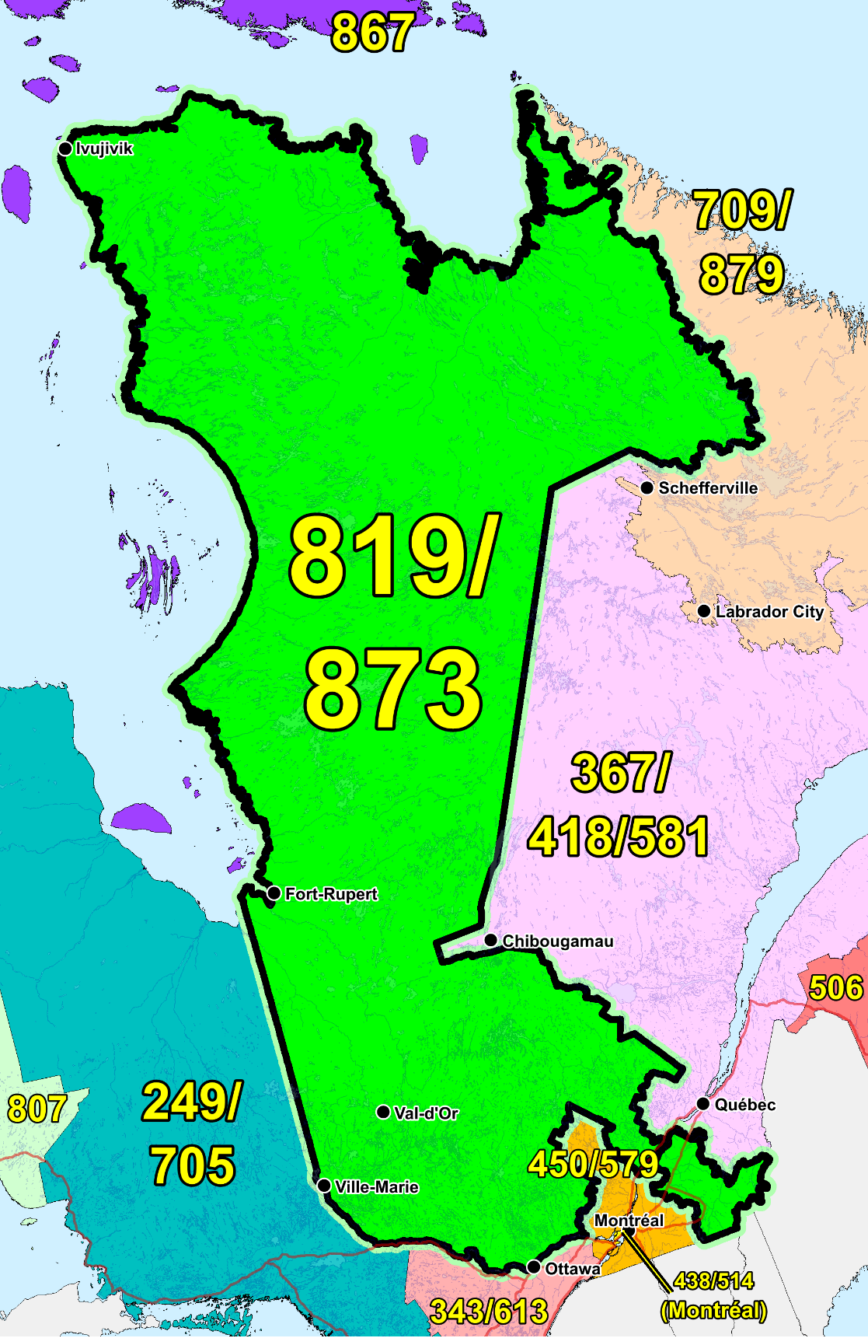

Figure 1 – Overview Map of NPA 819/873



**Figure 2 – NPA 819/873 Actual and Forecast CO Code Assignments**



Figure 3 – NPA 819/873 CO Code Exhaust – January 2021 R-NRUF



Figure 4 – NPA 819/873 CO Code Exhaust – July 2020 R-NRUF

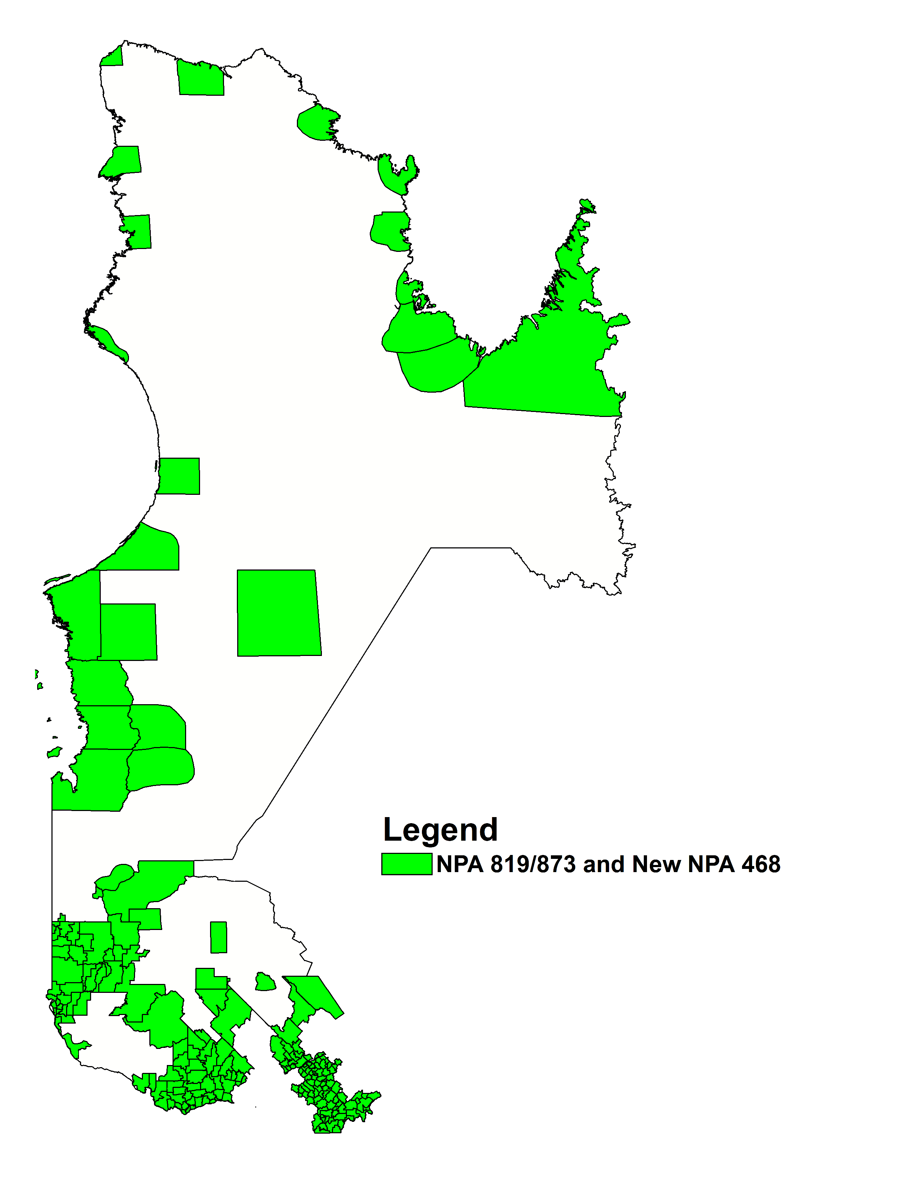

Figure 5 – Distributed Overlay

1. NPA 819/873 EXCHANGE AREAS

Table 1 – NPA 468/819/873 Exchange Areas After Distributed Overlay

| **NPA 468/819/9/873**  **Exchange Areas** |
| --- |
| Akulivik |
| Amos |
| Angliers |
| Arthabaska |
| Arundel |
| Asbestos |
| Aston-Jonction |
| Aupaluk |
| Ayer's Cliff |
| Aylmer |
| Barraute |
| Bearn |
| Beaucanton |
| Becancour |
| Belleterre |
| Bishopton |
| Bouchette |
| Bromptonville |
| Buckingham |
| Bury |
| Cadillac |
| Campbell's Bay |
| Champlain |
| Chapeau |
| Charette |
| Chartierville |
| Chelsea |
| Cheneville |
| Chesterville |
| Chisasibi |
| Clericy |
| Clova |
| Coaticook |
| Compton |
| Cookshire |
| Danville |
| Daveluyville |
| Deauville |
| Deschaillons |
| Drummondville |
| Dubuisson |
| Duparquet |
| Dupuy |
| East Angus |
| East Hereford |
| Eastmain |
| Eastmain 1 |
| Fabre |
| Ferme-Neuve |
| Fort-Coulonge |
| Fortierville |
| Frontenac |
| Fugereville |
| Gatineau |
| Gentilly |
| Gracefield |
| Grand'Mere |
| Grand-Remous |
| Grenville |
| Ham-Nord |
| Inukjuak |
| Ivujivik |
| Joutel |
| Kangiqsualujjuaq |
| Kangiqsujuaq |
| Kangirsuk |
| Kazabazua |
| Kingsey-Falls |
| Kuujjuaq |
| Kuujjuaraapik |
| La Corne |
| La Minerve |
| La Patrie |
| La Reine |
| La Sarre |
| La Tuque |
| Labelle |
| Lac-des-Ecorces |
| Lac-Drolet |
| Lac-du-Cerf |
| Lac-Edouard |
| Lac-Megantic |
| Laforge |
| L'Annonciation |
| Latulipe |
| Laurierville |
| L'Avenir |
| Laverlochere |
| Lebel-sur-Quevillon |
| Lorrainville |
| Louiseville |
| Louvicourt |
| Low |
| Luskville |
| Lyster |
| Macamic |
| Magog |
| Malartic |
| Maniwaki |
| Manouane |
| Manseau |
| Maskinonge |
| Matagami |
| Montebello |
| Mont-Laurier |
| Nantes |
| Nedelec |
| Nemaska |
| Nicolet |
| Nominingue |
| Norbertville |
| Normetal |
| North Hatley |
| Notre-Dame-de-la-Paix |
| Notre-Dame-de-la-Salette |
| Notre-Dame-de-Lourdes |
| Notre-Dame-du-Bon-Conseil |
| Notre-Dame-du-Laus |
| Notre-Dame-du-Nord |
| Obedjiwan |
| Ottawa-Hull |
| Palmarolle |
| Papineauville |
| Parc De La Verendrye |
| Parent |
| Perkins |
| Plessisville |
| Princeville |
| Puvirnituk |
| Quaqtaq |
| Quyon |
| Radisson |
| Remigny |
| Richmond |
| Riviere-Heva |
| Rochebaucourt |
| Rock Island |
| Rouyn-Noranda |
| Saint-Albert |
| Saint-Alexis-Des-Monts |
| Saint-Barnabe |
| Saint-Ludger |
| Saint-Paulin |
| Salluit |
| Sanmaur |
| Sawyerville |
| Scotstown |
| Senneterre |
| Shawinigan |
| Shawville |
| Sherbrooke |
| South Durham |
| St-Adolphe-de-Dudswell |
| St-Adolphe-D'Howard |
| St-Andre-Avellin |
| St-Boniface-de-Shawinigan |
| St-Bruno-de-Guigues |
| St-Celestin |
| St-Cyrille |
| St-Donat-de-Montcalm |
| Ste-Agathe |
| Ste-Angele |
| Ste-Anne-du-Lac |
| Ste-Eulalie |
| Ste-Gertrude |
| Ste-Marie-de-Blandford |
| St-Emile-de-Suffolk |
| Ste-Monique-de-Nicolet |
| Ste-Sophie-de-Levrard |
| St-Eugene-de-Guigues |
| St-Faustin |
| St-Felix-de-Kingsey |
| St-Germain-de-Grantham |
| St-Gregoire |
| St-Guillaume |
| St-Jovite |
| St-Leonard-d'Aston |
| St-Malo |
| St-Mathieu |
| St-Nazaire |
| Stoke |
| St-Pierre-de-Wakefield |
| St-Pierre-Les-Becquets |
| St-Roch-de-Mekinac |
| St-Sebastien (Frontenac Co.) |
| St-Sylvere |
| St-Wenceslas |
| Taschereau |
| Tasiujaq |
| Temiscaming |
| Thurso |
| Tingwick |
| Trois-Rivieres |
| Umiujaq |
| Val David |
| Val-des-Bois |
| Val-D'Or |
| Victoriaville |
| Ville-Marie |
| Villeroy |
| Wakefield |
| Warwick |
| Waskaganish |
| Waswanipi |
| Waterville |
| Weedon |
| Wemindji |
| Wickham |
| Windsor |
| Woburn |
| Wotton |
| Yamachiche |

1. Distribution List

|  |  |
| --- | --- |
| Bill Barsley  Canada  Telephone: 416-279-7989  Bill.Barsley@Outlook.com | Doug Birdwise  Interested Party  109 Westpark Drive  Ottawa, ON  Canada  K1B 3G4  Telephone: 613-830-0081  douglas.birdwise@sympatico.ca |
| Jeffrey DeSarno  Chief Tehnology Officer  Access Communications Co-operative Limited  2250 Park St  Regina, SK  S4N 7K7  Telephone: 306-565-5364  Fax: 306-565-5395  jeffrey.desarno@myaccess.coop | Nicola McLaughlin  Team Lead  Allstream  200 Wellington St W. F12  Toronto, ON  Canada  M5V 3G2  Telephone: 416-640-5271  Nicola.mclaughlin@allstream.com |
| Ronda Otto  Sr. Director Service Delivery  Allstream  Telephone: 763-270-3557  ronda.otto@allstream.com | Elizabth Pereira  Senior Manager, Service Delivery  Allstream  Telephone: 647-776-1868  elizabeth.pereira@allstream.com |
| NXX Admin  Bell Canada  nxx.admin@bell.ca | Joey-Lynn Abdulkader  Specialist Regulatory Affairs  Bell Canada  160 Elgin Street, 19th Floor  Ottawa, ON  Canada  K2P 2C4  Telephone: 613-785-6314  Fax: 613-560-0472  joey-lynn.abdulkader@bell.ca |
| Diane Faillant  Associate - Network Management/NSS (National Numbering Solution)  Bell Canada  671 LAGAUCHETIERE Ouest. 11  Montreal, QC  Canada  H3B 2M8  Telephone: 514-870-6044  Fax: 514-786-9062  diane.faillant@bell.ca | Marie-Christine Hudon  Network Provisioning  Bell Canada  671 Rue De La Gauchetière, O.11  Montreal, QC  H3B 2M8  Telephone: 514-870-7839  m-christine.hudon@bell.ca |
| Daniel Morrison  Specialist - Voice Network Services  Bell Canada  100 Dundas St Flr 3  London, ON  Canada  N6A 5B6  Telephone: 519-850-6386  daniel.morrison@bell.ca | Marian Hearn  Project Executive  Canadian LNP Consortium Inc.  350 Palladium Drive, Suite 208  Kanata, ON  Canada  K2V 1A8  Telephone: 613-287-0225  Fax: 800-406-9250  marian.hearn@clnpc.ca |
| Rodger McNabb  Manager Contracts and Receivables  Canadian LNP Consortium Inc.  350 Palladium Drive. Suite 208  Kanata, ON  Canada  K2V 1A8  Telephone: 613-287-0226  rodger.mcnabb@clnpc.ca | Jacques Sarrazin  President of the CLNP consortium  Canadian LNP Consortium Inc.  Suite 208, 350 Palladium Dr  Kanata, ON  Canada  K2V 1A8  Telephone: 613-287-0225  Fax: 613-823-1169  sarrazin@clnpc.ca |
| Pavel Bigarov  CNA System Administrator  Canadian Numbering Administrator  150 Isabella Street - Suite 605  Ottawa, ON  Canada  K1S 5H3  Telephone: 613-702-0016  pavel.bigarov@cnac.ca | Fiona Clegg  Numbering Resource Administration  Canadian Numbering Administrator  150 Isabella Street, Suite 605  Ottawa, ON  Canada  K1S 5H3  Telephone: 613-702-0016 ext. 202  fiona.clegg@cnac.ca |
| David Comrie  Numbering Resource Administration  Canadian Numbering Administrator  150 Isabella Street, Suite 605  Ottawa, ON  Canada  K1S 5H3  Telephone: 613-702-0016 ext. 204  david.comrie@cnac.ca | Suresh Khare  CO Code Manager  Canadian Numbering Administrator  150 Isabella Street, Suite 605  Ottawa, ON  Canada  K1S 5H3  Telephone: 613-702-0016 ext. 201  suresh.khare@cnac.ca |
| Natalie Lessard  Numbering Resource Administration  Canadian Numbering Administrator  150 Isabella Street, Suite 605  Ottawa, ON  Canada  K1S 5H3  Telephone: 613-702-0016 ext. 203  natalie.lessard@cnac.ca | Kelly T. Walsh  CNA Program Manager  Canadian Numbering Administrator  150 Isabella Street - Suite 605  Ottawa, ON  Canada  K1S 5H3  Telephone: 613-702-0016 ext 205  kelly.walsh@cnac.ca |
| Bill Mason  Manager, Numbering Administration  Canadian Radio-television and Telecommunications Commission  Central Building Les Terrasses de la Chaudière 1 Promenade du Portage  Gatineau, QC  Canada  K1A 0N2  Telephone: 819-953-8882  Fax: 819-953-0795  bill.mason@crtc.gc.ca | Danielle Paquin  Director, Governmental Affairs – Québec  Canadian Security Association (CANASA)  Canada  Telephone: (905) 513-0622 x 226  membership@canasa.org |
| Eric Smith  Vice President, Regulatory Affairs  Canadian Wireless Telecommunications Association (CWTA)  80 Elgin Street, Suite 30  Ottawa, ON  Canada  K1P 6R2  Telephone: 613-233-5884 Ext. 255  Fax: 613-233-2032  documentcontrol@cwta.ca | Chris Armstrong  Sales & Marketing Manager  CityWest cable & Telephone (formerly Prince Rupert Telephones)  248 Third Ave W.  Prince Rupert, BC  Canada  V8J 1L1  Telephone: 250-627-0902  Fax: 250-627-0905  Chris.Armstrong@cwct.ca |
| Ofir Smadja  President  COMsolve  3601 Highway 7 East, Suite 400  Markham, ON  Canada  L3R 0M3  Telephone: 416-915-5008  info@comsolveinc.com | Edward Antecol  VP Professional Services  COMsolve Inc.  70 East Beaver Creek Road, #202  Richmond Hill, ON  Canada  L4B 3B2  Telephone: 416-915-5008 x106  edward.antecol@comsolveinc.com |
| CLEC Admin  Comwave Networks  61 Wildcat Road  Toronto, ON  Canada  M3J 2P5  clecteam@comwave.net | Sundar Nagulan  Team Lead - Voice Engineering  Comwave Networks  61 Wildcat Rd  Toronto, ON  M3J 2P5  Telephone: 647-427-8363  snagulan@comwave.net |
| Albert Yin  Comwave Networks Inc.  Telephone: 416-663-9700 Ext 330  Fax: 416-736-3165  ayin@comwave.net | Denis Viens  Technicien Commutation  Cooptel  5521, Chemin de l'Aéroport  Valcourt, QC  J0E2L0  Telephone: 450-532-5656 ext 1042  Fax: 450-532-3148  dviens@cooptel.coop |
| Numbering E-Mail  Distributel Communications Limited  177 Nepean Street  Ottawa, ON  Canada  K2P 0B4  numbering@distributel.ca | Geoff Batstone  V.P., General Counsel  Distributel Communications Limited  177 Nepean Street, Suite 300  Ottawa, ON  Canada  Telephone: 613-319-9964  geoff.batstone@distributel.ca |
| Don Cavanagh  VP  Distributel Communications Limited  177 Nepean Street, Suite 300  Ottawa, ON  Canada  K2P 0B4  Telephone: 613-237-7005  Fax: 613-237-7009  donald.cavanagh@distributel.ca | Sarah Reilly  Porting Group Manager - Telecommunications  Distributel Communications Limited  177 Nepean Street, Suite 300  Ottawa, ON  Canada  K2P 0B4  Telephone: 613-237-7191  sarah.reilly@distributel.ca |
| Regulatory  Fibernetics Corporation  605 Boxwood Dr  Cambridge, ON  Canada  N3E1A5  regulatory@corp.fibernetics.ca | Rick Schleihauf  VP – Regulatory Affairs and Carrier Relations  Fibernetics Corporation  605 Boxwood Drive  Cambridge, ON  Canada  N3E 1A5  Telephone: 519-489-6700 ext 629  Fax: 519-653-7686  rschleihauf@corp.fibernetics.ca |
| Jennifer McCue  N/A  FlexITy  Suite 800, 45 Vogell Rd  Richmond, ON  L4B 3p6  Telephone: 905-787-3547  Fax: 905-787-3599  jennifer.mccue@flexity.ca | Groupe Masketel  ingops.telephonie@maskatel.qc.ca |
| Praba Gunam  President/CEO  InnSysVoice Corp.  4500 Sheppard Ave E, Suite 111  Toronto, ON  Canada  M1S 3R6  Telephone: 416-800-0797  praba@innsys.ca | Deirdre Massiah-Gomes  Interested Party  Canada  Telephone: 416-684-3070  Massiahgomesdeirdre@gmail.com |
| Iristel  team.regulatory@iristel.com | Iristel Inc.  11 Bowan Court  Toronto, ON  Canada  M2K 3A8  didorders@iristel.com |
| Andreea Badea  Iristel Inc.  11 Bowan Court  Toronto, ON  Canada  M2K 3A8  Telephone: 416-800-4747  abadea@iristel.ro | Samer Bishay  CEO  Iristel Inc.  11 Bowan Court  Toronto, ON  Canada  M2K 3A8  Telephone: 416-800-9999  Fax: 416-628-0891  sbishay@iristel.com |
| Andrew Matoga  VP President  ISP Telecom  1155 Boul Rene-Levesque O Suite 2500  Montreal, QC  Canada  H3B 2K4  Telephone: 416-548-4626  Fax: 416-548-4847  andrew@isptelecom.net | Jenoshan Balasingam  IXICA Communications Inc.  174 Shropshire Drive  Toronto, ON  Canada  M1P 1Z7  Telephone: 844-747-2729 ext: 1100  jenoshan@ixica.com |
| Phillip Koneswaran  VP - Business  IXICA Communications Inc.  174 Shropshire Drive  Toronto, ON  Canada  M1P 1Z7  Telephone: 844-747-2729 ext: 2100  phillip@ixica.com | Sharon Ledwell  Consultant for SSI Micro Ltd.  Ledwell Inc  26 Brookside Ave  Toront, ON  M6S4G7  Telephone: 416-904-0480  sharon@ledwellinc.ca |
| Michel Gilbert  Directeur Corporatif - Reglementation  NorthernTel, Limited Partnership  87 rue Ontario ouest 5eme etage St-Urbain  Montreal, QC  Canada  H2X 1Y8  Telephone: 514-493-5396  reglementa@telebec.com | Austin He  Network Planning Analyst, Network Planning  Primus Management ULC.  2680 Skymark Avenue, Suite 100  Mississauga, ON  Canada  L4W 5L6  Telephone: 416-207-3361  AHe@primustel.ca |
| Dennis Béland  Director, Regulatory Affairs, Telecommunications  Quebecor Media Inc.  612 St-Jacques, 15e étage Tour Sud  Montreal, QC  Canada  H3C 4M8  Telephone: 514-380-4792  Fax: 514-380-4664  dennis.beland@quebecor.com | Rogers  NumberAdmin@rci.rogers.com |
| Vivek Bhardwaj  Traffic Specialist  Rogers Communications  8200 Dixie Rd.  Brampton, ON  Canada  L6T 0C1  Telephone: 647-747-3569  vivek.bhardwaj@rci.rogers.com | Jennifer Mack  Traffic Specialist  Rogers Communications  8200 Dixie Rd.  Brampton, ON  Canada  L6T 0C1  Telephone: 647-747-2168  jennifer.mack@rci.rogers.ca |
| Emmanuel Shousha  Senior Traffic Specialist  Rogers Communications  800, Gauchetiere O, Bureau 4000  Montreal, QC  Canada  H5A 1K3  Telephone: 514-995-0000  se000895@rci.rogers.com | Jean-Michel Dupuis  Senior Public Services Specialist  Rogers Communications Canada Inc.  800 rue de la Gauchetiere Ouest, Suite 4000  Montreal, QC  Canada  H5A 1K3  Telephone: 1-866-501-7727  Fax: 1-800-506-3962  jeanmichel.dupuis@rci.rogers.com |
| Gerry Thompson  Manager, Intercarrier Relations  Rogers Communications Canada Inc.  350 Bloor Street East, 6th Floor  Toronto, ON  Canada  M4W 0A1  Telephone: 416-935-5239  Fax: 416-935-7719  Gerry.Thompson@rci.rogers.com | Nicholas Bayly  Carrier Services Specialist  Shaw Business  3636 23 ST NE  Calgary, AB  Canada  T2E 6Y7  Telephone: 403-538-5223  nicholas.bayly@sjrb.ca |
| Lien Kaura  Carrier Service Specialist  Shaw Communications Inc.  2441 37th Ave NE  Calgary, AB  Canada  T2E 6Y7  Telephone: 587-390-2982  Lien.Kaura@sjrb.ca | Ken Shackleton  Manager, Consumer Voice Technology and Infrastructure  Shaw Communications Inc.  2728 Hopewell Place NE  Calgary, AB  Canada  T1Y 7J7  Telephone: 403-303-4024  Fax: 403-930-1850  ken.shackleton@sjrb.ca |
| Bruce Uy  TN Administrator  Shaw Telecom Inc  2728 Hopewell Pl NE  Calgary, AB  T1Y 7J7  Telephone: 403-234-6271  Fax: 403-750-4501  bruce.uy@sjrb.ca | Regulatory Affairs  Shaw Telecom Inc.  630 - 3 Ave SW  Calgary, AB  Canada  T2P 4L4  regulatory@sjrb.ca |
| Dominic Germain  Internet services and switching director  Sogetel Inc.  111 Rue du 12-Novembre  Nicolet, QC  J3T1S3  Telephone: 819-293-1226  Fax: 819-293-6120  dominic.germain@sogetel.com | Krystle Nasr  SSi Connexions Inc.  365B Old Airport Rd.  Yellowknife, NT  Canada  X1A 3T4  Telephone: 613-271-6464  regulatory@ssimicro.com |
| Sabrena McBride  Product Manager  T-Mobile USA  3625 132nd Ave SE  Bellevue, WA  USA  98006  Telephone: 877-413-5903  Sabrena.mcbride32@t-mobile.com | Diane Dolan  Voice Service Manager  TekSavvy Solutions Inc  227 rue Montcalm  Gatineau, QC  Canada  J8Y 3B9  Telephone: 819-484-1234  ddolan@teksavvy.ca |
| Chantal Beaudoin  Collaboratrice principale - Coordination WNP & Gestion NPA  Telebec  555, avenue Centrale  Val-d’Or, QC  J9P1P6  Telephone: 819-824-7227  Fax: 819-824-7282  cbeaudoin@telebec.com | Lucie Pugliese  Administrator  Telecommunications Alliance  1575 Saturne  Brossard, QC  Canada  J4X 1N4  Telephone: 450-465-8277  Fax: 450-465-0703  lucie.pugliese@sympatico.ca |
| Telecommunications Xittel Inc  1350 rue Royale, bureau 800  Trois-Rivieres, QC  Canada  G9A 4J4  clec-admin@xittel.net | Olena Bilozerska  Network Planning Manager I, TS CC Planning & Management  TELUS  200 Consilium Place, Floor 6  Scarborough, ON  Canada  M1H 3G2  Telephone: 647-837-1798  Olena.Bilozerska@telus.com |
| Nancy McIntyre  Mgr - Planning & Engineering  TELUS  3777 Kingsway Floor 07S  Burnaby, BC  V5H 3Z7  Telephone: 604-908-2029  nancy.mcintyre2@telus.com | Karen Robinson  Network Planning Manager – Translations & Traffic Network Operation  TELUS  200 Consilium Place  Scarborough, ON  Canada  M1H 3J3  Telephone: 647-684-3053  Karen.Robinson3@telus.com |
| Peter Szabo  Sr. Engineer  TELUS  7th Floor – 3777 Kingsway  Burnaby, BC  Canada  V5H 3Z7  Telephone: 604-695-3188  Fax: 604-663-1300  peter.szabo@telus.com | Johny Fernandez  Technology Strategy  TELUS Mobility  200 Consilium Place, 6th Flr  Scarborough, ON  Canada  M1H 3J3  Telephone: 647-453-4442  Johny.fernandez@telus.com |
| Marc Berruyer  Network Planner  Videotron General Partnership  2155 Boul. Pie IX, 3e etage, bloc A  Montreal, QC  Canada  H1V 2E4  Telephone: 514-380-4255  Fax: 514-899-8452  marc.berruyer@videotron.com | Anh-Thu Nguyen  Ingenieur Planifi. & Gestion Du Trafic  Vidéotron ltée  2155 boul. Pie IX  Montréal, QC  Canada  H1V 2E4  Telephone: 514-380-1764  Anh-Thu.Nguyen@videotron.com |