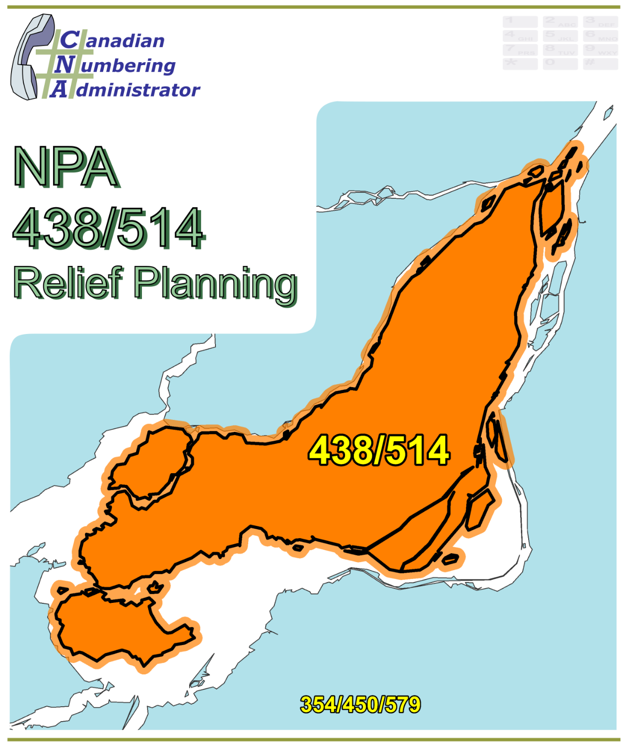

NPA 435/514 Proposal for Relief of an Overlay NPA Complex (PROC)

Version 1.0 – 17 June 2021

|  |  |
| --- | --- |
| Canadian Numbering Administrator (CNA)  Suresh Khare  613-702-0016 ext. 201  150 Isabella Street, Suite 605 Ottawa ON K1S 5H3  suresh.khare@cnac.ca |  |

**TABLE OF CONTENTS**

1. INTRODUCTION 1

2. NPA RELIEF PLANNING PROCESS 2

3. NPA RELIEF METHODS 3

4. NPA EXHAUST INFORMATION 3

5. RELIEF OPTION 4

5.1. Distributed Overlay 4

6. SUMMARY OF RELIEF OPTION 5

7. DIALLING CHANGES FOR LOCAL CALLS 5

8. PROPOSED SCHEDULE 5

9. JEOPARDY CONTINGENCY PLAN (JCP) 7

10. SELECTION OF RELIEF NPA CODE 14

11. RECOMMENDATIONS 15

ANNEXES 16

**LIST OF ANNEXES**

**ANNEX A**

Figure 1 – Overview Map of NPA 438/514

Figure 2 – NPA 438/514 Actual and Forecast CO Code Assignments

Figure 3 – NPA 438/514 CO Code Exhaust: January 2021 R-NRUF

Figure 4 – NPA 438/514 CO Code Exhaust: January 2021- (Rev 9 June) R-NRUF

Figure 5 – Distributed Overlay

**ANNEX B**

Table 1 – NPA 249/683/705 Exchange Areas After Distributed Overlay

**ANNEX C**

Distribution List

**ACRONYM LIST**

|  |  |
| --- | --- |
| CATF | Consumer Awareness Task Force |
| CNA | Canadian Numbering Administrator |
| CISC | CRTC Interconnection Steering Committee |
| CLEC | Competitive Local Exchange Carrier |
| CLNPC | Canadian Local Number Portability Consortium |
| CO | Central Office |
| CRTC | Canadian Radio-television and Telecommunications Commission |
| CSCN | Canadian Steering Committee on Numbering |
| EAS | Extended Area Service |
| G-NRUF | General Numbering Resource Utilization Forecast |
| ILEC | Incumbent Local Exchange Carrier |
| IPD | Initial Planning Document |
| ISP | Internet Service Provider |
| JCP | Jeopardy Contingency Plan |
| J‑NRUF | Jeopardy Numbering Resource Utilization Forecast |
| LEC | Local Exchange Carrier |
| LIR | Local Interconnection Region |
| LNP | Local Number Portability |
| NANP | North American Numbering Plan |
| NANPA | North American Numbering Plan Administrator |
| NITF | Network Implementation Task Force |
| NoC | Notice of Consultation |
| NPA | Numbering Plan Area (Area Code) |
| NRUF | Numbering Resource Utilization Forecast |
| PD | Planning Document |
| PED | Projected Exhaust Date |
| PL | Planning Letter |
| POI | Point of Interconnection |
| PROC | Proposal for Relief of an Overlay NPA Complex |
| PSAP | Public Safety Answering Point |
| RIP | Relief Implementation Plan |
| R-NRUF | Relief Planning Numbering Resource Utilization Forecast |
| RPC | Relief Planning Committee |
| TSP | Telecommunications Service Provider |
| WNP | Wireless Number Portability |
| WSP | Wireless Service Provider |

**Proposal for Relief of an Overlay NPA Complex (PROC)**

**Numbering Plan Area (NPA) 438/514**

**Highlight implies that these sections should be reviewed and updated in any planning document contribution(s).**

# INTRODUCTION

Numbering Plan Areas (NPAs) 418 and 514, commonly referred to as area codes, were originally assigned to Quebec by AT&T in 1947 as two of the 86 area codes to be used in Canada and the continental United States. In 1957 parts of NPAs 418 and 514 were split to create a new NPA 819. In 1998 NPA 514 was split to create new NPA 450. NPA 514 was retained for the Montreal area while NPA 450 became the area code for the area surrounding Montreal. In 2006 NPA 438 was added using the Distributed Overlay method in the NPA 514 Montreal area and mandatory ten-digit local dialling was implemented in area codes 438, 450 and 514. The following table provides a high-level summary of the history of area code usage in the area currently served by NPA 438/514 since 1947.

|  |  |
| --- | --- |
| **Year** | **Activity** |
| 1947 | Area Codes 418 and 514 are assigned to Quebec by AT&T |
| 1957 | New Area Code 819 for Quebec split from parts of 514 & 418 to serve western Quebec |
| 1998 | New area code 450 splits from 514 in Quebec; 514 is retained for the Montreal area, and 450 for the area surrounding Montreal |
| 2006 | New area code 438 overlay of 514 Montreal area; mandatory ten-digit local dialling implemented in area codes 438, 450 and 514 |

NPA 438/514 consists of 6 Exchange Areas serving Montreal and 5 other Exchange Areas in southern Quebec.

A list of the Exchange Areas in NPA 438/514 is provided in Annex B.

The table below provides a brief overview of recent activities leading to the development of this PROC for NPA 438/514.

| **Date** | **Activity** |
| --- | --- |
| 3 February 2017 | In Telecom Decision CRTC 2017-38, the Commission determined that area code 263 should be set aside as a potential future relief area code for NPA complex 438/514.  For the purposes of this document, it is assumed that the new NPA will be 263. |
| 26 March 2019 | The Canadian Numbering Administrator (CNA) published the January 2019 G‑NRUF results which indicated that the Projected Exhaust Date (PED) had advanced to October 2023. |
| 20 September 2019 | The CNA published the July 2019 R-NRUF results which indicated that the PED had moved out to June 2024. |
| 30 January 2020 | The CRTC released Telecom Notice of Consultation CRTC 2020‑37 - *Establishment of a CISC ad hoc committee for relief planning for area codes 438 and 514 in* Montreal, Quebec*.* In this Notice,the CRTC announced the establishment of a CRTC Interconnection Steering Committee ad hoc Relief Planning Committee (RPC) to examine options and make recommendations for providing numbering relief to area codes 438 and 514 in Montreal, Quebec. |
| 24 March 2020 | The CNA published the January 2020 R-NRUF results which indicated that the PED had moved out to March 2026. |
| 18 August 2020 | The CNA published the July 2020 R-NRUF results which indicated that the PED had advanced to December 2024. |
| 23 February 2021 | The CNA published the January 2021 R-NRUF results which indicated that the PED had advanced to July 2024. |
| 4 June 2021 | The CNA published the revised January 2021 G- & R-NRUF results which indicated that the PED had advanced to January 2022 and the NPA had entered a Jeopardy Condition. |
| 9 June 2021 | The CNA published the revised January 2021 G- & R-NRUF June 9 Revision results which indicated that the PED had advanced to February 2024 and the NPA was no longer in a Jeopardy Condition. |

This PROC is prepared by the CNA in accordance with Telecom Notice of Consultation CRTC 2020‑37 and the *Canadian NPA Relief Planning Guideline*, Version 7.0 dated 29 January 2019 (the Guideline). A copy of the Guideline is available from the Canadian Radio‑television and Telecommunications Commission (CRTC), CRTC Interconnection Steering Committee (CISC), Canadian Steering Committee on Numbering (CSCN) guidelines web page at: <https://crtc.gc.ca/cisc/eng/cisf3fg.htm>.

The objective of the NPA Relief Planning process is to ensure that Central Office (CO) Codes and telephone numbers are always available for use by Telecommunication Service Providers (TSPs) and their customers in the geographic area requiring relief.

It is very important to closely monitor the CO Code requirements of all existing and prospective CO Code Holders so that relief can be timed to ensure that CO Codes and telephone numbers are always available for service providers and customers.

In this PROC, a single option is identified for providing NPA relief in the NPA 438/514 geographic area. Given the magnitude of this undertaking, intercompany commitment and co‑operation are essential throughout the planning, provisioning and implementation stages of the introduction of the new NPA.

# NPA RELIEF PLANNING PROCESS

The NPA Relief Planning process and the roles of the participants (i.e., CRTC, CNA, CISC, Relief Planning Committee (RPC) participants and Interested Parties) for NPA Relief Planning are identified in the Guideline.

To increase public awareness and participation in the NPA Relief Planning process, the CRTC has determined that NPA RPCs will be established as ad hoc committees of the CISC. Generally, a separate ad hoc committee is created to deal with relief in each area code. The CNA, in its function as NPA Relief Planning Coordinator, acts as chair of these ad hoc committees. Meetings and conference calls of the ad hoc NPA RPCs are all open to public participation and are conducted in accordance with the *CISC Administrative Guidelines* which are available from the CRTC website at: <http://www.crtc.gc.ca/cisc/eng/cag.htm>.

NPA Relief Planning is conducted under the regulatory oversight of the CRTC. Notwithstanding the process detailed in the Guideline, the CRTC may exercise its authority under the *Telecommunications Act* to alter this process at any time. The CRTC has the authority under the *Telecommunications Act* to review, modify and give final approval to the Planning Document (PD) and the Relief Implementation Plan (RIP) developed and submitted by the RPC to the CRTC via the CISC process.

Section 7.1.6 of the *Canadian NPA Relief Planning Guideline* requires the CNA to create and maintain a distribution list of parties who may be interested in participating in the RPC and to provide them with advance notice of the initial RPC meeting and the release of a PROC.

Any person wishing to participate in the NPA Relief Planning process can contact the CNA and request to be added to the RPC distribution list. More information on how to participate in CRTC public processes is available at: <http://www.crtc.gc.ca/eng/info_sht/g4.htm>.

A summary of Canadian geographic area code relief history is available at: <http://www.cnac.ca/npa_codes/NPA_History.pdf>.

# NPA RELIEF METHODS

The purpose of this section is to identify and briefly describe NPA Relief Methods.

The Guideline states that: “The only NPA Relief Method considered in Canada is the Distributed Overlay Method which superimposes or “overlays” a Relief NPA on top of an entire existing NPA or NPAs.” There are three types of Distributed Overlay:

1. a Distributed Overlay over an existing geographic area served by a single existing NPA (A new NPA is overlaid over a single existing NPA (i.e., the geographic area) that is served by a single NPA);
2. a Distributed Overlay over an existing geographic area served by multiple existing overlay NPAs (A new NPA is overlaid over a single existing NPA (i.e., the geographic area) that is served by multiple existing overlay NPAs); and,
3. a Distributed Overlay over multiple existing geographic areas, each served by one or more existing NPAs (A new NPA is overlaid over multiple existing NPAs (i.e., different geographic areas served by multiple NPAs. This type of overlay may be considered for NPA relief for two or more adjacent NPAs (i.e., geographic areas) within a province).

# NPA EXHAUST INFORMATION

As indicated in the following table, NRUFs for NPA 438/514 were used to determine PEDs, (i.e. the dates when CO Codes in NPA 438/514 would be expected to exhaust).

|  |  |
| --- | --- |
| **NRUF** | **Projected Exhaust Date (PED)** |
| G‑NRUF January 2019 | October 2023 |
| R‑NRUF July 2019 | June 2024 |
| R‑NRUF January 2020 | March 2026 |
| R‑NRUF July 2020 | December 2024 |
| R‑NRUF January 2021 | July 2024 |
| R-NRUF January 2021 (Revised 4 June 2021) | January 2022 |
| R-NRUF January 2021 (Revised 9 June 2021) | February 2024 |

Refer to Annex A, Figures 2 through Figure 4 for graphs of forecast CO Code demand from current and prospective CO Code Holders and Administrative Codes set aside in Area Code 438/514 for the two most recent NRUFs (January 2021 (Revised 9 June 2021)).

# RELIEF OPTION

The Relief Option identified and examined in this PROC is a Distributed Overlay over an existing geographic area served by multiple existing overlay NPAs.

Using this method, a new NPA is overlaid over the geographic area that is served by the NPA 438/514 complex.

The Relief Option identified above was evaluated using the following assumption: The Relief Date for the Distributed Overlay will be 22 October 2022 (approximately 16 months prior to the NPA 438/514 PED of February 2024 identified using the January 2021 (Revised 9 June 2021) R‑NRUF results. The Relief Date of 22 October 2022 would align with the proposed Relief Date for two other NPAs in Relief Planning in Quebec.

See Annex A, Figure 5 **–** Distributed Overlay for a diagram of this Relief Option.

## Distributed Overlay

A Distributed Overlay Relief Option was evaluated which would overlay the NPA 263 over all 6 Exchange Areas comprising the NPA 438/514 area. See Annex A, Figure 5 **–** Distributed Overlay.

The introduction of a Distributed Overlay would keep the same number of NPA Relief Planning areas in Quebec.

After this Distributed Overlay, CO Codes in NPA 263/438/514 would be expected to exhaust in Q2 2036.

Subsequent exhaust of NPA 438/514 was forecast using the historical Five-year Median growth value of 60 CO Codes per year by comparing the January 2021 R-NRUF (Revised 9 June 2021) data in the table below:

| **Statistical Method** | **Data** | **Period** | **Quantity of CO Codes** |
| --- | --- | --- | --- |
| Median | forecast growth | next six years | 84 |
| Average | forecast growth | five-year period (January 2022 until January 2027) | 82 |
| Average | forecast growth | next six years | 88 |
| Average | historical growth | past five years | 62 |
| Median | historical growth | past five years | 60 |

# SUMMARY OF RELIEF OPTION

|  |  |  |  |
| --- | --- | --- | --- |
| **Relief Option** | **Projected Exhaust Dates** | | **Subsequent Relief Dates** |
| **NPA 438/514** | **NPA 263/438/514** |
| Distributed Overlay | February-2024 | April-2036 | April-2035 |

**Note: Distributed Overlay of NPA 263 would be in service on 22 October 2022.**

# DIALLING CHANGES FOR LOCAL CALLS

Currently 10-digit dialling is mandatory for local calls originating within area code NPA 438/514 and neighbouring NPAs (i.e., NPA 345/450/579). Local dialling plans will not change with this relief.

# PROPOSED SCHEDULE

The CNA submits the following schedule for NPA 438/514 relief based on the recommendations contained in this PROC and the current PED of February 2024. The RPC will monitor the PED, and if it changes significantly in the future, the RPC will assess the situation and, if necessary, submit recommendations including a revised schedule to the CRTC for consideration and approval.

**RELIEF IMPLEMENTATION SCHEDULE**

**For a Distributed Overlay of NPA 263 over NPA 438/514**

To be completed by the RPC

# JEOPARDY CONTINGENCY PLAN (JCP)

The RPC has developed the following JCP for inclusion in the PD for NPA 438/514. This JCP is based on the example contained in Appendix F to the *Canadian NPA Relief Planning Guideline*.

This JCP shall remain in effect until superseded by another CRTC-approved JCP, the Jeopardy Condition is suspended or 66 days prior to the Relief Date.

The following measures shall be implemented in NPA 438/514 while a Jeopardy Condition is in effect.

During a Jeopardy Condition, CO Code Applicants shall submit all CO Code applications and related correspondence for the Jeopardy NPA to CRTC staff in addition to the CNA. The CNA shall only assign CO Codes from the exhausting NPA to a CO Code Applicant when instructed by CRTC staff.

1. Carriers and/or Telecommunications Service Providers (TSPs):
   1. shall age disconnected residential wireline telephone numbers for a maximum of two months;
   2. shall age disconnected wireless telephone numbers for a maximum of three months;
   3. shall age disconnected business wireline telephone numbers for a maximum of six months. Under special circumstances, the six month aging limit for business telephone numbers may be extended to twelve months, if required, to accommodate local directory publishing dates for high volume call-in applications (e.g., heavily advertised local business numbers such as radio talk shows, food ordering services, ticket sales, chat lines), or for numbers associated with public service emergency applications or for numbers advertised in directories for which customers have requested reference of calls;
   4. shall return all CO Codes that are not being used, nor intended to be used to directly serve customers to the assignment pool within two months (e.g., plant test codes);
   5. should work towards, and encourage existing customers, to either activate or return the reserved numbers to bring the reserved quantity down to a maximum of 10% of the quantity of numbers In-Service for that customer;
   6. shall not allow the quantity of reserved numbers to be increased by new reservation requests by existing customers to more than 10% of the quantity of numbers in service for that customer. In the case of new customers, number reservations shall be limited to 10% of the total quantity of telephone numbers being placed into service for that customer;
   7. shall, within 45 days from the date that the CNA declares a Jeopardy Condition submit a Part 1 Form for each remaining reserved CO Code either returning the reserved CO Code to the CNA or requesting assignment of the reserved CO Code. Once the 45-day period has elapsed, the CNA shall make available for general assignment all CO Codes that are still reserved and have not been applied for as assignments on a Part 1 Form received by the CNA. Within 60 days from the date that the CNA declares a Jeopardy Condition, the CNA shall report to CRTC staff and the RPC as to how many of these codes have been assigned or made available for general assignment;
   8. shall not be permitted to obtain a new CO Code reservation;
   9. shall place all CO Codes assigned prior to the Jeopardy Condition being declared In-Service within three months of the effective date for CO Code activation in the network, or within three months of the date that the Jeopardy Condition was declared. If the CO Code is an Initial Code and the CO Code Holder can demonstrate that, due to circumstances beyond its control, the In-Service date has been delayed beyond the applicable timeframe, then the CNA may grant an extension of up to two months to the In-Service date. The CNA shall initiate reclamation procedures for all CO Codes that have not been placed In-Service within these timeframes unless CRTC staff provides a further extension.
2. For new applications for Initial Codes, each CO Code Holder shall certify that the CO Code will be activated in the network and placed In-Service within four months of the date of application for the Code. If the CNA does not receive a Part 4 Form within this timeframe, confirming that the CO Code has been placed In-Service, the CNA will initiate reclamation measures. If the CO Code Holder can demonstrate that, due to circumstances beyond its control, the In-Service date has been delayed not more than six months from the original application date, then the CNA may grant an extension to the In-Service date, so long as the In-Service date is not more than six months beyond the original application date. If the In-Service date has been delayed more than six months from the original application date, then the CNA shall reclaim the Code unless CRTC staff provides a further extension.
3. When applying for an Additional Code for Growth, a CO Code Holder who is submitting a Part 1 Form and Appendix B worksheet shall also submit a completed Supplementary Form for a Growth CO Code Application (attached) which certifies and/or provides the following information for the specific switching entity/POI and Exchange Area when the Growth CO Code is being requested in a Jeopardy Condition:
   1. certification that all held telephone numbers have been released;
   2. certification that reserved numbers do not exceed ten percent of the total quantity of numbers as defined in Appendix G of the Canadian CO Code (NXX) Assignment Guideline;
   3. certification that each reseller/dealer had been advised of the Jeopardy Condition and the requirement that they would only be allocated additional numbers during the Jeopardy Condition on the provision to the CO Code Holder of written confirmation that their number inventory has been reduced to an amount less than two times the highest quantity of customer numbers assigned in any month during the previous 12 months. Additional numbering resources will only be provided by the CO Code Holder to the reseller/dealer to the extent that the reseller's/dealer's inventory can only increase up to a maximum of three months' inventory;
   4. confirmation that the Part 1 form submitted with the application has the Jeopardy Condition box in section 1.6 checked to certify that the existing CO Codes are projected to exhaust within 4 months of the date of application and that the months-to-exhaust is documented on an Appendix B submitted to the CNA;
   5. a completed Telephone Number Utilization Report for the applicable switching entity signed by both a company officer and the company’s authorized representative;
   6. confirmation that the requested Growth CO Code was forecasted in the most recent NRUF or an explanation as to why it was not is attached; and,
   7. confirmation that the requested Growth CO Code will be placed In-Service within four months of the date of assignment.
4. Any CO Codes for growth assigned after the implementation of this JCP must be activated in the network and placed In-Service within four months of assignment. In the event that a CO Code Holder is unable to place the CO Code In-Service within four months of the date of assignment, the CO Code Holder must return the assigned CO Codes or submit a written request for extension to the CNA. Such written requests must include documentation explaining the reason(s) for the missed date and proposing the new In-Service date. If the explanation includes reasons beyond the control of the CO Code Holder, the CNA may extend the In-Service date a maximum of one month. If the CO Code Holder does not place the CO Code In-Service within the one-month extension, the CNA shall initiate the reclamation process at the end of the one-month extension unless CRTC staff provides a further extension.
5. A Carrier that has multiple switching entities within an Exchange Area shall examine the possibility of, and implement where feasible, number sharing between those switches as a potential method to delay requirements for additional CO Codes.
6. The CNA will request two versions (two separate worksheets (Form 1 and Form 2)) of the J-NRUF input from all current and prospective CO Code Holders quarterly until three (3) months before relief is provided.
   1. The forecast quantities in Form 1 should be the same as or lower than the last R‑NRUF input submitted, prior to declaration of a Jeopardy Condition. CO Code Holder forecasts may reflect an increase in demand in the period subsequent to the Relief Date.
   2. Form 2 will reflect the actual demand required by the CO Code Holder's current business plan and will be provided for information purposes only.
7. The CNA will compare the initial J-NRUF input to the recent NRUF inputs, to assess forecasting trends. The CNA shall monitor all inputs and shall test them for reasonableness in consultation with the Carrier. If the CNA is dissatisfied with the reasonableness, or the rationale provided for the deviations, then the matter will be referred to the CRTC staff.
8. The CNA will request subsequent J-NRUF input from all current and prospective CO Code Holders quarterly until 3 months before relief is provided. If one or more R-NRUFs have already been conducted, and depending on the severity of the Jeopardy Condition, the CNA may defer a J-NRUF by up to two months if such a deferral brings the timing of that J‑NRUF and subsequent J-NRUFs into alignment with other NRUFs that are conducted at 12, 6 or 3 month intervals. Subsequent J-NRUF input will be compared with the initial J‑NRUF input to evaluate the effectiveness of the JCP. The CNA shall monitor all J-NRUF inputs and shall test them for reasonableness in consultation with the Telecommunications Service Providers. If the CNA is dissatisfied with the reasonableness, or the rationale provided for the changed forecasts, then the matter will be referred to CRTC staff.
9. A CO Code Applicant must have submitted a completed J-NRUF to the CNA before the CNA may assign a CO Code to that CO Code Applicant.
10. If a CO Code applicant wishes to request more CO Codes than it identified in its most recent J NRUF, the CO Code Applicant should discuss the matter with the CNA. If the CO Code Applicant wishes to proceed with the request, the CO Code Applicant will forward the request and revised forecast to CRTC staff and the CNA for consideration.
11. The CO Codes identified in the NPA CO Code Inventory Chart as “Assignable CO Codes in a Jeopardy Condition” will be assigned in the order determined by the RPC after all CO Codes which are “Available for Assignment as of [day month year] have been assigned.
12. After each J-NRUF, the CNA shall provide CRTC staff, the RPC and CSCN participants with a report providing an updated NPA CO Code Inventory Chart for the NPA in jeopardy as well as the aggregate results of the most recent J-NRUF.
13. Exceptional issues or concerns may be referred by the CNA, or by individual entities (with a courtesy copy to the CNA), to the CRTC staff for resolution.
14. In a situation where the Relief Date is on or after the PED, the quantity of CO Codes that may be assigned to a CO Code Applicant prior to the end of the Jeopardy Condition (i.e. 66 days prior to the Relief Date) shall be limited to the quantity forecasted by the CO Code Applicant in its most recent NRUF forecast submitted prior to the Jeopardy Condition being declared by the CNA (if no previous NRUF was submitted, then the previous forecast will be deemed to be zero codes). When making requests to obtain CO Codes prior to the end of the Jeopardy Condition (i.e. 66 days prior to the Relief Date), the CO Code Applicant may change the Exchange Area or the month when the CO Code assignment is required, provided a new J-NRUF and explanation accompanies the application. The control imposed by this option may be relaxed if subsequent J-NRUFs defer the PED to after the Relief Date. CO Codes that become available for assignment due to future reduced demand from other current and prospective CO Code Holders may be assigned at the discretion of CRTC staff.
15. If the CNA determines that the implementation of the JCP has not extended the Projected Exhaust Date of the NPA beyond the Relief Date, the CNA will consult with CRTC staff and further CO Code conservation and assignment procedures may be ordered by the Commission (e.g., rationing, lottery, etc.).

Supplementary form for a Growth CO Code Application – Page 1 of 2 – Telephone Number Utilization Report

This form is required with each request for an Additional Code for Growth in an NPA where a Jeopardy Condition is in effect. It should be submitted to the CNA together with the Part 1 and Appendix B forms that are required for an application for an Additional Code for Growth. See the Part 1 form for information on how and where to submit the form.

I hereby certify that the following information is true and accurate to the best of my knowledge and has been prepared in accordance with Special Conservation Procedures for a Jeopardy Condition contained in the *Canadian NPA Relief Planning Guideline* or the applicable approved Jeopardy Contingency Plan.



Name & Signature of Authorized Representative of Code Holder Title Date



Name & Signature of Company Officer (see item 3 of this JCP) Title Date

Contact information: Entity Name: __________________ Contact Name: _____________

Address: __________________ City, Province, Postal Code: _____________

Telephone: __________________ Facsimile: _____________

E-mail: __________________

Switch Identification (Switching Entity/POI) CLLI: _______________ Exchange Area: ________________

For the above Switch Identification and Exchange Area for which a Growth CO Code is requested:

I certify that all held telephone numbers have been released

I certify the total quantity of reserved numbers does not exceed ten percent (10%) of the total quantity of telephone numbers as defined in Appendix G of the *Canadian CO Code (NXX) Assignment Guideline*

I certify that each reseller/dealer has been advised of the Jeopardy Condition and the requirement that they would only be allocated additional numbers during the Jeopardy Condition on the provision to the CO Code Holder of written confirmation that their number inventory has been reduced to an amount less than two (2) times the highest quantity of customer numbers assigned in any month during the previous twelve (12) months. Additional numbering resources will only be provided by the CO Code Holder to the reseller/dealer to the extent that the reseller's/dealer's inventory can only increase up to a maximum of three months' inventory.

The Part 1 form submitted with the application has the Jeopardy Condition box in section 6 checked (this certifies that the existing CO Codes are projected to exhaust within four (4) months of the date of the application or within the period specified in an approved Jeopardy Contingency Plan, and that the months-to-exhaust is documented on an Appendix B submitted to the CNA).

The Telephone Number Utilization Report on page 2 of this form has been completed.

The requested Growth CO Code was forecasted in the most recent NRUF, or an explanation as to why it was not is attached.

The requested Growth CO Code will be placed In-Service within four (4) months of the date of assignment.

**Supplementary Form for a Growth CO Code Application – Page 2 of 2 – Telephone Number Utilization Report**

Use Arial 9 to complete this form. (Note: If the spreadsheet below does not show on your display, please change the Work view to "Print Layout" or "Reading Layout")



Remarks: _______________________________________________________________________________

________________________________________________________________________________________

**NPA 438/514 CO Code Inventory Chart**

The following chart and the instructions it contains will apply in NPA 438/514 in a Jeopardy Condition.

The chart below lists quantities of CO Codes unassignable prior to a Jeopardy Condition, CO Codes that become assignable in a Jeopardy Condition and CO Codes in NPA 438/514 assigned and In‑service as of 17 June 2021. The CO Codes that become assignable in a Jeopardy Condition shall only be made available for assignment when all other available CO Codes have been assigned in the order listed below.

|  |  |  |
| --- | --- | --- |
|  |  | **Quantity** |
| **A** | **Total CO Codes in NPAs 438/514** **(NXX format)** | **1600** |
|  | | |
| **B** | **CO Codes unassignable prior to a Jeopardy Condition** |  |
|  | N11 Service Codes (211, 311, 411, 511, 611, 711, 811, 911) | 16 |
|  | Special Use Codes (555, 950 & 976) | 5 |
|  | Home NPA Code(s) | 4 |
|  | Current Neighbouring NPA Codes (450, 579) | 4 |
|  | Future Geographic NPA Codes (263, 460, 468, 537, 584, 753)  (Note 1) | 12 |
|  | Plant Test Codes (958 & 959) | 4 |
|  | Special 7-digit Dialling Codes (310, 610 & 810) | 5 |
|  | **Total B** | 50 |
|  | | |
| **C** | **CO Codes assignable prior to a Jeopardy Condition (C=A-B)** | **1550** |
|  | | |
| **D** | CO Codes unassignable prior to a Jeopardy Condition that become assignable in a Jeopardy Condition: |  |
| Future Canadian Geographic NPA Codes (Note 1 & 2) | 10 |
| Current Neighbouring NPA Codes (450, 579) (Note 3) | 4 |
| **Total D** | **14** |
|  | | |
| **E** | **Assignable CO Codes in a Jeopardy Condition (E=C+D)** | **1554** |
| **F** | **Assigned CO Codes as of 17 June 2021** | **1271** |
| **G** | **Net CO Codes available for assignment as of 17 June 2021 without a Jeopardy Condition (G=C-F)** | 279 |
| **H** | **Net CO Codes available for assignment as of 17 June 2021 in a Jeopardy Condition (H=E-F)** | 293 |

**Notes:**

1. In Telecom Decision CRTC 2017-38, the Commission determined that area code 263 should be set aside as a potential future relief area code for area codes 438 and 514.
2. CO Codes 460, 468, 537, 584 and 753 should become assignable in a Jeopardy Condition.
3. In an extreme Jeopardy Condition (i.e. when the Projected Exhaust Date is earlier than the Relief Date), the current Neighbouring NPA Codes 450 and 579 could be assignable with CRTC staff approval.

# SELECTION OF RELIEF NPA CODE

If the recommended Relief Option requires a new NPA Code, the criteria for selection of an appropriate area code for relief is addressed in section 4.11 of the *Canadian NPA Relief Planning Guideline*. The criteria that should be taken into account when Future Canadian Geographic NPAs are being considered as candidates for relief of a specific current Canadian Geographic NPA include the following:

1. The preferred Future Canadian Geographic NPA Code should not be an NPA Code that is assigned as a CO Code in the area that is being relieved (Home NPA(s)).
2. The preferred Future Canadian Geographic NPA Code should not be an NPA Code that is assigned as a CO Code in another NPA within the same province where there is a possibility that a single new NPA Code could be overlaid on more than one NPA within the province, or where boundary realignment could occur that affects another NPA.
3. The preferred Future Canadian Geographic NPA Code should not be an NPA Code that is assigned as a CO Code in an Exchange Area in a neighbouring NPA, if the neighbouring NPA has 7-digit local calling within the NPA and i) the Exchange Area in the neighbouring NPA where the CO Code is assigned has local calling to the NPA being relieved or ii) the Exchange Area in the neighbouring NPA where the CO Code is assigned does not have local calling to the NPA being relieved, but other Exchange Areas within that neighbouring NPA have 7-digit local calling to the Exchange Area where the CO Code is assigned as well as local calling to the new NPA.

CO Codes corresponding to Future Canadian Geographic NPA Codes which are not assigned in NPA 438/514 and therefore meet criterion a) above are 263, 460, 468, 537, 584 and 753.

CO Codes 263, 460, 468, 537, 584 and 753 are all assigned in at least one neighbouring NPA so none of these resources meet criterion b).

Criterion c) is not applicable since NPA 438/514 and all neighbouring NPAs have 10‑digit local calling.

The NPA Code Selection Tool located on the CNA web site at <http://www.cnac.ca/npa_codes/relief/NPA_Selection_Tool.xlsx> can assist in selecting a relief NPA Code from the pool of NPA Codes reserved for relief of geographic Canadian NPAs. The following table, extracted from the NPA Code Selection Tool, shows all codes corresponding to Future Canadian Geographic NPA Codes that are designated as unassignable CO Codes in the Home NPA, and therefore are preferred candidates when selecting a relief NPA Code for NPA 438/514.

| **NXX corresponding to Future NPA** | **263** | **460** | **468** | **537** | **584** | **753** |
| --- | --- | --- | --- | --- | --- | --- |
| Distributed Overlay | ✓ | ✓ | ✓ | ✓ | ✓ | ✓ |

✓ Indicates that corresponding CO Code is designated as unassignable in Home NPA(s)

All of the NPA Codes (263, 460, 468, 537, 584 and 753) are equally suitable as a new NPA Code for the relief of NPA 438/514, unless analysis of potential future code reservations for NPA reliefs in other areas of Canada, or TSP cost considerations indicate a preference for one code over another for the relief of NPA 438/514.

In Telecom Decision CRTC 2017‑38, the Commission determined that area code 263 should be set aside as a potential future relief area code for area codes 438, 514 (NPA 438/514 complex).

# RECOMMENDATIONS

The CNA recommends:

1. The Relief Method should be a **Distributed Overlay** of a new NPA Code on Ontario NPA 438/514;
2. The Relief NPA Code for NPA 438/514 should be NPA **263** as per Telecom Decision CRTC 2017-38, dated 3 February 2017; and
3. The Relief Date should be **22 October 2022** to provide Carriers and customers with advanced notification and sufficient lead-time to implement relief in NPA 438/514.

ANNEXES

1. Maps and Figures

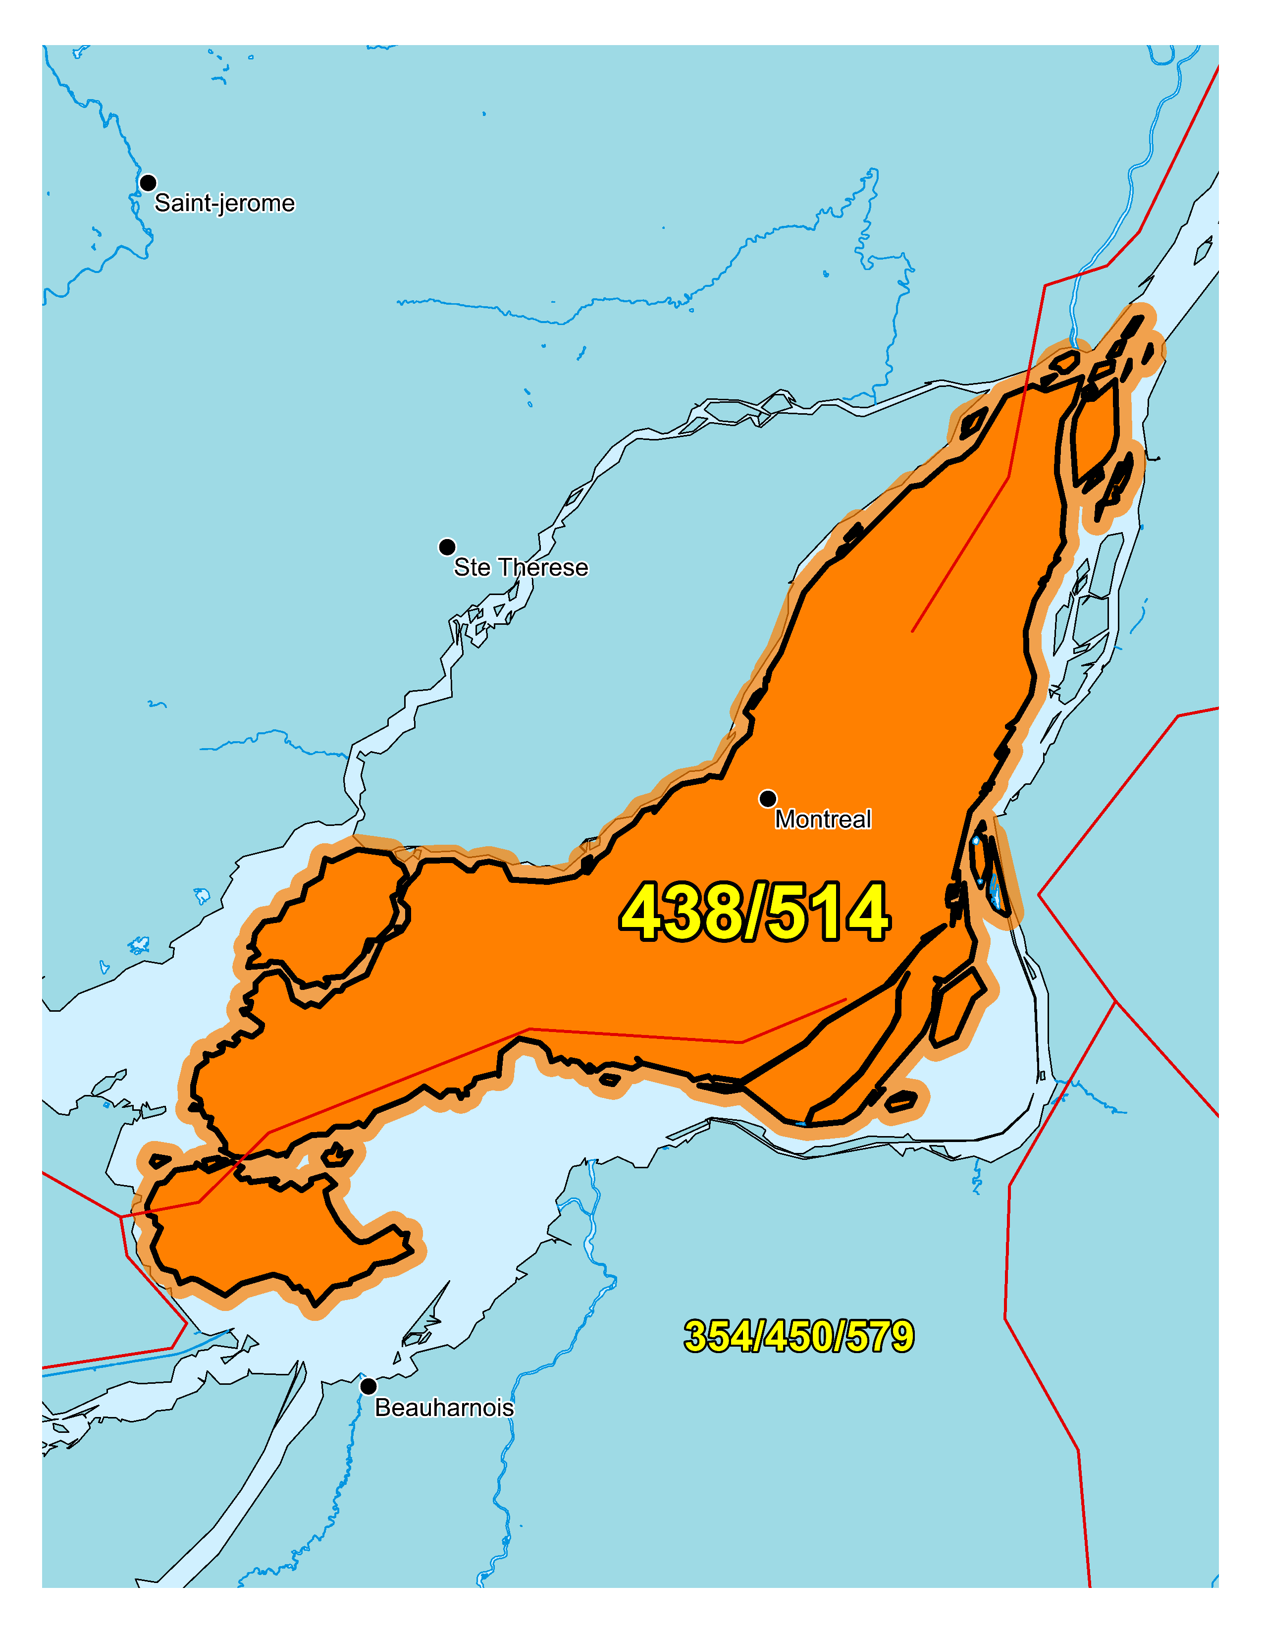

Figure 1 – Overview Map of NPA 438/514



Figure 2 – NPA 438/514 Actual and Forecast CO Code Assignments



Figure 3 – NPA 438/514 CO Code Exhaust: January 2021 R-NRUF

Figure 4 – NPA 438/514 CO Code Exhaust: January 2021- (Rev 9 June) R-NRUF

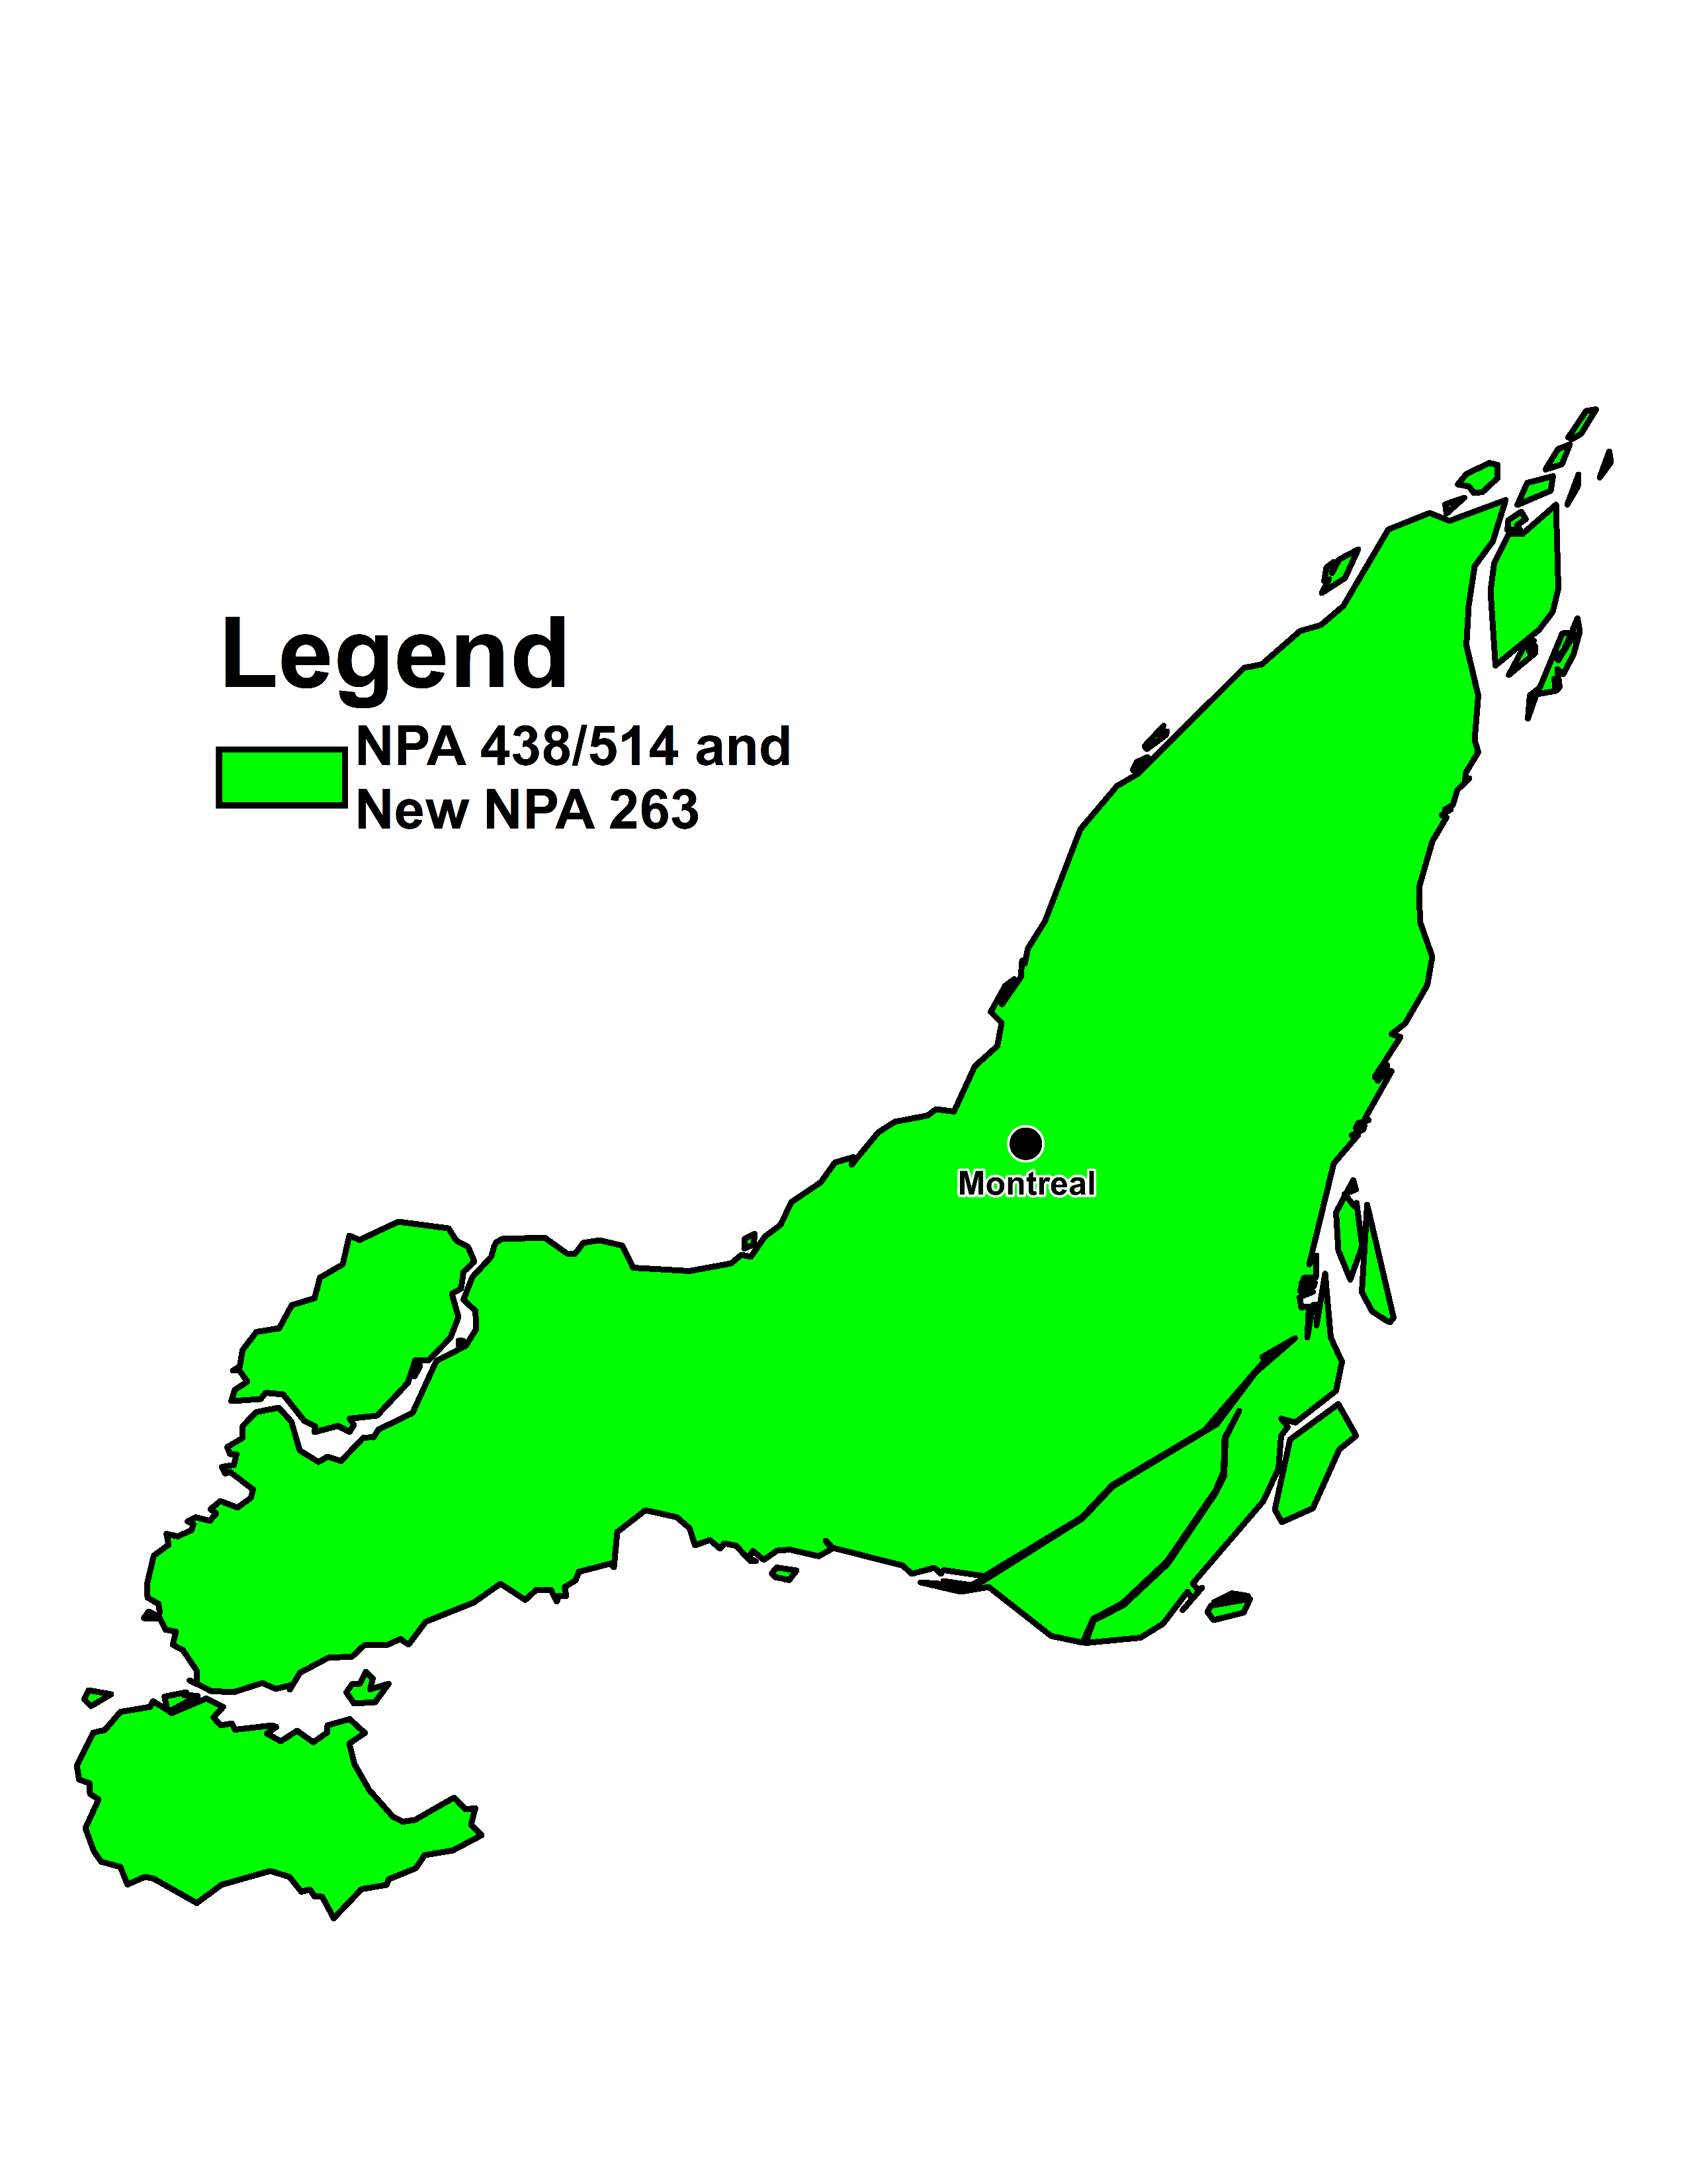

Figure 5 – Distributed Overlay

1. NPA 263/438/514 Exchange Areas

Table 1 – NPA 249/683/705 Exchange Areas After Distributed Overlay

| **NPA 263/438/514**  **Exchange Areas** |
| --- |
|
|
| Ile-Perrot |
| Lachine |
| Montreal |
| Pointe-Claire |
| Roxboro |
| Ste-Genevieve |

1. Distribution List

|  |  |
| --- | --- |
| 9144-3036 Quebec Inc. (Navigue.com )  reglementaire.clec@navigue.com | Iristel  team.regulatory@iristel.com |
| Iristel Inc.  11 Bowan Court  Toronto, ON  Canada  M2K 3A8  didorders@iristel.com | Rogers  NumberAdmin@rci.rogers.com |
| Telecommunications Xittel Inc  1350 rue Royale, bureau 800  Trois-Rivieres, QC  Canada  G9A 4J4  clec-admin@xittel.net | CLEC Admin  Comwave Networks  61 Wildcat Road  Toronto, ON  Canada  M3J 2P5  clecteam@comwave.net |
| Numbering E-Mail  Distributel Communications Limited  177 Nepean Street  Ottawa, ON  Canada  K2P 0B4  numbering@distributel.ca | NXX Admin  Bell Canada  nxx.admin@bell.ca |
| Regulatory  Fibernetics Corporation  605 Boxwood Dr  Cambridge, ON  Canada  N3E1A5  regulatory@corp.fibernetics.ca | Regulatory Dept.  InnSysVoice Corp.  4500 Sheppard Ave E, Suite 111  Toronto, ON  Canada  M1S 3R6  regulatory@innsys.ca |
| Joey-Lynn Abdulkader  Specialist Regulatory Affairs  Bell Canada  160 Elgin Street, 19th Floor  Ottawa, ON  Canada  K2P 2C4  Telephone: 613-785-6314  Fax: 613-560-0472  joey-lynn.abdulkader@bell.ca | Edward Antecol  VP Professional Services  COMsolve Inc.  70 East Beaver Creek Road, #202  Richmond Hill, ON  Canada  L4B 3B2  Telephone: 416-915-5008 x106  edward.antecol@comsolveinc.com |
| Andreea Badea  Iristel Inc.  11 Bowan Court  Toronto, ON  Canada  M2K 3A8  Telephone: 416-800-4747  abadea@iristel.ro | Jenoshan Balasingam  IXICA Communications Inc.  174 Shropshire Drive  Toronto, ON  Canada  M1P 1Z7  Telephone: 844-747-2729 ext: 1100  jenoshan@ixica.com |
| Bill Barsley  Canada  Telephone: 416-279-7989  Bill.Barsley@Outlook.com | Geoff Batstone  V.P., General Counsel  Distributel Communications Limited  177 Nepean Street, Suite 300  Ottawa, ON  Canada  Telephone: 613-319-9964  geoff.batstone@distributel.ca |
| Nicholas Bayly  Carrier Services Specialist  Shaw Business  3636 23 ST NE  Calgary, AB  Canada  T2E 6Y7  Telephone: 403-538-5223  nicholas.bayly@sjrb.ca | Chantal Beaudoin  Collaboratrice principale - Coordination WNP & Gestion NPA  Telebec  555, avenue Centrale  Val-d’Or, QC  J9P1P6  Telephone: 819-824-7227  Fax: 819-824-7282  cbeaudoin@telebec.com |
| Dennis Béland  Director, Regulatory Affairs, Telecommunications  Quebecor Media Inc.  612 St-Jacques, 15e étage Tour Sud  Montreal, QC  Canada  H3C 4M8  Telephone: 514-380-4792  Fax: 514-380-4664  dennis.beland@quebecor.com | Jean Bélanger  Treasurer  La Compagnie de Téléphone de St-Victor  264 Rue St-Joseph  Saint-Victor, Beauce, QC  Canada  G0M 2B0  Telephone: 418-588-0123  Fax: 418-588-8888  telvic@telvic.net |
| Marc Berruyer  Network Planner  Videotron General Partnership  2155 Boul. Pie IX, 3e etage, bloc A  Montreal, QC  Canada  H1V 2E4  Telephone: 514-380-4255  Fax: 514-899-8452  marc.berruyer@videotron.com | Vivek Bhardwaj  Traffic Specialist  Rogers Communications  8200 Dixie Rd.  Brampton, ON  Canada  L6T 0C1  Telephone: 647-747-3569  vivek.bhardwaj@rci.rogers.com |
| Pavel Bigarov  CNA System Administrator  Canadian Numbering Administrator  150 Isabella Street - Suite 605  Ottawa, ON  Canada  K1S 5H3  Telephone: 613-702-0016  pavel.bigarov@cnac.ca | Olena Bilozerska  Network Planning Manager I, TS CC Planning & Management  TELUS  200 Consilium Place, Floor 6  Scarborough, ON  Canada  M1H 3G2  Telephone: 647-837-1798  Olena.Bilozerska@telus.com |
| Doug Birdwise  Interested Party  109 Westpark Drive  Ottawa, ON  Canada  K1B 3G4  Telephone: 613-830-0081  douglas.birdwise@sympatico.ca | Richard Biron  Avocat  Telephone Milot Inc.  111 rue du 12-Novembre  Nicolet, QC  Canada  J3T 1S3  Telephone: 819-293-1202  richard.biron@sogetel.com |
| Samer Bishay  CEO  Iristel Inc.  11 Bowan Court  Toronto, ON  Canada  M2K 3A8  Telephone: 416-800-9999  Fax: 416-628-0891  sbishay@iristel.com | Yanick Boily  Sr. Directeur, Affaires réglementaires, Télécommunications  Quebecor Media  Montreal, QC  Canada  Telephone: 514-380-7313  yanick.boily@quebecor.com |
| Gilles Brunet  Director - Carrier Relations  Videotron General Partnership  465 Mc Gill  Montreal, QC  Canada  H2Y 2H1  Telephone: 514-380-4512  Fax: 514-380-9731  gilles.brunet@videotron.com | Melanye Caisse  Telecom Analyst  ISP Telecom Inc  1155 Boul Rene-Levesque Ouest Suite 2500  Montreal, QC  Canada  H3B 2K4  Telephone: 416-548-4819  Fax: 416-548-4818  melanye@isptelecom.net |
| Don Cavanagh  VP  Distributel Communications Limited  177 Nepean Street, Suite 300  Ottawa, ON  Canada  K2P 0B4  Telephone: 613-237-7005  Fax: 613-237-7009  donald.cavanagh@distributel.ca | Fiona Clegg  Numbering Resource Administration  Canadian Numbering Administrator  150 Isabella Street, Suite 605  Ottawa, ON  Canada  K1S 5H3  Telephone: 613-702-0016 ext. 202  fiona.clegg@cnac.ca |
| David Comrie  Numbering Resource Administration  Canadian Numbering Administrator  150 Isabella Street, Suite 605  Ottawa, ON  Canada  K1S 5H3  Telephone: 613-702-0016 ext. 204  david.comrie@cnac.ca | Yves Cote  Coordonnateur à l'exploitation, région Maskinongé  Téléphone Milot Inc.  2640, rue Laflèche C.P. 30  Saint- Paulin, QC  Canada  J0K 3G0  Telephone: 819-268-2546  Fax: 819-268-2951  yves.cote@sogetel.com |
| Zahra Deliri  Contractor  Shaw Telecom Inc.  Telephone: 587-390-2964  Zahra.Deliri@sjrb.ca | Diane Dolan  Voice Service Manager  TekSavvy Solutions Inc  227 rue Montcalm  Gatineau, QC  Canada  J8Y 3B9  Telephone: 819-484-1234  ddolan@teksavvy.ca |
| Tommy Doucet  Telephony Specialist  Telecommunications Xittel  1350 Royale Office #800  Trois-Riviere, QC  G9A 4J4  Telephone: 819-370-3232 X 2022  tdoucet@xittel.net | Irma Dulay  Primus Telecommunications Canada Inc.  500- 5343 Dundas St West  Toronto, ON  Canada  M9B 6K5  Telephone: 416-207-7151  Fax: 877-329-6875  idulay@primustel.ca |
| Jean-Michel Dupuis  Senior Public Services Specialist  Rogers Communications Canada Inc.  800 rue de la Gauchetiere Ouest, Suite 4000  Montreal, QC  Canada  H5A 1K3  Telephone: 1-866-501-7727  Fax: 1-800-506-3962  jeanmichel.dupuis@rci.rogers.com | Diane Faillant  Associate - Network Management/NSS (National Numbering Solution)  Bell Canada  671 LAGAUCHETIERE Ouest. 11  Montreal, QC  Canada  H3B 2M8  Telephone: 514-870-6044  Fax: 514-786-9062  diane.faillant@bell.ca |
| Johny Fernandez  Technology Strategy  TELUS Mobility  200 Consilium Place, 6th Flr  Scarborough, ON  Canada  M1H 3J3  Telephone: 647-453-4442  Johny.fernandez@telus.com | Jean-Rene Gaudet  Vice-président, Ingénierie corporative et opérations/Chef de service, téléphonie et télévision IP  Maskatel  916 Rue Saint-Pierre  Drummondville, QC  J2C3Y2  Telephone: 819-445-0410  jrgaudet@maskatel.qc.ca |
| Michel Gilbert  Directeur Corporatif - Reglementation  Telebec, Societe en commandite  87 rue Ontario ouest 5eme etage St-Urbain  Montreal, QC  Canada  H2X 1Y8  Telephone: 514-493-5396  reglementa@telebec.com | Marcelle Girard  VoIP Administrator  Groupe Maskatel LP  Canada  Telephone: 819-519-4061  mgirard@maskatel.qc.ca |
| Jacques Gravel  VP Ingenierie Corporative et operations  Group Maskatel LP  780 Boul Casavant Ouest  Saint-Hyacinthe, QC  J2S 7S3  Telephone: 450-252-9345  jgravel@maskatel.qc.ca | Praba Gunam  President/CEO  InnSysVoice Corp.  4500 Sheppard Ave E, Suite 111  Toronto, ON  Canada  M1S 3R6  Telephone: 416-800-0797  praba@innsys.ca |
| Austin He  Network Planning Analyst, Network Planning  Primus Management ULC.  2680 Skymark Avenue, Suite 100  Mississauga, ON  Canada  L4W 5L6  Telephone: 416-207-3361  AHe@primustel.ca | Marian Hearn  Project Executive  Canadian LNP Consortium Inc.  350 Palladium Drive, Suite 208  Kanata, ON  Canada  K2V 1A8  Telephone: 613-287-0225  Fax: 800-406-9250  marian.hearn@clnpc.ca |
| Marie-Christine Hudon  Network Provisioning  Bell Canada  671 Rue De La Gauchetière, O.11  Montreal, QC  H3B 2M8  Telephone: 514-870-7839  m-christine.hudon@bell.ca | Kim Isaacs  Director Carrier Relations  Allstream Business, Inc.  6160 Golden Hills Dr  Golden Valley, MN  USA  55416  Telephone: 763-745-8463  Kim.Isaacs@allstream.com |
| Stephanie Jackson  Manager - Public Services Integration; Traffic Engineering  Rogers Communications Canada Inc.  8200 Dixie Road  Brampton, ON  Canada  L6T 0C1  Telephone: 647-747-4402  Fax: 647-747-4557  stephanie.jackson@rci.rogers.com | Alan Jordache  Senior Engineer  TELUS Mobility  200 Consilium Pl, Floor 13  Scarborough, ON  M1H 3J3  Telephone: 416-279-3248  Fax: 416-279-3930  ALAN.JORDACHE@TELUS.COM |
| Lien Kaura  Carrier Service Specialist  Shaw Communications Inc.  2441 37th Ave NE  Calgary, AB  Canada  T2E 6Y7  Telephone: 587-390-2982  Lien.Kaura@sjrb.ca | Suresh Khare  CO Code Manager  Canadian Numbering Administrator  150 Isabella Street, Suite 605  Ottawa, ON  Canada  K1S 5H3  Telephone: 613-702-0016 ext. 201  suresh.khare@cnac.ca |
| Phillip Koneswaran  VP - Business  IXICA Communications Inc.  174 Shropshire Drive  Toronto, ON  Canada  M1P 1Z7  Telephone: 844-747-2729 ext: 2100  phillip@ixica.com | Rock Lacroix  9163-7918 Quebec Inc (CoopTel)  5521 Chemin de l'Areoport  Valcourt, QC  Canada  J0E 2L0  Telephone: 450-532-6060  Fax: 450-532-6050  ipsolutions@cooptel.qc.ca |
| Suzanne Lamarre  Conseillère stratégique  Groupe Maskatel LP  Montreal, QC  Canada  Telephone: 514-799-5003  suzanne@lamarrestrategies.com | Roland Lamer  Téléphone de St-Éphrem inc.  3455, boulevard Choquette  Saint-Hyacinthe, QC  Canada  J2S 7Z8  Telephone: 450-251-4082  Fax: 450-252-2281  reglementaire@maskatel.qc.ca |
| Raymonde Lapierre  La Compagnie de Téléphone de Lambton Inc.  233 rue du Collège  Lambton, QC  Canada  G0M 1H0  Telephone: 418-486-2627  Fax: 418-486-7627  tellambton@tellambton.net | Pierre Leblanc  Administrateur IPTV et unités distantes  CoopTel  5521, Chemin de l'Aéroport  Valcourt, QC  J0E2L0  Telephone: (450) 532-5656 x 1006  Fax: (450) 532-3148  pleblanc@cooptel.coop |
| Natalie Lessard  Numbering Resource Administration  Canadian Numbering Administrator  150 Isabella Street, Suite 605  Ottawa, ON  Canada  K1S 5H3  Telephone: 613-702-0016 ext. 203  natalie.lessard@cnac.ca | Jennifer Mack  Traffic Specialist  Rogers Communications  8200 Dixie Rd.  Brampton, ON  Canada  L6T 0C1  Telephone: 647-747-2168  jennifer.mack@rci.rogers.ca |
| John MacKenzie  Regulatory Affairs  Telus  Telephone: 780-493-5579  john.mackenzie@telus.com | Wanda Marie Mali  Manager - National Numbering Solutions  Bell Canada  100 Borough Dr, Floor 5 Blue  Scarborough, ON  M1P4W2  Telephone: 416-296-6076  Fax: 416-296-0685  wanda_marie.mali@bell.ca |
| Bill Mason  Manager, Numbering Administration  CRTC  Central Building Les Terrasses de la Chaudière 1 Promenade du Portage  Gatineau, QC  Canada  K1A 0N2  Telephone: 819-953-8882  Fax: 819-953-0795  bill.mason@crtc.gc.ca | Deirdre Massiah-Gomes  Interested Party  Canada  Telephone: 416-684-3070  Massiahgomesdeirdre@gmail.com |
| Jean-Francois Mathieu  La Compagne de Telephone Upton (Telupton 2000 Inc.)  732 Rue St-Ephrem C.P. 90  Upton, QC  Canada  J0H 2E0  Telephone: 450-549-1020  Fax: 450-549-4455  j-fmathieu@telupton.qc.ca | Andrew Matoga  VP President  ISP Telecom  1155 Boul Rene-Levesque O Suite 2500  Montreal, QC  Canada  H3B 2K4  Telephone: 416-548-4626  Fax: 416-548-4847  andrew@isptelecom.net |
| Sabrena McBride  Product Manager  T-Mobile USA  3625 132nd Ave SE  Bellevue, WA  USA  98006  Telephone: 877-413-5903  Sabrena.mcbride32@t-mobile.com | Nancy McIntyre  Mgr - Planning & Engineering  TELUS  3777 Kingsway Floor 07S  Burnaby, BC  V5H 3Z7  Telephone: 604-908-2029  nancy.mcintyre2@telus.com |
| Nicola McLaughlin  Team Lead  Allstream  200 Wellington St W. F12  Toronto, ON  Canada  M5V 3G2  Telephone: 416-640-5271  Nicola.mclaughlin@allstream.com | Rodger McNabb  Manager Contracts and Receivables  Canadian LNP Consortium Inc.  350 Palladium Drive. Suite 208  Kanata, ON  Canada  K2V 1A8  Telephone: 613-287-0226  rodger.mcnabb@clnpc.ca |
| Jacqueline Michelis  Media Relations  Bell Canada  160 Elgin Strett  Ottawa, ON  Canada  K2P 3C4  Telephone: 613-785-1427  jacqueline.michelis@bell.ca | Daniel Morrison  Specialist - Voice Network Services  Bell Canada  100 Dundas St Flr 3  London, ON  Canada  N6A 5B6  Telephone: 519-850-6386  daniel.morrison@bell.ca |
| Sundar Nagulan  Team Lead - Voice Engineering  Comwave Networks  61 Wildcat Rd  Toronto, ON  M3J 2P5  Telephone: 647-427-8363  snagulan@comwave.net | Bernard Nicol  Technicien de Central  Maskatel  916 Rue Saint-Pierre  Drummondville, QC  J2C3Y2  Telephone: 819-445-0414  bnicol@maskatel.qc.ca |
| Catherine O’Grady  Senior Manager, Provisioning  Allstream  200 Wellington St W. F12  Toronto, ON  Canada  M5V 3G2  Telephone: 416-644-9703  catherine.ogrady@allstream.com | Simon-Pierre Olivier  Director, Regulatory Affairs  Rogers Communications Canada Inc.  800 de la Gauchetiere West, 4th Floor  Montreal, QC  Canada  H5A 1K3  Telephone: 514-350-6595  Fax: 514-734-6622  simon-pierre.olivier@fidomobile.ca |
| Danielle Paquin  Director, Governmental Affairs – Québec  Canadian Security Association (CANASA)  Canada  Telephone: (905) 513-0622 x 226  membership@canasa.org | Jocelyne Patry  Secretary-Treasurer & General Manager  La Cie de Téléphone de Courcelles Inc.  Case postale 10, 101 Avenue Champlain  Courcelles, Cté Beauce Sud, QC  Canada  G0M 1C0  Telephone: 418-483-5255  Fax: 418-483-5855  jpatry@telcourcelles.qc.ca |
| Michelle Preda  Regulatory Affairs Manager  Iristel  675 Cochrane Dr  Markham, ON  L3R0B8  Telephone: 416-800-0032  mpreda@iristel.ro | Lucie Pugliese  Administrator  Telecommunications Alliance  1575 Saturne  Brossard, QC  Canada  J4X 1N4  Telephone: 450-465-8277  Fax: 450-465-0703  lucie.pugliese@sympatico.ca |
| Brian Reyes  Traffic Specialist  Rogers Communications  8200 Dixie Rd  Brampton, ON  L6T0C1  Telephone: 647-747-4657  brian.reyes@rci.rogers.com | Karen Robinson  Network Planning Manager – Translations & Traffic Network Operation  TELUS  200 Consilium Place  Scarborough, ON  Canada  M1H 3J3  Telephone: 647-684-3053  Karen.Robinson3@telus.com |
| Marie-Eve Rocheleau  Cooptel  5521 Chemin de l'Aeroport  Valcourt, QC  J0E2L0  Telephone: 450-532-5656 ext 1029  Fax: 450-532-3148  mrocheleau@cooptel.coop | Lyne Rodrigue  Le Téléphone de St-Éphrem Inc.  34, route 271 Sud, bureau 10  St-Éphrem De Beauce, QC  Canada  G0M 1R0  Telephone: 418-484-2010  Fax: 418-484-2120  telstep@telstep.net |
| Leo Santoro  Network Analyst  Bell Mobility  5115 Creekbank Rd, Floor 3  Mississauga, ON  Canada  L4W 5R1  Telephone: 905-282-3021  Fax: 905-282-3106  leo.santoro@bell.ca | Rick Schleihauf  VP – Regulatory Affairs and Carrier Relations  Fibernetics Corporation  605 Boxwood Drive  Cambridge, ON  Canada  N3E 1A5  Telephone: 519-489-6700 ext 629  Fax: 519-653-7686  rschleihauf@corp.fibernetics.ca |
| Ken Shackleton  Manager, Consumer Voice Technology and Infrastructure  Shaw Communications Inc.  2728 Hopewell Place NE  Calgary, AB  Canada  T1Y 7J7  Telephone: 403-303-4024  Fax: 403-930-1850  ken.shackleton@sjrb.ca | Emmanuel Shousha  Senior Traffic Specialist  Rogers Communications  800, Gauchetiere O, Bureau 4000  Montreal, QC  Canada  H5A 1K3  Telephone: 514-995-0000  se000895@rci.rogers.com |
| Ofir Smadja  President  COMsolve  3601 Highway 7 East, Suite 400  Markham, ON  Canada  L3R 0M3  Telephone: 416-915-5008  info@comsolveinc.com | Eric Smith  Vice President, Regulatory Affairs  Canadian Wireless Telecommunications Association (CWTA)  80 Elgin Street, Suite 30  Ottawa, ON  Canada  K1P 6R2  Telephone: 613-233-5884 Ext. 255  Fax: 613-233-2032  documentcontrol@cwta.ca |
| Eric St-Yves  Analyste Planification  Videotron  2155 Pie IX  Montreal, QC  H1V 2E4  Telephone: 514-380-4751  eric.st-yves@videotron.com | Peter Szabo  Sr. Engineer  TELUS  7th Floor – 3777 Kingsway  Burnaby, BC  Canada  V5H 3Z7  Telephone: 604-695-3188  Fax: 604-663-1300  peter.szabo@telus.com |
| Jacques Taillefer  President  Maskatel  3455 Choquette  St-Hyacinthe, QC  J2S7Z8  Telephone: 450-250-7121  jacques.taillefer@maskatel.qc.ca | Gerry Thompson  Manager, Intercarrier Relations  Rogers Communications Canada Inc.  350 Bloor Street East, 6th Floor  Toronto, ON  Canada  M4W 0A1  Telephone: 416-935-5239  Fax: 416-935-7719  Gerry.Thompson@rci.rogers.com |
| Kelly T. Walsh  CNA Program Manager  Canadian Numbering Administrator  150 Isabella Street - Suite 605  Ottawa, ON  Canada  K1S 5H3  Telephone: 613-702-0016 ext 205  kelly.walsh@cnac.ca | Vince Yelle  Telecommunications Xittel Inc  Telephone: 819-370-3232  Fax: 819-374-0325  vyelle@xittel.net |
| Albert Yin  Comwave Networks Inc.  Telephone: 416-663-9700 Ext 330  Fax: 416-736-3165  ayin@comwave.net |  |