Number: PL- XXX
Date: XX September 2018
From: Canadian Numbering Administrator (CNA)
Subject: NPA 428 to Overlay NPA 506 (New Brunswick, Canada)
Related Previous Planning Letter: N/A
_____________________________________________________________________

In Telecom Decision CRTC 2018-332, dated 30 August 2018, the Canadian Radio-television and Telecommunications Commission (CRTC) directed that relief for New Brunswick area code 506 be provided through a Distributed Overlay using new area code 428 effective 21 November 2020.

The new area code 428 has been assigned by the North American Numbering Plan Administrator (NANPA) and will be implemented on the Relief Date of 21 November 2020 as a Distributed Overlay over the geographic area of the province of New Brunswick currently served by the 506 area code. The area code 506 consists of 88 Exchange Areas serving the province of New Brunswick which includes the major communities of Bathurst, Campbellton, Edmundston, Fredericton, Miramichi, Moncton, and Saint John. A map showing the location of the area served by NPA 506, and a list of the 88 Exchange Areas are attached to this letter.

Commencing on 13 August 2020, many local calls dialled with 7 digits will first be connected to a network announcement notifying callers that the local number they have dialled must be preceded by its area code and that their call will now proceed after which the call will be completed. Carriers operating in NPA 506 that opt to employ a network announcement will phase in this network announcement from 13 to 20 August 2020 and maintain it until mandatory 10-digit local dialling is introduced on 7 November 2020.

When mandatory local 10-digit dialling begins, many calls dialled with 7 digits will be connected to a network announcement informing the caller that the number they dialled must be preceded by its area code, their call cannot be completed as dialled, and to hang up and redial using the area code. Carriers operating in NPA 506 that opt to employ a network announcement will phase in this network announcement from 7 to 14 November 2020, and replace it by a standard network announcement starting between 24 February and 26 March 2021.

The dialling plan for the area served by NPA codes 428 and 506 will be as follows:

- All local calls, including Extended Area Service calls, originating within the 428/506 overlay area and neighbouring NPAs must be dialled with 10 digits; i.e., NPA-NXX-XXXX.
- Toll and alternatively billed calls originating within the 428/506 overlay area will continue to be dialled with 10 digits after the appropriate prefix digit(s).

All international and domestic Telecommunications Service Providers (TSPs) should ensure that the new 428 NPA is activated throughout their networks by 22 May 2020 which is the start date for network testing.

The following test numbers for the new NPA 428 will be made available effective 22 May 2020. Routing of calls to area code 428 can be verified by dialling the 8378 (TEST) numbers which do not provide answer supervision. Billing of calls to area code 428 can be verified by dialling the 2455 (BILL) numbers which provide answer supervision.

Test Number | Exchange Area  (Rate Center) | Carrier
428-580-8378 and -2455 | Moncton | TELUS Mobility
428-610-8378 and -2455 | Saint John | Bell Canada
428-810-8378 and -2455 | Moncton | TELUS Integrated Communications
428-999-8378 and -2455 | Fredericton | TELUS Mobility

Calls successfully completed to test numbers will receive the following announcement:
“You have successfully completed a call to the 428 Area Code Test Number at [CARRIER NAME] in New Brunswick, Canada. La communication a été établie avec succès au numéro de vérification de l'indicatif régional 428, à [NOM DU TÉLÉCOMMUNICATEUR], Nouveau Brunswick, Canada.”

The disconnection dates for the test numbers will be between 25 January 2021 and 24 February 2021.

Central Office (NXX) Codes within NPA 428 may be assigned to TSPs starting from 21 May 2020, but cannot be activated in the PSTN prior to the Relief Date of 21 November 2020.

For general questions about this relief activity, contact the Canadian Numbering Administrator at www.cnac.ca. Specific questions related to telecommunications services and network routing should be directed to the appropriate TSP.

Attachments

Attachment 1
Map of the NPA 506 area
(After relief the NPA 506 area will be the NPA 428/506 area)

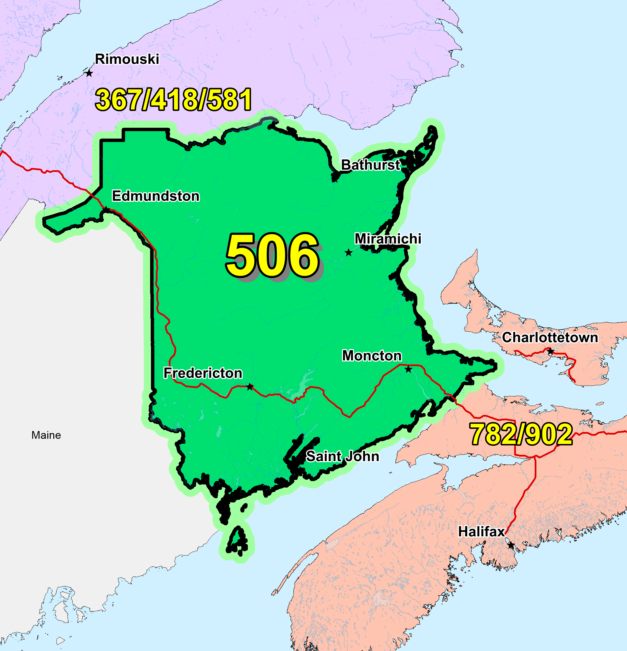

Attachment 2
Exchange Areas in NPA 506

Existing Exchange Areas in NPA 506; these will be in NPA 428 and 506 after the Overlay

Exchange Name
Allardville
Balmoral
Bathurst
Belledune
Campbellton
Caraquet
Dalhousie
Grande-Anse
Lameque
Paquetville
Petit-Rocher
Saint-Isidore
Shippagan
Tracadie
Baker Brook
Clair
Edmundston
Florenceville
Grand Falls
Hartland
Kedgwick
New Denmark
Perth-Andover
Plaster Rock
Saint Basile
Sainte-Anne-de-Madawaska
Saint-Quentin
St. Leonard
Woodstock
Baie-Sainte Anne
Blackville
Boiestown
Bouctouche
Cap-Pele
Cocagne
Doaktown
Dorchester
Fords Mills
Memramcook
Miramichi
Neguac
Richibucto
Rogersville
Sackville
Saint-Antoine
Shediac
St. Louis-de-Kent
Stanley
Blacks Harbour
Browns Flat
Campobello
Deer Island
Grand Bay-Westfield
Grand Manan
Hampton
Maces Bay
Norton
Petitcodiac
Rothesay
Saint John
Salisbury
Springfield
St. Andrews
St. George
St. Martins
St. Stephen
Summerville
Sussex
Welsford
Youngs Cove Road
Albert
Alma
Hillsborough
Moncton
Port Elgin
Chipman
Fredericton
Fredericton Junction
Gagetown
Harvey Station
Hoyt
Keswick
McAdam
Meductic
Millville
Minto
Nackawic
Oromocto

