CRTC INTERCONNECTION STEERING COMMITTEE
CONTRIBUTION FORM:
Working Group: CSCN Date of Submission: 2024-04-05
Contribution #: 231B
TIF #: TBP Questions Team File ID: CNCO231B
Task Title: Thousands-block Pooling Question Team
Related to Task(s) ID:
Contributor:
Name: David Comrie
Company: CSCN
Address:
Tel:
Fax:
E-mail: david.comrie@cnac.ca
Distribution to: CSCN
Subject: Draft memorandum to CSCN - Recommend NPAC Related Requirements for thousands-block pooling implementation in Canada

Memorandum

To: CSCN
From: The 1K-Block Questions Team
Date: 26 March 2024
Re: Recommend NPAC Related Requirements for thousands-block pooling implementation in Canada

The following recommended requirements are being submitted to CSCN for further consideration as discussed by the Thousands-Block Questions Team. These recommendations are drawn from the current ATIS-0300119 “Thousands-Block (NPA-NXX-X) & Central Office Code (NPA-NXX) Administration Guidelines” and the “North American Numbering Council (NANC) Functional Requirements Specification for the Number Portability Administration Center (NPAC) Service Management System (SMS).” [There is a need to specify the Functional Requirement Specification (FRS) version of the NPAC SMS specifications i.e., the 2023 iconectiv FRS for the NPAC SMS, or the 2017 Neustar FRS version for the NPAC SMS. CSCN to validate preference to use latest NPAC SMS FRS. CLNPC to determine extent of Neustar NPAC SMS development.]
The recommendations contained herein are based on the following basic assumptions:
- NPAC will support thousands-block pooling,
- numbering resources allocated to a wireline carrier are to be utilized to provide service to a customer’s premises located in the same Exchange Area that the numbering resources are assigned and be eligible to request numbering resources in that Exchange Area. Exceptions exist (e.g., foreign exchange service),
- numbering resources allocated to a wireless carrier may be utilized by customers regardless of location. However, the wireless carrier must have appropriate network interconnection arrangements in place to receive traffic from the PSTN destined for its customers (e.g., a POI in the appropriate LIR or Local Calling Area) and be eligible to request numbering resources in the requested Exchange Area,
- numbering resource assignment will continue to require a Switching Entity/POI CLLI as part of the “Part 1 Form” for an NPA NXX (CO code) as well as for the “Part 1A Form” used for thousands-block requests;
- The CNA, in its capacity as the Pooling Administrator (PA), shall maintain a pool of available thousands-blocks per Exchange Area (rate center equivalent) from which Service Providers (SPs) may request thousands-blocks, modify information about thousands-blocks that have been assigned to them, or disconnect (i.e., return) thousands-blocks that have been assigned to the SP; and
- PA will assign blocks of size 1,000 because BIRRDS and NPAC only accommodate that size.

High Level SP-PA-NPAC Relationship Recommendations

All references to Part 1A, Part 3A, Part 1 and Part 3 are references to legacy forms used in the US as specified in the current ATIS specification. However, as of October 28, 2024, the US and the ATIS specifications will be moving to integrated Part 1 and Part 3 forms.

PA Block Assignments and NPAC SMS Block Activations

- The PA will receive requests for thousands-block activations, modifications and disconnects within the NPAC SMS from SPs, and forward these requests to the NPAC. For block activation requests, the PA will insert (i) the assigned thousands-block identifiers (NPA-NXX-X’s), and (ii) the earliest standard NPAC SMS activation date unless a later date is requested (expedited requests tbd). Having the PA validate SP thousands-block activation requests before forwarding to the NPAC will prevent SP’s from making unauthorized changes to thousands-blocks belonging to other carriers.
- For all thousands-block activation, modification and disconnect requests, NPAC SMS will provide confirmations directly back to thousands-block requestor and PA. PA will not provide a confirmation back to requestor regarding NPAC SMS block activation. [Tbd based on FRS version for NPAC SMS. Neustar 2017 FRS relies on PA to forward the block activation to the SP.]
- PA will provide a “Part 3A Form” confirming thousands-block assignments to the SP. See diagram below.
- SP is responsible for the thousands-block routing information contained in any thousands-block activation or modification request e.g., SSN and DPC values.
- PA will not send a “Part 1B form” to NPAC where a block assignment request is for a thousands-block being allocated to the Code Holder on the switch where the CO code resides. Default routing will be relied upon when there is an LSMS/LNP query.
- SP must input the BIRRDS “A” record within 7 days of being assigned a CO Code. Block activations within the NPAC SMS cannot be processed until the CO Code has been opened for portability in the NPAC database.
- PA database of available blocks will indicate if a block is pending activation in the PSTN (which includes NPAC).
- PA database of available blocks will indicate if a block is contaminated and the level of contamination at the time the block is added to the pool.

Block Disconnects
- PA will need to obtain NPAC reports when processing requests for the return of numbering resources from SPs (for both thousands-block and CO code returns).
- The NPAC SMS shall use the default routing restoration information in the Number Pooling Block Holder Information as the block holder default routing, when a ported pooled telephone number is disconnected (or port to original port is activated), and returns the TN(s) to the block, once the Block exists,
- The NPAC SMS shall send a notification to the Code Holder, and suppress the notification to the Block Holder, when a ported pooled telephone number is disconnected from a block that has been returned to the PA. However, even though the customer disconnect date notification goes to the Code Holder, the TN cannot be re-assigned in their inventory in regions where thousands block pooling is in place. Code Holder receives the notification in order to provide vacant number treatment as applicable.
- For block disconnects (returns), the SP, before disconnecting a block, must:
(i) verify that the degree of contamination is less than or equal to the specified maximum for a block return i.e., ported out telephone numbers and telephone numbers assigned to the SP’s customers cannot exceed the maximum for a block return. It is recommended that SP’s rely on NPAC SMS reports (or third party derivatives) rather than LSMS reports when determining number of ported out numbers prior to a block return, and
(ii) perform an intra-carrier port for all existing telephone numbers assigned to the SP’s customers (i.e., the telephone numbers must show up as ported in the NPAC SMS).
PA may deny a block return if the contamination level (as determined by PA) exceeds the maximum contamination level for a block return.
- To implement a block disconnect, a SP provider must provide Part 1A form and Part 1B form equivalents to the PA. The PA will forward the block disconnect request to the NPAC SMS after verifying SP is the block holder and provide a confirmation back to the SP that the PA has processed the block disconnect request (Part 3A form equivalent). Subsequently, the NPAC will provide a confirmation of the NPAC SMS block disconnect to both the SP and the PA. (NPAC SMS FRS version dependent).

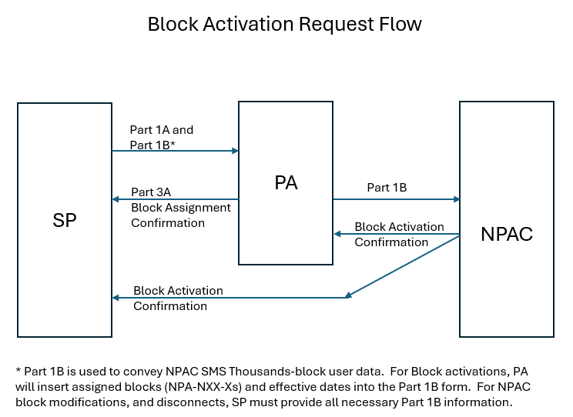

RR3-183
RR3-184

